Hydra Introduction
What is Hydra?
Hydra is a brute force online password cracking program, a quick system login password “hacking” tool.
Hydra can run through a list and “brute force” some authentication services. Imagine trying to manually guess someone’s password on a particular service (SSH, Web Application Form, FTP or SNMP) - we can use Hydra to run through a password list and speed this process up for us, determining the correct password.
According to its official repository, Hydra supports, i.e., has the ability to brute force the following protocols: “Asterisk, AFP, Cisco AAA, Cisco auth, Cisco enable, CVS, Firebird, FTP, HTTP-FORM-GET, HTTP-FORM-POST, HTTP-GET, HTTP-HEAD, HTTP-POST, HTTP-PROXY, HTTPS-FORM-GET, HTTPS-FORM-POST, HTTPS-GET, HTTPS-HEAD, HTTPS-POST, HTTP-Proxy, ICQ, IMAP, IRC, LDAP, MEMCACHED, MONGODB, MS-SQL, MYSQL, NCP, NNTP, Oracle Listener, Oracle SID, Oracle, PC-Anywhere, PCNFS, POP3, POSTGRES, Radmin, RDP, Rexec, Rlogin, Rsh, RTSP, SAP/R3, SIP, SMB, SMTP, SMTP Enum, SNMP v1+v2+v3, SOCKS5, SSH (v1 and v2), SSHKEY, Subversion, TeamSpeak (TS2), Telnet, VMware-Auth, VNC and XMPP.”
For more information on the options of each protocol in Hydra, you can check the Kali Hydra tool page.
This shows the importance of using a strong password; if your password is common, doesn’t contain special characters and is not above eight characters, it will be prone to be guessed. A one-hundred-million-password list contains common passwords, so when an out-of-the-box application uses an easy password to log in, change it from the default! CCTV cameras and web frameworks often use admin:password as the default login credentials, which is obviously not strong enough.

Using Hydra
Hydra is already installed on the AttackBox. Start the AttackBox by pressing the Start AttackBox button below, which will start the machine in Split-Screen view. If it is not visible, use the blue Show Split View button at the top of the page.
Once done, Click the green Start Machine button below to deploy the machine attached to this task, then navigate to http://MACHINE_IP on the AttackBox (this machine can take up to 3 minutes to boot).
However, you can check its official repositories if you prefer to use another Linux distribution. For instance, you can install Hydra on an Ubuntu or Fedora system by executing apt install hydra or dnf install hydra. Furthermore, you can download it from its official THC-Hydra repository.

Hydra Commands
The options we pass into Hydra depend on which service (protocol) we’re attacking. For example, if we wanted to brute force FTP with the username being user and a password list being passlist.txt, we’d use the following command:
hydra -l user -P passlist.txt ftp://10.49.174.144
For this deployed machine, here are the commands to use Hydra on SSH and a web form (POST method).

SSH
hydra -l <username> -P <full path to pass> 10.49.174.144 -t 4 ssh
Option | Description
-l | specifies the (SSH) username for login
-P | indicates a list of passwords
-t | sets the number of threads to spawn
For example, hydra -l root -P passwords.txt 10.49.174.144 -t 4 ssh will run with the following arguments:
- Hydra will use root as the username for ssh
- It will try the passwords in the passwords.txt file
- There will be four threads running in parallel as indicated by -t 4

Post Web Form
We can use Hydra to brute force web forms, too. You must know which type of request it is making; GET or POST methods are commonly used. You can use your browser’s network tab (in developer tools) to see the request types or view the source code.
sudo hydra <username> <wordlist> 10.49.174.144 http-post-form "<path>:<login_credentials>:<invalid_response>"
Option | Description
-l | the username for (web form) login
-P | the password list to use
http-post-form | The type of the form is POST
<path> | the login page URL, for example, login.php
<login_credentials> | the username and password used to log in, for example, username=^USER^&password=^PASS^
<invalid_response> | part of the response when the login fails
-V | verbose output for every attempt
Below is a more concrete example Hydra command to brute force a POST login form:
hydra -l <username> -P <wordlist> 10.49.174.144 http-post-form "/:username=^USER^&password=^PASS^:F=incorrect" -V
- The login page is only /, i.e., the main IP address.
- The username is the form field where the username is entered
- The specified username(s) will replace ^USER^
- The password is the form field where the password is entered
- The provided passwords will be replacing ^PASS^
- Finally, F=incorrect is a string that appears in the server reply when the login fails
On a side note, if the web server is listening on a non-default port number, you can explicitly specify the port number using -s <port>, for example:
hydra -l <username> -P <wordlist> 10.49.174.144 http-post-form "/:username=^USER^&password=^PASS^:F=incorrect" -s <port> -V
You should now have enough information to put this into practice and brute-force your credentials on the deployed machine!

Practical:
Use Hydra to brute-force molly's web password. What is the value of flag 1? 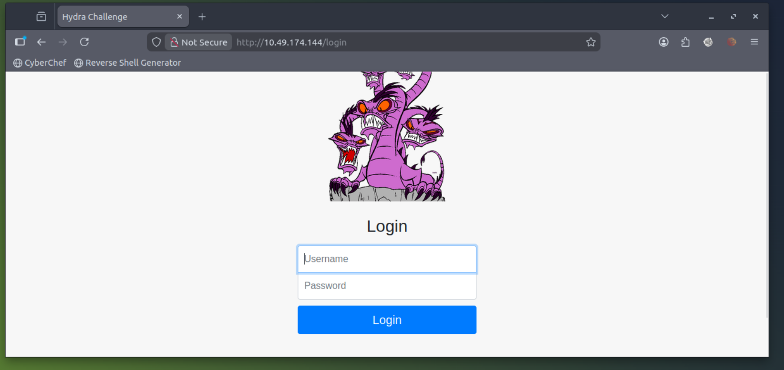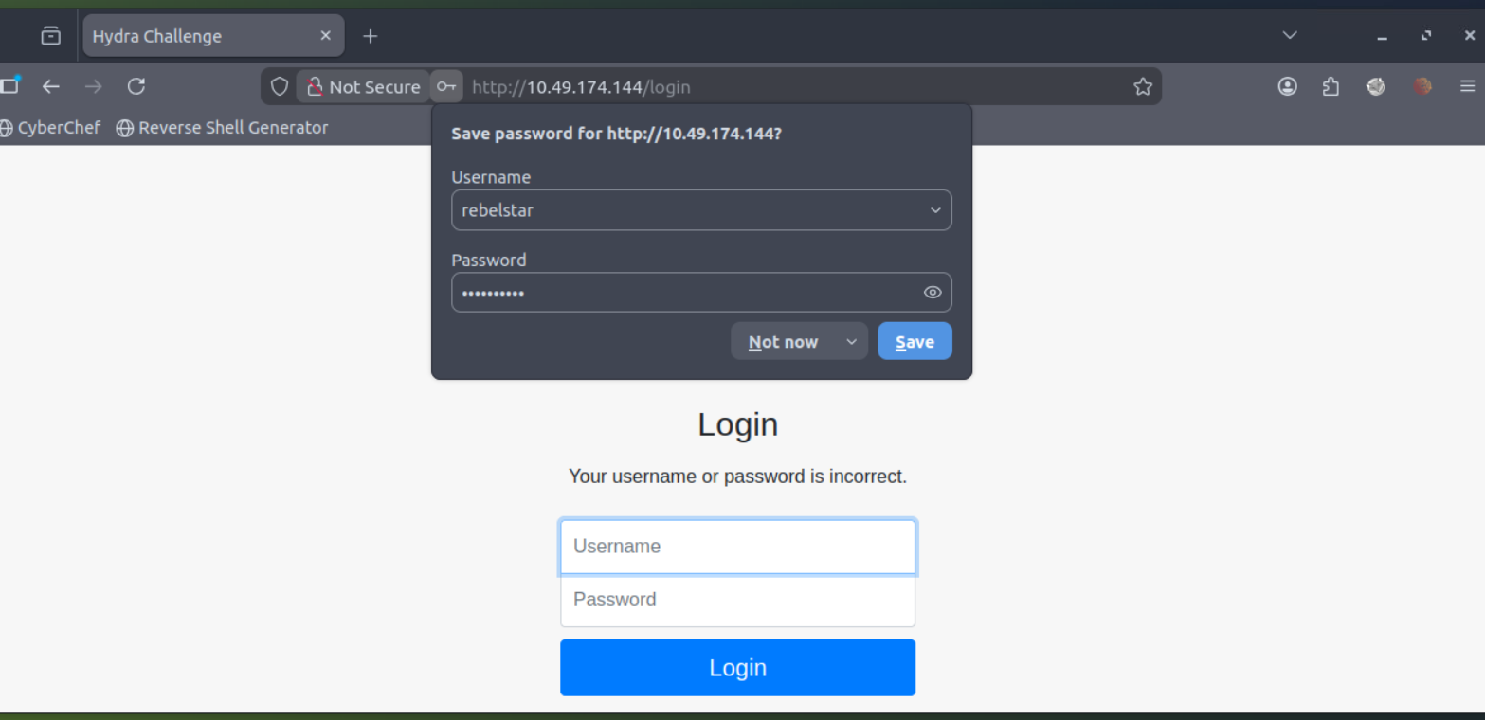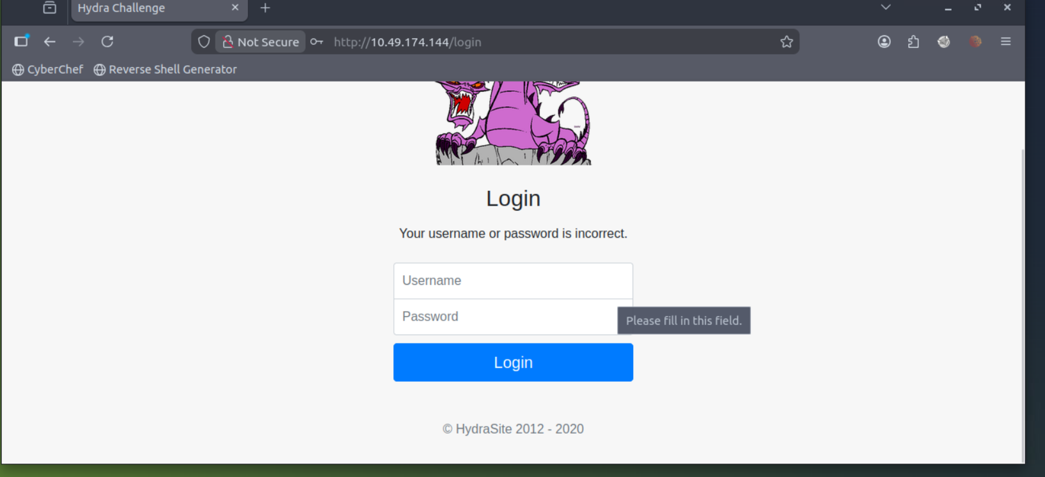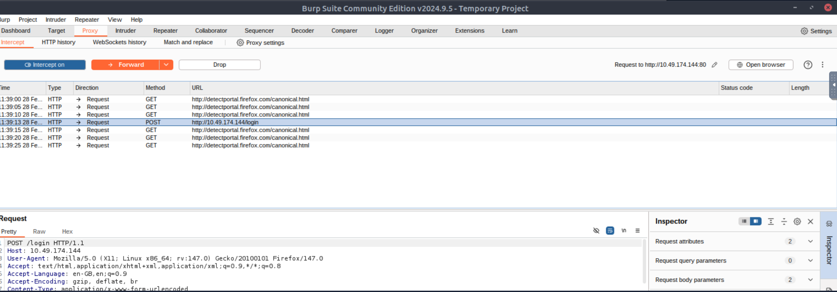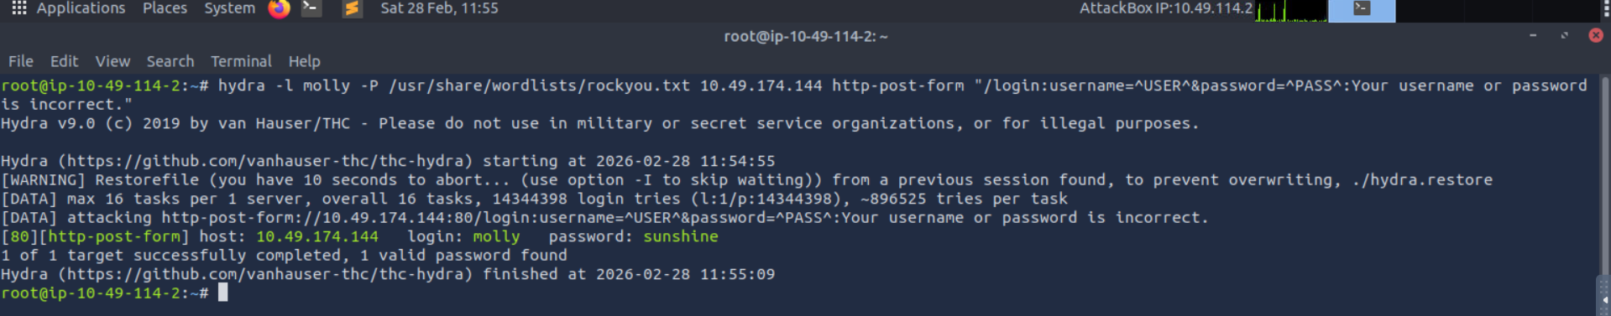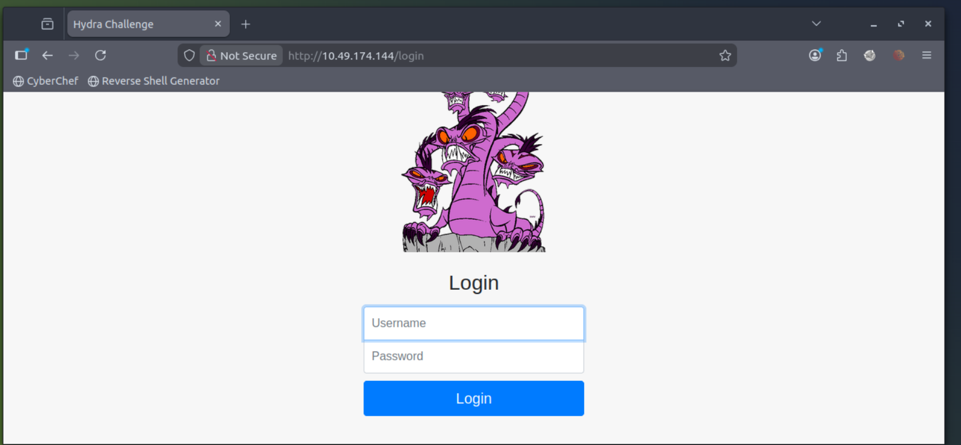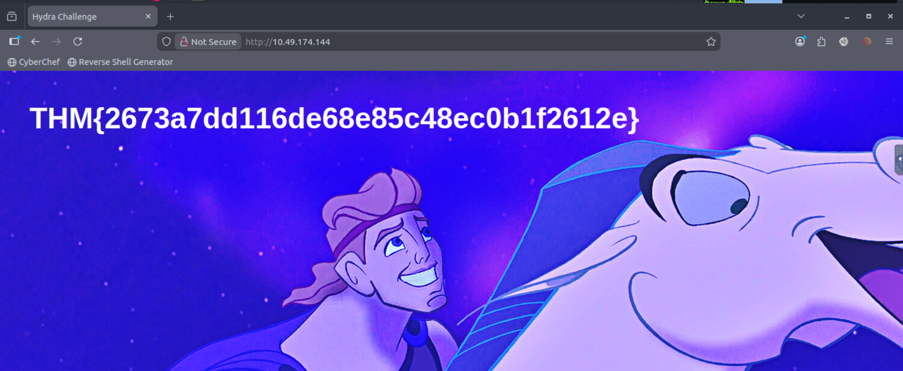

Use Hydra to brute-force molly's SSH password. What is the value of flag 2?