Windows Command Line

Introduction
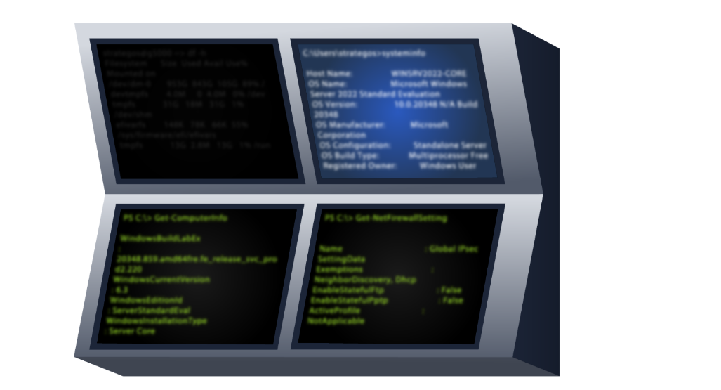
Everyone prefers a graphical user interface (GUI) until they master a command-line interface (CLI). There are many reasons for that. One reason is that GUIs are usually intuitive. If someone offers you a GUI interface you are unfamiliar with, you can quickly poke around and discover a non-trivial part. Compare this with dealing with a CLI, i.e., a prompt.
CLI interfaces usually have a learning curve; however, as you master the command line, you will find it faster and more efficient. Consider this trivial example: How many clicks do you need to find your IP address using the graphical desktop? Using the command-line interface, you don’t even need to raise your hands off the keyboard. Let’s say you want to recheck your IP address. You need to issue the same command instead of moving the mouse pointer to every corner of your screen.
There are many other advantages to using a CLI besides speed and efficiency. We will mention a few:
- Lower resource usage: CLIs require fewer system resources than graphics-intensive GUIs. In other words, you can run your CLI system on older hardware or systems with limited memory. If you are using cloud computing, your system will require lower resources, which in turn will lower your bill.
- Automation: While you can automate GUI tasks, creating a batch file or script with the commands you need to repeat is much easier.
- Remote management: CLI makes it very convenient to use SSH to manage a remote system such as a server, router, or an IoT device. This approach works well on slow network speeds and systems with limited resources.

Basic System Information
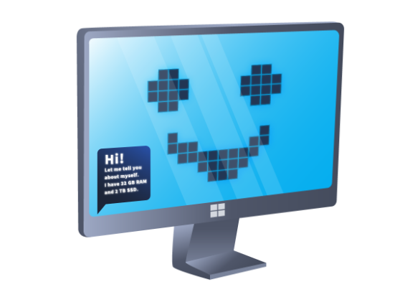
Before issuing commands, we should note that we can only issue the commands within the Windows Path. You can issue the command set to check your path from the command line. The terminal output below shows the path where MS Windows will execute commands, as indicated by the line starting with Path=.
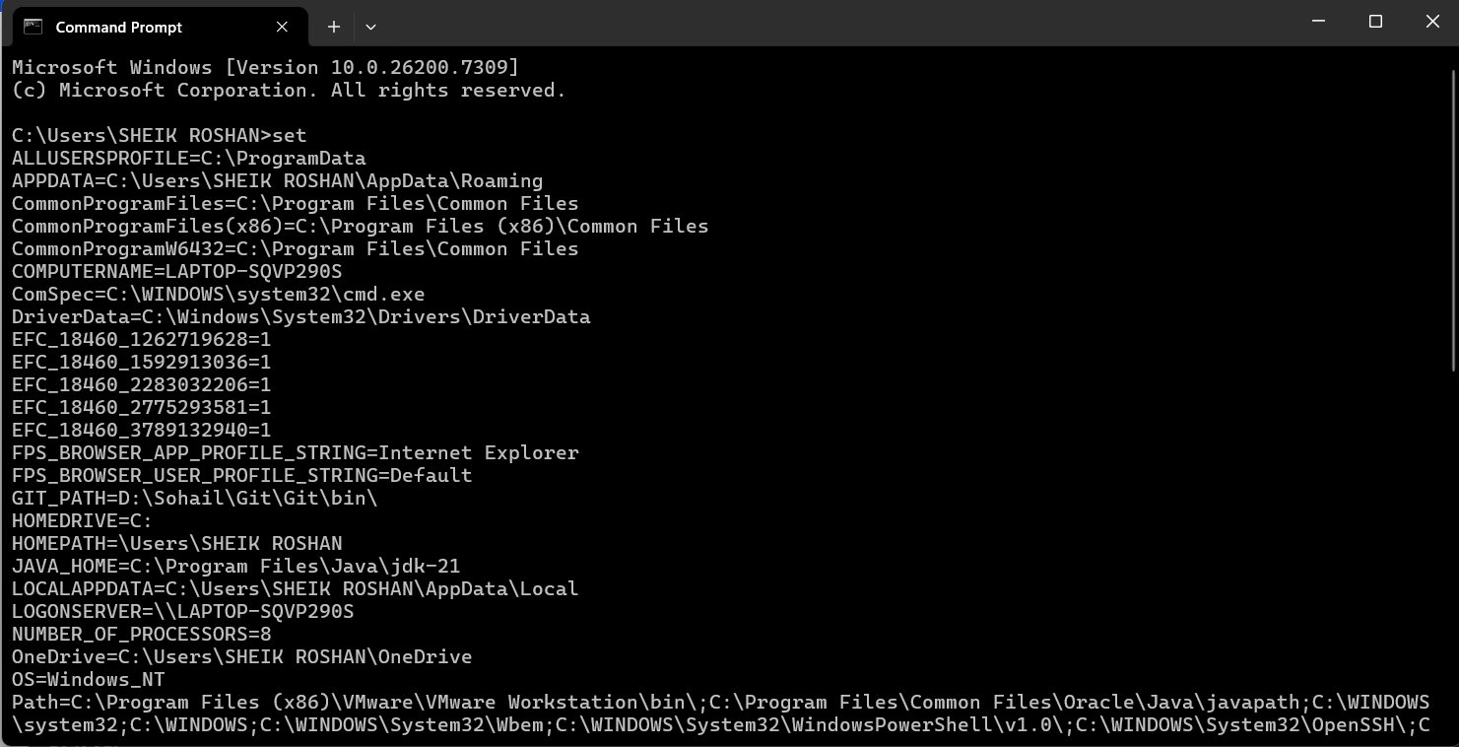
Let’s use the ver command to determine the operating system (OS) version. The terminal below shows an example output. 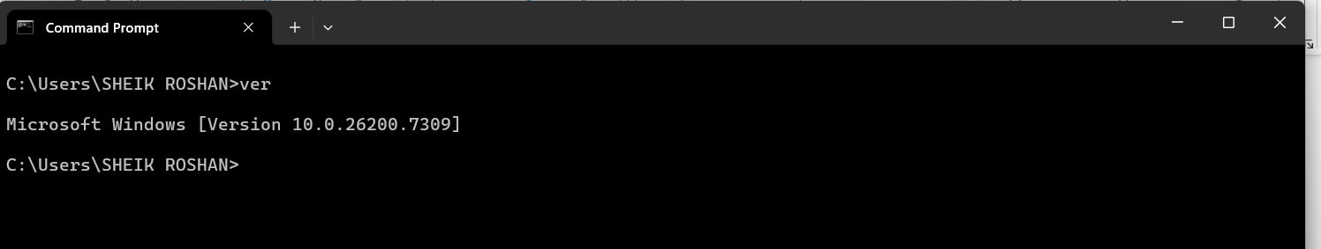
Enough warming up. Let’s discover more in-depth information about the system. We can run the systeminfo command to list various information about the system such as OS information, system details, processor and memory. The terminal below shows a snippet of the displayed output. 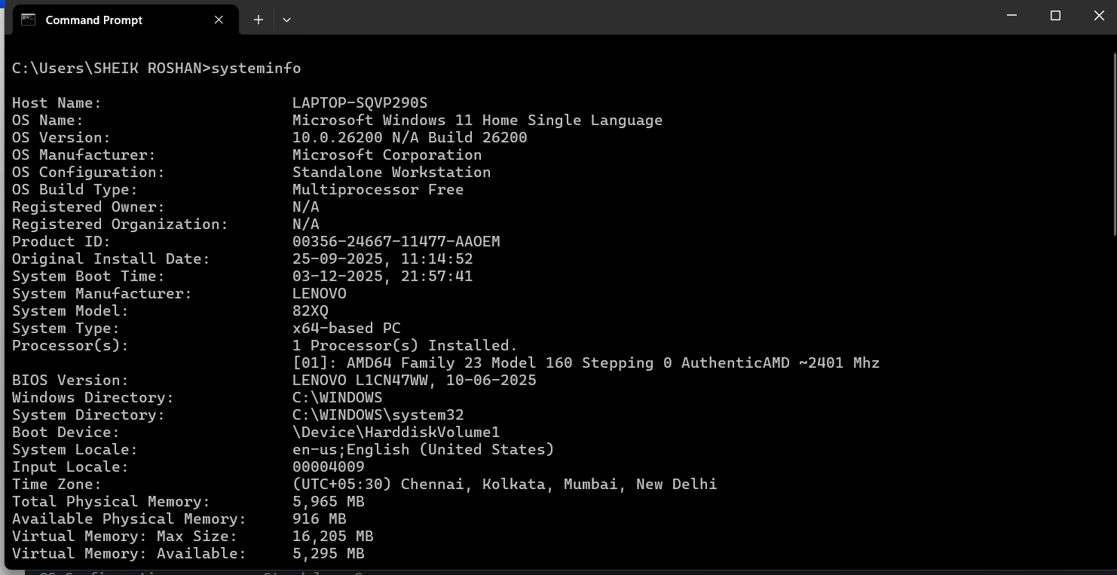

Before moving on, it is good to mention a couple of tricks.
First, you can pipe it through more if the output is too long. Then, you can view it page after page by pressing the space bar button. To demonstrate this, try running driverquery and compare it with running driverquery | more. In the latter, you can display the output page by page and you can exit it using CTRL + C.
- help - Provides help information for a specific command
- cls - Clears the Command Prompt screen.
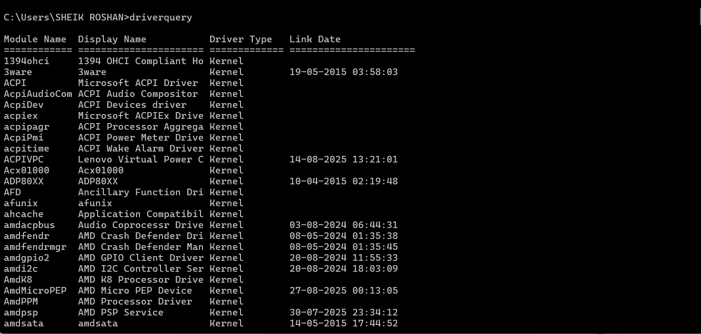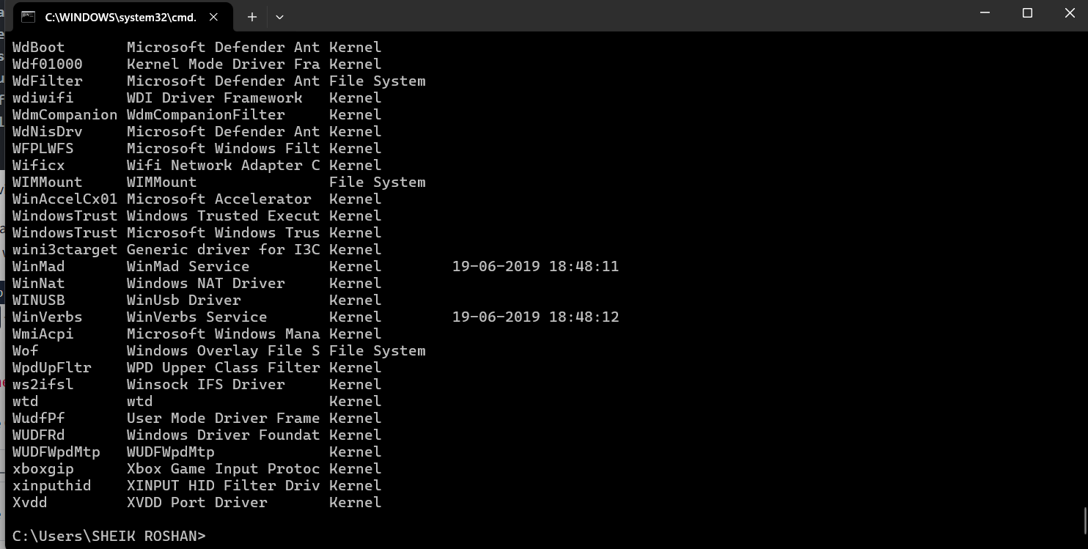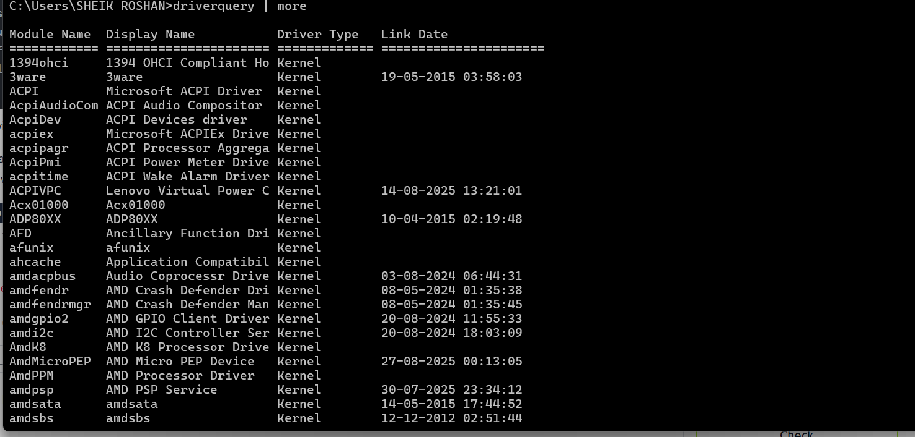

Practical (Checking windows CMD)
Used SSH method to connect from my attack box to vulnerable machine and I am able to login
Command: ssh username@Ip address
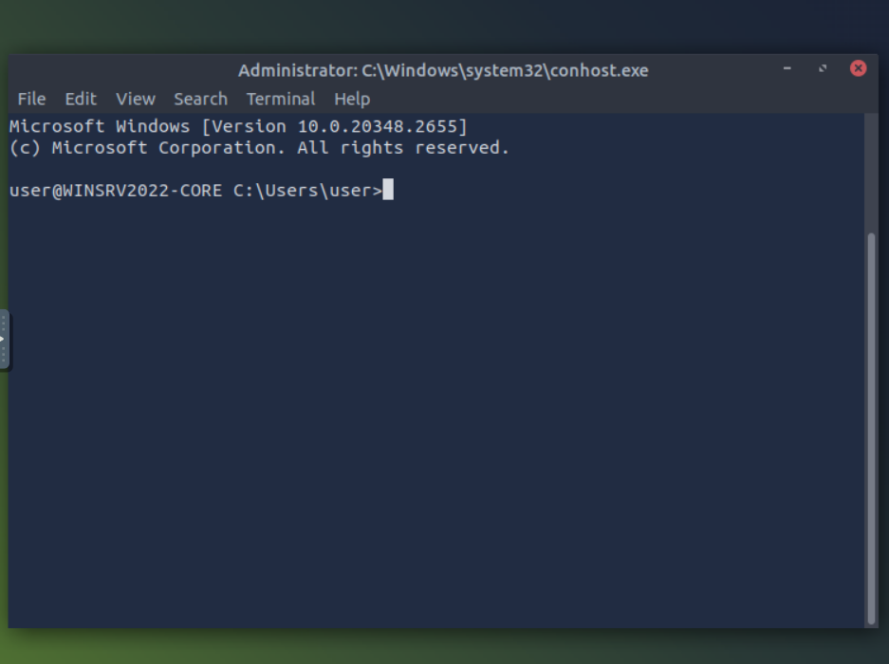

What is the OS version of the Windows VM? 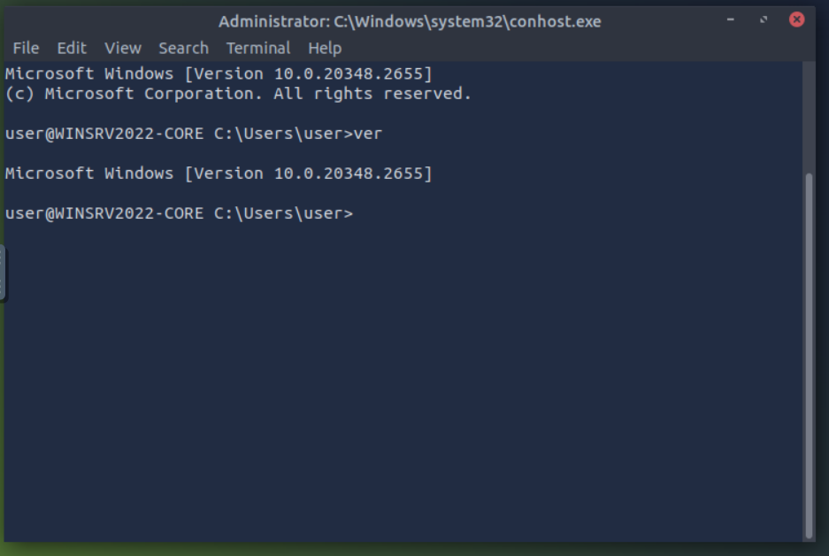
What is the hostname of the Windows VM? 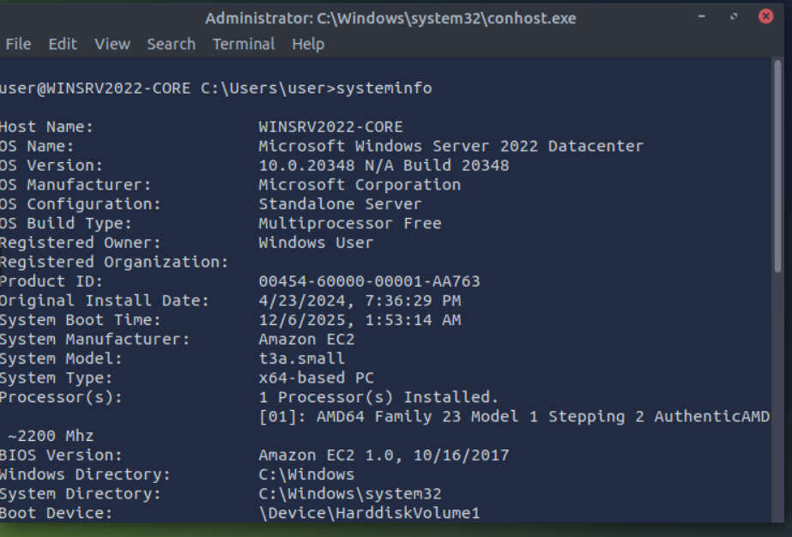

Network Troubleshooting
Most of us are used to looking up MS Windows network configuration from the GUI interface. The command-line interface provides many networking-related commands to look up your current configuration, check ongoing connections, and troubleshoot networking issues.

Network Configuration
You can check your network information using ipconfig. The terminal output below shows our IP address, subnet mask, and default gateway. 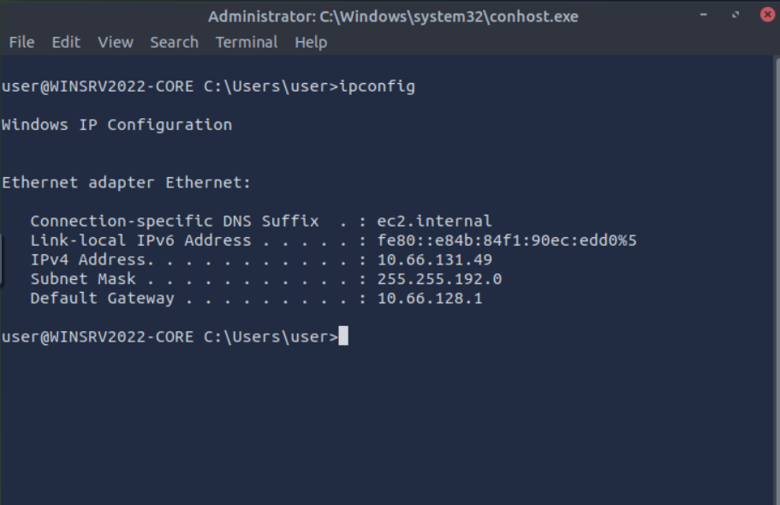
You can also use ipconfig /all for more information about your network configuration. As shown in the terminal below, we can view our DNS servers and confirm that DHCP is enabled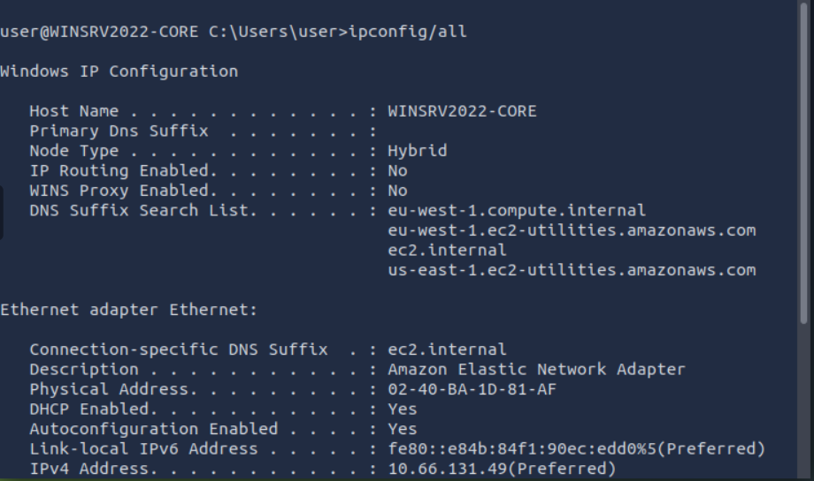

Network Troubleshooting
One common troubleshooting task is checking if the server can access a particular server on the Internet. The command syntax is ping target_name. Inspired by ping-pong, we send a specific ICMP packet and listen for a response. If a response is received, we know that we can reach the target and that the target can reach us.
Let’s find out if we reach example.com. In the terminal output below, we can see that we have successfully received four replies. Furthermore, we got some statistics; for instance, the average round trip time is 78 milliseconds. 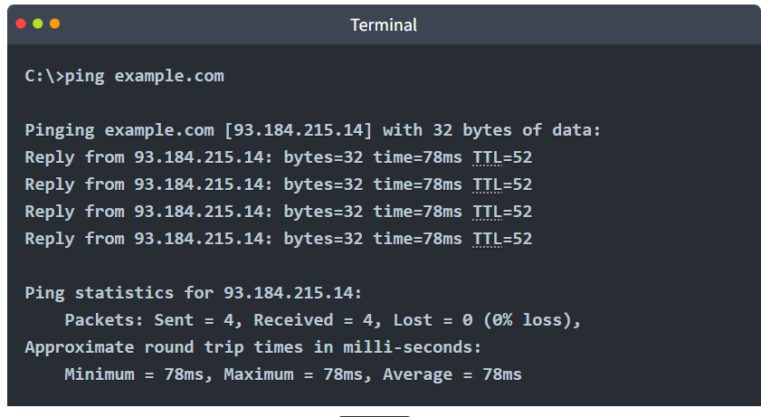
Another valuable tool for troubleshooting is tracert, which stands for trace route. The command tracert target_name traces the network route traversed to reach the target. Without getting into more details, it expects the routers on the path to notify us if they drop a packet because its time-to-live (TTL) has reached zero. The terminal output below shows that we passed through 15 routers before reaching our target.
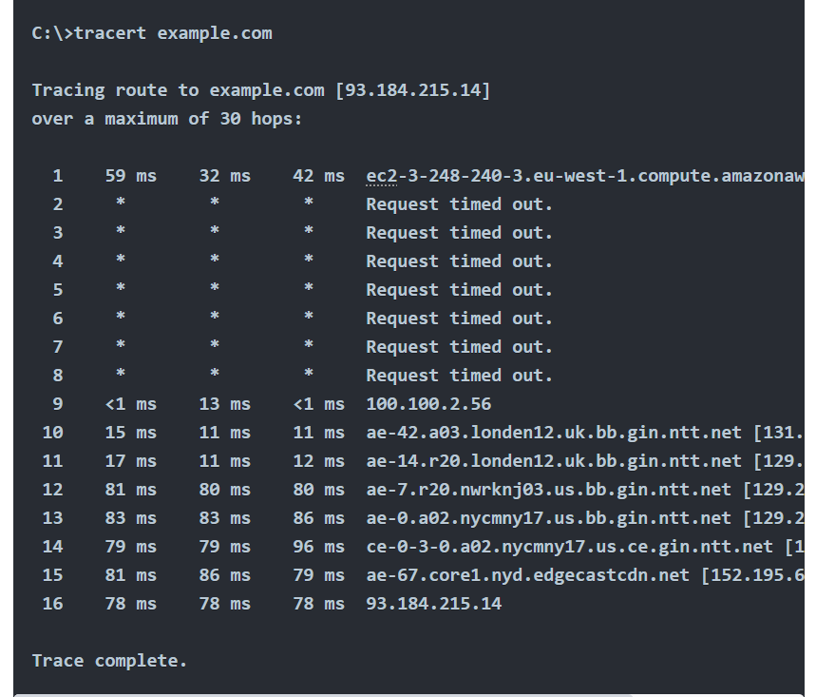

More Networking Commands
One networking command worth knowing is nslookup. It looks up a host or domain and returns its IP address. The syntax nslookup example.com will look up example.com using the default name server; however, nslookup example.com 1.1.1.1 will use the name server one.one.one.one. The terminal below shows the output of both commands. The results are identical; however, you can see that the answers were retrieved from different name servers. 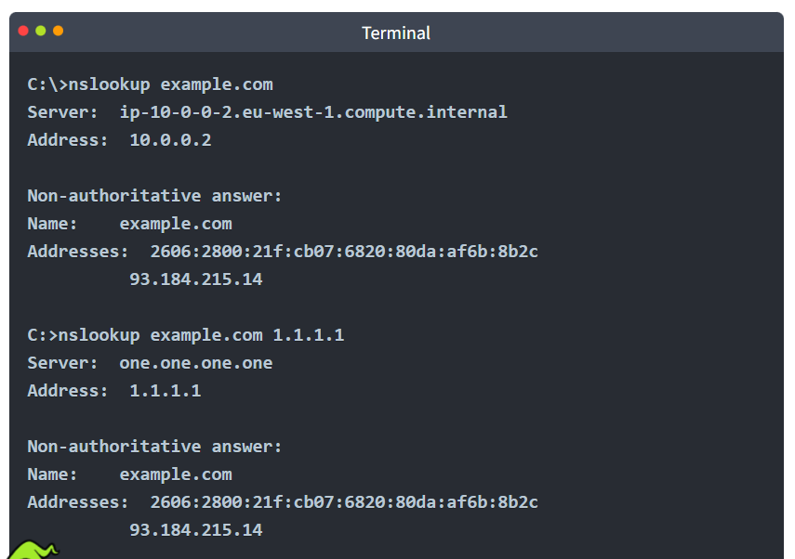
The final networking command we will cover in this room is netstat. This command displays current network connections and listening ports. A basic netstat command with no arguments will show you established connections, as shown below. In this case, we only have one SSH connection; we figured out it is SSH because it is bound to port 22. 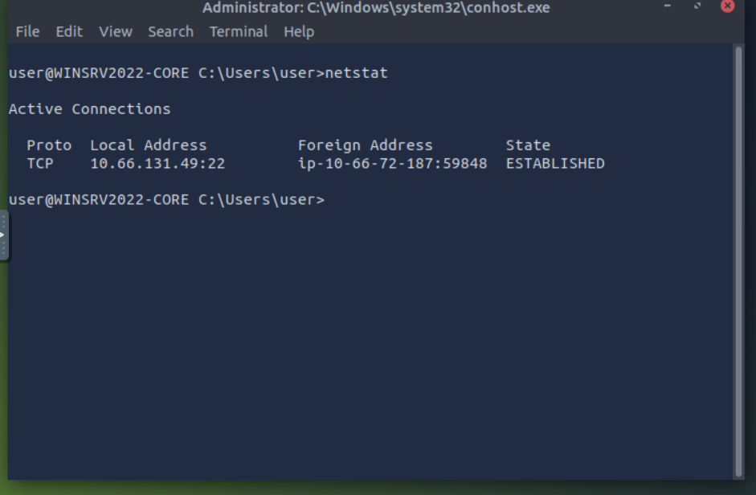
If you are curious about the other options, you can run netstat -h, where -h displays the help page. We opted for the following options:
- -a displays all established connections and listening ports
- -b shows the program associated with each listening port and established connection
- -o reveals the process ID (PID) associated with the connection
- -n uses a numerical form for addresses and port numbers
We combine these four options and execute the netstat -abon command. The result is quite long, but we display the first few lines in the terminal below. It is clear now that the executable sshd.exe is responsible for listening for incoming connections on port 22, as shown in the first line. We can also see the process ID (PID) associated with each connection.
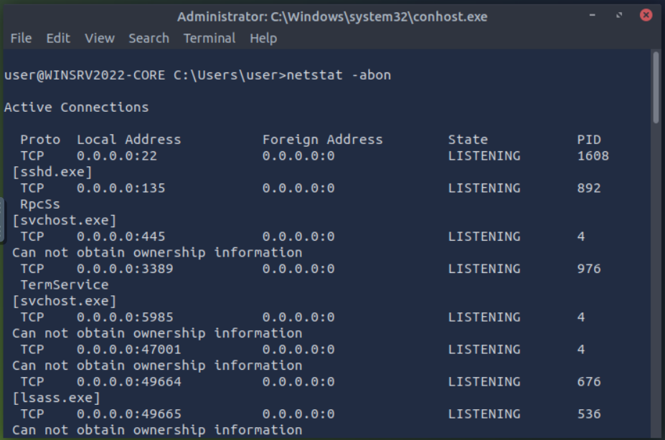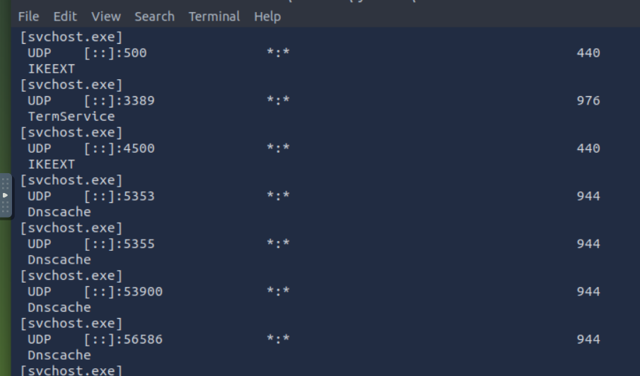

Practical (checking network configuration in cmd)
Which command can we use to look up the server’s physical address (MAC address)? 
What is the name of the service listening on port 135? 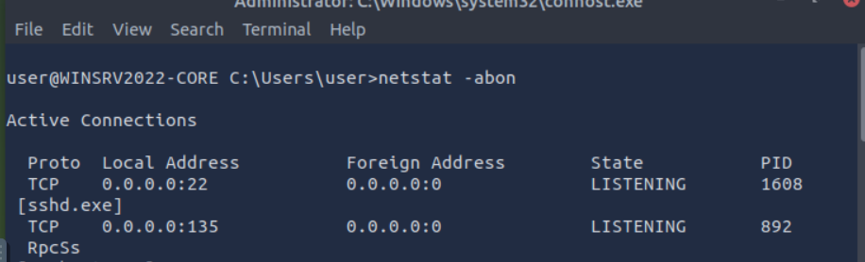
What is the name of the service listening on port 3389? 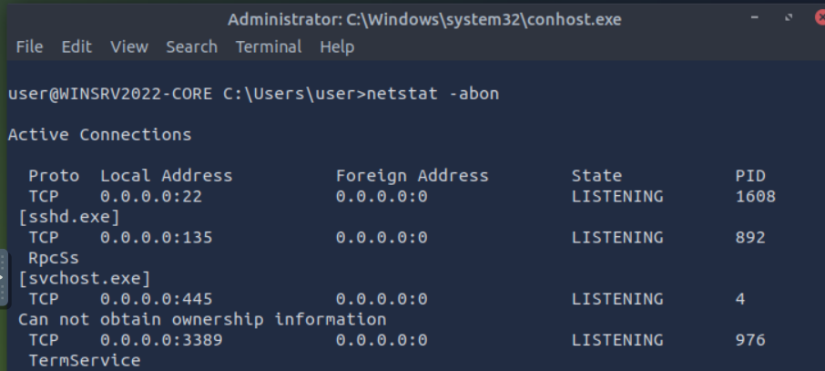

File and Disk Management
You have learned to look up basic system information and check the network configuration. Now, let’s discover how to browse the directories and move files around.

Working With Directories
You can use cd without parameters to display the current drive and directory. It is the equivalent of asking the system, where am I?
You can view the child directories using dir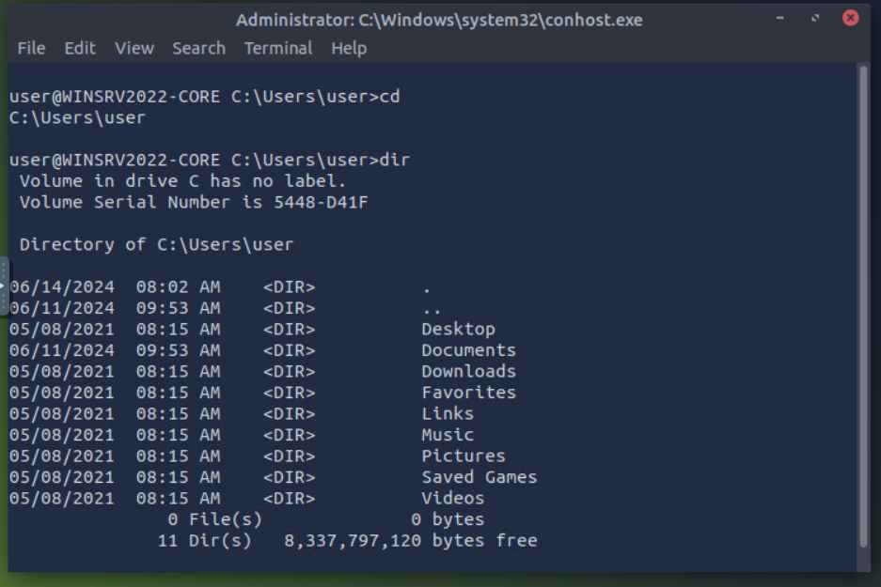
Note that you can use the following options with dir:
- dir /a - Displays hidden and system files as well.
- dir /s - Displays files in the current directory and all subdirectories.
You can type tree to visually represent the child directories and subdirectories.
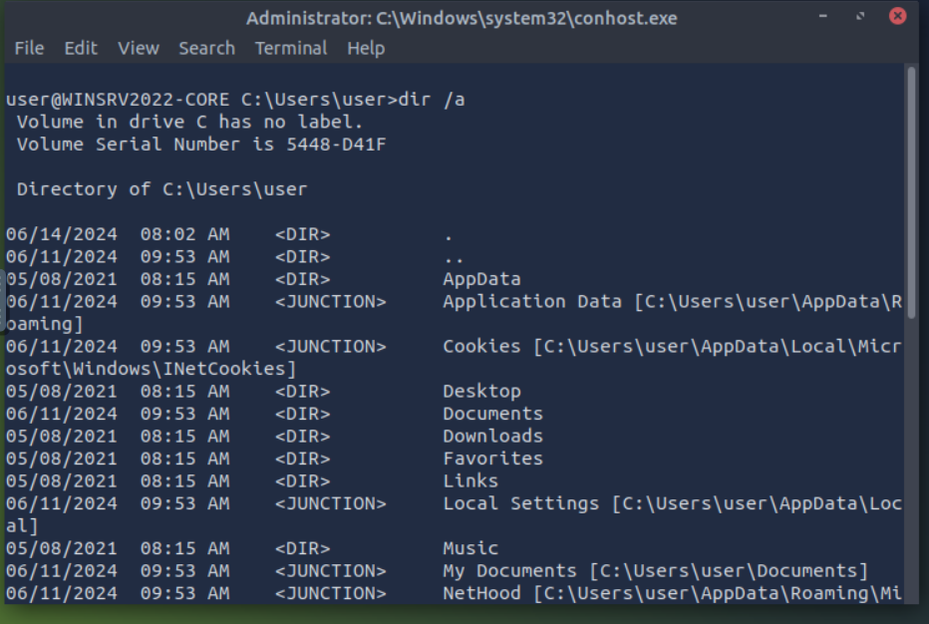
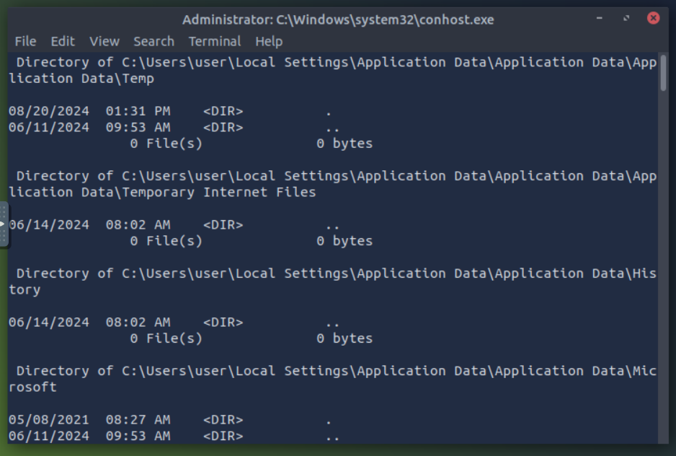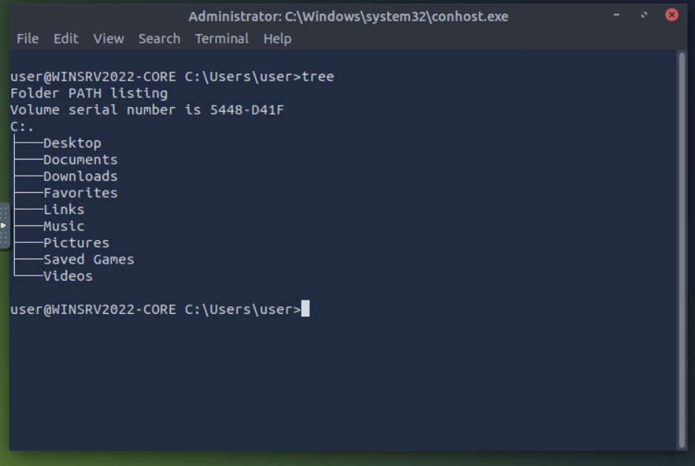
You can change to any directory by using the command cd target_directory; this is equivalent to double-clicking the target_directory on your desktop. Furthermore, you can use cd .. to go up one level. An example is shown in the terminal output below.
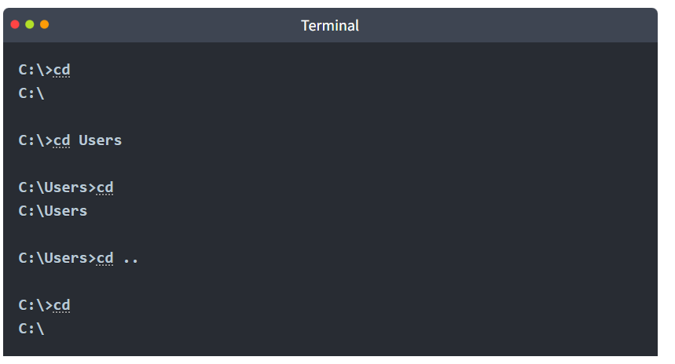
To create a directory, use mkdir directory_name; mkdir stands for make directory. To delete a directory, use rmdir directory_name; rmdir stands for remove directory. The terminal output below shows creating and deleting a directory. 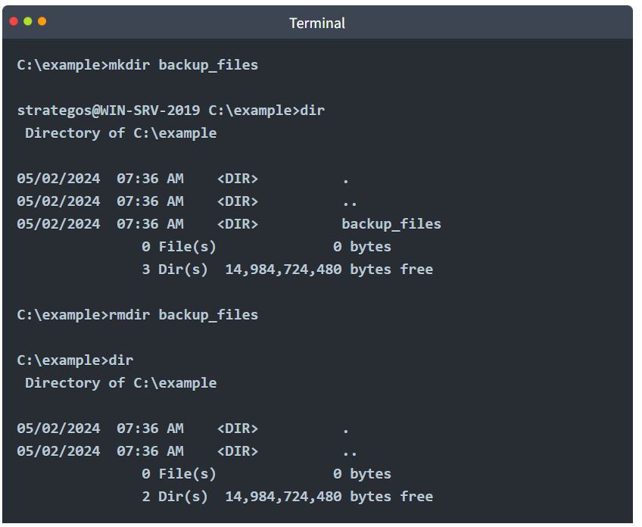

Working With Files
You are working with the command line. You are curious about the contents of a particular text file. You can easily view text files with the command type. This command will dump the contents of the text file on the screen; this is convenient for files that fit within your terminal window. You might want to consider more for longer text files. This command will display enough text file contents to fill your terminal window. In other words, for long text files, more will display a single page and wait for you to press Spacebar to move by one page (flip the page) or Enter to move by one line.
The copy command allows you to copy files from one location to another. The following terminal output provides an example. 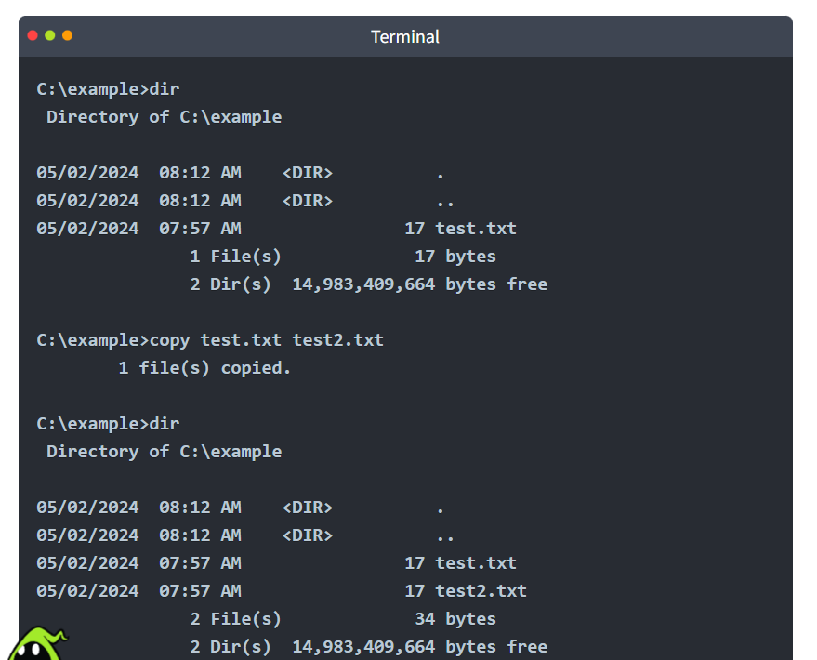
Similarly, you can move files using the move command. An example is shown in the terminal output below. 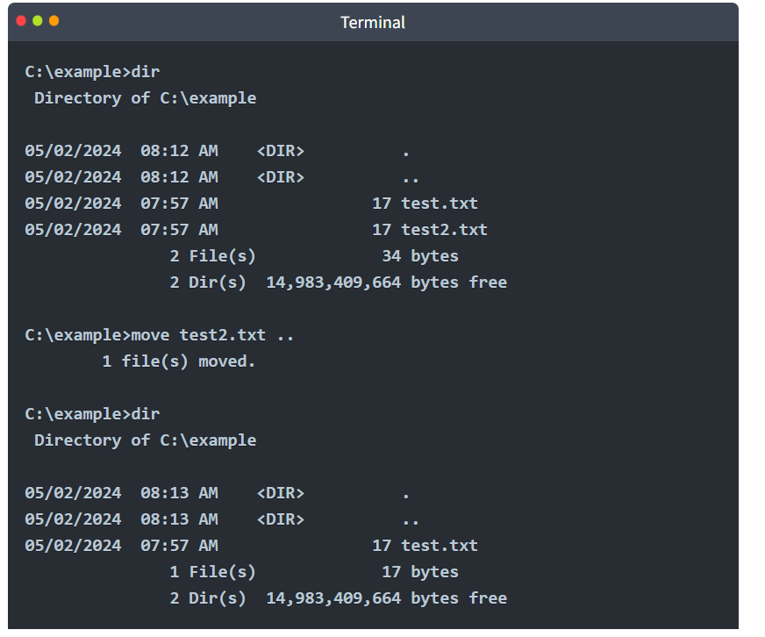
Finally, we can delete a file using del or erase. 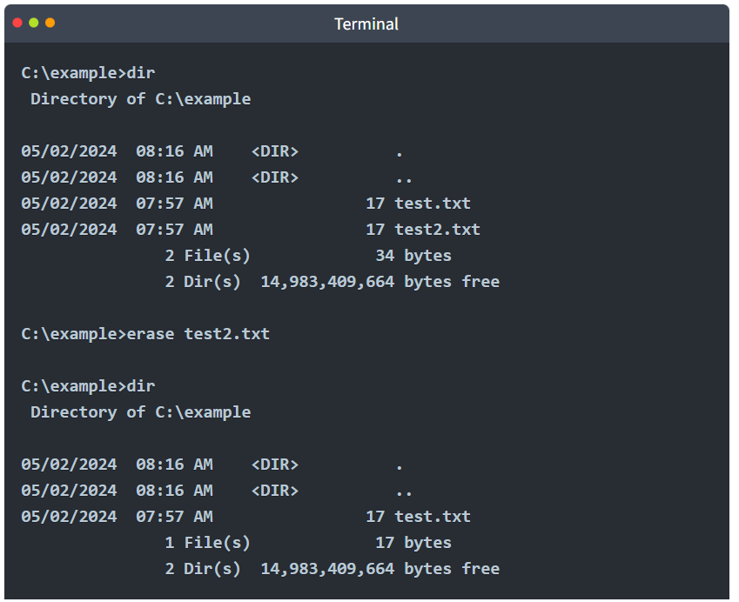

Practical (checking Directories)
What are the file’s contents in C:\Treasure\Hunt? 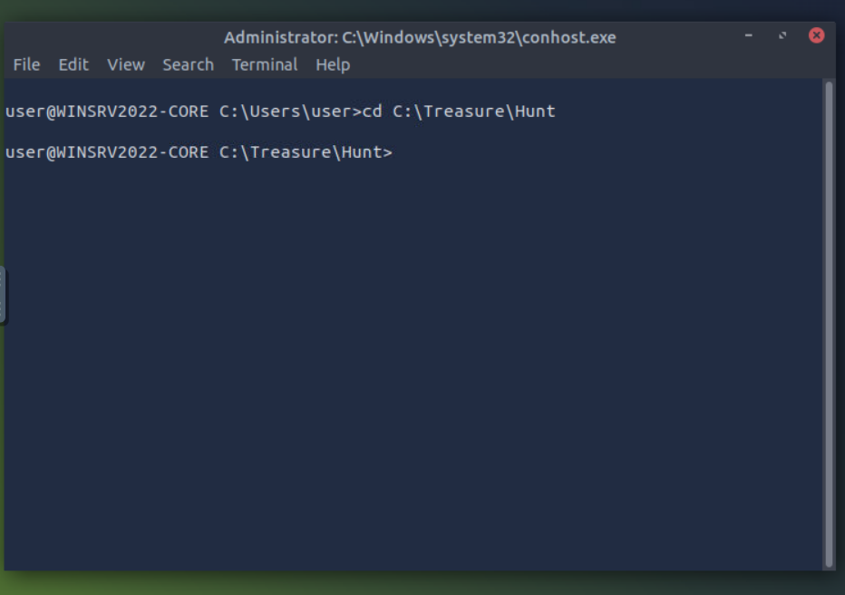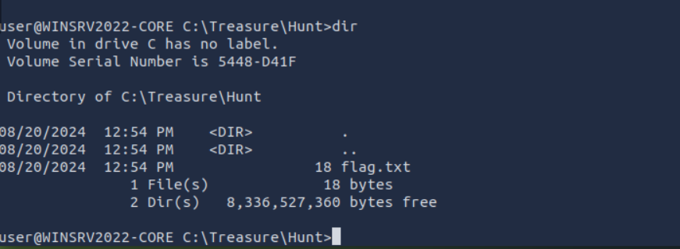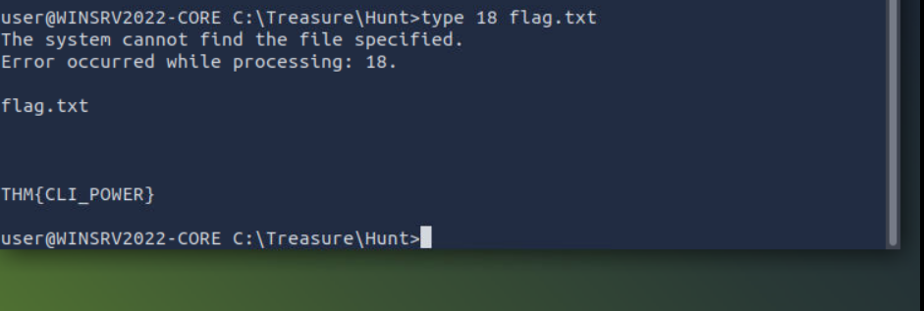

Task and Process Management
You must be familiar with MS Windows Task Manager and might be familiar with killing non-responsive processes. Let’s discover how to achieve a similar functionality using the command line.
We can list the running processes using tasklist. 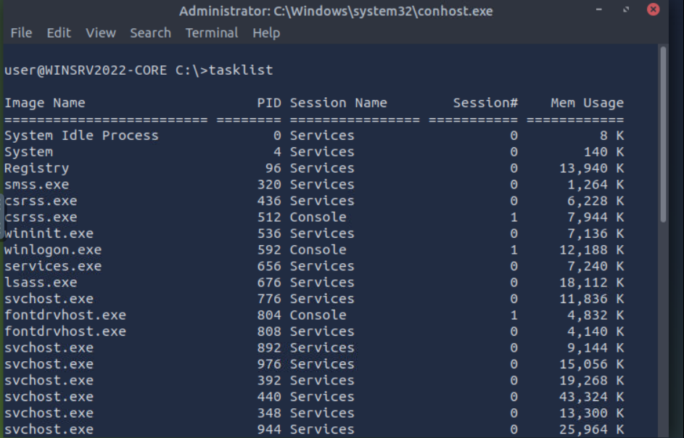
Some filtering is helpful because the output is expected to be very long. You can check all available filters by displaying the help page using tasklist /?. Let’s say that we want to search for tasks related to sshd.exe, we can do that with the command tasklist /FI "imagename eq sshd.exe". Note that /FI is used to set the filter image name equals sshd.exe.
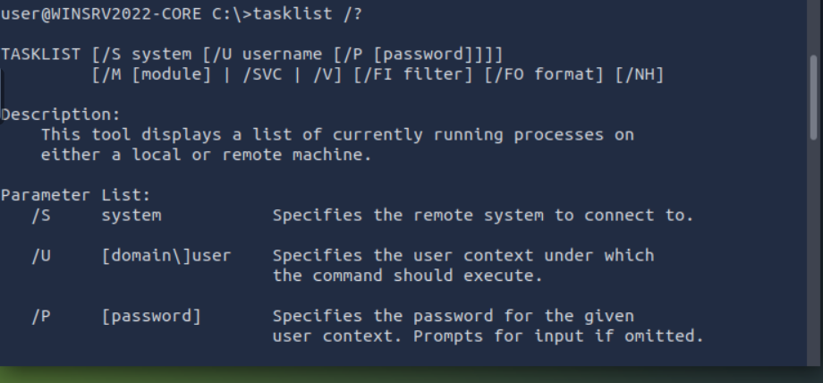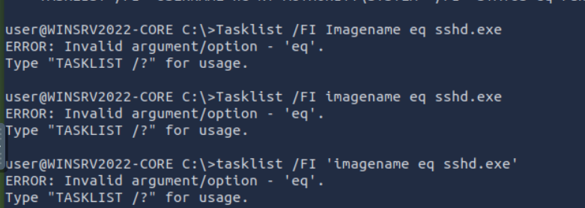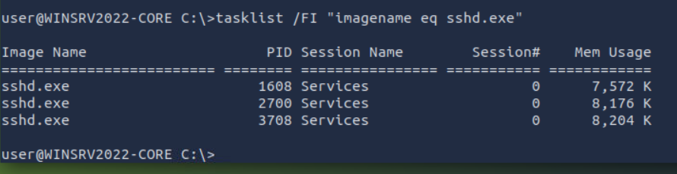
With the process ID (PID) known, we can terminate any task using taskkill /PID target_pid. For example, if we want to kill the process with PID 4567, we would issue the command taskkill /PID 4567.

Practical (Task manager)
What command would you use to find the running processes related to notepad.exe? 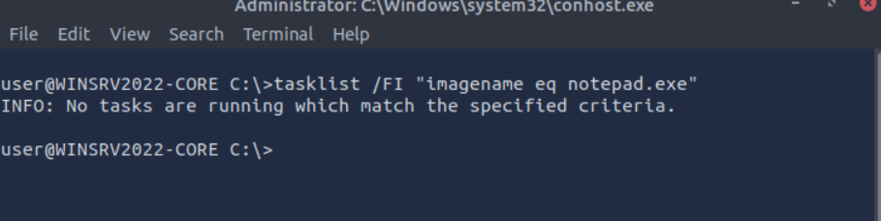

What command can you use to kill the process with PID 1516?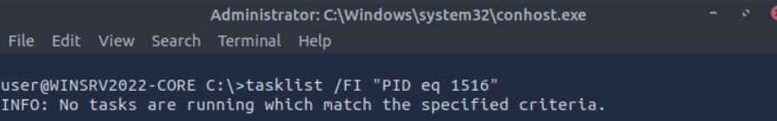 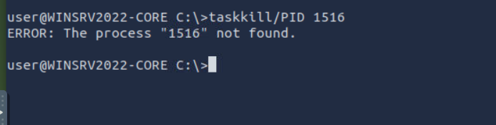

Conclusion
In this room, we focused on the most practical commands for accessing a networked system over the command line.
We intentionally omitted a few common commands as we didn’t see a real value for including them in a beginner room. We mention them below so that you know that the command line can be used for other tasks.
- chkdsk: checks the file system and disk volumes for errors and bad sectors.
- driverquery: displays a list of installed device drivers.
- sfc /scannow: scans system files for corruption and repairs them if possible.

It is important to remember all the commands covered in the previous tasks; moreover, it is equally important to know that /? can be used with most commands to display a help page.
In this room, we used the command more in two ways:
- Display text files: more file.txt
- Pipe long output to view it page by page: some_command | more
Equipped with this knowledge, we now know how to display the help page of a new command and how to display long output one page at a time.
Now that you know the Windows command line, it is time to move to the Windows PowerShell room.
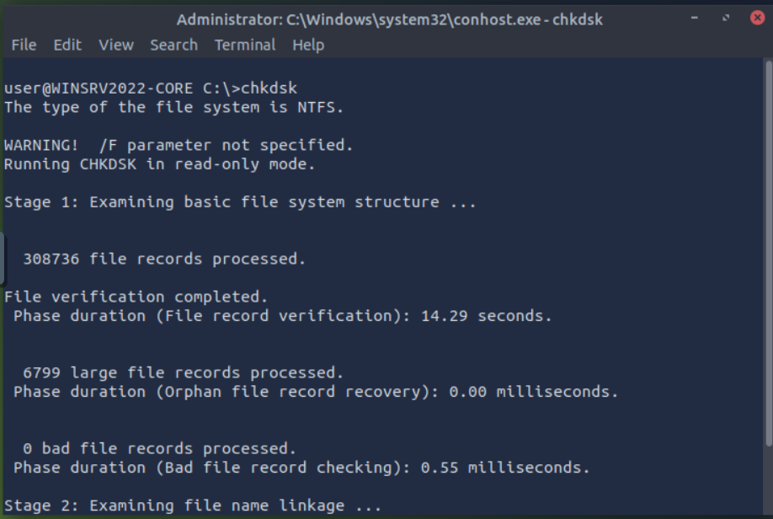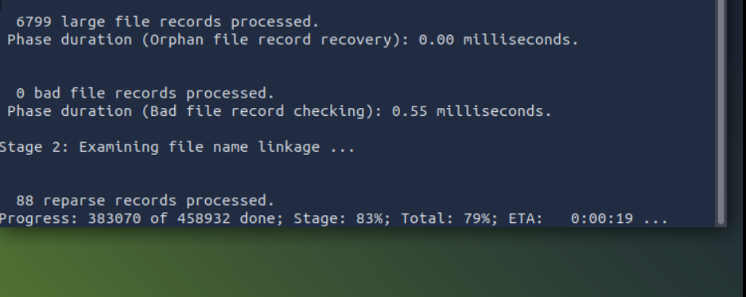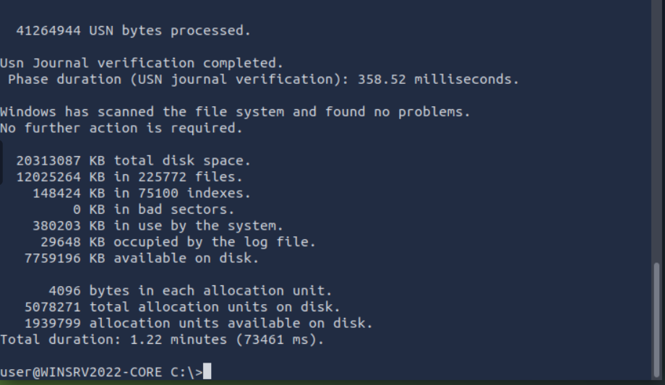
Scanning using sfc /scannow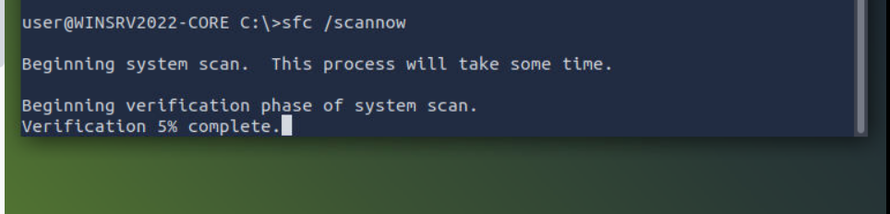

Practical (checking other commands)
The command shutdown /s can shut down a system. What is the command you can use to restart a system?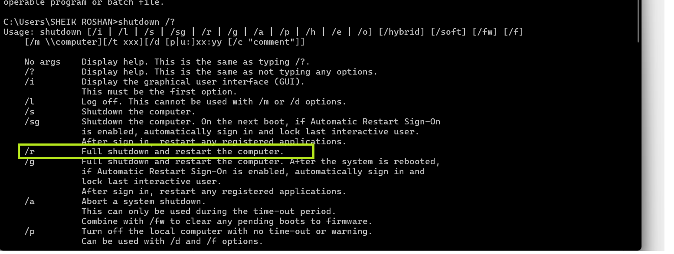
What command can you use to abort a scheduled system shutdown?