Introduction

This room is the third room in a series of four rooms about computer networking:
- Networking Concepts
- Networking Essentials
- Networking Core Protocols (this room)
- Networking Secure Protocols
Room Prerequisites
To benefit from this room, we recommend that you know the following:
- ISO OSI model and layers
- TCP/IP model and layers
- Ethernet, IP, and TCP protocols
In other words, starting this room after Networking Concepts is the recommended approach.
Learning Objectives
By the time you finish this room, you will have learned about the following protocols:
- WHOIS
- DNS
- HTTP and FTP
- SMTP, POP3, and IMAP
Click on the Start AttackBox button at the top; click on the Start Machine button belowt to start the attached virtual machine (VM).

DNS: Remembering Addresses
Do you remember the IP addresses of your favourite websites? Unless it is a private IP address of a local device, no one needs to worry about memorizing IP addresses. This is in part due to the Domain Name System (DNS), which is responsible for properly mapping a domain name to an IP address.
- A record: The A (Address) record maps a hostname to one or more IPv4 addresses. For example, you can set example.com to resolve to 172.17.2.172.
- AAAA Record: The AAAA record is similar to the A Record, but it is for IPv6. Remember that it is AAAA (quad-A), as AA and AAA would refer to a battery size; furthermore, AAA refers to Authentication, Authorization, and Accounting; neither falls under DNS.
- CNAME Record: The CNAME (Canonical Name) record maps a domain name to another domain name. For example, www.example.com can be mapped to example.com or even to example.org.
- MX Record: The MX (Mail Exchange) record specifies the mail server responsible for handling emails for a domain.
In other words, when you type example.com in your browser, your browser tries to resolve this domain name by querying the DNS server for the A record. However, when you try to send an email to test@example.com, the mail server would query the DNS server to find the MX record.

If you want to look up the IP address of a domain from the command line, you can use a tool such as nslookup. Consider the example in the terminal below where we look up example.com. 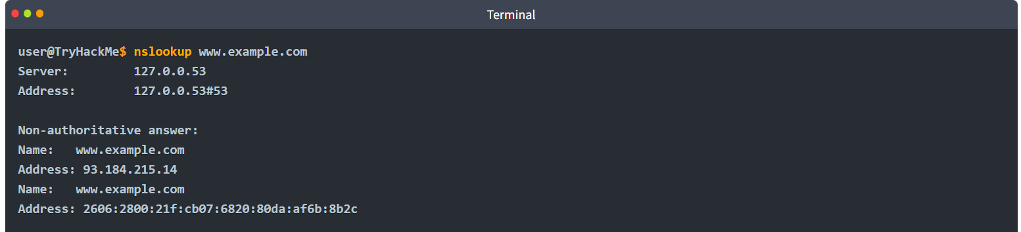The query above led to four packets. In the terminal below, we can see that the first and third packets send DNS queries for the A and AAAA records, respectively. The second and fourth packets show the DNS query responses.
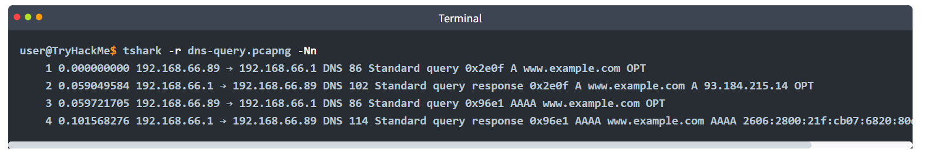

WHOIS
In the previous task, we covered how a domain name is resolved into an IP address. However, for this to happen, someone needs to have the authority to set the A, AAAA, and MX records, among other DNS records for the domain. Whoever registers a domain name is granted this power. Therefore, if you register example.com, you can set any valid DNS records for example.com.
You can register any available domain name for one or more years. You need to pay the annual fee, and you are required to provide accurate contact information as the registrant. This information is part of the data available via WHOIS records and is available publicly. (Although written in uppercase, WHOIS is not an acronym; it is pronounced who is.) However, don’t worry if you want to register a domain without revealing your contact information publicly; you can use one of the privacy services that hide all your information from the WHOIS records.
You can look up the WHOIS records of any registered domain name using one of the online services or via the command-line tool whois, available on Linux systems, among others. As expected, a WHOIS record provides information about the entity that registered a domain name, including name, phone number, email, and address. In the screenshot shown below, you can see when the record was first created and when it was last updated. Moreover, you can find the registrant’s name, address, phone, and email.
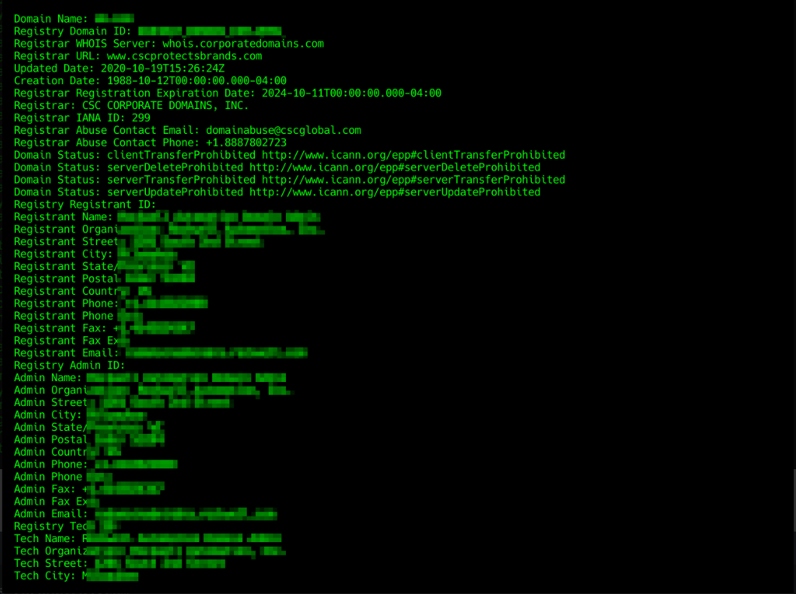
In the terminal output below, we have used the whois command to look up a domain whose WHOIS record is protected by privacy protection. 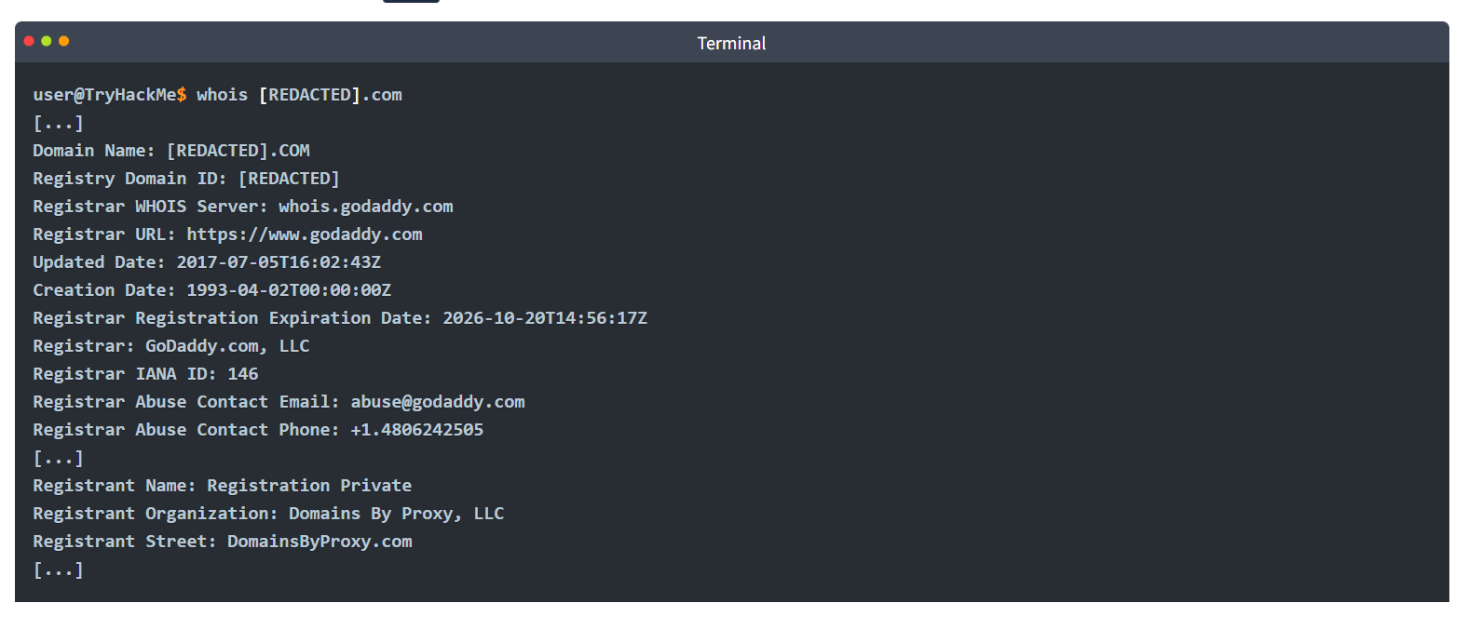

HTTP(S): Accessing the Web
When you fire up your browser, you mainly use HTTP and HTTPS protocols. HTTP stands for Hypertext Transfer Protocol; the S in HTTPS stands for Secure. This protocol relies on TCP and defines how your web browser communicates with the web servers.
Some of the commands or methods that your web browser commonly issues to the web server are:
- GET retrieves data from a server, such as an HTML file or an image.
- POST allows us to submit new data to the server, such as submitting a form or uploading a file.
- PUT is used to create a new resource on the server and to update and overwrite existing information.
- DELETE, as the name suggests, is used to delete a specified file or resource on the server.
HTTP and HTTPS commonly use TCP ports 80 and 443, respectively, and less commonly other ports such as 8080 and 8443.
In the following example, we use our Firefox browser to access the web server on MACHINE_IP. Our browser fetches the web page and displays it perfectly; however, we are interested in what happens behind the scenes.
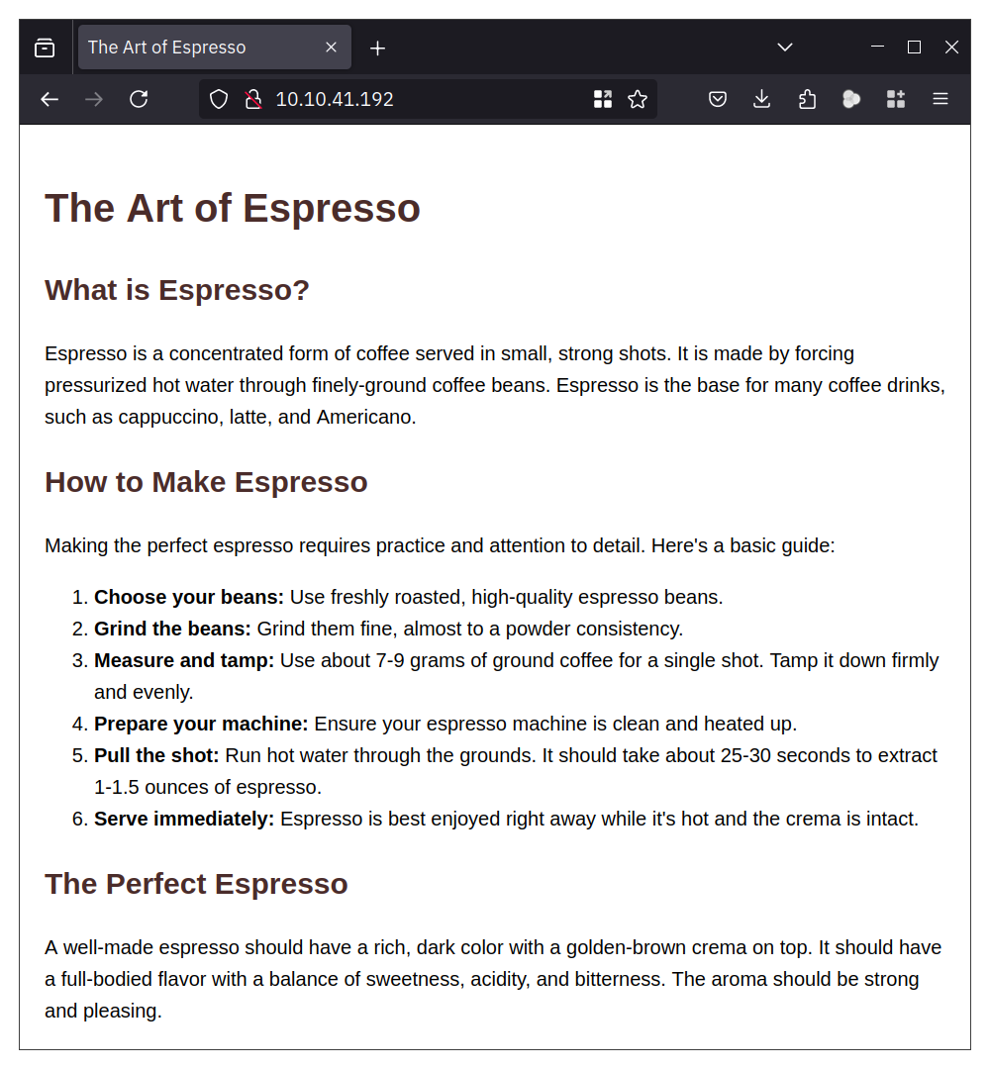
Using Wireshark, we can examine the exchange between the Firefox browser and the web server more closely. The screenshot below from Wireshark shows the text sent by our browser in red and the web server response in blue. As you can tell, a lot of information is exchanged between the client and the server that does not get rendered to the user. Examples include the web server version and when the page was last modified.
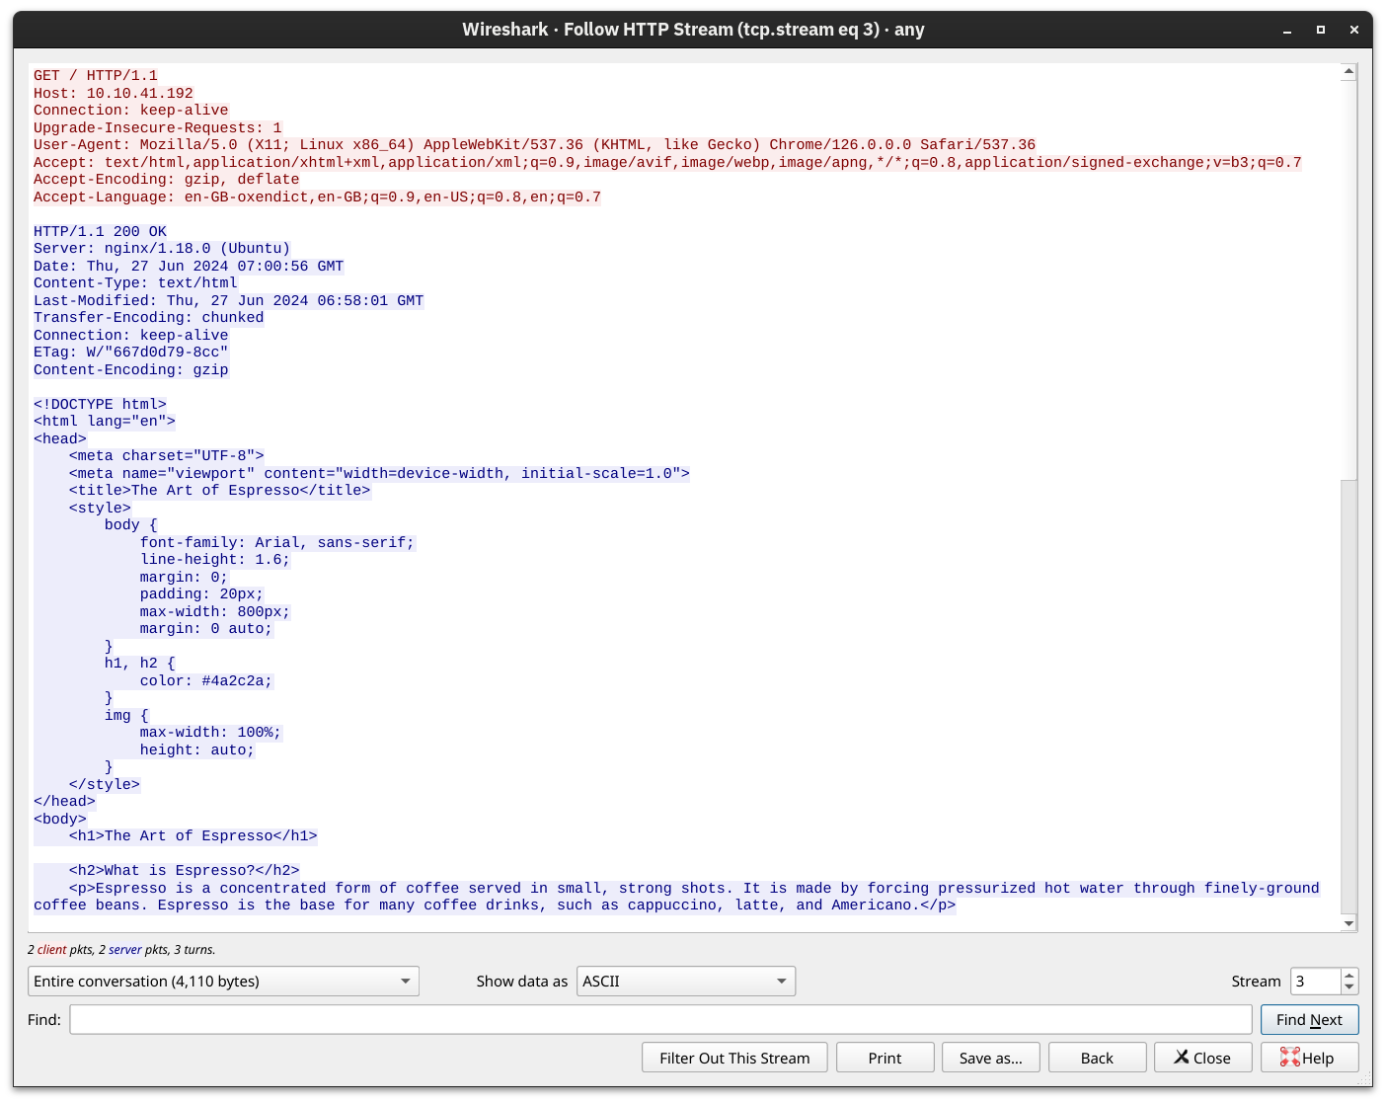
As you remember from Networking Concepts, we used the telnet client to connect to the web server running on MACHINE_IP at port 80. We had to send a couple of lines: GET / HTTP/1.1 and Host: anything to get the page we wanted. (On some servers, you might get the file without sending Host: anything.) You can use this method to access any page and not just the default page /. To get file.html, you would send GET /file.html HTTP/1.1, for instance (GET /file.html might work depending on the web server in use). This approach is efficient for troubleshooting as you would be “talking HTTP” with the server.

Practical:
Use telnet to access the file flag.html on 10.65.190.43. What is the hidden flag? 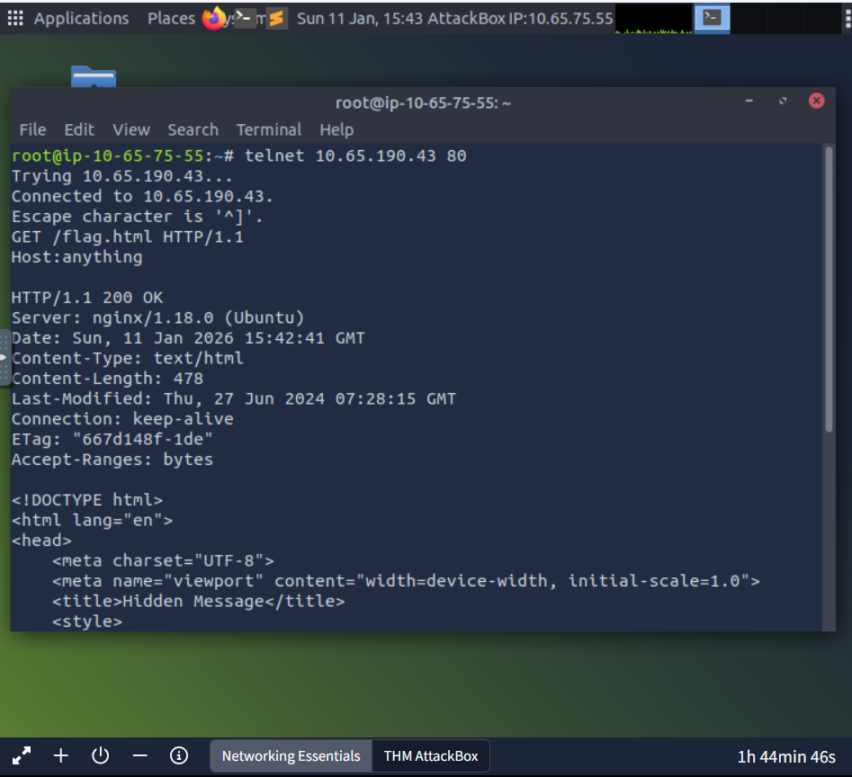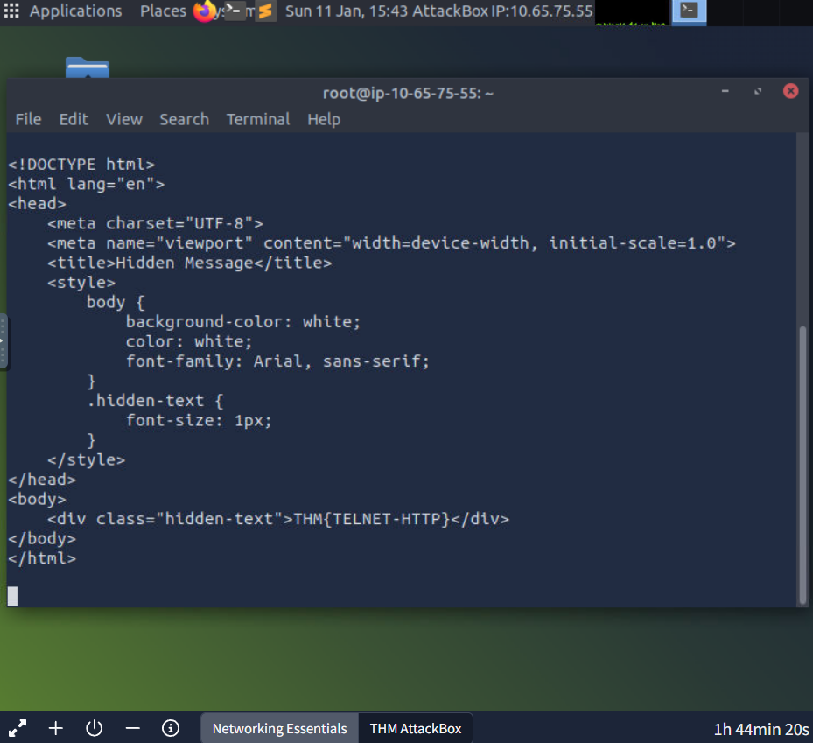

FTP: Transferring Files
Unlike HTTP, which is designed to retrieve web pages, File Transfer Protocol (FTP) is designed to transfer files. As a result, FTP is very efficient for file transfer, and when all conditions are equal, it can achieve higher speeds than HTTP.
Example commands defined by the FTP protocol are:
- USER is used to input the username
- PASS is used to enter the password
- RETR (retrieve) is used to download a file from the FTP server to the client.
- STOR (store) is used to upload a file from the client to the FTP server.
FTP server listens on TCP port 21 by default; data transfer is conducted via another connection from the client to the server.

Practical:
In the terminal below we executed the command ftp 10.65.190.43 to connect to the remote FTP server using the local ftp client. Then we went through the following steps:
- We used the username anonymous to log in
- We didn’t need to provide any password
- Issuing ls returned a list of files available for download
- type ascii switched to ASCII mode as this is a text file
- get coffee.txt allowed us to retrieve the file we want
The command exchange via the FTP client is shown in the terminal below.
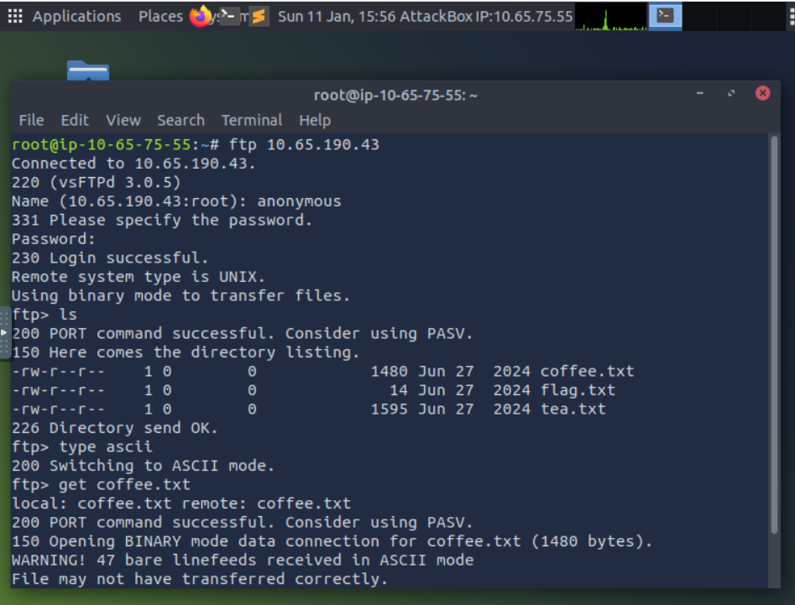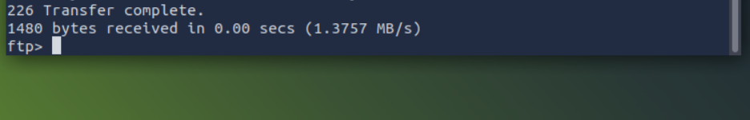
We used Wireshark to examine the exchanged messages more closely. The client’s messages are in red, while the server’s responses are in blue. Notice how various commands differ between the client and the server. For example, when you type ls on the client, the client sends LIST to the server. One last thing to note is that the directory listing and the file we downloaded are sent over a separate connection each.
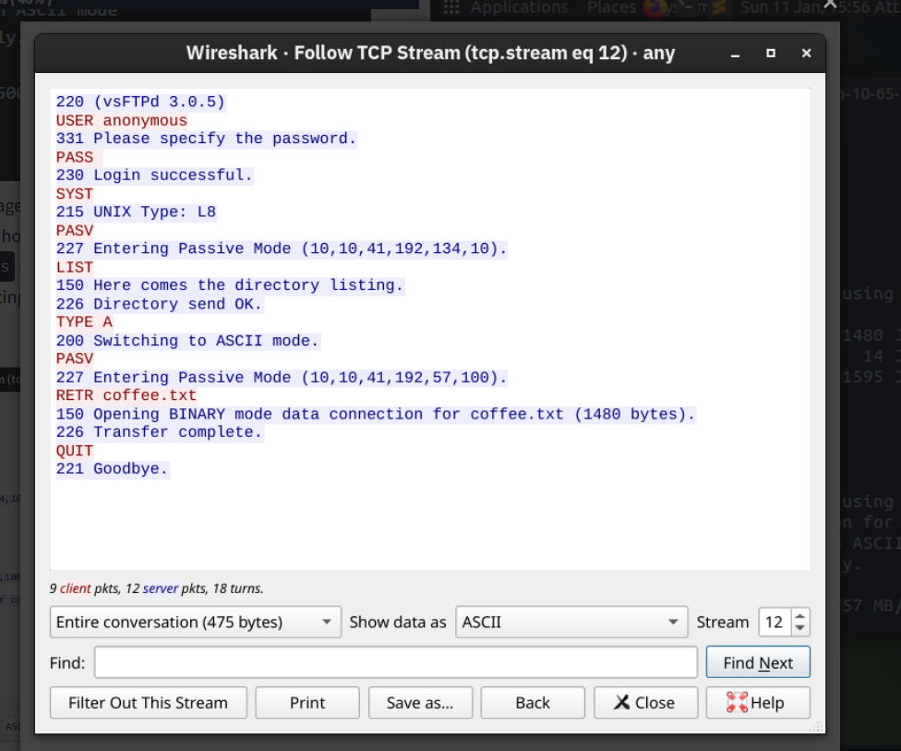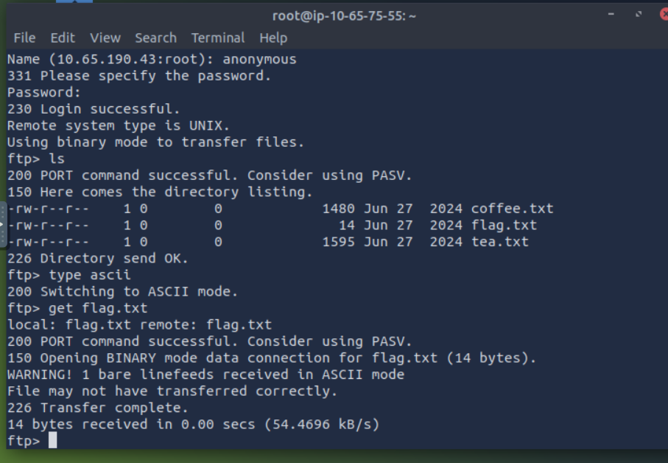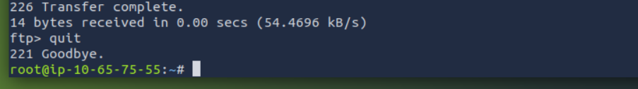
Using the FTP client ftp on the AttackBox, access the FTP server at 10.65.190.43 and retrieve flag.txt. What is the flag found? 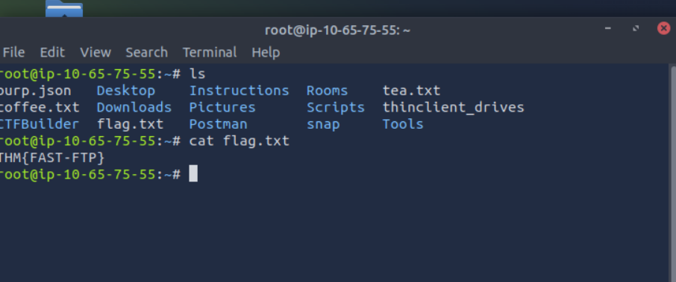

SMTP: Sending Email
As with browsing the web and downloading files, sending email needs its own protocol. Simple Mail Transfer Protocol (SMTP) defines how a mail client talks with a mail server and how a mail server talks with another.
The analogy for the SMTP protocol is when you go to the local post office to send a package. You greet the employee, tell them where you want to send your package, and provide the sender’s information before handing them the package. Depending on the country you are in, you might be asked to show your identity card. This process is not very different from an SMTP session.
Let’s present some of the commands used by your mail client when it transfers an email to an SMTP server:
- HELO or EHLO initiates an SMTP session
- MAIL FROM specifies the sender’s email address
- RCPT TO specifies the recipient’s email address
- DATA indicates that the client will begin sending the content of the email message
- . is sent on a line by itself to indicate the end of the email message
The terminal below shows an example of an email sent via telnet. The SMTP server listens on TCP port 25 by default.
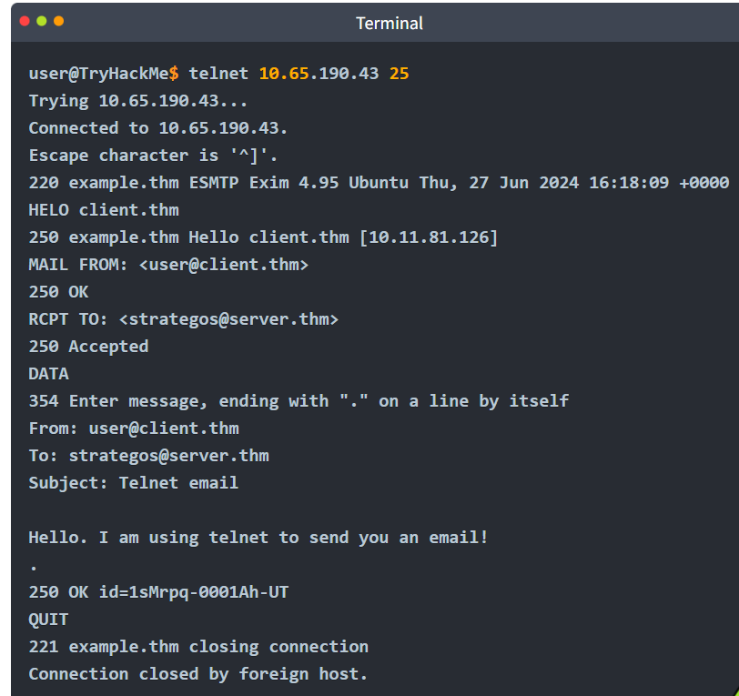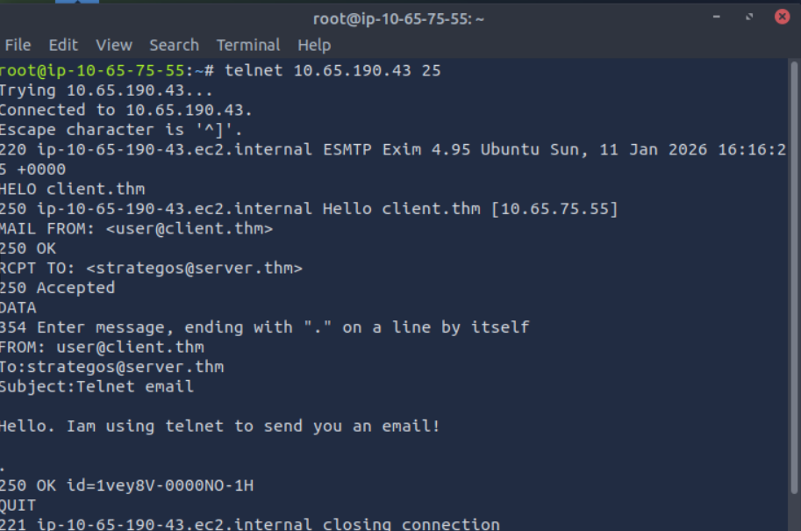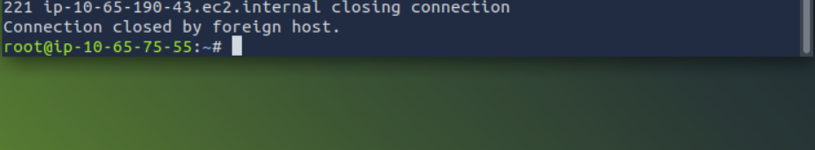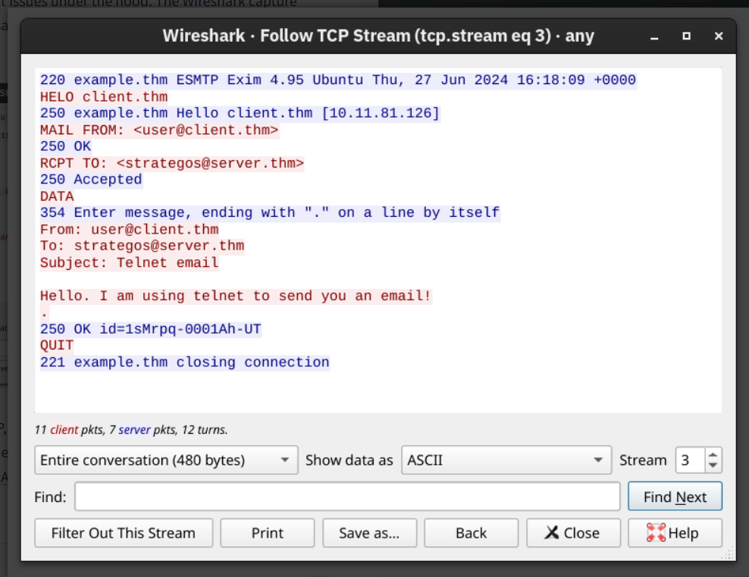
Now that we have covered some basic HTTP, FTP, and SMTP commands, you should have gained a solid understanding of how protocols are designed and used. It should be effortless to learn how other text-based protocols, such as POP3 and IMAP, work.

POP3: Receiving Email
You’ve received an email and want to download it to your local mail client. The Post Office Protocol version 3 (POP3) is designed to allow the client to communicate with a mail server and retrieve email messages.
Without going into in-depth technical details, an email client sends its messages by relying on SMTP and retrieves them using POP3. SMTP is similar to handing your envelope or package to the post office, and POP3 is similar to checking your local mailbox for new letters or packages.
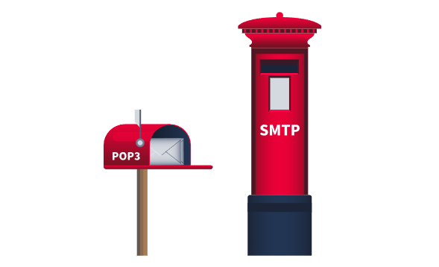
Some common POP3 commands are:
- USER <username> identifies the user
- PASS <password> provides the user’s password
- STAT requests the number of messages and total size
- LIST lists all messages and their sizes
- RETR <message_number> retrieves the specified message
- DELE <message_number> marks a message for deletion
- QUIT ends the POP3 session applying changes, such as deletions
In the terminal below, we can see a POP3 session over telnet. Since the POP3 server listens on TCP port 110 by default, the command to connect to the TELNET port is telnet 10.65.190.43 110. The exchange below retrieves the email message sent in the previous task.
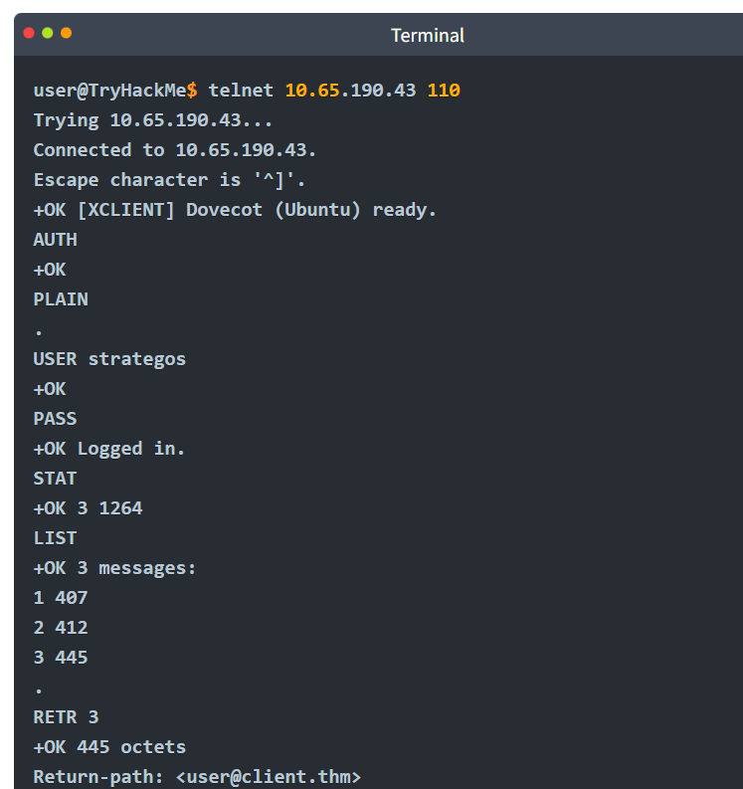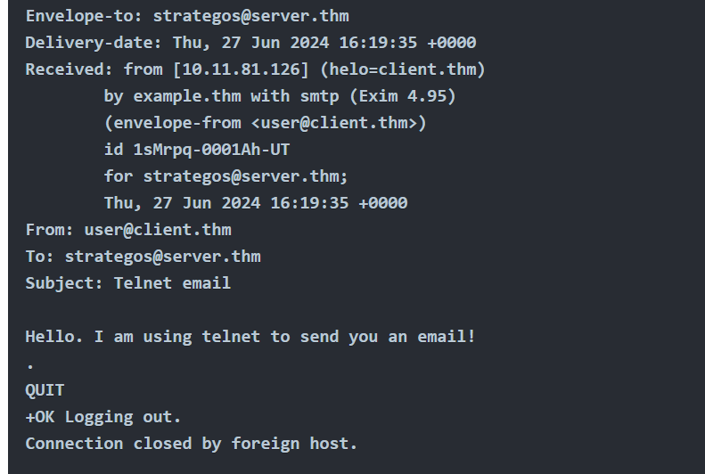
Someone capturing the network packets would be able to intercept the exchanged traffic. As per previous Wireshark captures, the commands in red are sent by the client, and the lines in blue are the server’s. It is also clear that someone capturing the traffic can read the passwords.
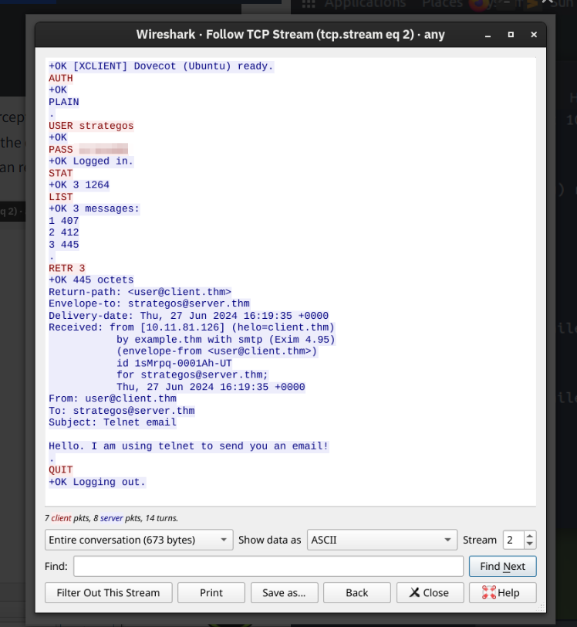

Practical:
Connecting to a POP3 server requires authentication. Use the following login credentials when needed:
- Username: linda
- Password: Pa$$123
Use telnet to connect to 10.65.190.43’s POP3 server. What is the flag contained in the fourth message?
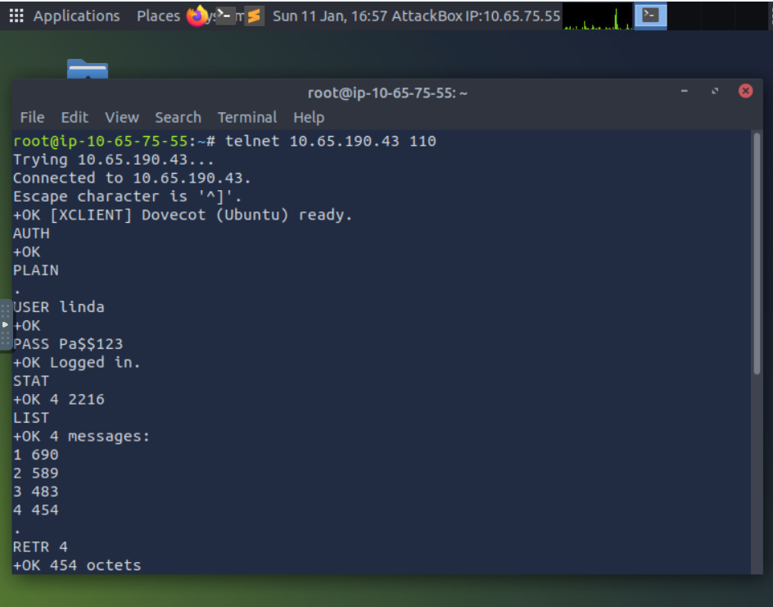
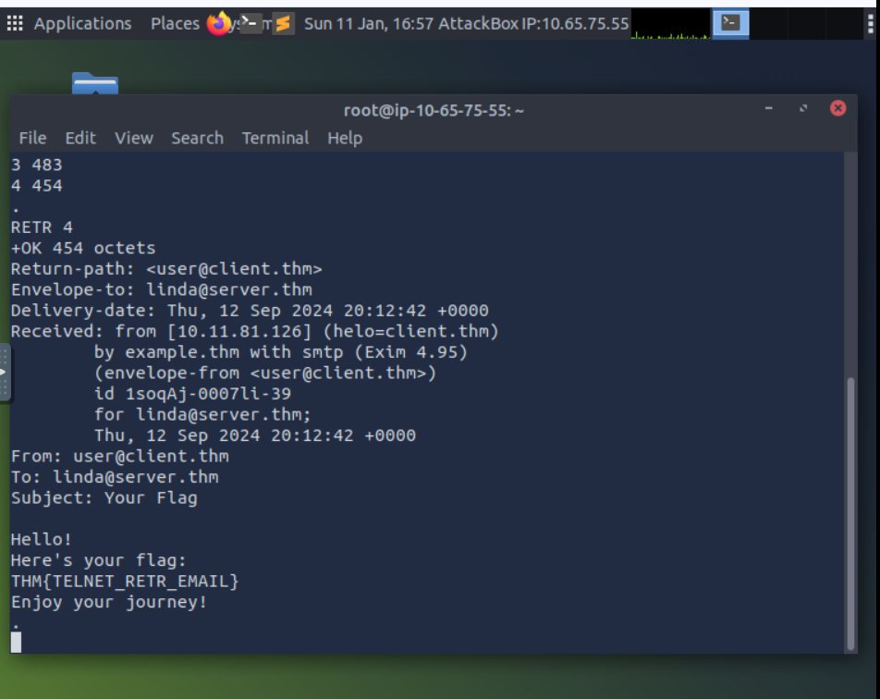

IMAP: Synchronizing Email
POP3 is enough when working from one device, e.g., your favourite email client on your desktop computer. However, what if you want to check your email from your office desktop computer and from your laptop or smartphone? In this scenario, you need a protocol that allows synchronization of messages instead of deleting a message after retrieving it. One solution to maintaining a synchronized mailbox across multiple devices is Internet Message Access Protocol (IMAP).
IMAP allows synchronizing read, moved, and deleted messages. IMAP is quite convenient when you check your email via multiple clients. Unlike POP3, which tends to minimize server storage as email is downloaded and deleted from the remote server, IMAP tends to use more storage as email is kept on the server and synchronized across the email clients.
The IMAP protocol commands are more complicated than the POP3 protocol commands. We list a few examples below:
- LOGIN <username> <password> authenticates the user
- SELECT <mailbox> selects the mailbox folder to work with
- FETCH <mail_number> <data_item_name> Example fetch 3 body[] to fetch message number 3, header and body.
- MOVE <sequence_set> <mailbox> moves the specified messages to another mailbox
- COPY <sequence_set> <data_item_name> copies the specified messages to another mailbox
- LOGOUT logs out
Knowing that the IMAP server listens on TCP port 143 by default, we will use telnet to connect to 10.65.190.43’s port 143 and fetch the message we sent in an earlier task.
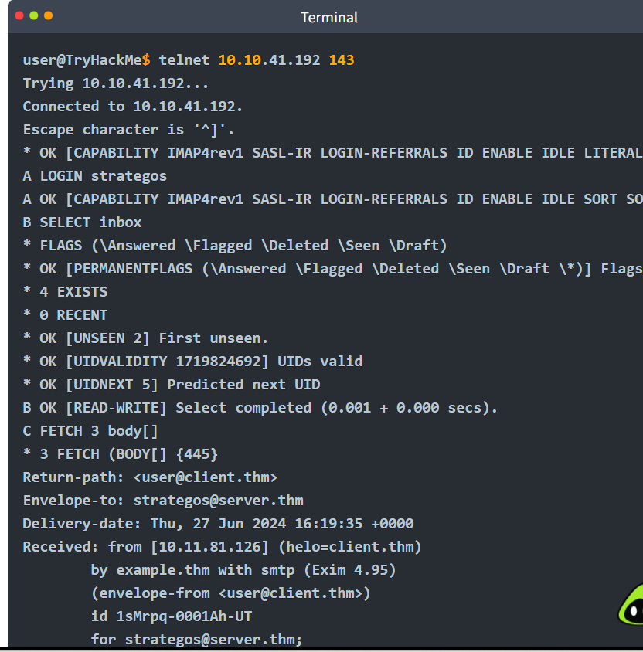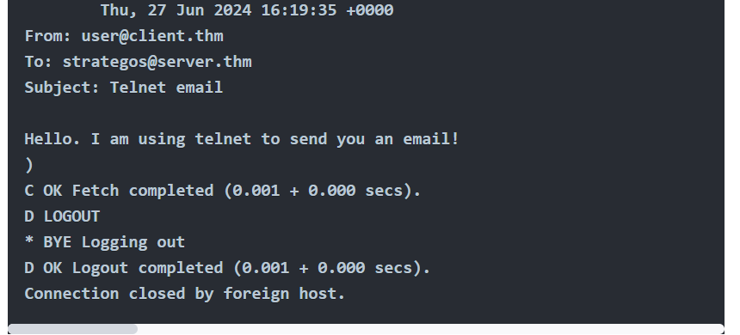
The screenshot below shows the exchanged messages between the client and the server as seen from Wireshark. The client only needed to send four commands, shown in red, and the “long” server responses are shown in blue.
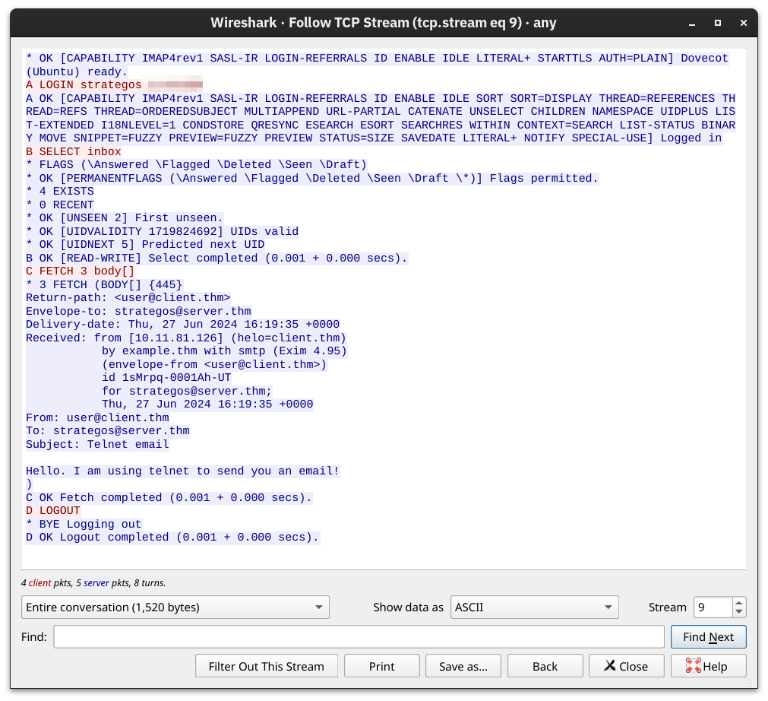

Practical:
What IMAP command retrieves the fourth email message?
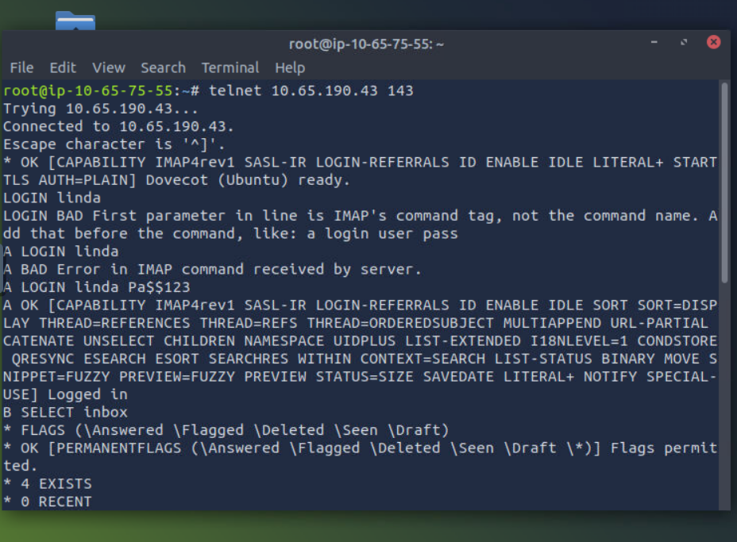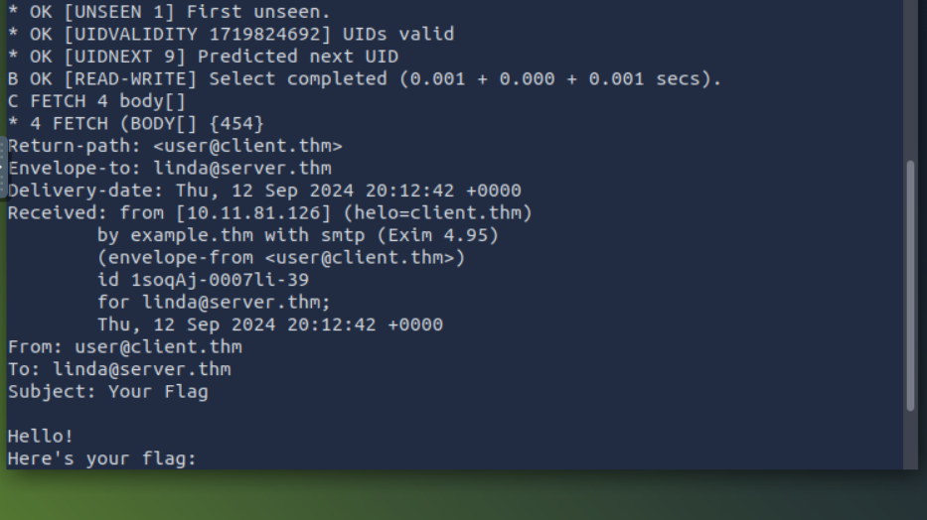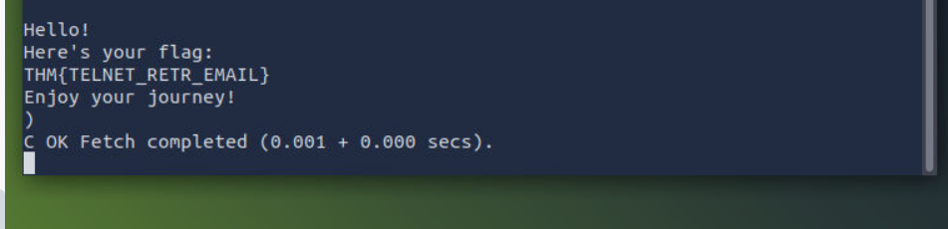

Ports:
