Introduction
JavaScript (JS) is a popular scripting language that allows web developers to add interactive features to websites containing HTML and CSS (styling). Once the HTML elements are created, you can add interactiveness like validation, onClick actions, animations, etc, through JS. Learning the language is equally important as that of HTML and CSS. The JS scripts are used primarily with HTML.
This room is designed as an introductory overview of JS, specifically tailored for beginners with limited JS experience. The primary focus is on teaching the fundamentals of JS from a cyber perspective and how hackers utilise legitimate functionalities to achieve malicious results.

Room Prerequisites
- Linux Fundamentals Module
- Web Application Basics
- How Websites Work

Learning Objectives
- Understand the basics of JS
- Integrating JS in HTML
- Abusing Dialogue Function
- Bypassing Control Flow Statements
- Exploring Minified Files

Essential Concepts

Variables
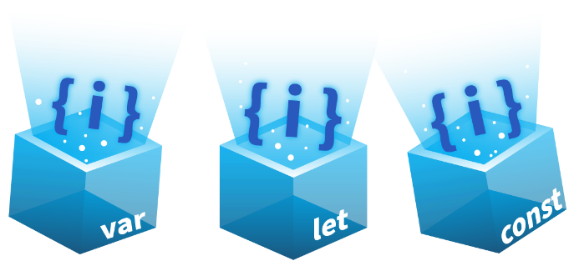
Variables are containers that allow you to store data values in them. Like any other language, variables in JS are similar to containers to store data. When you store something in a bucket, you also need to label it so that it can be referenced later on easily. Similarly, in JS, each variable has a name; when we store a certain value in a variable, we assign a name to it to reference it later. There are three ways to declare variables in JS: var, let, and const. While var is function-scoped, both let, and const are block-scoped, offering better control over variable visibility within specific code blocks.

Data Types
In JS, data types define the type of value a variable can hold. Examples include string (text), number, boolean (true/false), null, undefined, and object (for more complex data like arrays or objects).

Functions
A function represents a block of code designed to perform a specific task. Inside a function, you group code that needs to perform a similar task. For example, you are developing a web application in which you need to print students' results on the web page. The ideal case would be to create a function PrintResult(rollNum) that would accept the roll number of the user as an argument
<script>
function PrintResult(rollNum) {
alert("Username with roll number " + rollNum + " has passed the exam");
// any other logic to display the result
}
// prepare an array of roll numbers (data)
const rollNumbers = [101, 102, 103];

// Note: We only have 3 roll numbers, so after i = 2, rollNumbers[i] becomes undefined

for (let i = 0; i < 100; i++) {
PrintResult(rollNumbers[i]);
}
</script>

So, instead of writing the same print code for all the students, we will use a simple function to print the result.

Loops
Loops allow you to run a code block multiple times as long as a condition is true. Common loops in JS are for, while, and do...while, which are used to repeat tasks, like going through a list of items. For example, if we want to print the results of 100 students, we can call the PrintResult(rollNum) function 100 times by writing it 100 times, or we can create a loop that will be iterated through 1 to 100 and will call the PrintResult(rollNum) function as shown below.

// Function to print student result
function PrintResult(rollNum) {
alert("Username with roll number " + rollNum + " has passed the exam");
// any other logic to the display result
}

// prepare an array of roll numbers (data)
const rollNumbers = [101, 102, 103];

// Note: We only have 3 roll numbers, so after i = 2, rollNumbers[i] becomes undefined

for (let i = 0; i < 100; i++) {
PrintResult(rollNumbers[i]); // this will be called 100 times
}

Request-Response Cycle
In web development, the request-response cycle is when a user's browser (the client) sends a request to a web server, and the server responds with the requested information. This could be a webpage, data, or other resources. You can learn more about it here.

JavaScript Overview
In this task, we’ll use JS to create our first program. JS is an interpreted language, meaning the code is executed directly in the browser without prior compilation. Below is a sample JS code demonstrating key concepts, such as defining a variable, understanding data types, using control flow statements, and writing simple functions. These essential building blocks help create more dynamic and interactive web apps. Don’t worry if it looks a bit new now - we will discuss each of these concepts in detail later on.
// Hello, World! program
console.log("Hello, World!");

// Variable and Data Type
let age = 25; // Number type

// Control Flow Statement
if (age >= 18) {
console.log("You are an adult.");
} else {
console.log("You are a minor.");
}

// Function
function greet(name) {
console.log("Hello, " + name + "!");
}

// Calling the function
greet("Bob");

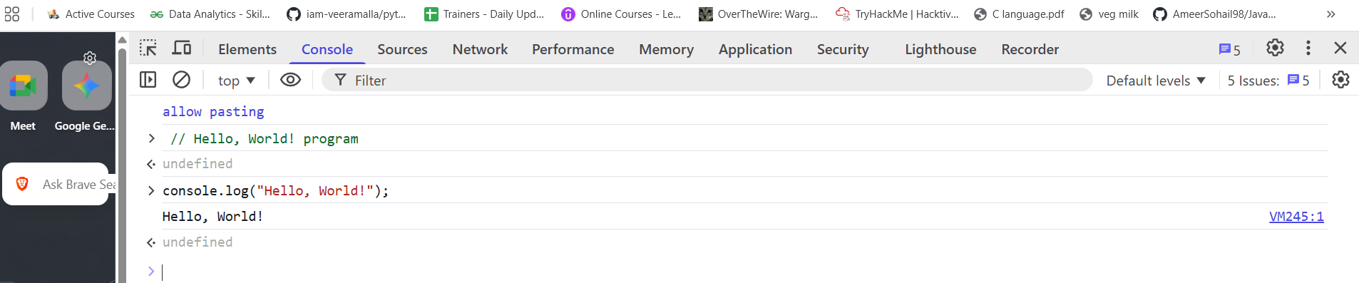
JS is primarily executed on the client side, which makes it easy to inspect and interact with HTML directly within the browser. We’ll use the Google Chrome Console feature to run our first JS program, allowing us to write and execute JS code easily without additional tools. Follow these steps to get started:

Let's create a simple JS program that adds two numbers and displays the result. Below is the code

let x = 5;
let y = 10;
let result = x + y;
console.log("The result is: " + result);

- In the code above, x and y are variables holding the numbers. x + y is an expression that adds the two numbers together, whereas console.log is a function used to print the result to the console.
- Copy the above code and paste it into the console by pressing the key Ctrl + V. Once pasted, press Enter. You should see the result displayed as:
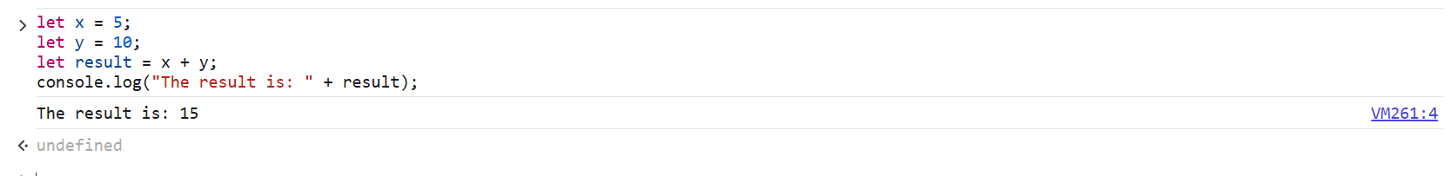
Congratulations! You’ve successfully created your first program in JS. This is just the beginning, and there’s much more to explore as we dive deeper into JS in this room.

Integrating JavaScript in HTML
This task assumes you have a basic understanding of HTML and its structure. This section will explore how JS can be integrated into HTML. Usually, JS is not used to render content; it works with HTML and CSS to create dynamic and interactive web pages. If you're unfamiliar with HTML, reviewing it through the provided link is recommended. There are two main ways to integrate JS into HTML: internally and externally.

Internal JavaScript
Internal JS refers to embedding the JS code directly within an HTML document. This method is preferable for beginners because it allows them to see how the script interacts with the HTML. The script is inserted between <script> tags. These tags can be placed inside the <head> section, typically used for scripts that need to be loaded before the page content is rendered, or inside the <body> section, where the script can be utilised to interact with elements as they are loaded on the web page.
Example
To create an HTML document with internal JS, right-click on the Desktop and select Create Document > Empty File. Name the file internal.html. Next, right-click the internal.html file and open it in a text editor or any code editor.
Once the editor is open, paste the following code:
<!DOCTYPE html>
<html lang="en">
<head>
<title>Internal JS</title>
</head>
<body>
<h1>Addition of Two Numbers</h1>
<p id="result"></p>

<script>
let x = 5;
let y = 10;
let result = x + y;
document.getElementById("result").innerHTML = "The result is: " + result;
</script>
</body>
</html>

