What Is an IDS
As we know, firewalls are the security solution usually deployed on the boundary of a network to protect its incoming and outgoing traffic. The firewall checks the traffic when a connection is going to take place and denies it if it violates the firewall rules. However, there should be some security to detect the activities of the connection that passed through the firewall and has already taken place. So, if an attacker successfully bypasses a firewall via a legitimate-looking connection and then performs any malicious activities inside the network, there should be something to detect it in a timely manner. For this purpose, we have a security solution inside the network. This solution is known as an Intrusion Detection System (IDS).
Think of an example of a building’s security. A firewall acts as the gatekeeper, checking the people coming in and going out. There is always a chance that some bad actor will successfully sneak inside and start performing malicious activities. He was missed at the gate, but what if we catch him even after he gets in? This can be done by the surveillance cameras present throughout the building. The IDS plays the role of surveillance cameras. It sits in a corner, monitors the network traffic based on its signature and anomaly-based detections, and detects any abnormal traffic going out or inside the network. Upon every detection, an alert is generated for the security administrators. IDS does not act on those detections; it only notifies the security administrators about the malicious activity.
This room will equip you with sound knowledge of IDS solutions. We will also explore the most popular open-source IDS solution in the upcoming tasks.
Learning Objectives
- Types of IDS and their detection capabilities
- Working of Snort IDS
- Default and custom rules in Snort IDS
- Making a custom rule in Snort IDS
Prerequisites
This room expects the users to have completed or explored the following rooms:
- Firewall Fundamentals
- Network Concepts

Types of IDS
IDS can be categorized differently depending on certain factors. An IDS’s main categorization depends on its deployment and detection modes.

Deployment Modes
IDS can be deployed in the following ways:
- Host Intrusion Detection System (HIDS): Host-based IDS solutions are installed individually on the hosts and are responsible for only detecting potential security threats associated with that particular host. They provide detailed visibility of the host’s activities. However, host intrusion detection systems can be challenging to manage in large networks as they are resource-intensive and require management on each host.
- Network Intrusion Detection System (NIDS): Network-based IDS solutions are crucial in detecting potentially malicious activities within the whole network, regardless of any specific hosts. They monitor the network traffic of all the hosts involved to detect suspicious activities. It provides a centralized view of all the detections inside the whole network.
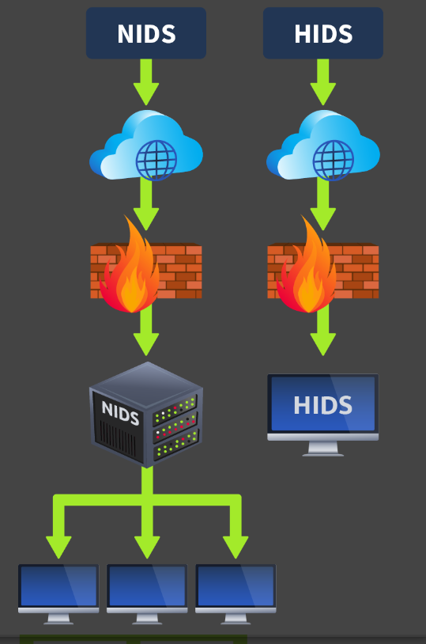

Detection Modes
- Signature-Based IDS: Many attacks occur every day. Each attack has its unique pattern, which is known as a signature. These signatures are preserved by the IDS in their databases so that if the same attack happens in the future, it gets detected by its signature and reported to the security administrators for action. The stronger the signature database of the IDS is, the more efficiently it will detect known threats. However, the signature-based IDS is unable to detect zero-day attacks. Zero-day attacks have no prior signatures (patterns) and are not saved inside the IDS databases. Therefore, the signature-based IDS can only detect the attacks that happened previously, and its signatures (patterns) are saved inside the database. In the upcoming tasks, we will explore a signature-based IDS named Snort.
- Anomaly-Based IDS: This type of IDS first learns the normal behavior (baseline) of the network or system and performs detections if there is any deviation from the normal behavior. Anomaly-based IDS can also detect zero-day attacks because they don’t rely on available signatures for detection. They detect abnormalities inside the network or system by comparing the current state with the normal behavior (baseline). However, this type of IDS may generate a lot of false positives (marking benign activities as malicious) because the nature of most legitimate programs matches the malicious ones. Anomaly-based IDS would mark them malicious and believe anything behaving unusually is malicious. We can also reduce the false positives generated by anomaly-based IDS by fine-tuning it (manually defining the normal behavior in the IDS).
- Hybrid IDS: A hybrid IDS combines the detection methods of signature-based IDS and anomaly-based IDS to leverage the strengths of each approach. Some known threats may already have some signatures in the IDS database; in this case, the hybrid IDS would use the detection technique of the signature-based IDS. If it encounters a new threat, it can leverage the detection method of anomaly-based IDS.
Signature-based IDS can detect threats quickly, while other IDS can have a high processing overhead. However, it is also essential to consider the IDS based on several different factors. Signature-based IDS can be a good option for covering a small threat surface. Anomaly-based IDS and hybrid IDS can help detect modern zero-day attacks, which are increasing daily and can cause massive damage to organizations.

IDS Example: Snort
Snort is one of the most widely used open-source IDS solutions developed in 1998. It uses signature-based and anomaly-based detections to identify known threats. These are defined in the rule files of the Snort tool. Several built-in rule files come pre-installed in this tool’s package. These built-in rule files contain a variety of known attack patterns. Snort’s built-in rules can detect a lot of malicious traffic for you. However, you can configure Snort to detect specific types of network traffic not covered by the default rule files. You can create custom rules based on your requirements to detect specific traffic. You can also disable any built-in detection rules if they don’t point to harmful traffic for your system or network and define some custom rules instead. In the upcoming task, we will explore the built-in rules and make custom rules to detect specific traffic

Modes of Snort
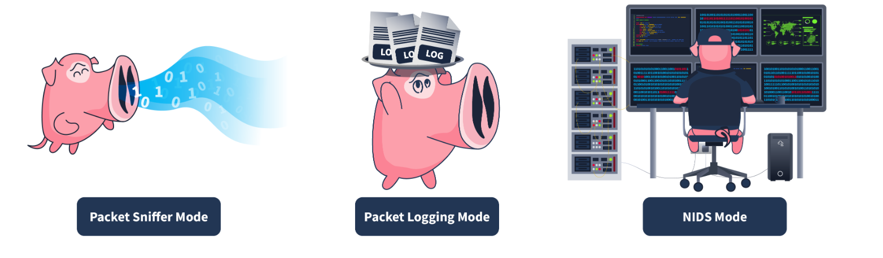
Mode | Description | Use Case
Packet sniffer mode | This mode reads and displays network packets without performing any analysis on them. The packet sniffer mode of Snort does not directly relate to IDS capabilities, but it can be helpful in network monitoring and troubleshooting. In some cases, system administrators might need to read the traffic flow without performing any detection to diagnose specific issues. In this case, they can utilize the packet sniffer mode of Snort. This mode allows you to display the network traffic on the console or even output it in a file. | The network team observes some network performance issues. To diagnose the issue, they need detailed insights into the network traffic. For this purpose, they can utilize Snort’s packet sniffer mode.
Packet logging mode | Snort performs detection on the network traffic in real-time and displays the detections as alerts on the console for the security administrators to take action. However, in some cases, the network traffic needs to be logged for later analysis. The packet logging mode of Snort allows you to log the network traffic as a PCAP (standard packet capture format) file. This includes all the network traffic and any detections from it. Forensic investigators can use these Snort log files to perform the root cause analysis of previous attacks. | The security team needs to initiate a forensic investigation of a network attack. They would need the traffic logs to perform the root cause analysis. The network traffic logged through Snort’s packet logging mode can help them.
Network Intrusion Detection System mode | Snort’s NIDS mode is the primary mode that monitors network traffic in real-time and applies its rule files to identify any match to the known attack patterns stored as signatures. If there is a match, it generates an alert. This mode provides the main functionality of an IDS solution. | The security team must proactively monitor their network or systems to detect potential threats. They can leverage Snort’s NIDS mode to achieve this.

The most relevant use of Snort as an IDS comes from its NIDS mode. However, Snort can be used in any of the above modes depending upon the requirement.

Snort Usage
During Snort installation, you must provide your network interface and range. You can run Snort normally, where it only captures the traffic intended for your host. However, if you want to use Snort to capture and detect intrusions in your whole network, you must turn on the promiscuous mode of your host’s network interface.
First, let’s start the Virtual Machine by pressing the Start Machine button given below. The machine will start in split view. In case the VM is not visible, use the blue Show Split View button at the top of the page.
Snort has some built-in rule files, a configuration file, and other files. These are stored in the /etc/snort directory. The key file for Snort is its configuration file snort.conf, where you can specify which rule files to enable, which network range to monitor, and allow other settings. The rule files are stored in the rules folder. Let's use the ls command to list all the files and folders present in Snort's main directory: 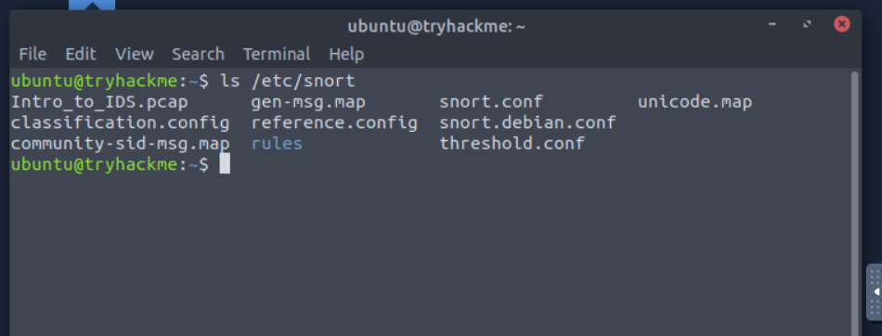

Rule Format
Now, let’s discuss how rules are created in Snort. There is a specific way of writing the rules. A sample rule would detect ICMP packets (usually used when you ping a host) coming from any IP address and port and reaching the home network (the network range is defined in Snort’s configuration file) to any port. Once such traffic is detected, it generates “Ping Detected” alerts.
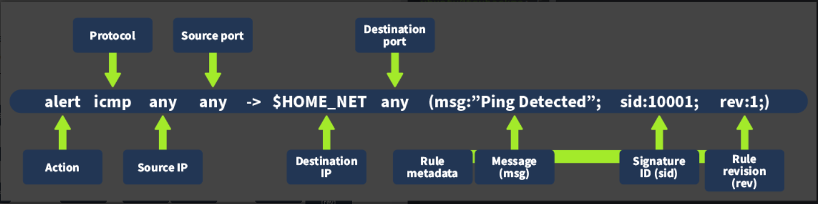
The details of the components involved in this rule are given below:
- Action: This specifies which action to take when the rule triggers. In this case, we have the action to "alert" when the traffic matches this rule.
- Protocol: This refers to the protocol that matches this rule. In this case, we use the protocol "ICMP" when pinging a host.
- Source IP: This determines the IP originating from the traffic. Since we want to detect traffic from any source IP, we set this as "any".
- Source port: This determines the port from which the traffic originates. Since we want to detect traffic from any source port, we set this as "any".
- Destination IP: This specifies the destination IP to which the matching traffic comes; it generates the alert. In this case, we used "$HOME_NET". This is a variable, and we defined its value as our whole network’s range in Snort’s configuration file.
- Destination port: This specifies the port the traffic would reach. Since we want to detect traffic coming to any port, we set it to "any."
- Rule metadata: Every rule has some metadata. That is defined at the end of the rule in parentheses. The following are its components:
  - Message (msg): This describes the message displayed when the subject rule triggers. The message should indicate the type of activity detected. In this case, we used "Ping Detected".
  - Signature ID (sid): Every rule has a unique identifier that differentiates it from others. This identifier is called the signature ID (sid). In this case, we set the sid to "10001".
  - Rule revision (rev): This sets the rule's revision number. Every time the rule is modified, its revision number is incremented, which helps in tracking changes to any rule.

Rule Creation
Let’s paste the sample rule explained above into the custom "local.rules" file in the Snort rules directory.
Firstly, open the "local.rules" file in a text editor:
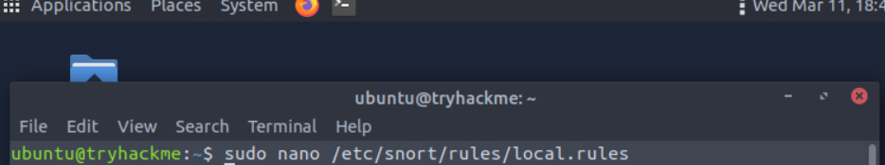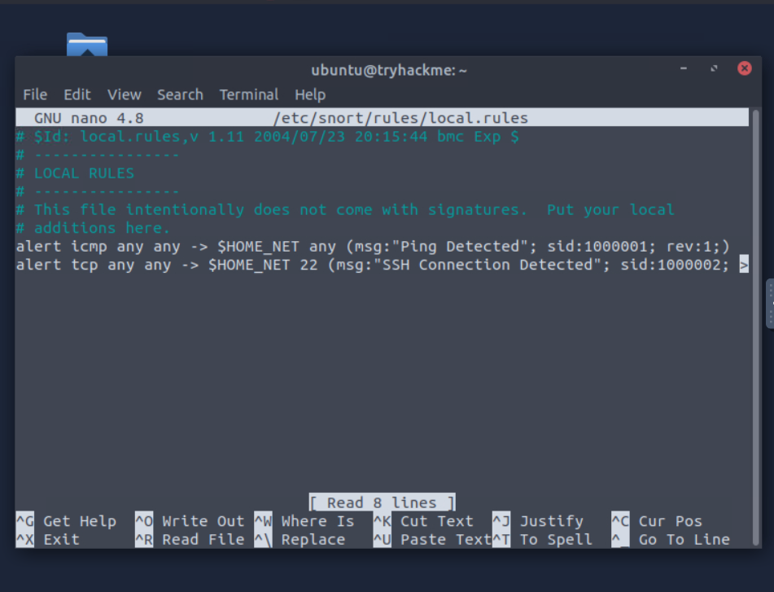

Now, add the following rule after the already present rules to the file: 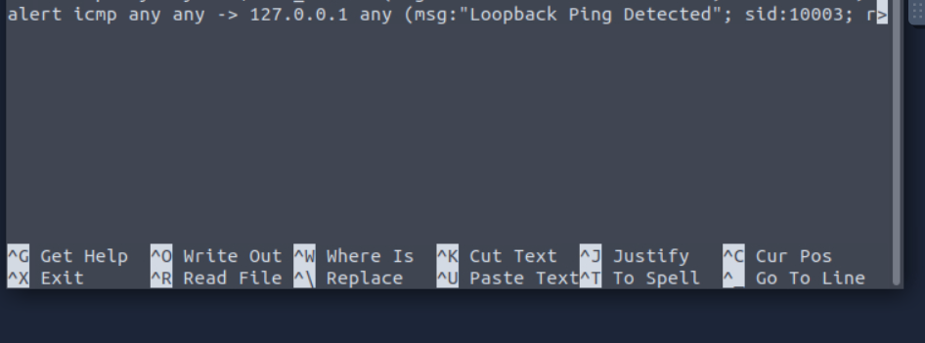
Note: We will need the other rules in the next task, so do not delete them.
Once you successfully edit the file, press "ctrl+x" and it will ask you to press "y" if you want to save the changes. Press "y" to save the changes.

Rule Testing
Let’s first start the Snort tool to detect any intrusions defined in the rule file. For this, we have to execute the following command with sudo privileges in our console: 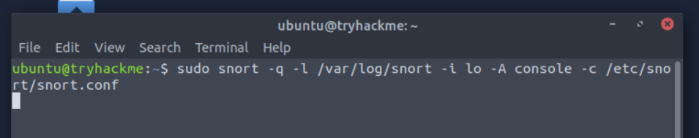Note: In case your loopback interface is not called "lo", replace it with the correct interface name.
As this rule is designed to alert us on any ICMP packets to our loopback address, let’s try to ping our loopback address to see if our rule works:

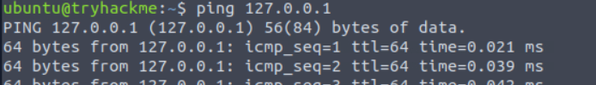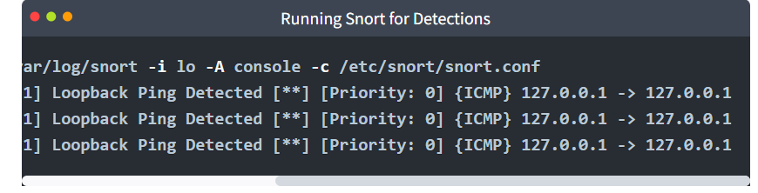

Running Snort on PCAP Files
We saw how Snort can be used for intrusion detection on real-time traffic. However, you may sometimes encounter a scenario where you have historical network traffic logged in a file, and you have to perform a forensic investigation to determine any signs of intrusion through that traffic. This traffic is usually logged in the standard packet capture format "PCAP". Snort is also equipped to perform detections on these PCAP files containing historical network traffic.


The following command with sudo privilege can be used to perform this action:
sudo snort -q -l /var/log/snort -r Task.pcap -A console -c /etc/snort/snort.conf
Note: Replace the "Task.pcap" with the path to your PCAP file for analysis.

Practical Lab
Exercise
Scenario: You are a third-party forensic investigator. A company contacts you to investigate a recent attack on their network. They handed over a PCAP file named "Intro_to_IDS.pcap", which contained the network traffic captured during the attack. Your task is to run Snort on this PCAP file and answer the questions given in this task.
Note:The PCAP file Intro_to_IDS.pcap is placed in the /etc/snort/ directory. You have to change your directory to /etc/snort and run the PCAP analysis command on that new PCAP file the same way as we did in task 4.
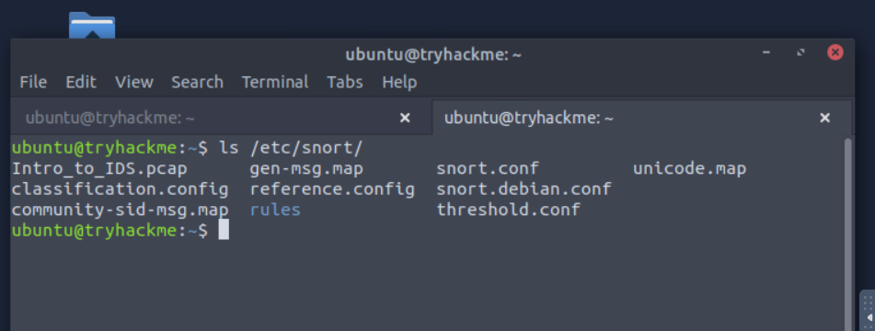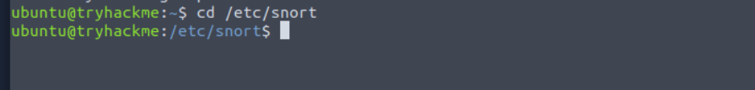

What is the IP address of the machine that tried to connect to the subject machine using SSH? 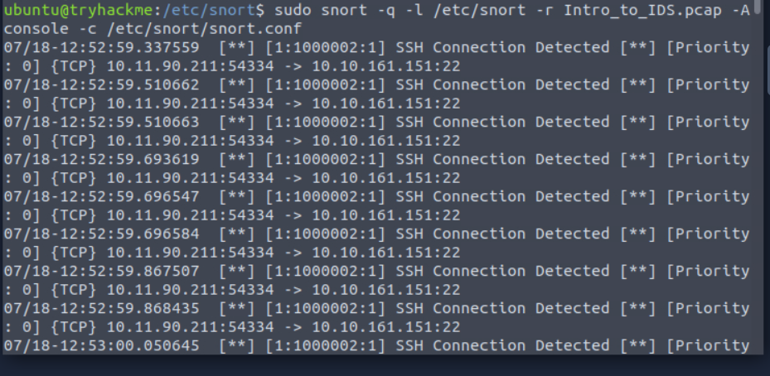
What other rule message besides the SSH message is detected in the PCAP file? 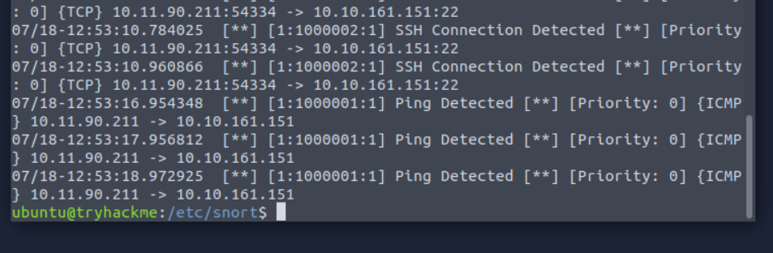

What is the sid of the rule that detects SSH? 