**Date Submitted: 12/13/19**

**Task 01:**

**Small changes made to the config.h in the collector cc1350 file.**

**Modified Code:**

**------------------------------------------------------------------------------------**

**Task 02:**

**Small changes made to the config.h in the sensor cc1350 file**

**Modified Code:**

**------------------------------------------------------------------------------------**

**Task 03:**

Youtube Link: <https://youtu.be/--zn4G3uinE>

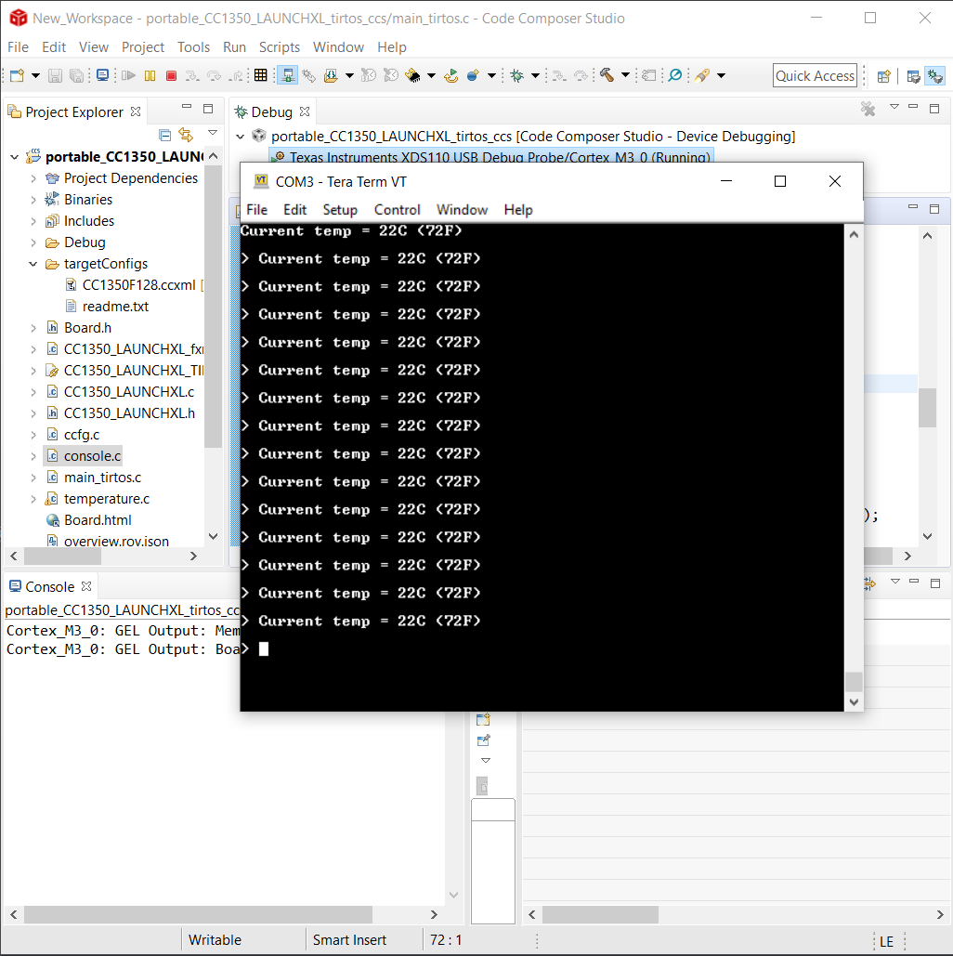

**Modified Code:**

**------------------------------------------------------------------------------------**

**Task 04:**

Youtube Link: https://youtu.be/g2riq80zmAw

**Modified Code:**

**------------------------------------------------------------------------------------**

**Task 01:**

Youtube Link:

**Modified Code:**

**------------------------------------------------------------------------------------**

**Task 02:**

Youtube Link: https://youtu.be/o8JsR07PKo4

**Modified Code:**

**------------------------------------------------------------------------------------**

**Task 03:**

Youtube Link: https://youtu.be/DrB321WHluE

**Modified Code:**