**Date Submitted: 11/30/19**

**Task 01:**

Youtube Link: N/A

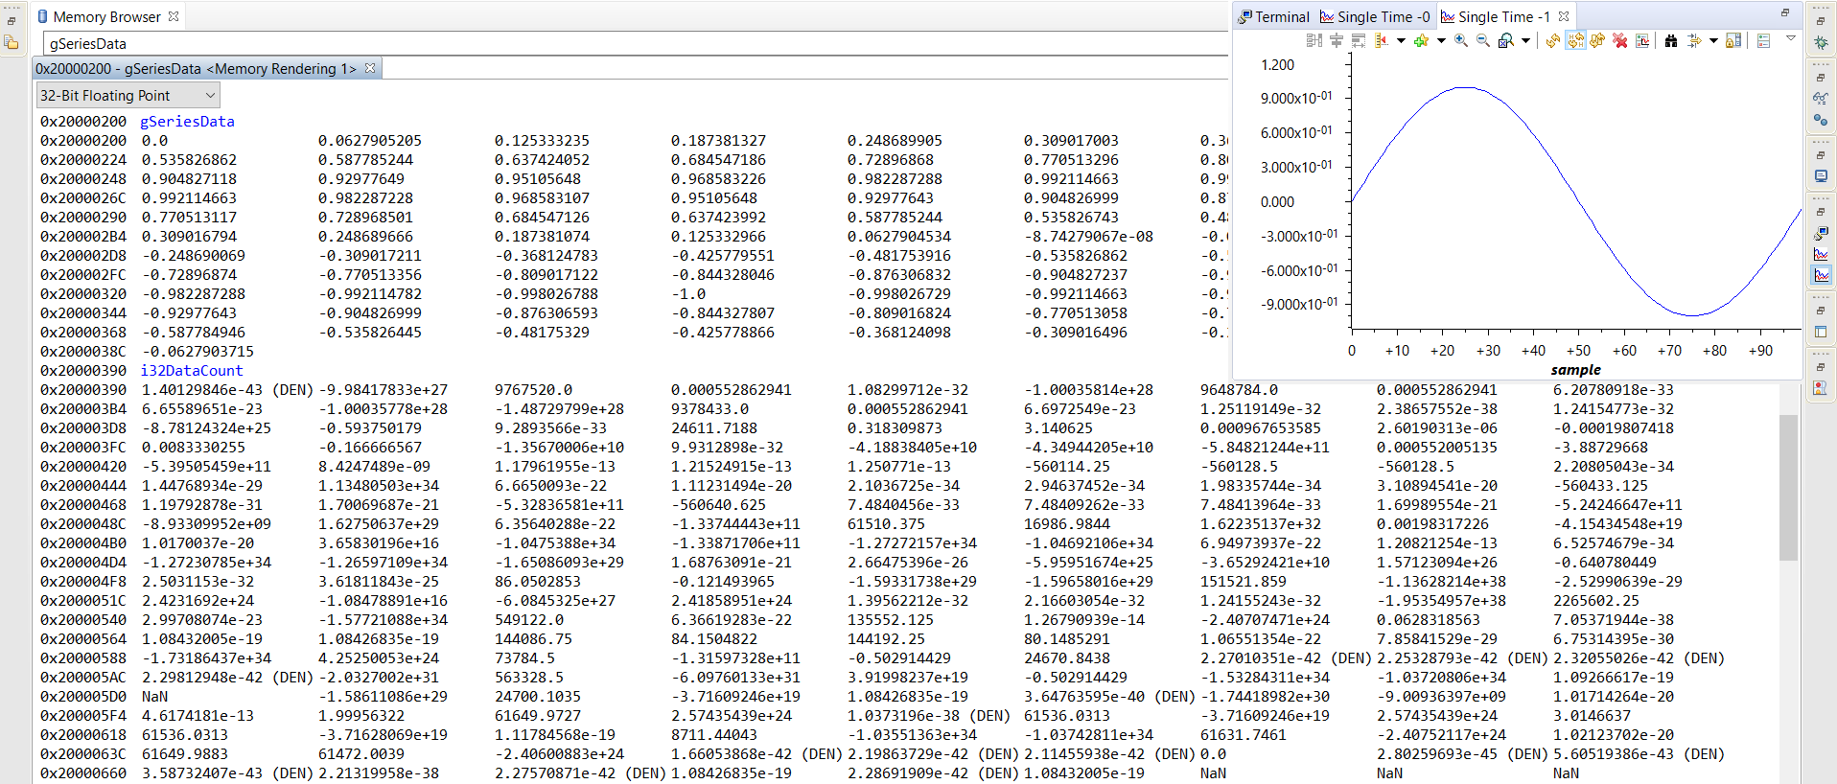

**Modified Code:**

**#include <stdint.h>**

**#include <stdbool.h>**

**#include <math.h> //uses sinf() function**

**#include "inc/hw_memmap.h"**

**#include "inc/hw_types.h"**

**#include "driverlib/fpu.h" //support for Floating Point Unit**

**#include "driverlib/sysctl.h"**

**#include "driverlib/rom.h"**

**#ifndef M_PI //defines M_PI**

**#define M_PI 3.14159265358979323846**

**#endif**

**#define SERIES_LENGTH 100 //creates depth of data buffer**

**float gSeriesData[SERIES_LENGTH]; //creates an array of floats SERIES_LENGTH long**

**int32_t i32DataCount = 0; //computation loop counter**

**int main(void)**

**{**

**float fRadians; //used to calculate sine**

**ROM_FPULazyStackingEnable(); //turn on Lazy Stacking**

**ROM_FPUEnable(); //turn on FPU, from reset it is off**

**//set up system clock to 50MHz**

**ROM_SysCtlClockSet(SYSCTL_SYSDIV_4 | SYSCTL_USE_PLL | SYSCTL_XTAL_16MHZ | SYSCTL_OSC_MAIN);**

**fRadians = ((2 * M_PI) / SERIES_LENGTH); //creates full sine wave cycle**

**while(i32DataCount < SERIES_LENGTH)**

**{**

**//loop to calculate the sine value for each**

**//of the 100 values of the angle**

**//then places them in the array**

**gSeriesData[i32DataCount] = sinf(fRadians * i32DataCount); //calculation**

**i32DataCount++; //add to array count**

**}**

**while(1)**

**{**

**}**

**}**

**------------------------------------------------------------------------------------**

**Task 02:**

Youtube Link: https://youtu.be/iGIinh2atBs

**Modified Code:**

**#include <stdint.h>**

**#include <stdbool.h>**

**#include <math.h> //uses sinf() function**

**#include "inc/hw_memmap.h"**

**#include "inc/hw_types.h"**

**#include "driverlib/fpu.h" //support for Floating Point Unit**

**#include "driverlib/sysctl.h"**

**#include "driverlib/rom.h"**

**#ifndef M_PI //defines M_PI**

**#define M_PI 3.14159265358979323846**

**#endif**

**#define SERIES_LENGTH 100 //creates depth of data buffer**

**float gSeriesData[SERIES_LENGTH]; //creates an array of floats SERIES_LENGTH long**

**int32_t i32DataCount = 0; //computation loop counter**

**int main(void)**

**{**

**float fRadians_one; //used to calculate sine at 50t**

**float fRadians_two; //used to calculate sine at 200t**

**FPULazyStackingEnable(); //turn on Lazy Stacking**

**FPUEnable(); //turn on FPU, from reset it is off**

**//set up system clock to 50MHz**

**SysCtlClockSet(SYSCTL_SYSDIV_4 | SYSCTL_USE_PLL | SYSCTL_XTAL_16MHZ | SYSCTL_OSC_MAIN);**

**fRadians_one = ((2 * M_PI*50) / SERIES_LENGTH); // First pi**

**fRadians_two = ((2 * M_PI*200) / SERIES_LENGTH); // second pi**

**while(i32DataCount < SERIES_LENGTH)**

**{**

**//loop to calculate the sine value for each**

**//of the 100 values of the angle**

**//then places them in the array**

**gSeriesData[i32DataCount] = 1.0*sinf(fRadians_one * i32DataCount) + (0.5*(cosf(fRadians_two * i32DataCount)));**

**//calculation**

**i32DataCount++; //add to array count**

**}**

**while(1)**

**{**

**}**

**}**