Marwadi Education Foundation’s Group of Institutions

Computer/Information Technology (IT)

Engineering Department



Subject: Software Engineering (**2160701)**

Project Report



**CERTIFICATE**

This is to certify that **EktaBoda(160573116001)**of B.E. Semester **VI(Information And Technology)** has completed his **Software Engineering I-A** work for the project entitled “**EduNotes.com**” satisfactorily in fulfillment for requirement of **Software Engineering** course, Gujarat Technical University, Ahmadabad, in the academic year **2017-2018.**

**Sign of Faculty Guide**

Prof. NAVJYOTSINH JADEJA



**CERTIFICATE**

This is to certify that **AmeeRajkotiya(160573116001)**of B.E. Semester **VI(Information And Technology)** has completed his **Software Engineering I-A** work for the project entitled “**EduNotes.com**” satisfactorily in fulfillment for requirement of **Software Engineering** course, Gujarat Technical University, Ahmadabad, in the academic year **2017-2018.**

**Sign of Faculty Guide**

Prof. NAVJYOTSINH JADEJA

**Acknowledgments**

* We are very thankful to Prof.NAVJYOTSINH JADEJA for their support and expert guidance.we express our heartfelt thanks and deep sense of gratitude under whose supervision and ceaseless encouragement, the present project was successfully accomplished.
* I extend my sincere thanks to Prof.SUNIL SONIHead Of Department of Information Technology have devoted his valuable time and shared his expertise knowledge.
* We also take this opportunity to thank all the other staff member of the information technology department for their valuable guidance and for completion of project.
* We choose this topic because we realize our responsibility towards the Society. So we discover that many students wants handwritten material for their study but their is no one platform to download this material and also many students wants to share their book with other students to help them.
* So, we like to help them for doing this on one website those name is EduNotes.com .

**Abstract**

* In our project ‘EduNotes.com’ we are creating website for students from various discipline are given a platform for sharing their notes and educational content on this site. And this content shall be utilized by engineering students to aid their studies and for competitive exams like GATE, CAT, GPSC, UPSC, .
* The site shall be managed by the developer all the content shall be uploaded by the students/faculties.
* Our System is basically helps to student who can share it’s notes and who are

**Objective And Functionality**

* **Users can uploads:-**
* PDF
* Videos
* PPTs
* Project Reports
* Previous year papers and their solutions
* Solved problems
* Latest News regarding subject
* **Other Functionality :-**
* Live chat sessions
* Live classes
* Doubts forum
* Link their Blogs

**1.1 Purpose:-**

* We will trying to make GTU material for all the branches.This material will be easy and helpful. If students/faculty have any creativity about Engineering subjects, they can send it to us. If it is useful we will post it in our sites. Through which we can help to one another.
* The purpose of our site and app is to help in education. So let's get together and share our handwritten book and our material with other student.
* At EduNotes, our mission is to enable students and teachers to interact directly through quality study materials that we provide of one of the best teachers from various institutes, in turn attempting to change the quality of education provided in the classroom which has become notes oriented. Hence, improving classroom effective time where the major focus should be on making students understand better than worrying about dictating notes for examination.
* We believe that education is one of our basic rights and should be available to all in the cheapest possible form.
* Most importantly, we do realize that we have received a lot from Mother Nature and it’s our time to pay back the debts that we owe to her. So save paper and visit EduNotes.com.

**1.2 Targeted audience :-**

* GTU Engineering Students
* Faculty
* People who are preparing for competitive exam
* People who are interested in learning.

**1.3 product scope:-**

* GTU Engineering Students can use this material.
* Who can preparing for competitive exam they also download the material from our app or website.
* For another university student also use this material if they have common subjects.

**1.4 future enhancement possible :-**

* Other university also added by us in future.

**References :-**

* [*www.edunotes.in.*](http://www.edunotes.in.)
* [*www.lectures4free.blogspot.in*](http://www.lectures4free.blogspot.in) :- we can only upload videos related to GATE exam preparation.
* [*www.lecturenotes.in*](http://www.lecturenotes.in) :- They can provide platform for BPUT,KIIT,AMITY and JATUH universities only and we find that we can only upload pdf file and some videos on programming languages on it.
* [*http://www.sakshieducation.com*](http://www.sakshieducation.com) :- In this website student can not upload they notes and only one material per subject is given.

1. **Project Management**
   1. **Project Planning and scheduling :-**

The ***Waterfall Model*** was first Process Model to be introduced. It is very simple to understand and use. In a Waterfall model, each phase must be completed before the next phase can begin and there is no overlapping in the phases. Waterfall model is the earliest [***SDLC***](http://toolsqa.wpengine.com/software-testing/software-development-life-cycle/)approach that was used for software development.

In “***The Waterfall***” approach, the whole process of software development is divided into separate phases. The outcome of one phase acts as the input for the next phase sequentially. This means that any phase in the development process begins only if the previous phase is complete. The waterfall model is a sequential design process in which progress is seen as flowing steadily downwards (like a waterfall) through the phases of ***Conception, Initiation, Analysis, Design, Construction, Testing, Production/Implementation and Maintenance.***

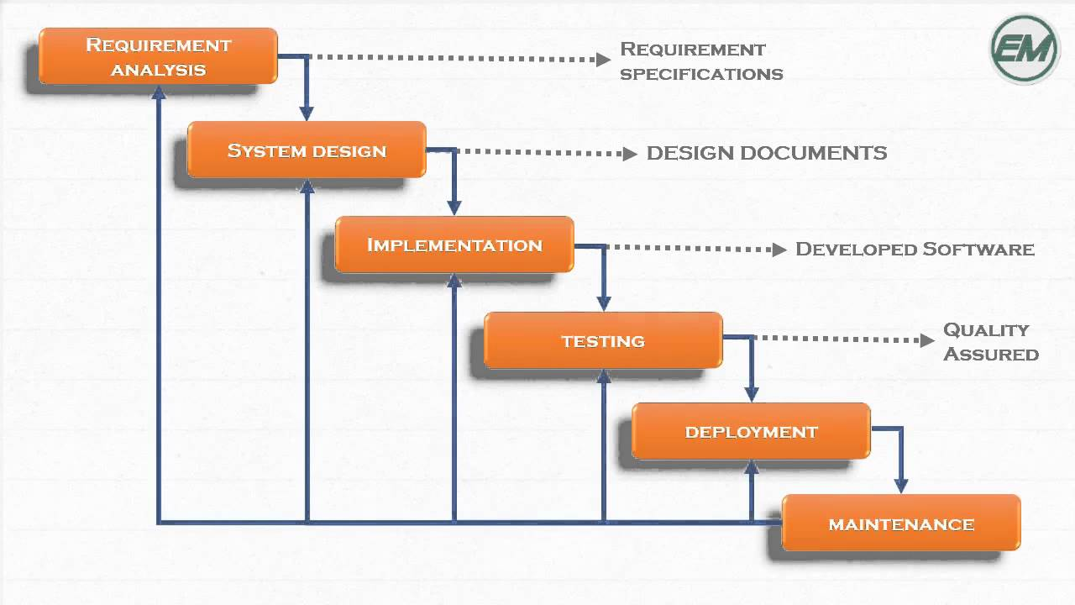

As the ***Waterfall Model*** illustrates the software development process in a linear sequential flow; hence it is also referred to as a ***Linear-Sequential Life Cycle Model***.

All these phases are cascaded to each other in which progress is seen as flowing steadily downwards (like a waterfall) through the phases. The next phase is started only after the defined set of goals are achieved for previous phase and it is signed off, so the name “*Waterfall Model*“.

* This model is used only when the requirements are very well known, clear and fixed.
* Product definition is stable.
* Technology is understood.
* There are no ambiguous requirements
* Ample resources with required expertise are available freely
* The project is short.

**Planning and scheduling :-**

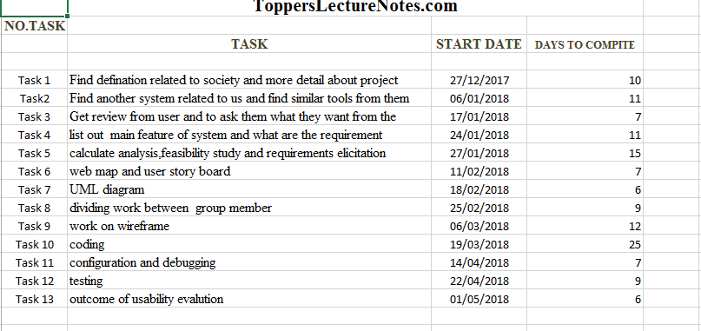

**2.2 Risk Management**

**Risk Identification&Analysis&Planning :-**

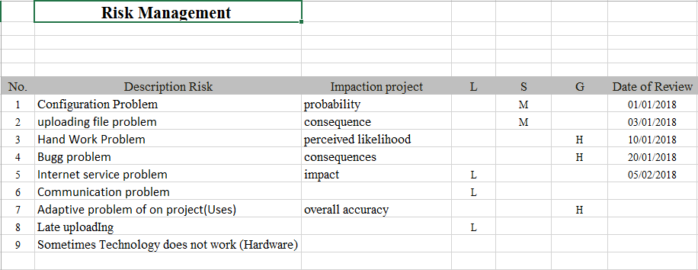

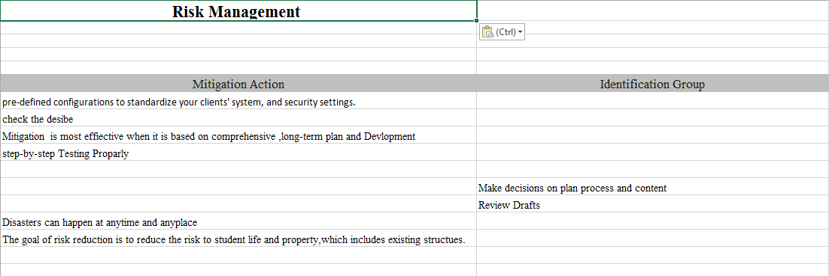

* 1. **Effort Estimation &Cost Analysis :-**

