AGENTIC AI COURSEWORK

Comparing CoT ToT and ReAct Planning Workflows
Experiential Learning Unit 2 | Course Outcome CO-2
Name: Ameersohiel N Momin
Class: LYAIA4
Prepared by Ameersohiel N Momin | 2 November 2026
This project compares three planning approaches on the same three-day Mumbai business-trip task. It injects a hotel-availability failure to show the difference between a fixed sequence, branch search, and reactive replanning.

Project Overview
This project compares three planning approaches on the same three-day Mumbai business-trip task. It injects a hotel-availability failure to show the difference between a fixed sequence, branch search, and reactive replanning.

Learning Objective
Explain how linear planning, tree exploration, and a feedback-driven ReAct loop handle known and unexpected failures.

System Workflow
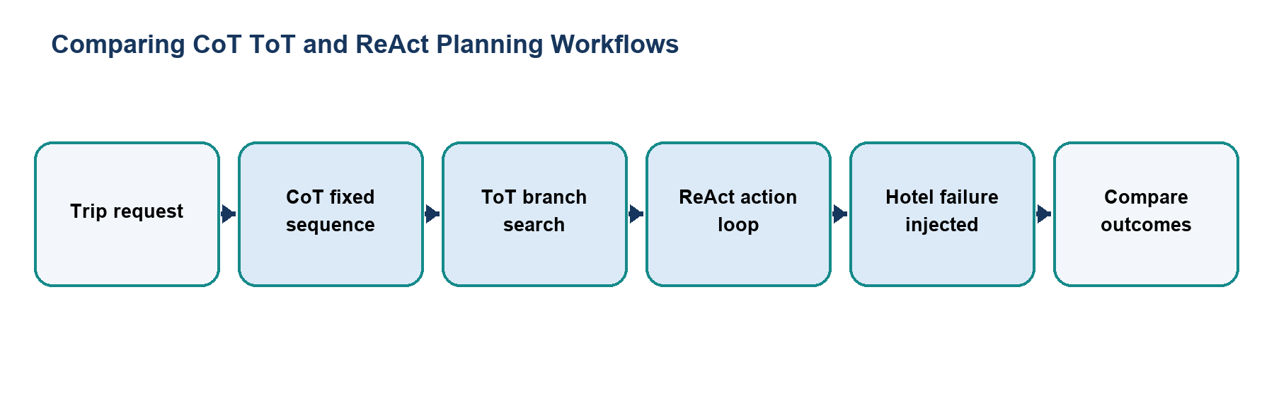
Figure 1. Main workflow for Comparing CoT ToT and ReAct Planning Workflows.
The workflow is implemented with local Python modules and deterministic examples. Each stage makes the project’s decisions and outcomes visible for review.

Files and Their Purpose
File | Purpose
README.md | Assignment report describing the trip constraints, planner strategies, failure handling, comparison, and commands.
cot_planner.py | Implements a fixed Chain-of-Thought-style itinerary sequence. In the injected scenario, execution stops when the preferred hotel is unavailable.
tot_planner.py | Builds and scores candidate trip branches, skips an unavailable hotel option, and selects the next available candidate.
react_workflow.py | Implements the iterative ReAct travel planner and deterministic mock travel tools. It replaces the failed hotel step with a fallback.
compare_planners.py | Runs all three planners with failure injection enabled and prints a side-by-side result table.
traces/cot_trace.txt | Captured execution trace for the fixed CoT workflow.
traces/tot_trace.txt | Captured search and selection trace for the ToT planner.
traces/react_trace.txt | Captured Thought–Action–Observation trace showing the ReAct fallback.

How to Run
Run these commands from the repository root with Python 3.9 or newer. The coursework uses the Python standard library and does not require external API credentials.
python3 02_Experiential_Learning_Unit_2_Planning_ReAct/compare_planners.py
python3 02_Experiential_Learning_Unit_2_Planning_ReAct/cot_planner.py
python3 02_Experiential_Learning_Unit_2_Planning_ReAct/tot_planner.py
python3 02_Experiential_Learning_Unit_2_Planning_ReAct/react_workflow.py

Results and Verification
Check | Observed behavior
CoT | Stops at the injected hotel failure and does not complete the remaining plan.
ToT | Skips the unavailable branch and chooses another option.
ReAct | Observes the failure, replans, and resumes with a fallback hotel.
Suite check | The combined comparison is included in the repository runner; all 15 configured checks passed during review.

Scope and Limitations
The trip services and hotel availability are simulated. The planner comparison illustrates control-flow behavior rather than making live bookings or using a language model.

Conclusion
This submission documents the design, implementation files, run procedure, and observed behavior of Comparing CoT ToT and ReAct Planning Workflows. The project provides a reproducible classroom demonstration of its stated agentic AI concept.

