AGENTIC AI COURSEWORK

Agent Memory Knowledge Retrieval and Safe Computation
Experiential Learning Unit 3 | Course Outcome CO-3
Name: Ameersohiel N Momin
Class: LYAIA4
Prepared by Ameersohiel N Momin | 2 November 2026
This project contrasts a memoryless baseline with a memory-augmented agent. The latter retrieves policy passages from a local vector store, keeps a short conversation buffer, and uses a restricted arithmetic tool for multi-step calculations.

Project Overview
This project contrasts a memoryless baseline with a memory-augmented agent. The latter retrieves policy passages from a local vector store, keeps a short conversation buffer, and uses a restricted arithmetic tool for multi-step calculations.

Learning Objective
Demonstrate how short-term memory, retrieval, and tool use support policy-grounded follow-up answers and calculations.

System Workflow
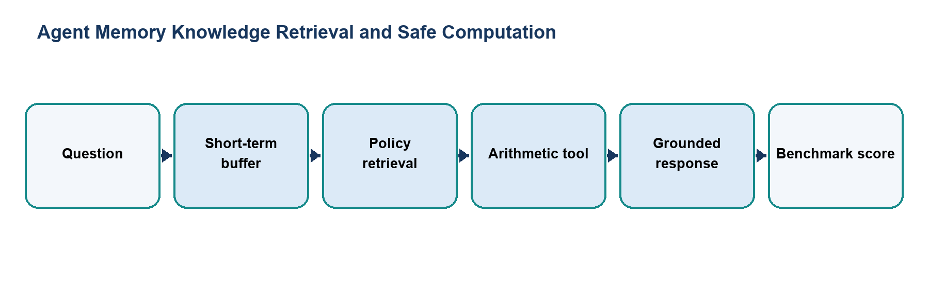
Figure 1. Main workflow for Agent Memory Knowledge Retrieval and Safe Computation.
The workflow is implemented with local Python modules and deterministic examples. Each stage makes the project’s decisions and outcomes visible for review.

Files and Their Purpose
File | Purpose
README.md | Experiment report covering the memory design, tools, evaluation questions, results, and commands.
agent.py | Defines MemorylessAgent and MemoryAgent. The memory agent retrieves relevant policy context, derives arithmetic expressions, computes them, and returns a cited answer.
benchmark_evaluation.py | Runs five expected-answer checks for both agents, prints a comparison, saves results, and fails if the memory agent misses any expected answer.
memory/__init__.py | Marks the memory components as a Python package.
memory/short_term_buffer.py | Stores recent role/content/timestamp entries in a bounded FIFO buffer and provides context and scratchpad views.
memory/vector_store.py | Implements a small pure-Python term-frequency and cosine-similarity store preloaded with business policy entries.
tools/__init__.py | Marks the tool components as a Python package.
tools/search_tool.py | Wraps the local vector store and returns ranked results, citations, and a confidence estimate.
tools/code_exec_tool.py | Evaluates arithmetic in a restricted namespace after rejecting a list of unsafe constructs.
results/benchmark_results.txt | Generated benchmark output with each question, expected value, answer, and correctness result.

How to Run
Run these commands from the repository root with Python 3.9 or newer. The coursework uses the Python standard library and does not require external API credentials.
python3 03_Experiential_Learning_Unit_3_Memory_and_Tools/benchmark_evaluation.py
python3 03_Experiential_Learning_Unit_3_Memory_and_Tools/agent.py

Results and Verification
Check | Observed behavior
Memoryless baseline | 0/5 expected-keyword checks.
Memory agent | 5/5 expected-keyword checks after fixing multi-policy retrieval and budget-question computation.
Suite check | Benchmark included in the repository runner; all 15 configured checks passed during review.

Scope and Limitations
The policy corpus and vector store are small and local. Benchmark correctness uses expected-keyword matching, not semantic evaluation. The restricted evaluator is a teaching demonstration, not a production sandbox.

Conclusion
This submission documents the design, implementation files, run procedure, and observed behavior of Agent Memory Knowledge Retrieval and Safe Computation. The project provides a reproducible classroom demonstration of its stated agentic AI concept.

