AGENTIC AI COURSEWORK

Coordination Handoffs Deadlocks and Error Cascades
Experiential Learning Unit 4 | Course Outcome CO-4
Name: Ameersohiel N Momin
Class: LYAIA4
Prepared by Ameersohiel N Momin | 2 November 2026
This project presents several coordination patterns for teams of agents: a research-and-writing crew, explicit message handoffs, dependency-cycle detection, and a demonstration of error propagation with mitigation.

Project Overview
This project presents several coordination patterns for teams of agents: a research-and-writing crew, explicit message handoffs, dependency-cycle detection, and a demonstration of error propagation with mitigation.

Learning Objective
Identify coordination failure modes and demonstrate supervisory recovery strategies for handoffs, deadlocks, and corrupted data.

System Workflow
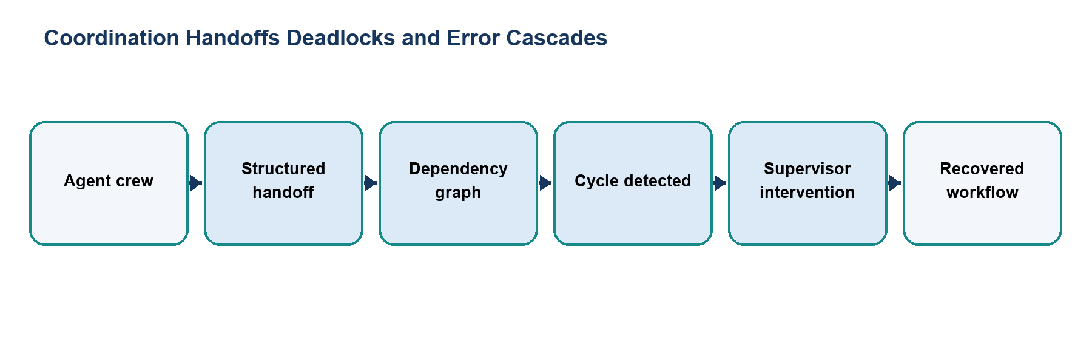
Figure 1. Main workflow for Coordination Handoffs Deadlocks and Error Cascades.
The workflow is implemented with local Python modules and deterministic examples. Each stage makes the project’s decisions and outcomes visible for review.

Files and Their Purpose
File | Purpose
README.md | Explains the four demonstrations, their learning goals, and individual run commands.
crew_architecture.py | Implements researcher, writer, and editor roles in a report-writing crew.
handoff_protocol.py | Defines messages and a protocol for passing work and context between agents.
deadlock_breaker.py | Tracks agent dependencies, detects a wait-for cycle, and uses a supervisor arbitrator to break the cycle.
error_propagation_demo.py | Simulates corrupted data moving through a pipeline and demonstrates a mitigation step before downstream reporting.

How to Run
Run these commands from the repository root with Python 3.9 or newer. The coursework uses the Python standard library and does not require external API credentials.
python3 05_Experiential_Learning_Unit_4_Team_of_Agents/crew_architecture.py
python3 05_Experiential_Learning_Unit_4_Team_of_Agents/handoff_protocol.py
python3 05_Experiential_Learning_Unit_4_Team_of_Agents/deadlock_breaker.py
python3 05_Experiential_Learning_Unit_4_Team_of_Agents/error_propagation_demo.py

Results and Verification
Check | Observed behavior
Crew | Runs researcher, writer, and editor stages.
Handoff | Passes structured messages between participants.
Deadlock | Detects a dependency cycle and applies a supervisor decision.
Error propagation | Compares the effect of corrupted input with a mitigation path.
Suite check | The crew, deadlock, and error demos are included in the repository runner; all 15 configured checks passed during review.

Scope and Limitations
The agents, messages, and task dependencies are in-memory simulations. They do not run in parallel or connect to external orchestration services.

Conclusion
This submission documents the design, implementation files, run procedure, and observed behavior of Coordination Handoffs Deadlocks and Error Cascades. The project provides a reproducible classroom demonstration of its stated agentic AI concept.

