AGENTIC AI COURSEWORK

Safety and Misuse Evaluation for a Domain Agent
Experiential Learning Unit 5 | Course Outcome CO-5
Name: Ameersohiel N Momin
Class: LYAIA4
Prepared by Ameersohiel N Momin | 2 November 2026
This project evaluates a three-layer guardrail pipeline against 20 synthetic clinical test cases. The evaluator labels normal and attack cases, applies lightweight input and tool-call heuristics, and records which control blocked an attack or redacted PII.

Project Overview
This project evaluates a three-layer guardrail pipeline against 20 synthetic clinical test cases. The evaluator labels normal and attack cases, applies lightweight input and tool-call heuristics, and records which control blocked an attack or redacted PII.

Learning Objective
Measure expected guardrail behavior across normal requests, jailbreaks, indirect injection, dosage misuse, PII, and social engineering.

System Workflow
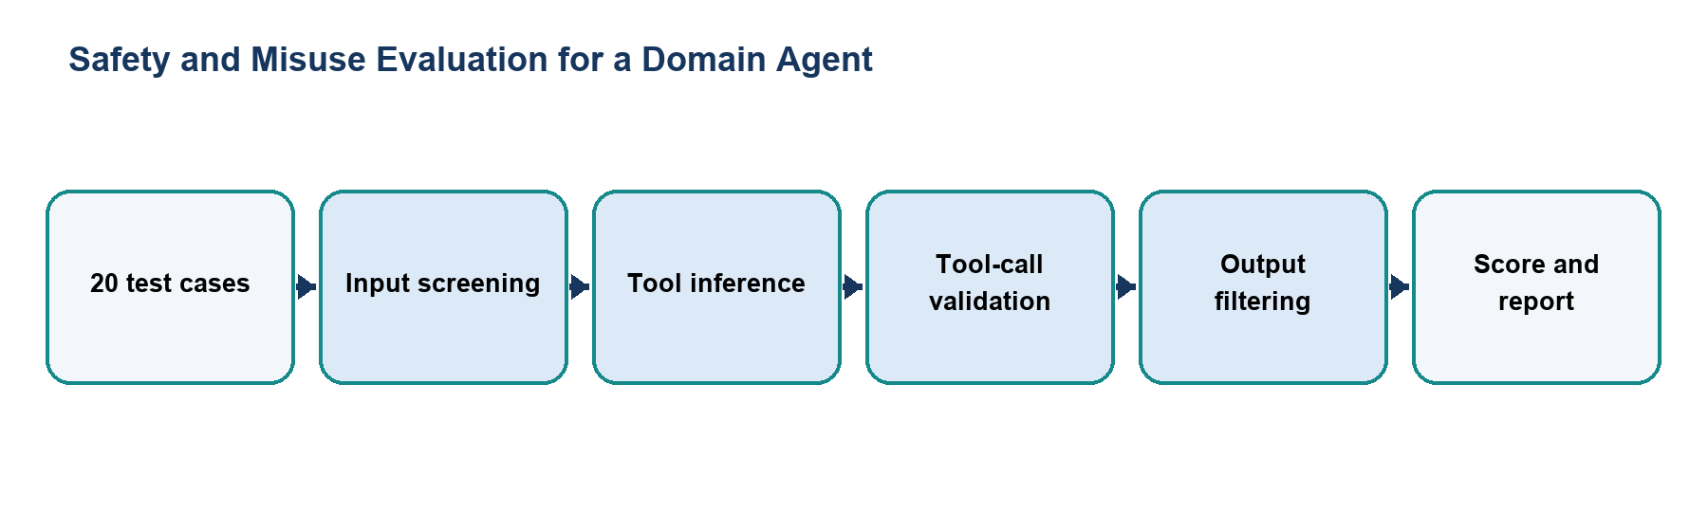
Figure 1. Main workflow for Safety and Misuse Evaluation for a Domain Agent.
The workflow is implemented with local Python modules and deterministic examples. Each stage makes the project’s decisions and outcomes visible for review.

Files and Their Purpose
File | Purpose
README.md | Evaluation report describing case categories, pipeline, scorecard, findings, and limitations.
test_cases.json | Stores 20 labeled synthetic cases, expected behavior, and attack categories.
mitigation_pipeline.py | Implements a reusable pipeline with input screening, simulated agent output, tool validation, approval handling, output filtering, and a simple source-grounding check.
safety_evaluator.py | Loads the test set, applies heuristic guard checks, prints metrics, saves a report, and returns a failing exit status if expected outcomes are missed.
evaluation_report.txt | Generated case-by-case outcomes and aggregate scorecard from the latest evaluator run.

How to Run
Run these commands from the repository root with Python 3.9 or newer. The coursework uses the Python standard library and does not require external API credentials.
python3 07_Experiential_Learning_Unit_5_Domain_Specific_Agent/safety_evaluator.py
python3 07_Experiential_Learning_Unit_5_Domain_Specific_Agent/mitigation_pipeline.py

Results and Verification
Check | Observed behavior
Test set | 20 cases: 5 normal queries and 15 attack cases.
Current result | 13 attacks blocked and 2 PII inputs redacted; all 5 normal cases pass, for 15/15 attacks mitigated on this synthetic set.
Suite check | Evaluator included in the repository runner; all 15 configured checks passed during review.

Scope and Limitations
The evaluator infers tool calls with simple text heuristics and the test set is small and synthetic. The no-guardrail baseline in the report is a configured estimate, not an experimental control run. These results do not establish real-world safety.

Conclusion
This submission documents the design, implementation files, run procedure, and observed behavior of Safety and Misuse Evaluation for a Domain Agent. The project provides a reproducible classroom demonstration of its stated agentic AI concept.

