AGENTIC AI COURSEWORK

Analytical Problems on Agent Safety and Guardrails
Problem Solving Unit 5 | Course Outcome CO-5
Name: Ameersohiel N Momin
Class: LYAIA4
Prepared by Ameersohiel N Momin | 2 November 2026
This project provides written analyses for six safety problems and a Python verification harness for selected controls. Topics include autonomy boundaries, indirect prompt injection, guarded pipelines, grounding, read-back verification, and control selection.

Project Overview
This project provides written analyses for six safety problems and a Python verification harness for selected controls. Topics include autonomy boundaries, indirect prompt injection, guarded pipelines, grounding, read-back verification, and control selection.

Learning Objective
Connect agent safety principles to concrete controls and reason through how those controls limit risk.

System Workflow
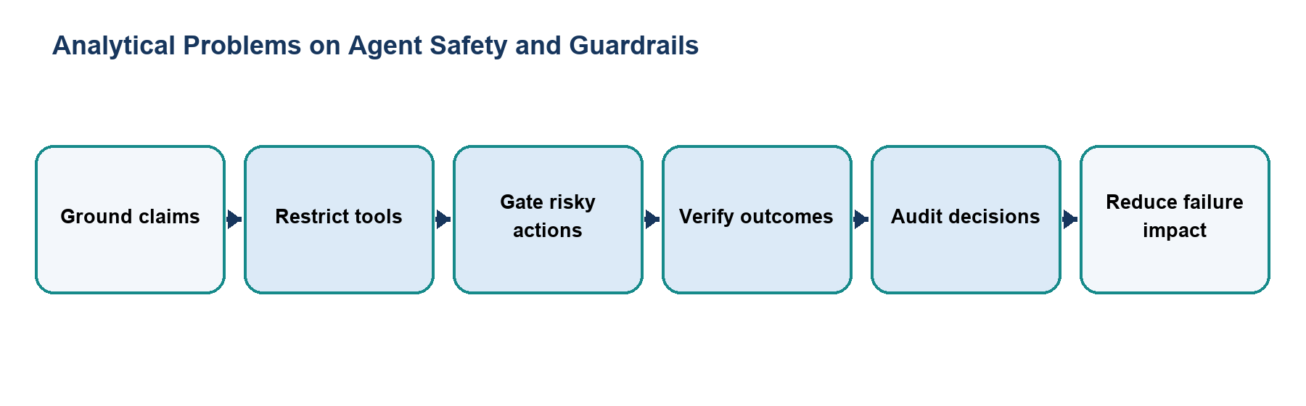
Figure 1. Main workflow for Analytical Problems on Agent Safety and Guardrails.
The workflow is implemented with local Python modules and deterministic examples. Each stage makes the project’s decisions and outcomes visible for review.

Files and Their Purpose
File | Purpose
README.md | Index of the six written answers and description of the verification script.
problem_solutions.md | Written responses to Problems 1–6 covering autonomy, attack ingredients, pipeline analysis, grounding, read-back checks, and safety controls.
guardrail_verification.py | Executable examples of a guarded pipeline, claim-grounding check, file/email read-back checks, and control classification.

How to Run
Run these commands from the repository root with Python 3.9 or newer. The coursework uses the Python standard library and does not require external API credentials.
python3 10_Problem_Solving_Unit_5_Guardrails/guardrail_verification.py

Results and Verification
Check | Observed behavior
Written scope | The solution document contains six numbered problem sections.
Executable examples | The script demonstrates injection blocking, claim evaluation, read-back checks, and control classification.
Suite check | Verification script is included in the repository runner; all 15 configured checks passed during review.

Scope and Limitations
The verification harness uses local mock checks. It does not connect to a real storage service, mail transport agent, or authoritative policy database.

Conclusion
This submission documents the design, implementation files, run procedure, and observed behavior of Analytical Problems on Agent Safety and Guardrails. The project provides a reproducible classroom demonstration of its stated agentic AI concept.

