AGENTIC AI COURSEWORK

ReAct Reasoning Agent for Infrastructure Deployment
Homework Unit 2 | Course Outcome CO-2
Name: Ameersohiel N Momin
Enrollment No: ADT23SOCB0116
Class: LYAIA4
Roll No: 03
Prepared by Ameersohiel N Momin | 2 November 2026
This project demonstrates a ReAct agent that plans and executes a multi-cloud deployment through mock infrastructure tools. When the primary database region reaches its quota, the agent records the error, replans to a fallback region, then runs health and deployment checks.

Project Overview
This project demonstrates a ReAct agent that plans and executes a multi-cloud deployment through mock infrastructure tools. When the primary database region reaches its quota, the agent records the error, replans to a fallback region, then runs health and deployment checks.

Learning Objective
Show how a Reason–Act–Observe loop can track state, use tools, recover from a failed action, and validate the final result.

System Workflow
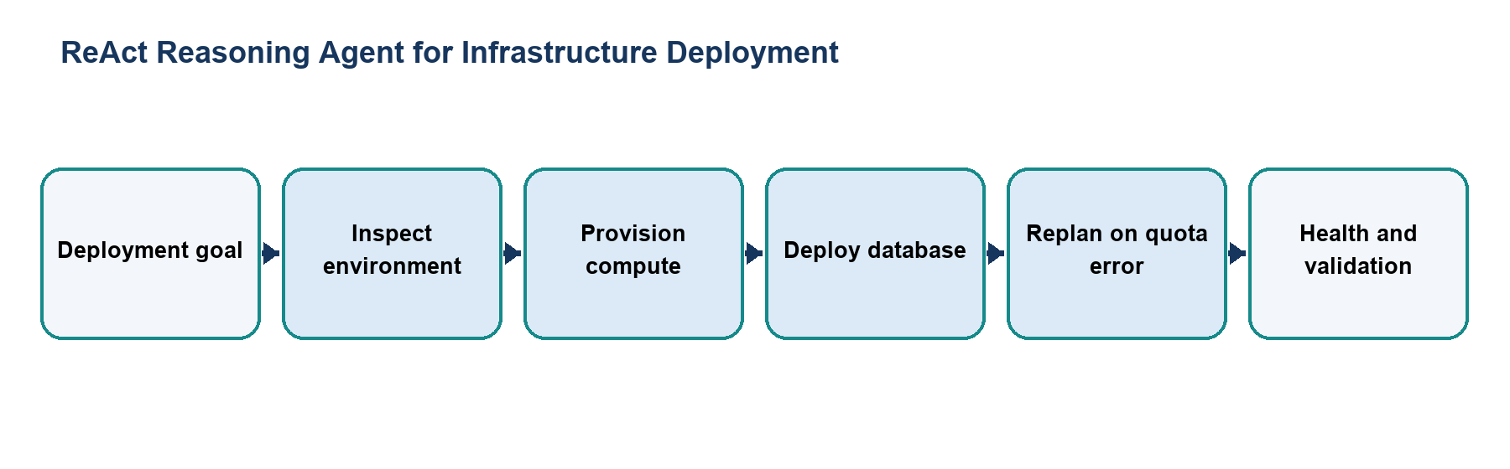
Figure 1. Main workflow for ReAct Reasoning Agent for Infrastructure Deployment.
The workflow is implemented with local Python modules and deterministic examples. Each stage makes the project’s decisions and outcomes visible for review.

Files and Their Purpose
File | Purpose
README.md | Assignment report, scenario description, trace summary, replanning explanation, file map, and run commands.
main.py | Defines the plan-step representation and ReActAgent loop. It selects an action, observes tool results, updates state, and inserts a fallback deployment step after a quota error.
tools.py | Implements deterministic mock tools for environment inspection, compute provisioning, database deployment, health checks, and final validation. ToolError represents simulated failures.
tests/__init__.py | Marks the tests directory as a Python package so unittest can discover the test module.
tests/test_replanning.py | Checks that the deployment agent catches the primary-region failure, replans, completes the workflow, and records the expected state.
traces/full_run_trace.txt | Readable record of the agent’s thoughts, tool actions, observations, failed database attempt, fallback, and final checks.

How to Run
Run these commands from the repository root with Python 3.9 or newer. The coursework uses the Python standard library and does not require external API credentials.
python3 01_Homework_Unit_2_ReAct_Agent/main.py
python3 -m unittest 01_Homework_Unit_2_ReAct_Agent/tests/test_replanning.py -v

Results and Verification
Check | Observed behavior
Expected primary failure | Database deployment in ap-south-1 exceeds the simulated quota.
Recovery | The plan inserts a deployment in ap-south-2 and continues.
Completion | Health checks and deployment validation report success.
Suite check | Included in the repository runner; all 15 configured checks passed during review.

Scope and Limitations
Cloud services are simulated locally. The project does not provision real infrastructure or connect to a cloud account.

Conclusion
This submission documents the design, implementation files, run procedure, and observed behavior of ReAct Reasoning Agent for Infrastructure Deployment. The project provides a reproducible classroom demonstration of its stated agentic AI concept.

