AGENTIC AI COURSEWORK

Multi Agent Security Audit and Patching Team
Homework Unit 4 | Course Outcome CO-4
Name: Ameersohiel N Momin
Enrollment No: ADT23SOCB0116
Class: LYAIA4
Roll No: 03
Prepared by Ameersohiel N Momin | 2 November 2026
This project models a coordinated audit team in which specialist agents inspect code and policies, then a coordinator combines their findings. A second demonstration compares an unmanaged failure scenario with a mitigation strategy.

Project Overview
This project models a coordinated audit team in which specialist agents inspect code and policies, then a coordinator combines their findings. A second demonstration compares an unmanaged failure scenario with a mitigation strategy.

Learning Objective
Show role-based agent specialization, coordination, consolidated recommendations, and failure mitigation in a security-audit scenario.

System Workflow
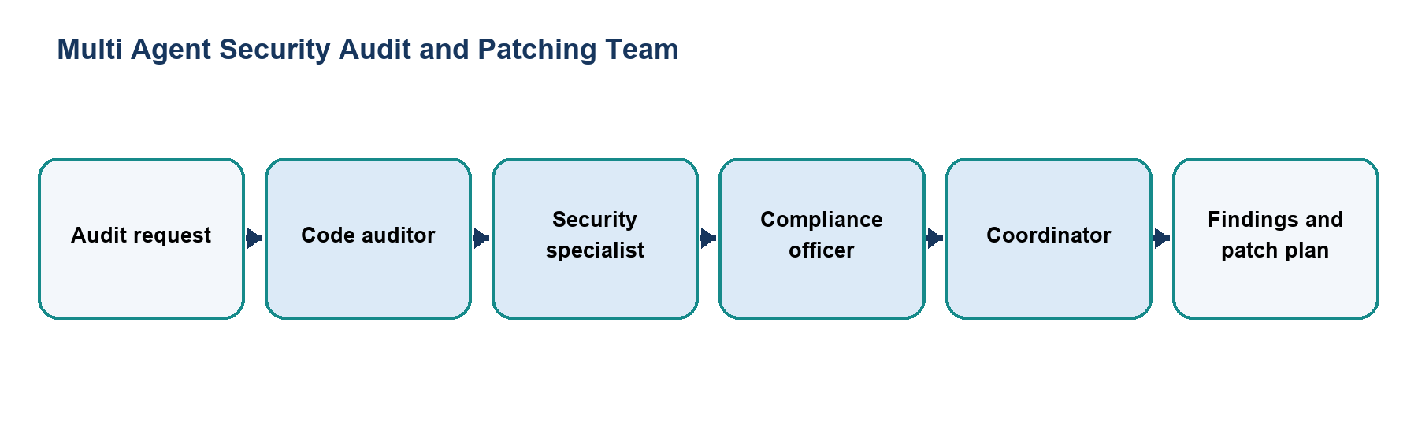
Figure 1. Main workflow for Multi Agent Security Audit and Patching Team.
The workflow is implemented with local Python modules and deterministic examples. Each stage makes the project’s decisions and outcomes visible for review.

Files and Their Purpose
File | Purpose
README.md | Project overview, agent roles, execution instructions, and expected audit artifacts.
agents/__init__.py | Marks the specialist agent modules as a Python package.
agents/code_auditor.py | Implements the code-review specialist and its findings for the sample audit.
agents/security_specialist.py | Implements the security specialist for threat and vulnerability review.
agents/compliance_officer.py | Implements the compliance role and checks the scenario against policy requirements.
coordinator.py | Coordinates specialist work and combines the outputs into an overall audit response.
run_team.py | Entry point that creates and runs the security-audit team.
failure_mitigation.py | Runs failure and mitigated scenarios and compares how coordination controls affect the outcome.
traces/multi_agent_run.txt | Saved record of the team execution, specialist handoffs, and combined result.

How to Run
Run these commands from the repository root with Python 3.9 or newer. The coursework uses the Python standard library and does not require external API credentials.
python3 04_Homework_Unit_4_Multi_Agent_Team/run_team.py
python3 04_Homework_Unit_4_Multi_Agent_Team/failure_mitigation.py

Results and Verification
Check | Observed behavior
Team workflow | Specialist findings are combined by the coordinator.
Mitigation demonstration | The paired scenarios show the effect of a recovery/control step.
Suite check | Both entry points are included in the repository runner; all 15 configured checks passed during review.

Scope and Limitations
The specialists and audit evidence are scripted simulations. No repository is scanned and no real patch is applied to production code.

Conclusion
This submission documents the design, implementation files, run procedure, and observed behavior of Multi Agent Security Audit and Patching Team. The project provides a reproducible classroom demonstration of its stated agentic AI concept.

