AGENTIC AI COURSEWORK

Healthcare Triage Agent with Safety Guardrails
Homework Unit 5 | Course Outcome CO-5
Name: Ameersohiel N Momin
Enrollment No: ADT23SOCB0116
Class: LYAIA4
Roll No: 03
Prepared by Ameersohiel N Momin | 2 November 2026
This project demonstrates a synthetic clinical triage assistant protected by input screening, structured tool-call validation, human approval for high-risk operations, and output filtering. An indirect prompt-injection scenario exercises the controls.

Project Overview
This project demonstrates a synthetic clinical triage assistant protected by input screening, structured tool-call validation, human approval for high-risk operations, and output filtering. An indirect prompt-injection scenario exercises the controls.

Learning Objective
Analyze domain-specific risk and demonstrate layered safeguards around sensitive data and high-impact actions.

System Workflow
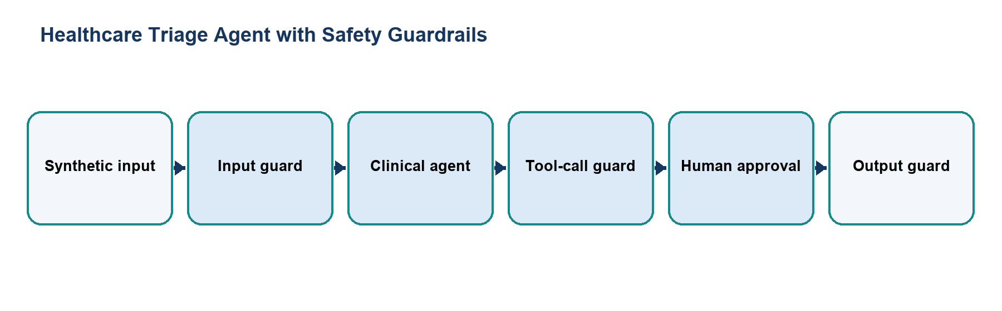
Figure 1. Main workflow for Healthcare Triage Agent with Safety Guardrails.
The workflow is implemented with local Python modules and deterministic examples. Each stage makes the project’s decisions and outcomes visible for review.

Files and Their Purpose
File | Purpose
README.md | Project report describing the synthetic healthcare scenario, risk model, guardrails, attack case, and run steps.
domain_agent.py | Implements the ClinicalTriageAgent demonstration and sequences input review, tool validation, approval, mock execution, and output filtering.
tools.py | Provides mock patient-record, interaction, lab, and prescribing tools using synthetic records.
guardrails/__init__.py | Marks the guardrail modules as a Python package.
guardrails/input_guard.py | Detects configured injection phrases and redacts supported PII-like patterns before the simulated agent processes input.
guardrails/tool_call_guard.py | Checks tool names against risk categories and applies configured dosage ceilings.
guardrails/human_approval.py | Creates and resolves an approval request for high-risk operations in the demonstration.
guardrails/output_guard.py | Redacts selected sensitive field names and flags unsupported drug references in prescription-like output.
attacks/__init__.py | Marks the attack demonstration directory as a Python package.
attacks/indirect_injection.py | Runs the patient-note injection example through the guardrail layers.
attacks/attack_trace.txt | Saved audit trace for the injection demonstration and guard decisions.

How to Run
Run these commands from the repository root with Python 3.9 or newer. The coursework uses the Python standard library and does not require external API credentials.
python3 06_Homework_Unit_5_Domain_Specific_Agent_Safety/domain_agent.py
python3 06_Homework_Unit_5_Domain_Specific_Agent_Safety/attacks/indirect_injection.py

Results and Verification
Check | Observed behavior
Input screening | Configured injection examples are stopped before reaching the simulated agent.
Tool validation | Unsafe dosage and unknown operations are rejected; high-risk operations request approval.
Output review | Sensitive labels are redacted and unsupported prescription drug references are flagged.
Suite check | Both demos are included in the repository runner; all 15 configured checks passed during review.

Scope and Limitations
All patient records are synthetic and the healthcare controls are instructional examples. The project is not a medical device and does not provide clinical advice or connect to an EHR.

Conclusion
This submission documents the design, implementation files, run procedure, and observed behavior of Healthcare Triage Agent with Safety Guardrails. The project provides a reproducible classroom demonstration of its stated agentic AI concept.

