AGENTIC AI COURSEWORK

Agent Architecture Debate and ReAct Trace Critique
Participative Learning Units 1 and 2 | Course Outcomes CO-1 and CO-2
Name: Ameersohiel N Momin
Enrollment No: ADT23SOCB0116
Class: LYAIA4
Roll No: 03
Prepared by Ameersohiel N Momin | 2 November 2026
This project combines a written comparison of agent architectures with an executable critique of a flawed ReAct trace. A remediation engine demonstrates loop detection, confidence gating, and fallback selection.

Project Overview
This project combines a written comparison of agent architectures with an executable critique of a flawed ReAct trace. A remediation engine demonstrates loop detection, confidence gating, and fallback selection.

Learning Objective
Compare agent architectures and practice identifying and remediating failure patterns in reasoning-and-tool traces.

System Workflow
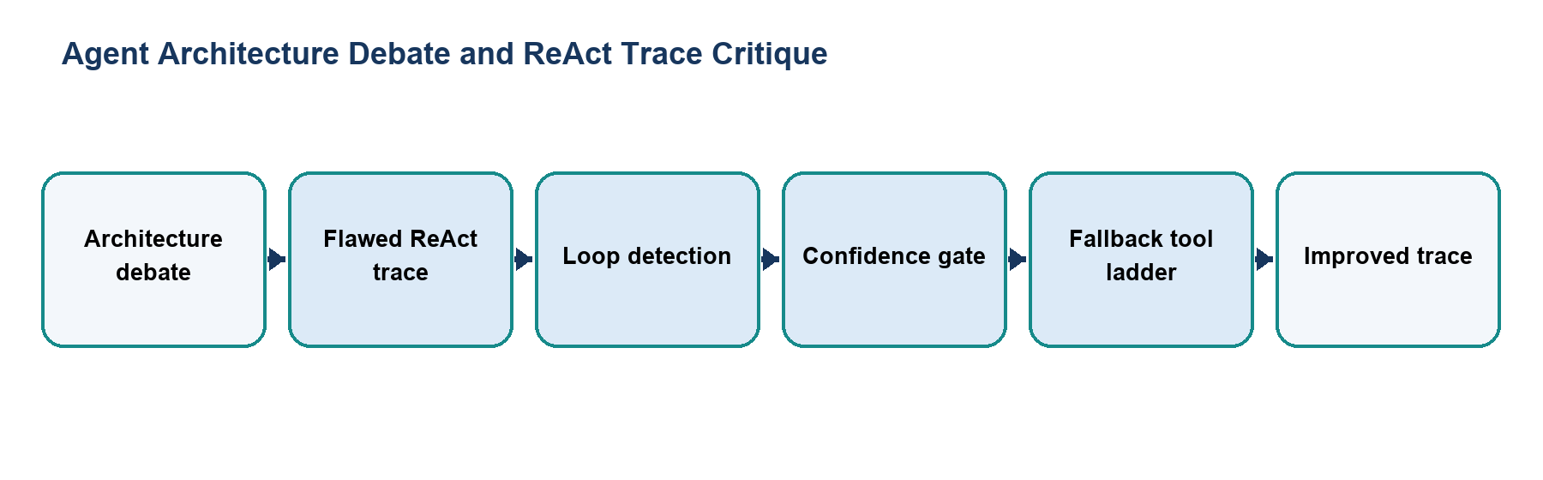
Figure 1. Main workflow for Agent Architecture Debate and ReAct Trace Critique.
The workflow is implemented with local Python modules and deterministic examples. Each stage makes the project’s decisions and outcomes visible for review.

Files and Their Purpose
File | Purpose
README.md | Activity description, learning goals, file guide, and run instructions.
debate_brief.md | Written briefing that compares reflex, model-based, goal-based, utility-based, and learning agents with domain examples.
live_demo_critique.py | Presents flawed and improved ReAct traces and supports an automated mode for repeatable demonstrations.
trace_remediation.py | Implements loop detection and confidence-based tool pivoting in a remediation example.

How to Run
Run these commands from the repository root with Python 3.9 or newer. The coursework uses the Python standard library and does not require external API credentials.
python3 08_Participative_Learning_Units_1_and_2/live_demo_critique.py --auto
python3 08_Participative_Learning_Units_1_and_2/trace_remediation.py

Results and Verification
Check | Observed behavior
Architecture content | The briefing covers multiple agent architectures and trade-offs.
Critique demo | Automated mode prints both the pathological and improved traces.
Remediation demo | Shows a bounded recovery path rather than repeating the same tool call indefinitely.
Suite check | Both scripts are included in the repository runner; all 15 configured checks passed during review.

Scope and Limitations
The trace examples and remediation policy are scripted teaching cases, not a live agent runtime or empirical study.

Conclusion
This submission documents the design, implementation files, run procedure, and observed behavior of Agent Architecture Debate and ReAct Trace Critique. The project provides a reproducible classroom demonstration of its stated agentic AI concept.

