AGENTIC AI COURSEWORK

Agent Governance Stakeholder Panel and Incident Simulation
Participative Learning Units 3, 4 and 5 | Course Outcomes CO-3 CO-4 and CO-5
Name: Ameersohiel N Momin
Enrollment No: ADT23SOCB0116
Class: LYAIA4
Roll No: 03
Prepared by Ameersohiel N Momin | 2 November 2026
This project pairs a stakeholder role-play and governance framework with a runnable multi-agent incident-response simulation. It focuses on memory privacy, tool privileges, inter-agent trust, auditability, and containment.

Project Overview
This project pairs a stakeholder role-play and governance framework with a runnable multi-agent incident-response simulation. It focuses on memory privacy, tool privileges, inter-agent trust, auditability, and containment.

Learning Objective
Discuss governance trade-offs and demonstrate coordinated containment of an indirect prompt-injection incident.

System Workflow
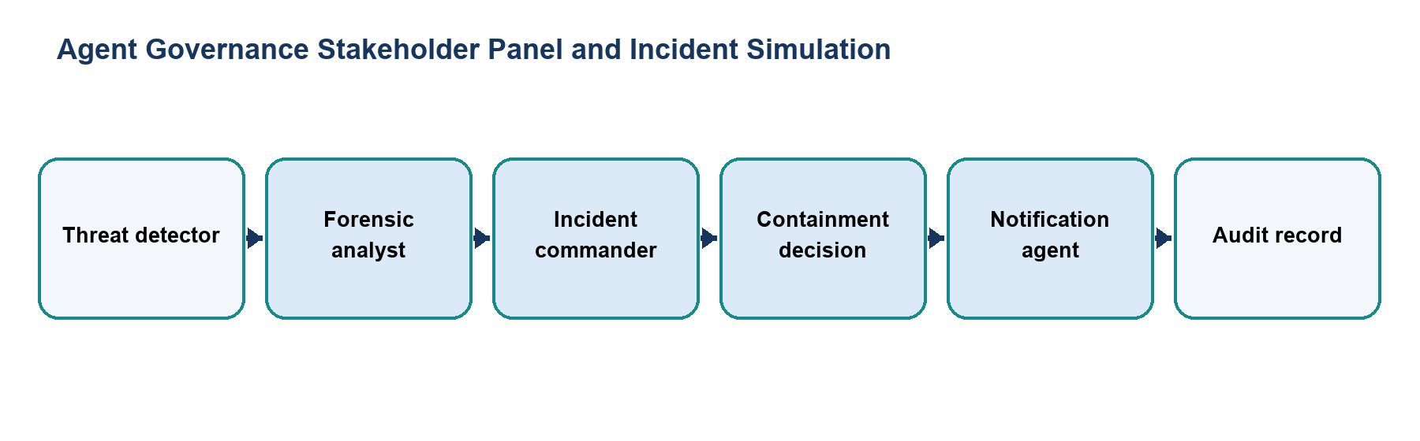
Figure 1. Main workflow for Agent Governance Stakeholder Panel and Incident Simulation.
The workflow is implemented with local Python modules and deterministic examples. Each stage makes the project’s decisions and outcomes visible for review.

Files and Their Purpose
File | Purpose
README.md | Activity overview, learning objectives, key artifacts, and simulation command.
roleplay_script.md | Stakeholder discussion among technical, operations, and safety/compliance perspectives.
governance_framework.md | Policy matrix covering governance dimensions such as memory, access, prompt-injection defense, audit trails, and kill switches.
incident_simulation.py | Implements threat detection, forensic review, command decisions, and notification stages for a simulated incident.

How to Run
Run these commands from the repository root with Python 3.9 or newer. The coursework uses the Python standard library and does not require external API credentials.
python3 09_Participative_Learning_Units_3_4_5/incident_simulation.py

Results and Verification
Check | Observed behavior
Written activity | Role-play presents stakeholder trade-offs and the framework records policy mandates.
Simulation | The four-agent workflow detects and contains the scripted threat scenario.
Suite check | Incident simulation is included in the repository runner; all 15 configured checks passed during review.

Scope and Limitations
The incident and response agents are scripted, in-memory examples. They do not access production systems, send notifications, or enforce real policies.

Conclusion
This submission documents the design, implementation files, run procedure, and observed behavior of Agent Governance Stakeholder Panel and Incident Simulation. The project provides a reproducible classroom demonstration of its stated agentic AI concept.

