GTP 2026 Check-in: what to do if the network has problems
Use this guide at the registration desk, 12-15 October 2026. Start with step 1 and only move down if the step above does not work. Nobody should be turned away because a phone or the website is slow.

Which step do I use?
What is happening | What you do | Who
Phone loses signal for a short time | Keep scanning. Scans are saved on the phone and sent when signal returns. | Scanners
A guest's QR code will not scan or is missing | Search for the guest by name and check them in (step 2). | Scanners and organizers
The website or the whole network is down | Write arrivals on the printed roster, then upload it later (steps 3 and 4). | Everyone, then an organizer

1. Short signal loss: keep scanning
- If the phone says the scan is queued, the guest has NOT been confirmed yet. That is normal.
- Keep the scanner page open. Do not close the tab or sign out. The phone retries by itself every 20 seconds and when signal returns.
- Tap Retry pending scans to try straight away.
- Scans that cannot be saved appear under Needs review with the reason. Tell an organizer. Dismiss them only after the guest is checked in another way.
- Queued scans count for the day they were scanned, as long as they upload within 72 hours.

2. QR code will not scan: find the guest by name
- Open Scan pass. Under Find a guest, type at least 2 letters of the name, email or organisation.
- Match the guest, then tap Check in.
- Tap Confirm check-in. The guest shows as Checked in today. If they were already checked in, the screen says so and the count does not go up.
- Every manual check-in is recorded with your name. Only check in people you have seen.

On a phone: search, then Confirm check-in.
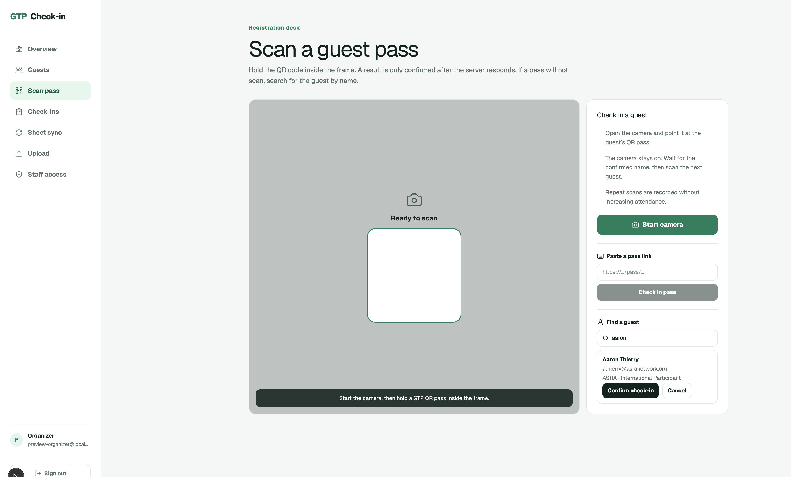
On a laptop: the same steps on the Scan pass page.

3. Website or network down: use the paper roster
- Do this before the event, not during it. An organizer opens Check-ins and taps Download roster each morning.
- Save the file on two phones or laptops and print one copy.
- If the site is down, tick people off on the printed copy, or type Y in the last column (Checked in (Y)) of the saved file. Keep one list per event day.
- Keep every list. Do not throw paper away until an organizer confirms the upload worked.
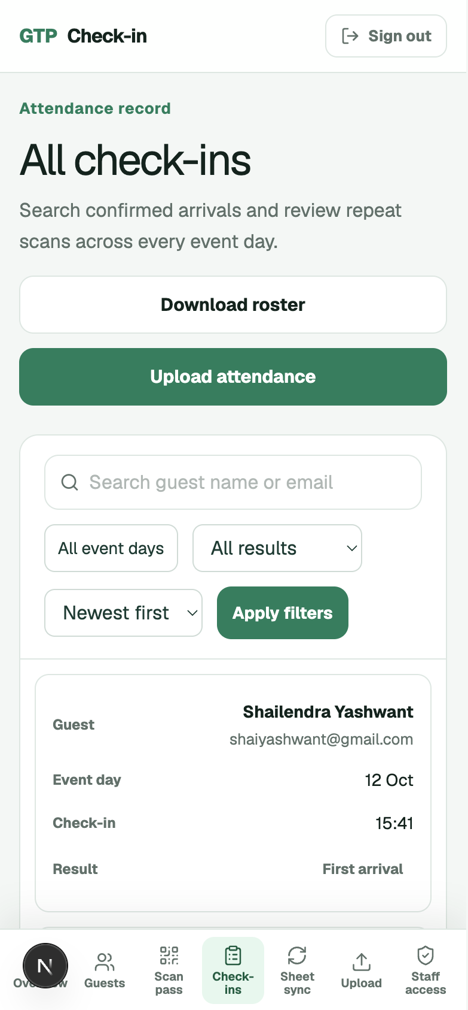
On a phone: Download roster is at the top of Check-ins.
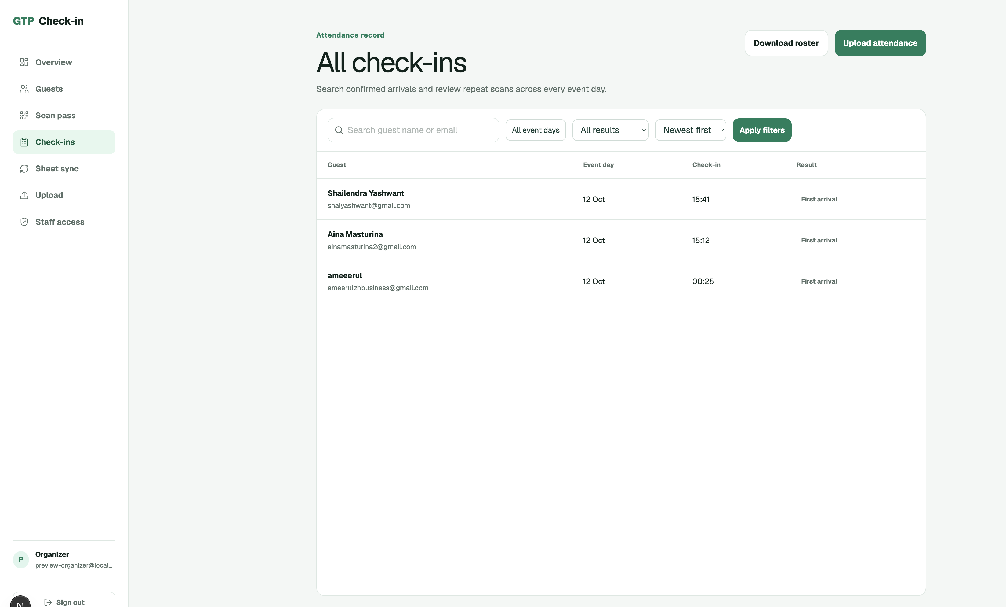
On a laptop: Download roster and Upload attendance, top right.

4. Back online: upload who attended (organizers)
- Open Upload (or Check-ins, then Upload attendance).
- Choose the event day the list is for. One list per day.
- Paste the emails, or choose the CSV file. In a roster file, only rows marked Y, yes, x or 1 are counted.
- Tap Preview. Check the numbers: ready to check in, already checked in, not on the guest list, inactive. Fix any email that was not matched.
- Tap Save attendance. It is safe to upload the same file twice. Nobody is counted twice.

On a phone: paste the list, Preview, then Save attendance.
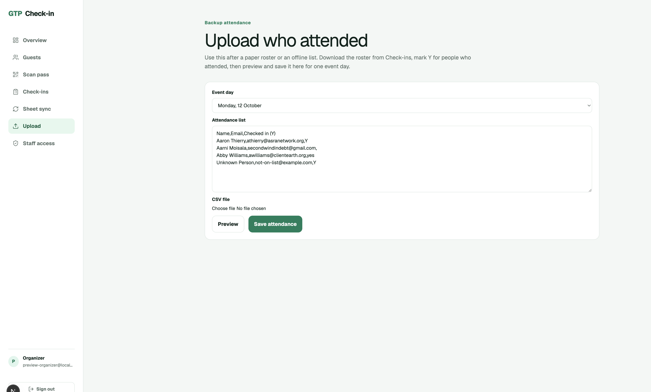
On a laptop: choose the day, paste or load the list, then Preview.

Before the event
- Every scanner signs in the day before and completes one test scan.
- Charge phones and bring power banks and a venue hotspot.
- Download and print the roster each morning.
- Keep at least two organizer accounts signed in.

End of each day
- Open each scanner phone and check the pending count is zero.
- Clear anything under Needs review.
- Download the roster again and save it as that day's record.

Who to call
Add the organizer names and phone numbers here.

