**PYTHON PROJECT REPORT**

(Project Semester: January-April 2025)

**Title of the Project: Electric Vehicle Trends**

**Submitted by:**

**Ameg Dines**

**Registration No.: 12320113  
Programme and Section: B.Tech CSE (K23FD)  
Course Code: INT375**

**Under the Guidance of:**Baljinder Kaur (UID : 27952)

**Discipline of CSE/IT**  
**Lovely School of Computer Science & Engineering**  
**Lovely Professional University, Phagwara**

**DECLARATION**

I, **Ameg Dines**, student of **Bachelors of Technology (B.Tech)** under CSE/IT Discipline at Lovely Professional University, Punjab, hereby declare that all the information furnished in this project report is based on my intensive work and is genuine.

Date: 11-April-2025

Registration No.: 12320113  
Name of the Student: **Ameg Dines**

# ****CERTIFICATE****

This is to certify that **Ameg Dines** bearing Registration No. **12320113** has completed **INT217** project titled **“Electric Vehicle Trends and Insights”** under my guidance and supervision. To the best of my knowledge, the present work is the result of her original development, effort, and study.

**Baljinder Kaur**  
**Assistant Professor**  
**School of Computer Science & Engineering**

**Lovely Professional University**  
**Phagwara, Punjab**

Date: **04-April-2025**

**ACKNOWLEDGMENT**

I would like to express my sincere gratitude to **Baljinder Kaur mam**, my project guide, for their invaluable support, guidance, and encouragement throughout the development of this project. Their expert insights and constructive feedback have been instrumental in shaping the project's outcome.

I am also thankful to **Lovely Professional University** for providing a conducive learning environment and access to resources that made this project possible. Additionally, I extend my appreciation to my professors and peers for their continuous motivation and insightful discussions, which greatly enhanced my understanding of the subject.

# ****TABLE OF CONTENTS****

1. Introduction
2. Source of Dataset
3. Dataset Preprocessing
4. Analysis on Dataset (for each objective)
   * i. General Description
   * ii. Specific Requirements
   * iii. Analysis Results
   * iv. Visualization
5. Conclusion
6. Future Scope
7. References

# ****1. INTRODUCTION****

The world automotive scene is experiencing a paradigm shift as electric cars (EVs) continue to gain popularity and acceptance. In the face of growing apprehensions about global warming, fossil fuel shortages, and air pollution, governments and states are turning toward cleaner and greener means of transportation. Electric vehicles have been one of the initiatives that have proven to be a viable option, with their low emission and energy-efficient profile posing a desirable alternative to conventional internal combustion engine (ICE) vehicles. This project will examine the increasing number of electric vehicles in Washington State based on real-world data and provide the results through an interactive dashboard fully developed in Microsoft Excel. Electric cars, especially Battery Electric Vehicles (BEVs) and Plug-in Hybrid Electric Vehicles (PHEVs), have been building traction in the last several years because of technological innovation, government incentives, and consumer knowledge. In Washington State—a state where environmentalism is prevalent and there is a technology-savvy population—there has been substantial growth in EV adoption. From examining detailed EV registration data published by the Washington State Department of Licensing, we seek to find important trends in consumer behaviour, manufacturer leadership, regional adoption, and feature preferences like price and electric range.

The primary goal of this project is to convert raw data into actionable information using structured data analysis and interactive visualizations. To achieve this, we utilized Excel's native features like Pivot Tables, Pivot Charts, slicers, and dashboard components. These facilities enable us to segment the data along different dimensions, including vehicle make, model year, county, city, electric vehicle type, utility company, and Clean Alternative Fuel Vehicle (CAFV) eligibility. With this multidimensional framework, we have organized the analysis in terms of six primary goals: trend over time, type contrast (BEV vs. PHEV), geographical distribution, price vs. range correlation, incentive eligibility, and utility provider support. Each goal is crafted not just to meet standards of academic analysis but also to provide answers to actual policy and marketplace questions. For instance, the trend analysis spotlights the rapid surge in EV growth over recent years, and the price-range correlation offers insight into consumer affordability and efficiency trade-offs. Examining the geographic distribution of EVs aids in determining infrastructure gaps and areas for public investment. Similarly, understanding CAFV eligibility allows stakeholders to assess the effectiveness of government incentives in influencing consumer decisions.

Beyond being technically proficient, the project also prioritizes user engagement and access. A live dashboard was created so that users—regardless of whether they are policymakers, researchers, or students—could interact with the data in real time through the use of slicers and filters. This makes both the experience and the usefulness of the analysis more interactive and more interactive. Insights are not only seen but dug into. Electric vehicles rapidly becoming the focus of sustainable transportation, data-driven tools such as this dashboard will have an important role to play in the development of smart, evidence-informed decisions.

**2. SOURCE OF DATASET**

The dataset used in this project is based on publicly available information from the U.S. government's open data platform, [**catalog.data.gov**](https://catalog.data.gov) (**https://catalog.data.gov/dataset/electric-vehicle-population-data**), specifically from the dataset titled [Electric Vehicle Population Data](https://catalog.data.gov/dataset/electric-vehicle-population-data). It is published by the Washington State Department of Licensing. It provides a snapshot of all electric vehicles registered in the state, updated regularly. The dataset includes over 100,000 rows and 20+ columns, offering detailed attributes such as:

* Vehicle Make and Model
* Electric Vehicle Type (BEV, PHEV)
* Model Year
* Base Manufacturer's Suggested Retail Price (MSRP)
* Electric Range
* City and County of registration
* Clean Alternative Fuel Vehicle (CAFV) Eligibility
* Utility Company providing power
* VIN (first 10 characters for anonymized identification)

The dataset is open for public access and reflects real-world trends, making it ideal for data analysis projects focused on sustainability and smart mobility.

# ****3. DATASET PREPROCESSING****

# To ensure the dataset was clean, consistent, and suitable for analysis, multiple preprocessing steps were performed: The dataset was first imported using Pandas. Text-based fields like the Make of the vehicle were standardized by converting them to uppercase, while Model names were formatted in title case for readability. City names were cleaned by removing any special characters or numbers and trimming excess spaces to ensure uniform geographic labeling.

# Postal Codes were extracted as valid 5-digit codes, and Model Year values were refined to capture only valid four-digit years. These transformations made it easier to group and analyze data by year and location. Numerical consistency was addressed by converting Electric Range and Base MSRP values into proper numeric formats. Any non-numeric values were handled gracefully using error coercion, which prevented them from breaking the analysis while marking them as NA if invalid.

# To maintain data integrity, duplicate records were removed. Additionally, rows containing missing or null values in essential columns such as County, City, Electric Vehicle Type, and Electric Utility were dropped. These fields were critical to regional, categorical, and technical analysis and thus could not be left incomplete. This preprocessing ensured that all data used in the visualizations and statistical summaries was accurate, reliable, and formatted in a consistent structure. It significantly improved the overall quality of insights drawn from the dataset.

# ****4. ANALYSIS ON DATASET****

**Objective 1: EV Adoption Over the Years**

**i.General Description:**

The dataset gives a detailed overview of electric vehicle (EV) registrations with attributes like make, model, model year, electric range, base MSRP, city, county, electric utility, and EV type. It represents adoption trends, performance specifications, and customer tastes in the EV market across different geographies. To investigate these forces, several visualizations were produced to examine manufacturer leadership, car types, geographic density, pricing trends, and technology development through time.

**ii. Specific Requirements**

* Determine the most registered EV manufacturers by registration number.
* Study the distribution of EV types (BEV, PHEV, etc.).
* Monitor how electric range has changed over various model years.
* Identify regions/counties with the highest EV uptake.
* Compare the average MSRP between various EV types.
* Recognize how electric range varies by model year and model.
* Study combined trends in electric range and base MSRP over time.

**iii. Analysis Results:**

* **Top 10 EV Makes:** Tesla is the most registered EV brand by a large margin, showcasing its market leadership and strong brand recognition. Nissan and Chevrolet follow, reflecting early adoption of models like the Nissan Leaf and Chevy Volt. Other manufacturers like Ford, BMW, and Kia also appear, indicating a growing diversity in EV offerings.
* **Electric Vehicle Type Distribution:** Battery Electric Vehicles (BEVs) dominate the distribution, followed by Plug-in Hybrid Electric Vehicles (PHEVs). This suggests a significant consumer shift toward fully electric mobility, likely due to increasing range, environmental awareness, and charging infrastructure improvements.
* **Average Electric Range by Model Year:** A steady increase in electric range is observed over the years, indicating continuous advancements in battery technology and vehicle efficiency. Vehicles manufactured in recent years provide significantly longer driving ranges than older ones, improving EV practicality and consumer confidence.
* **Top 10 Counties by EV Registrations:** King County ranks highest, followed by counties like Snohomish, Pierce, and Whatcom. These regions likely benefit from supportive local policies, greater environmental advocacy, and improved charging networks that promote EV usage.
* **Average Base MSRP by EV Type:** BEVs have the highest average MSRP, reflecting their advanced technologies and premium positioning in the market. Plug-in hybrids are more affordable, bridging the gap between traditional vehicles and full electrics. This price variation indicates that BEVs are targeting performance and luxury segments, while hybrids appeal to cost-conscious or transition-phase consumers.
* **Electric Range Distribution by Model Year (Boxplot):** Newer model years show wider and higher range values, indicating more options for buyers and significant performance improvements. Older models have shorter ranges and tighter variability, pointing to technological limitations at the time.
* **Electric Range by Model:** Tesla models such as the Model S, 3, and Y have significantly higher ranges compared to others. Some models from Nissan, Chevrolet, and Ford offer moderate range, supporting the idea of range as a key differentiator in consumer choice.
* **Trend of Electric Range vs Base MSRP:** Over the years, both range and MSRP have increased. This suggests that higher-priced newer models offer better range and performance, justifying the price increase and reflecting rising demand for long-distance capable EVs.

.

**iv. Visualization:**

# Bar plots, pie charts, line graphs, and boxplots were used to present trends clearly and visually. These charts helped highlight patterns and differences in vehicle types, brand popularity, pricing, and technological development. The visual format made complex data intuitive and comparative insights easier to grasp.

# 5.Conclusion

# The examination of the electric vehicle (EV) population dataset provides useful insights into what is happening in the current trends, trends, and technological progress in the EV environment. With careful data cleaning and preprocessing, a unified and reliable base was created to support thorough visual and statistical exploration of the data. Among the important findings was the dominance of Tesla in the EV market. Its wide margin of registrations reinforces its innovation, customer confidence, and performance-based design. Nonetheless, the fact that other producers such as Nissan, Chevrolet, and Ford exist illustrates the intensifying competition and diversification within the EV sector. This diversification in the models and makes of vehicles illustrates that customers are being presented with more choices, accommodating different demands and price segments.

# The dominance of Battery Electric Vehicles (BEVs) in the EV type distribution signals a decisive movement toward total electric mobility. This is consistent with increasing consumer trust in BEV reliability and range, enabled by ongoing developments in battery technology. The growth of average electric range by model year also solidifies this pattern, demonstrating how newer models are increasingly becoming usable for everyday and longer-distance travel. Geographically, some counties, particularly King County, have much higher rates of adoption. This indicates that local infrastructure, environmental policy, and public awareness are key factors in the adoption of EVs. Such regions could be used as examples by other regions that want to boost EV presence in their own locations. Pricing patterns indicated that BEVs tend to have a higher MSRP, possibly because of their technology and performance levels. This also highlights the demand for affordable EVs to enable mass consumption, particularly in price-conscious markets.

# The trend of MSRP and electric range over time is not only parallel, but it signifies that consumers are paying higher amounts, but they are also getting increased value when it comes to vehicle performance. This trend signifies a mature market that is weighing cost against innovation. Overall, the project is very successful in accomplishing its mission by discovering primary manufacturers, grasping vehicle type distributions, studying geographic concentrations, and examining trends in range and price. The visualizations convey a simple and convincing account of how the EV market is developing. This examination underscores the significance of ongoing investment in EV technology, infrastructure, and policy assistance to support and quicken the transition towards cleaner, more efficient transport.

**6.Future Scope**

While the current analysis has provided valuable insights into electric vehicle (EV) trends, there are several opportunities for future enhancements and deeper exploration:

1. **Time Series Forecasting:**  
   Integrating time-series data models would help in forecasting of EV uptake, range development, and pricing movement. ARIMA, Prophet, or LSTM-type predictive models may assist stakeholders to forecast future development and make pre-emptive infrastructure preparations accordingly.
2. **Geospatial Analysis:**  
   With more geographic information (latitude and longitude), geospatial visualization software such as Folium or GeoPandas may be employed to plot EV density, determine underserved regions, and plan for future charging infrastructure.
3. **Consumer Behavior Analysis:**  
   Incorporating demographic and socio-economic data could reveal how factors like income, education, or age groups influence EV adoption, helping governments and manufacturers tailor their strategies.
4. **Inclusion of Charging Station Data:**  
   By combining EV population data with charging station availability, one could assess infrastructure adequacy and identify regions needing investment in fast-charging networks.
5. **Environmental Impact Evaluation:**  
   Further integration of emissions data can help quantify the carbon offset achieved through EV adoption in specific regions, reinforcing the environmental benefits of switching to electric mobility.
6. **Model Comparison and Recommendation Systems:**  
   Using machine learning, a recommendation engine could be developed to suggest EV models based on user needs (e.g., range, price, utility provider). Clustering algorithms could also group similar EVs based on specifications.
7. **Real-time Data Integration:**  
   With access to live registration data and vehicle telemetry, a real-time EV dashboard could be created to monitor changes in the EV ecosystem dynamically.
8. **Policy Impact Studies:**  
   Analysis of incentives, rebates, or government mandates could help evaluate their effectiveness in driving EV adoption. This would support data-driven policy-making.

# ****7.REFERENCES****

* National Archives, "EV population data", Data.gov, [Online]. Available: <https://catalog.data.gov/dataset/electric-vehicle-population-data>
* Electric Vehicle Data Source (WA State)

**8.Linked in ScreenShots**



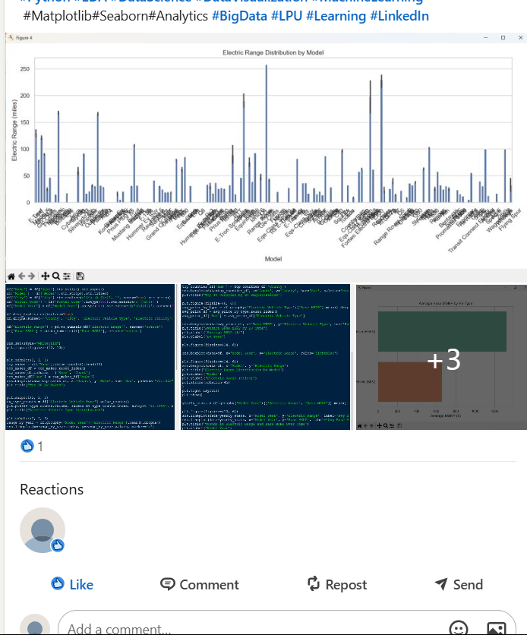

Linked in : <https://www.linkedin.com/in/ameg-dines/>

**9.Git hub Screenshots**

Git hub: <https://github.com/AmegDines/Project-python/blob/main/Project.py>