PROPOSAL FOR ELECTRONIC INVOICING CONVERSION
Great Slate, Inc., Castleton, Vermont

TO: President; Vice President/CFO; Vice President/COO
FROM: Amel Osman, Office Manager
DATE: April 14, 2026
SUBJECT: Electronic Invoicing Conversion: Stage 1 Approval Requested

Over the past several weeks, I have observed that a significant portion of accounting staff time is spent managing printing delays rather than core financial responsibilities. The department’s primary printer supports all invoicing tasks but experiences frequent jams, averaging twelve incidents per week and requiring approximately 180 minutes of staff time weekly to resolve. The combination of these printing inefficiencies, growing demand for electronic invoices, and ongoing mailing costs presents a clear opportunity to improve workflow and reduce costs. To address this, I propose a two-stage solution: leasing a modern all-in-one printer, copier, scanner, and fax machine while transitioning to electronic PDF invoicing, followed by upgrading the accounts receivable system to generate and deliver invoices automatically.

Background and Problem Situation

Printing Challenges
Great Slate’s invoicing process is constrained by an aging, inefficient printing system. The department relies on a single shared printer that produces documents at only 6 pages per minute and experiences an average of 12 jams per week. Each jam takes approximately 15 minutes to resolve, resulting in about 3 hours of lost productivity per week. This printer has become a critical bottleneck, contributing to workflow disruptions and increased stress, particularly following recent downsizing. Printer-related issues have also led to occasional tension among employees over responsibility for resolving problems.

Postage and Mailing Costs
The current process requires invoices to be physically printed before they are recorded in accounts receivable, resulting in ongoing mailing and postage costs. Each month, approximately 1,000 invoices are mailed at a combined cost of $600, or $7,200 annually. Although each invoice takes only about 6 seconds to prepare, the total adds up to nearly 100 minutes per month. This is a recurring expense that consumes staff time on routine tasks reducible through more efficient processes.

PDF Scanning Inefficiencies
In addition to printing and mailing challenges, the process for generating PDF invoices is inefficient and time-consuming. The company relies on a 20-year-old flatbed scanner that scans one page at a time, requiring multi-page invoices to be scanned individually and manually compiled. This process takes approximately 10 minutes per invoice. As more customers request electronic invoices each month, this workflow increases the burden on staff without improving efficiency. Together, these printing, mailing, and scanning challenges reduce productivity and create unnecessary operational strain.

Proposed Solution

Stage 1: Equipment Lease and Customer Conversion
The most immediate and practical step is to lease a modern, high-speed all-in-one printer, copier, scanner, and fax machine while beginning the transition to electronic PDF invoicing. This approach directly addresses current printing delays and scanning inefficiencies while creating an opportunity to reduce mailing costs. Each customer who transitions to PDF invoicing saves $0.60 per invoice and eliminates the time associated with printing, handling, and mailing physical documents.

After reviewing available business-grade equipment, I recommend leasing the Brother MFC-L5915DW Business Monochrome Laser All-in-One Printer. This machine is well suited for a high-volume office environment and resolves the limitations of the current system. It offers print speeds of up to 50 pages per minute—significantly faster than the existing printer. It also supports duplex scanning via a 70-sheet automatic document feeder, allowing multi-page invoices to be processed in a single pass. In addition, it provides direct scan-to-PDF and email functionality, eliminating the need for manual file compilation.

The lease cost is $150 per month for a six-month term and includes a comprehensive maintenance package, which helps ensure reliable performance and minimizes downtime. At the same time, customer outreach can begin to offer PDF invoicing as an option. Based on available data, approximately 20 percent of customers are expected to convert within the first month, 40 percent within two months, and up to 80 percent within three months. This phased approach allows for a gradual transition while continuing to meet the needs of customers who require printed invoices.

Stage 2: Accounting System Upgrade
While Stage 1 provides immediate operational and financial improvement, it does not fully resolve the underlying limitation of the current billing system. At present, invoices must be printed before they are recorded in accounts receivable, with no option for direct digital output. A longer-term solution would involve upgrading or modifying the accounts receivable system so that invoices can be generated as PDF files and delivered automatically to customers. This transition will require planning, coordination, and testing, and will involve executive leadership, the accounting department, and the software vendor. Progress made during Stage 1; establishing customer preferences and familiarity with electronic invoicing, will support a smoother, more effective long-term implementation.

Financial Benefits

Six-Month Cost Comparison
The table and Figure 1 compare the cost of maintaining the current invoicing process with implementing the proposed plan over a six-month period. Under the current process, Great Slate incurs a consistent monthly cost of $600 for envelopes and postage, resulting in a total of $3,600 over six months.

Table 1: Current Process vs. Proposed Plan (Monthly Cost = $600)
(Envelopes $50 + Postage $550)
Month | % on PDF | Postage + Envelopes | Lease Cost | Plan Total | Current | Savings
Month 1 | 0% | $600 | $150 | $750 | $600 | (-$150)
Month 2 | 20% | $480 | $150 | $630 | $600 | (-$30)
Month 3 | 40% | $360 | $150 | $510 | $600 | $90
Month 4 | 80% | $120 | $150 | $270 | $600 | $330
Month 5 | 80% | $120 | $150 | $270 | $600 | $330
Month 6 | 80% | $120 | $150 | $270 | $600 | $330
6-Month Total |  | $1,800 | $900 | $2,700 | $3,600 | $900

Under the proposed plan, the company incurs a monthly lease cost of $150 in addition to postage costs, which decrease gradually as customers transition to PDF invoicing. No savings are realized in Month 1, as customer conversion begins after implementation. Starting in Month 2, mailing costs decline based on expected adoption rates of 20 percent, 40 percent, and 80 percent. Each converted invoice saves $0.60, covering both postage and envelope costs.

Although the plan results in slightly higher costs during the first two months, it begins generating savings by Month 3 and produces substantial reductions by Month 4 as adoption increases. Over the full six-month period, the total cost of the proposed plan is $2,700 compared to $3,600 under the current process, resulting in net savings of $900. The initial added cost is temporary; the plan becomes cost-effective within three months. Beyond direct savings, the company will also benefit from reduced labor costs as electronic invoicing adoption grows.

Figure 1 — Six-Month Cost Comparison
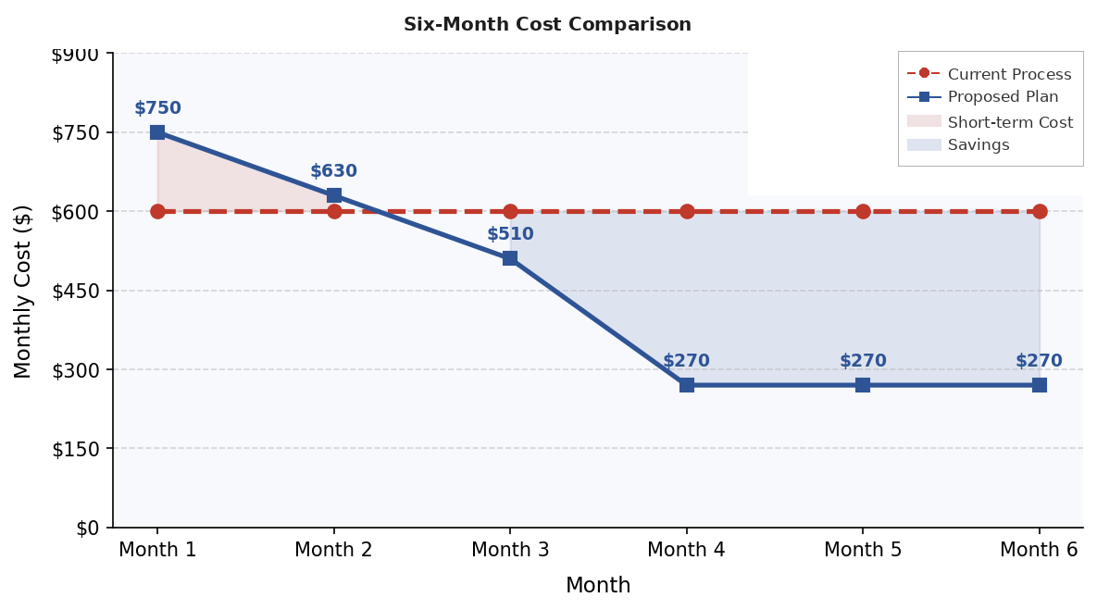

Operational and Other Benefits

The proposed plan improves efficiency, reduces manual work, and strengthens workflow within the accounting department.

Efficiency and Productivity
Currently, one employee handles printing, scanning, and mailing tasks that consume significant time. Reducing printed volume and introducing a high-performance machine streamlines or eliminates many of these steps, freeing staff to focus on higher-value accounting work.

Employee Morale
Frequent printer issues have contributed to frustration and occasional conflict. Reliable, modern equipment reduces disruptions and supports a smoother workflow. Employees can complete tasks more efficiently in a less stressful environment, improving morale and collaboration.

Accuracy and Risk Reduction
Automated scanning and reduced manual handling lower the risk of misplaced documents and processing errors. Standardized digital workflows improve consistency and record management.

Customer Experience
Electronic invoicing enables faster delivery, easier record-keeping, and quicker sharing with accounts payable teams. These improvements enhance convenience and present Great Slate as a more efficient and modern partner.

Timeline and Employees Involved

Stage 1: Implementation and Customer Conversion (Months 1 to 6)
Stage 1 will be led by the office manager, who will coordinate the equipment lease, oversee installation, and manage customer outreach to convert accounts to PDF invoicing. The billing employee will support day-to-day use of the new machine and handle invoicing requests. The VP/CFO will approve the lease and support the accounting department during implementation. The rollout will occur over six months, with customer outreach concentrated in the first three months and aligned to the expected 20, 40, and 80 percent conversion schedule. The existing printer will remain available during the transition for customers who require paper invoices.

Stage 2: Accounting System Upgrade (Planning and Long-Term Implementation)
Stage 2 will involve upgrading or modifying the accounts receivable system to generate and deliver invoices electronically. This phase will be led by executive leadership, including the VP/CFO and VP/COO, in coordination with the accounting department and the software vendor. It will require planning, development, and testing before full implementation. While the office manager will not be directly involved, planning should begin during the later months of Stage 1 to support a longer-term implementation timeline.

Evidence of Ability to Deliver
The data and projections in this proposal are based on six weeks of direct observation, internal records review, and manufacturer specifications. Mailing cost figures have been verified using company data, and workflow estimates reflect observed printing, scanning, and processing times. These observations align with the documented printer inefficiencies, manual scanning process, and mailing workload. Customer conversion projections are based on data from comparable organizations that have implemented similar transitions to electronic invoicing.

The recommended machine was selected based on its performance capabilities, reliability, and alignment with the company’s operational needs. It is widely available, supported by an established service network, and includes a comprehensive maintenance package under the proposed lease agreement. This ensures consistent performance and minimizes downtime throughout the implementation period.

Great Slate has a clear opportunity to address workflow inefficiencies and reduce operational costs. The current invoicing process, which relies on a slow, jam-prone printer and manual processing, results in lost productivity and approximately $7,200 in annual mailing expenses. The proposed plan offers a practical, low-risk solution that improves efficiency and generates an estimated $900 in savings within the first six months.

I respectfully recommend that the president and vice presidents approve Stage 1 and move forward with implementation. This approach offers an immediate, low-risk opportunity to improve operations, reduce costs, and support a more efficient work environment for staff. I am prepared to begin upon approval and welcome any questions or further discussion.

