ASSIGNMENT 6

Amelia Farrell

October 18th 2021

Making predictions in earning potential

We will first Fit a linear model using the age variable as the predictor and earn as the outcome.

age_lm <- lm(earn ~ age, data = heights_df)

Viewing the summary of your model

##   
## Call:  
## lm(formula = earn ~ age, data = heights_df)  
##   
## Residuals:  
## Min 1Q Median 3Q Max   
## -25098 -12622 -3667 6883 177579   
##   
## Coefficients:  
## Estimate Std. Error t value Pr(>|t|)   
## (Intercept) 19041.53 1571.26 12.119 < 2e-16 ***  
## age 99.41 35.46 2.804 0.00514 **   
## ---  
## Signif. codes: 0 '***' 0.001 '**' 0.01 '*' 0.05 '.' 0.1 ' ' 1  
##   
## Residual standard error: 19420 on 1190 degrees of freedom  
## Multiple R-squared: 0.006561, Adjusted R-squared: 0.005727   
## F-statistic: 7.86 on 1 and 1190 DF, p-value: 0.005137

Now we can create predictions whith our model using the predict() function. The neww data frame (“age_predict_df”) will have the same age values, but it will have the predicted earning values, using the original age data to make the predictions. The predictions are being put into the new data frame (age_predict_df).

age_predict_df <- data.frame(earn = predict(age_lm, heights_df), age=heights_df$age)

Lets plot the predictions against the original data below. 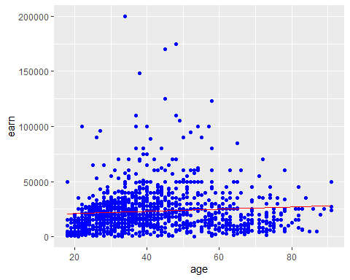

Corrected Sum of Squares Total

mean_earn <- mean(heights_df$earn)  
sst <- sum((mean_earn - heights_df$earn)^2)  
mean_earn

## [1] 23154.77

sst

## [1] 451591883937

## Corrected Sum of Squares for Model

ssm <- sum((mean_earn - age_predict_df$earn)^2)  
ssm

## [1] 2963111900

Residuals

residuals <- heights_df$earn - age_predict_df$earn

Sum of Squares for Error

sse <- sum(residuals^2)

R Squared R^2 = SSM/SST

r_squared <- ssm/sst  
r_squared

## [1] 0.006561482

Number of observations

n <- nrow(heights_df)  
n

## [1] 1192

Number of regression parameters

p <- 2  
p

## [1] 2

Corrected Degrees of Freedom for Model (p-1)

dfm <- p-1  
dfm

## [1] 1

Degrees of Freedom for Error (n-p)

dfe <- n-p  
dfe

## [1] 1190

Corrected Degrees of Freedom Total: DFT = n - 1

dft <- n-1  
dft

## [1] 1191

Mean of Squares for Model: MSM = SSM / DFM

msm <- ssm/dfm  
msm

## [1] 2963111900

Mean of Squares for Error: MSE = SSE / DFE

mse <- sse/dfe  
mse

## [1] 376998968

Mean of Squares Total: MST = SST / DFT

mst <- sst/dft  
mst

## [1] 379170348

F Statistic F = MSM/MSE

f_score <- msm/mse  
f_score

## [1] 7.859735

Adjusted R Squared R2 = 1 - (1 - R2)(n - 1) / (n - p)

adjusted_r_squared <- 1 - (1 - r_squared)*(n - 1) / (n - p)  
adjusted_r_squared

## [1] 0.005726659

Calculate the p-value from the F distribution

p_value <- pf(f_score, dfm, dft, lower.tail=F)  
p_value

## [1] 0.005136826

## References

Field, A., J. Miles, and Z. Field. 2012. Discovering Statistics Using R. SAGE Publications. <https://books.google.com/books?id=wd2K2zC3swIC>.

Lander, J. P. 2014. R for Everyone: Advanced Analytics and Graphics. Addison-Wesley Data and Analytics Series. Addison-Wesley. <https://books.google.com/books?id=3eBVAgAAQBAJ>.