**ANNEX B**

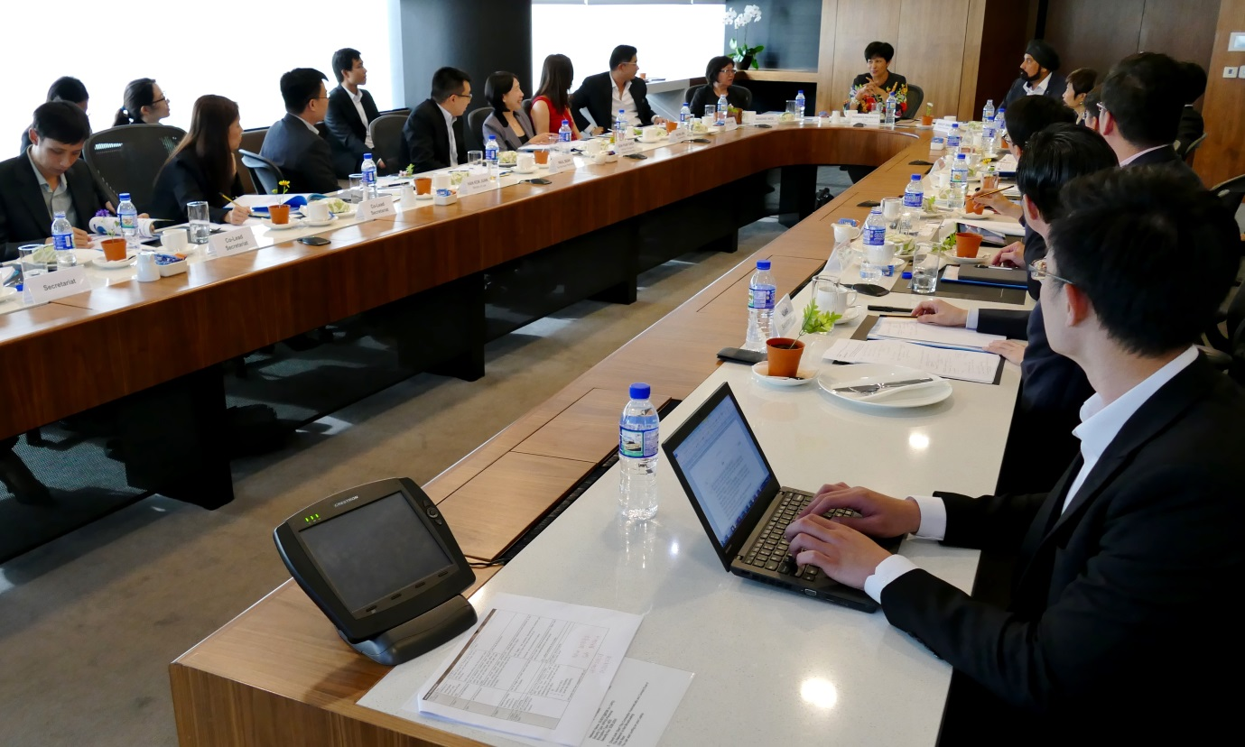

Caption: The Committee on the Future Economy’s Working Group on Legal and Accounting Services, co-chaired by Ms Indranee Rajah, Senior Minister of State, Ministry of Law and Ministry of Finance, and Mr Chaly Mah, Chairman of Deloitte and Chief Executive Officer of Deloitte Southeast Asia, held its first meeting on Thursday, 18 February 2016.

