NAME: {{ name }}
DATE: {{ date }}
Component | Details
Patient complaint | {{ complaint }}
Pain scale | {{ pain_scale }}
Observation/Palpation | {{ observation }}
ROM | {{ rom }}
MMT | {{ mmt }}
Others | {{ others }}
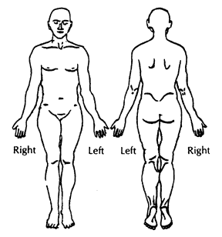

Intervention | {{ intervention }}
Evaluation | {{ evaluation }}
Review | {{ review }}
Attending therapist | {{ therapist }}

