

PUSAT SUKAN & REKREASI, UNIVERSITI SAINS MALAYSIA, 11800 GELUGOR, PULAU PINANG
SPORT INJURIES ASSESSMENT FORM

NAME: {{ name }}  MATRIX/STAFF NUM: {{ id_num }}  AGE: {{ age }}  GENDER: {{ gender }}  DATE OF ASSESSMENT: {{ date }}  DOCTOR DIAGNOSIS: {{ diagnosis }}  IN-CHARGE PHYSIOTHERAPIST: {{ therapist }} | 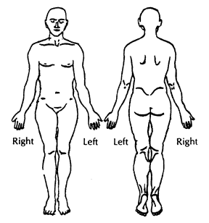
PRESENTING PROBLEM/PT. COMPLAINT
{{ complaint }}
PAIN SCALE: {{ pain_scale }}  Area – {{ area }}  Nature - {{ nature }}  Aggravating Factor – {{ aggravating }}  Easing Factor: {{ easing }}  24 Hours: {{ twenty_four_hours }}  Irritability: {{ irritability }} | CURRENT / PAST HISTORY (relating to current problem)  {{ history }}
SPECIAL QUESTION  General Health: {{ gen_health }}  Past Medical History/Surgery: {{ pmh_surgery }}  MRI/X-Ray: {{ radiology }}  Medication/Steroid: {{ medication }}  Occupation: {{ occupation }}  Social History: {{ social_hx }} | OBSERVATION  {{ observation }}
PALPATION
{{ palpation }}

EXAMINATION
ROM  {{ rom }} | Muscle Power  {{ muscle_power }}
Joint Circumference  {{ joint_circ }} | Special Test  {{ special_test }}

PLAN OF TREATMENT
Pain Management  {{ pain_mgmt }} | Exercise Therapy  {{ exercise_rx }}

