**or create a new repository on the command line**

echo "# DatingApp_ByBiniyam" >> README.md

git init

git add README.md

git commit -m "first commit"

git branch -M main

git remote add origin https://github.com/Amenbiniyam/DatingApp_ByBiniyam.git

git push -u origin main

**Angular 12 Note on Training**

**Section 4: Authentication Basics**

* **How to store pass in DB**
* **Using inheritance in C# DRY**
* **Using the C# debugger**
* **Using data transfer objects (DTOs)**
* **Validation**
* **JSON Web tokens (JWTs)**
* **Using services in C#**
* **Middleware**
* **Extension method DRY**

**Requirements**

**How to store pass in DB**

**We have to Hashing and Salting password method to store in db**

**JWT (JSON Web Token)**

**Format**

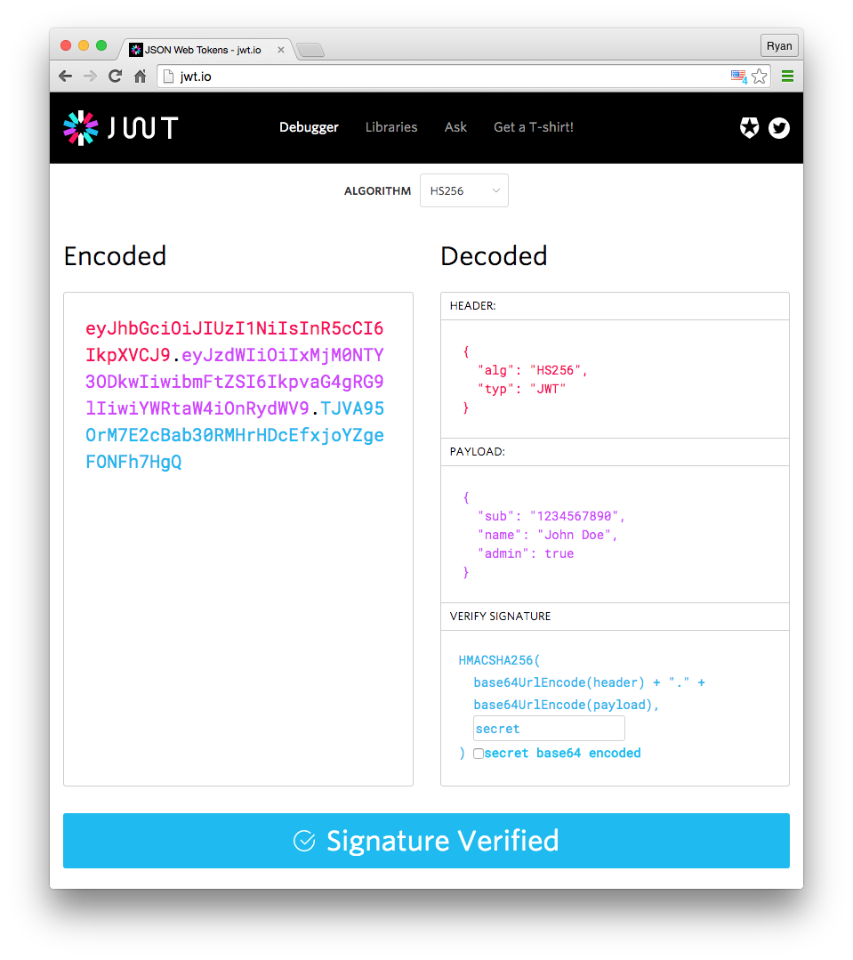

**Token Authentication**

**Client ---------send username & pass--------------------------------🡪 Server**

**< -------------validate credin and return JWT----------------------**

* **Client store JWT in web browser**
* **And in every request jwt also sent to server**
* **Server validate user without checking the database with that jwt**

**Advantage of JWT -----**

* **no session is require**
* **single token can be using with multiple backends**
* **mobile friendly**
* **performance**
* **no cookies require**

**Section 5**

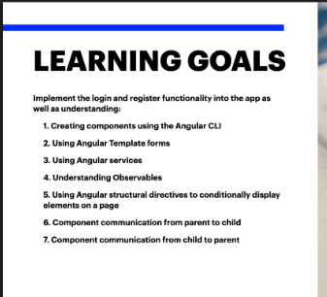

* **Creating Component of CLI**

**Component creating without test file**

**#ng g c nav – skip-tests**

* **Angular provide two way binding that means binding data or properties on our component and display on our template that is called Two way Data Bindng**

**To make a form an Angular form** <form #loginForm="ngForm" class="d-flex" (ngSubmit)="login()" autocomplete="off">

* **To create services #ng g s account --skip-tests**

**Observable**

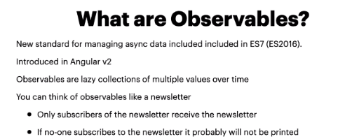

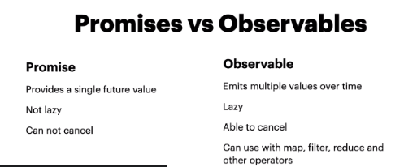

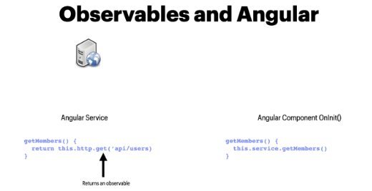

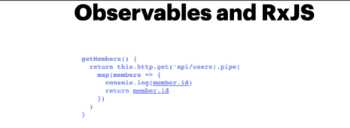

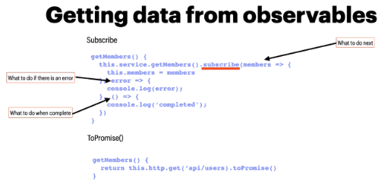

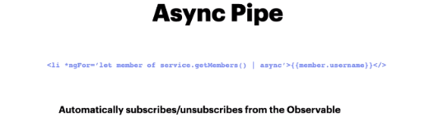

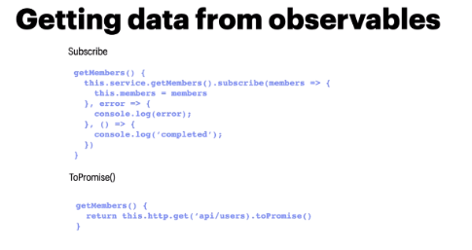

**Parent to Child and Child to parent Communication**

 <app-register [usersFromHomeComponent]="users"  (cancelRegister)="cancelRegisterMode($event)" ></app-register>

[usersFromHomeComponent]="users --- parent to child

(cancelRegister)="cancelRegisterMode($event)" ---- child to parent

**Section 6**

**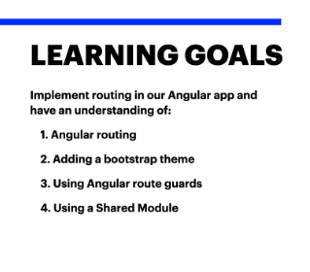  
1. Adding Angular Routings**

**2. Adding links to nav bar link based on the routing we have given**

**To make selected link active in nav bar use** routerLinkActive="active"

**Routing or redirecting in component level use this code**       this.router.navigateByUrl('/members');