Students’ Dropout Analysis and Early Prediction
By Amer Zakaria (amer_154532)
Project Steps:
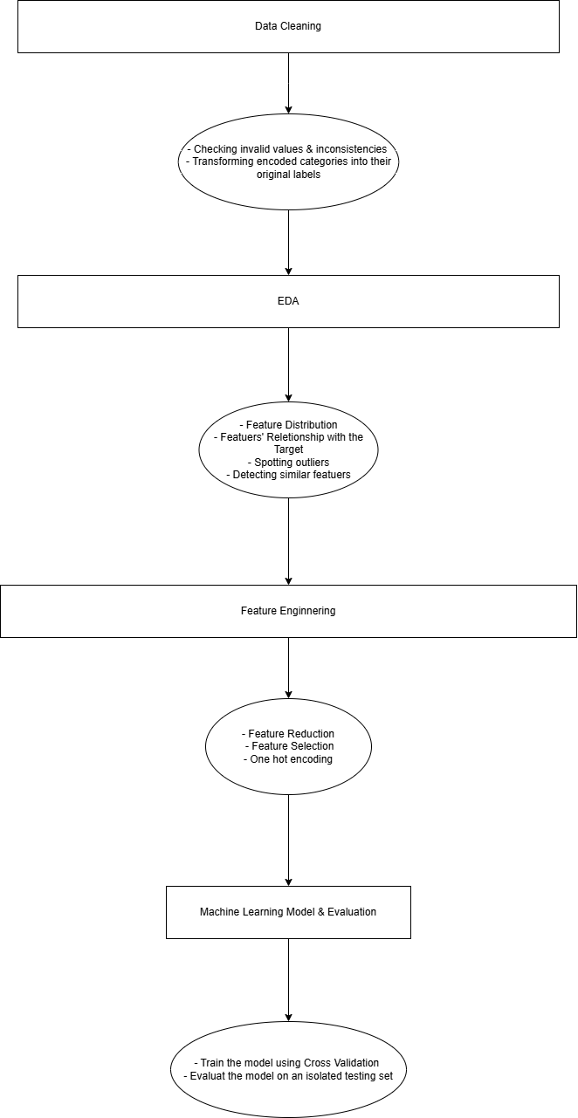

Intro
This project aims to understand and analyze students’ personal data that has been collected about them at the time of their enrollment in various courses in a Portuguese University, as well as their first and second semester information, which is present in the dataset.
Additionally, since the dataset also contains a student status (graduate, enrolled, and dropout) at the end of the normal duration of the course, enrolled means still studying at that time, so we could make a predictive model that predicts whether a student is going to drop out or not while he/she is still an undergraduate.

Dataset Features
With a description for vague ones based on my understanding

Features captured at the time of the student's enrollment in the course
- Marital status
- Application mode
How the student entered the course (e.g., transferred from another course).
- Application order
The position of the course in the student’s preference list.
- Course
The course in which the student is enrolled.
- Daytime/evening attendance
Indicates whether the course takes place during the day or evening.
- Previous qualification
The highest qualification obtained before enrollment.
- Previous qualification (grade)
- Nationality
- Mother's qualification
- Father's qualification
- Mother's occupation
- Father's occupation
- Admission grade
A composite score reflecting entry performance (e.g., prior grades and entrance exams).
- Displaced
- Educational special needs
- Debtor
Indicates whether the student owes money to the university.
- Tuition fees up to date
Indicates whether tuition fees have been paid.
- Gender
- Scholarship holder
- Age at enrollment
- International
Indicates whether the student is an international student.
- Unemployment rate
- Inflation rate
- GDP

Features that hold information about the 1st and 2nd semesters
- Curricular units 1st sem (credited)
- Curricular units 1st sem (enrolled)
- Curricular units 1st sem (evaluations)
- Curricular units 1st sem (approved)
- Curricular units 1st sem (grade)
- Curricular units 1st sem (without evaluations)
- Curricular units 2nd sem (credited)
- Curricular units 2nd sem (enrolled)
- Curricular units 2nd sem (evaluations)
- Curricular units 2nd sem (approved)
- Curricular units 2nd sem (grade)
- Curricular units 2nd sem (without evaluations)

Data Cleaning & Preprocessing
The data is already cleaned, as the dataset source website explicitly states: "We performed a rigorous data preprocessing to handle data from anomalies, unexplainable outliers, and missing values." ~Dataset Website
But I’ve done some verification
- Check null values & empty values
- Check duplicates
- Check that there are no rows that contain a student who is both Portuguese and international at the same time (the university is in Portugal).
The interesting thing that I’ve done is that I converted the encoded categories into their true labels (e.g. “Portuguese” instead of 1), which would make plots and visualization meaningful, easier to scan, and enable me to perform one-hot encoding in feature engineering with the column names reflecting the real labels (e.g. Martial status_single… 0 or 1).
I’ve done it with the help of the mapping files in data/processed/encoded_columns_description_tables
and the result is stored in data/processed/2_cleaned.csv

Exploratory Data Analysis (EDA)
All of the output of this section can be generated by running src/main.py and the result can be found in the outputs/ folder in the root directory

Statistics
- Numerical features statistics:
 | mean | std | min | max
Age at enrollment | 23.22 | 7.58 | 17 | 70
Application order | 1.72 | 1.31 | 0 | 9
Previous qualification (grade) | 132.61 | 13.18 | 95 | 190
Admission grade | 126.97 | 14.48 | 95 | 190
Inflation rate | 1.22 | 1.38 | -0.8 | 3.7
Unemployment rate | 11.56 | 2.66 | 7.6 | 16.2
GDP | 0.001 | 2.26 | -4.06 | 3.51
Curricular units 1st sem (credited) | 0.70 | 2.36 | 0 | 20
Curricular units 1st sem (enrolled) | 6.27 | 2.48 | 0 | 26
Curricular units 1st sem (evaluations) | 8.29 | 4.17 | 0 | 45
Curricular units 1st sem (approved) | 4.70 | 3.09 | 0 | 26
Curricular units 1st sem (grade) | 10.64 | 4.84 | 0 | 18.875
Curricular units 1st sem (without evaluations) | 0.13 | 0.69 | 0 | 12
Curricular units 2nd sem (credited) | 0.54 | 1.91 | 0 | 19
Curricular units 2nd sem (enrolled) | 6.23 | 2.19 | 0 | 23
Curricular units 2nd sem (evaluations) | 8.06 | 3.94 | 0 | 33
Curricular units 2nd sem (approved) | 4.43 | 3.01 | 0 | 20
Curricular units 2nd sem (grade) | 10.23 | 5.21 | 0 | 18.57
Curricular units 2nd sem (without evaluations) | 0.15 | 0.75 | 0 | 12
Distributions:
The whole list of distributions for all of the features can be found at `outputs/figures/feature_distribution`
- Distribution of the Target:
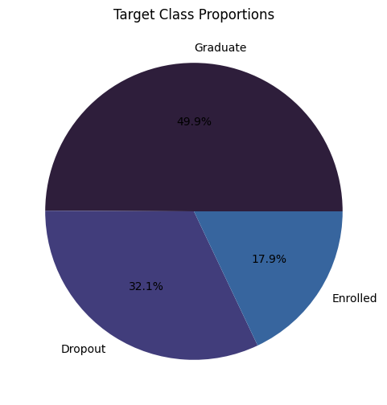
The distribution of the student status (the target) at the end of the normal duration of the enrolled course

- Categorical features distributions:
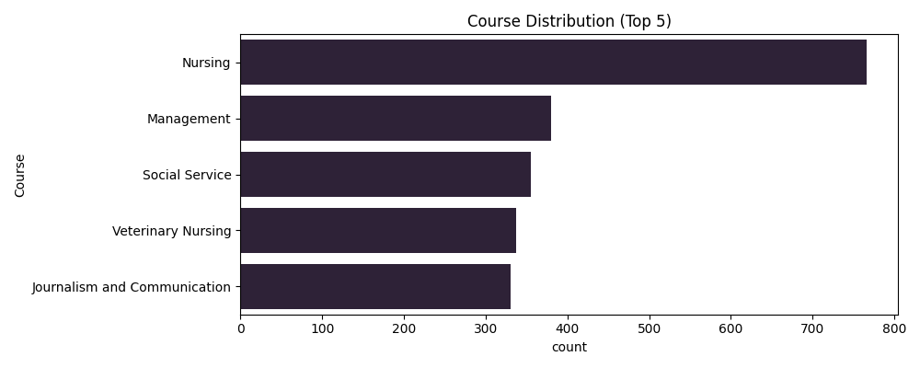
  - 700+ students enrolled in the Nursing course
  - ~350 students enrolled in Management
- Numerical features distributions:
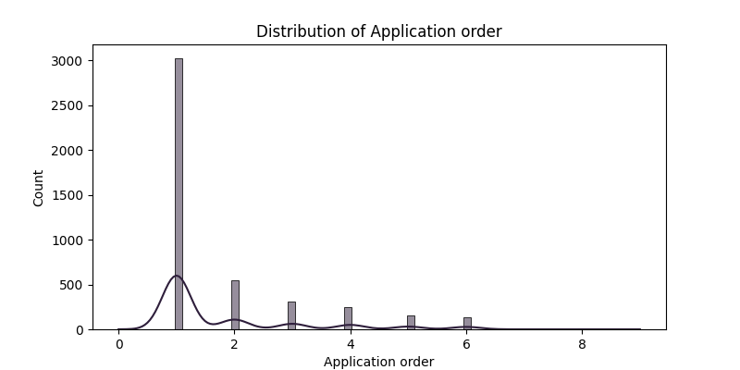
  - approximately 3,000 out of 4424 students had put the course that they have been accepted into at the very top in their list of preferences
  - No student has put the course they have been accepted into as the 7th one in their preference list
  - The line shows the trend over the Application order for all of the students

Analysis
It’s mainly built to support the “Feature Engineering” phase in the project (feature selection, feature reduction, and outlier detection)
- Categorical features' relationship with the dropped_out feature:
  - Dropped out feature for a student (is either 0 didn’t drop out or 1 dropped out) at the end of the normal duration of the course
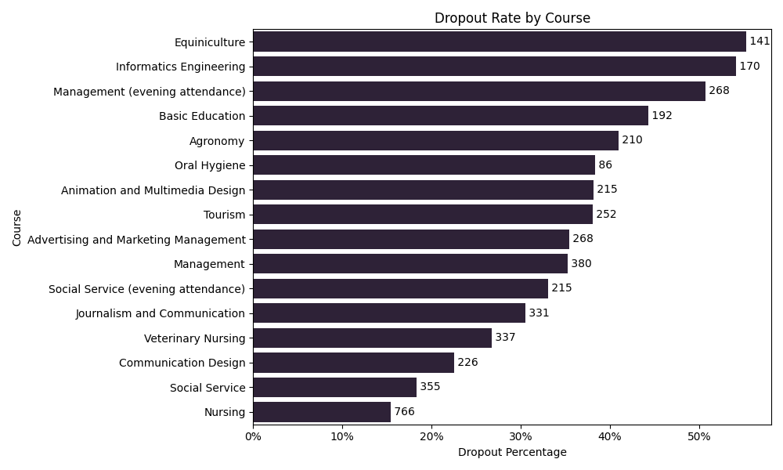
  - Only 15% of students who have enrolled in the Nursing course dropped out (and in general, 766 students have enrolled in nursing)
- Numerical features’ relationship with success
  - Success is an ordinal categorical feature (success (0 = dropout, 1 = enrolled, 2 = graduate)
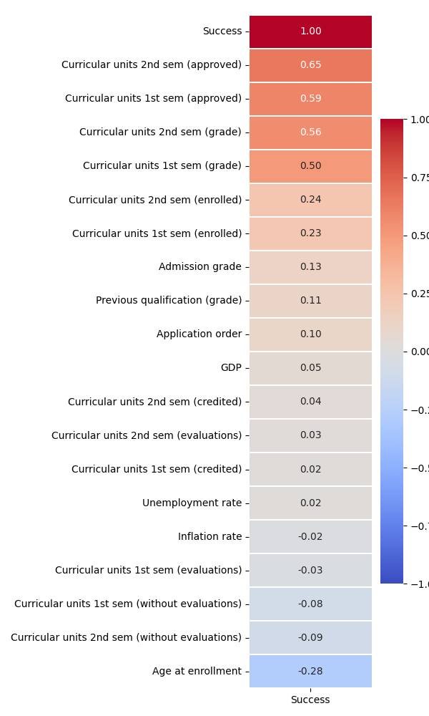
- Outliers:
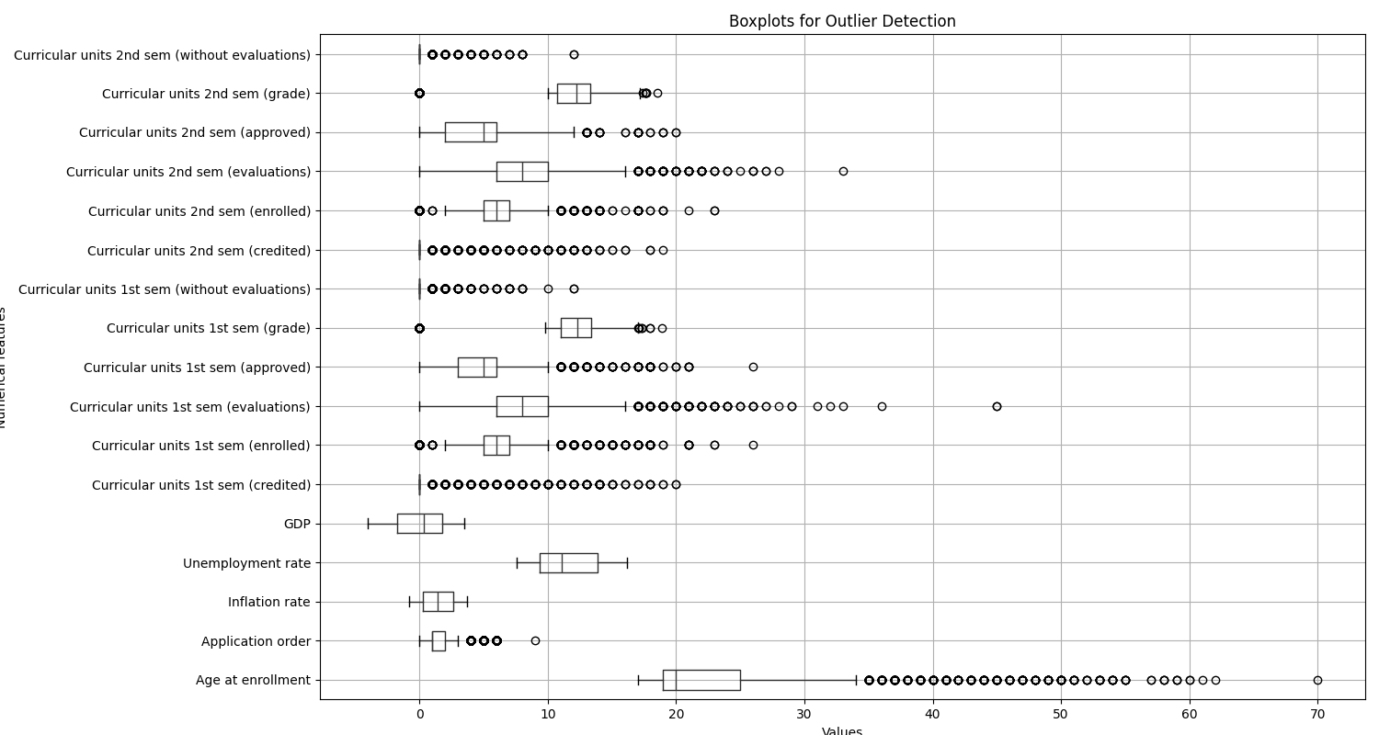
This shows that value points that are outside the box and the line are data points that could be outliers or illogical.
I can observe that there’s a student who has enrolled at the age of 70!
Since the data has already been preprocessed from the source, I can see nothing else suspicious.
- Semester 1 & 2 correlation:
Feature | Spearman Correlation (1st vs 2nd)
(credited) | 0.91
(enrolled) | 0.96
(evaluations) | 0.69
(approved) | 0.89
(grade) | 0.76
(without evaluations) | 0.38
Most of the semester 1 and 2 corresponding features are highly correlated.

Feature Engineering
This step prepares the dataset features used to predict students’ dropout potential
It contains:
- Feature Reduction: Averaging the semesters 1 & 2 corresponding features as they are highly correlated:
- Feature Selection: Drop numerical & categorical features that have a weak effect on the prediction of dropout, which have been noticed at the analysis phase
Example:
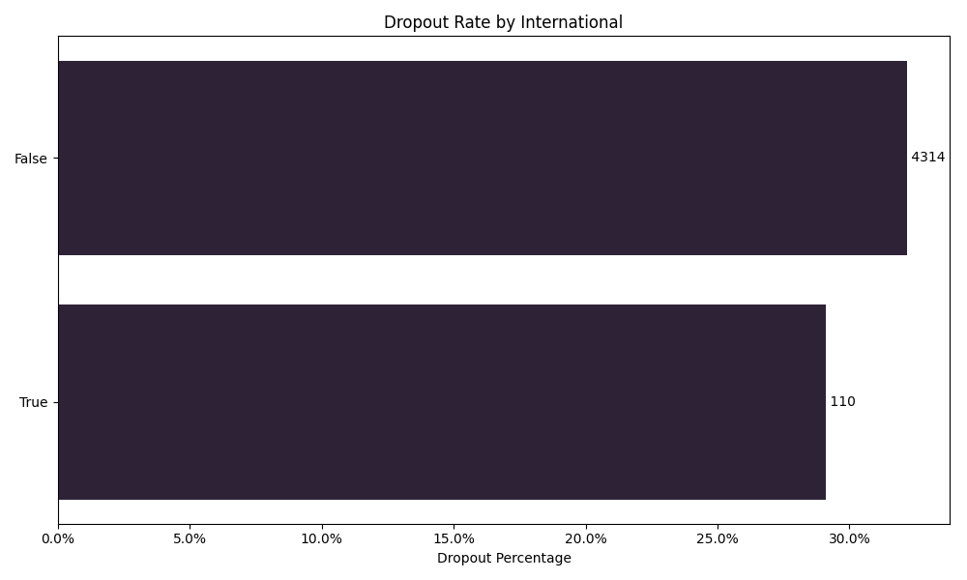
The “Internation” feature won’t help the model predict dropout potential because there is no variation for the different categories (True and False)
Whereas for scholarship: 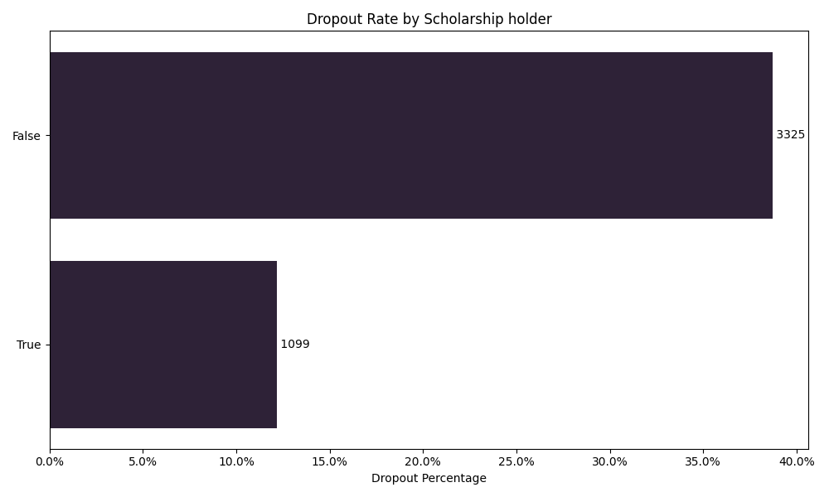
There is approximately 25% difference in dropout rates for students who are enrolled in a scholarship program and those who are not, which means this feature is highly valuable for the model to predict the dropout potential
- One-hot-encoding:
I performed one-hot encoding for non-ordinal categorical features to avoid false ordinal relationships with the target.
But for each feature, I am ignoring categories with less than 15 occurrences (where I am setting all of the one-hot encoded columns to 0)\
The result of which can be found at `data/processed/3_preprocessed.csv` from the root directory

Machine Learning Model
I’ve used the Decision Tree and Logistic Regression models to predict the dropout binary (0 didn’t drop out, and 1 dropped out)
Kept aside a testing set which consists of 15% of the dataset without training anything on it, so that I can ultimately evaluate the model's accuracy based on it
On the remaining 85% of data, I used 5-fold crossover, which trained and validated the dataset across 5 different splits, which allowed me to avoid overfitting and ensured that model performance is evaluated on all parts of the training data.
The output result of the modelling is as follows:

Decision Tree Cross-Validation Scores (5 folds):
['0.77', '0.79', '0.79', '0.79', '0.80']
Mean CV Score: 0.79
Decision Tree accuracy score: 0.77
Logistic Regression Cross-Validation Scores (5 folds):
['0.85', '0.85', '0.86', '0.85', '0.85']
Mean CV Score: 0.85
Logistic Regression accuracy score: 0.84

Interpretation:
Both models had consistent cross-validation results across all of the splits.
As for the testing set evaluation, Logistic Regression has been more effective at predicting the dropout potential of the students using the accuracy score evaluation method (which takes the correct predictions and divides them by the total predictions made).
We can say that 84% of the time, the Logistic Regression model could predict whether a student would drop out or not at the end of the normal duration of the course he/she has enrolled in.

