Kingdom of Saudi Arabia 
Ministry of Education
Gulf Colleges
Department of Information Technology

An AI Platform for Analysing Customer Sentiment and Food Preference Behaviour in Saudi Restaurants
Saudi Restaurant Sentiment & Food Preference Analytics Platform
Submitted by
Name: [Student name] ID: [Student ID]
Graduation Project
Supervisor: Dr. Baha Eldin Hamouda
November 2026

Abstract
Restaurants in Saudi Arabia receive thousands of online reviews on platforms such as Google Maps, most of them written in Saudi and Gulf dialects. These reviews contain valuable feedback about food, prices, portion sizes, service, delivery, cleanliness and atmosphere, but they are too numerous and too informal to be read and summarised by hand. This project designs, implements and evaluates a local, Arabic, right-to-left web platform that applies artificial intelligence to restaurant reviews in order to measure customer sentiment, identify the aspects customers praise or criticise, and extract the dishes they mention.
The core of the platform is an interpretable, lexicon- and rule-based aspect-based sentiment analyser built for Modern Standard Arabic and Saudi dialect. It handles negation (for example ‎"مو حلو"‎ and ‎"ماعجبني"‎), intensifiers, contrast clauses introduced by ‎"بس"‎ and ‎"لكن"‎, implicit aspects and aspect-dependent words, and it reports a confidence score together with flags for mixed and uncertain results. A dictionary-based extractor recognises 57 Saudi and international dishes and 154 spelling variants without ever inventing a dish that is not mentioned. A TF-IDF and logistic-regression model built with scikit-learn serves as a machine-learning baseline. The platform stores data in SQLite, presents interactive dashboards built with Streamlit and Plotly, and exports reports to Excel and Arabic PDF.
The system was developed and evaluated on AQTE, a public dataset of 14,783 real Google Maps reviews of 774 restaurants across Saudi Arabia, annotated with 63,620 aspect-sentiment-quote triplets. The lexicon was improved over four versions using a development sample of 2,000 reviews drawn only from the training split; aspect-detection F1 on this sample rose from 0.775 to 0.814, and the sentiment of correctly detected aspects was right in about 90% of cases. On the held-out test split of 1,908 reviews, the final lexicon-based analyser achieved 0.819 accuracy and 0.595 macro-F1 for overall sentiment against a majority-class baseline of 0.272, and an aspect-detection F1 of 0.827 with 90.3% aspect-sentiment accuracy, closely matching the development results. The scikit-learn baseline achieved a higher 0.684 macro-F1 for overall sentiment but provides neither aspect-level results nor explanations, so the two approaches are complementary. The neutral class and the rarely mentioned delivery and quantity aspects remain the main weaknesses.
The results show that a transparent, dialect-aware lexicon approach can give restaurant owners and researchers reliable, explainable insight into customer opinion without paid cloud services, while the evaluation framework provides a reproducible basis for comparing future models.
Keywords: sentiment analysis; aspect-based sentiment analysis; Arabic natural language processing; Saudi dialect; restaurant reviews; lexicon-based methods; Streamlit.

Acknowledgments
First and foremost, I thank Allah for giving me the strength, patience and knowledge to complete this project.
I would like to express my sincere gratitude to my supervisor, Dr. Baha Eldin Hamouda, for his guidance, encouragement and valuable feedback throughout every stage of this work. His comments on the research questions and the evaluation design helped shape the project into its final form.
I am also grateful to the faculty and staff of the Department of Information Technology at Gulf Colleges for the knowledge and support they provided during my years of study.
I thank the authors of the AQTE dataset for making their annotated collection of Saudi restaurant reviews publicly available, and the open-source community behind Python, scikit-learn, Streamlit and the other tools used in this project.
Finally, I owe special thanks to my family for their continuous support, patience and encouragement.
Table of Contents

List of Figures

List of Tables

Chapter 1: Introduction

1.1 Introduction
Eating out is a central part of social life in Saudi Arabia. Families, friends and colleagues gather in restaurants and cafés, and food delivery applications have made restaurant meals part of everyday routine. Before choosing where to eat, many customers now read what others have written online, and after their visit many of them leave a review of their own. Google Maps, delivery applications and social media have therefore become a large and continuously growing record of what customers think about the food, prices, service and atmosphere of restaurants across the Kingdom.
For a restaurant owner this record is extremely valuable: it shows which dishes customers love, which complaints keep recurring, and whether service is improving or getting worse. For a researcher it is a window onto consumer behaviour and food preferences. Yet the same record is very difficult to use. A popular restaurant can collect hundreds of reviews a month; most of them are short, informal and written in Saudi or Gulf dialect rather than Modern Standard Arabic; spelling varies from writer to writer; and a single review often praises one thing and criticises another in the same sentence, as in ‎"الكبسة لذيذة مرة بس الخدمة بطيئة"‎ (the kabsa is very tasty, but the service is slow).
Sentiment analysis, a branch of natural language processing (NLP), studies how to identify automatically the opinions expressed in text. Its most useful form for businesses is aspect-based sentiment analysis (ABSA), which does not stop at labelling a whole review as positive or negative but determines the sentiment expressed towards each aspect mentioned, such as food quality, price or service. Most mature ABSA tools, however, were built for English. Arabic, and Saudi dialect in particular, poses additional challenges: rich morphology, attached prefixes and suffixes, inconsistent spelling, dialect-specific vocabulary, and negation patterns such as ‎"مو"‎ and ‎"ما"‎ that general tools often miss.
This project responds to that gap by building and evaluating an AI platform that analyses Arabic restaurant reviews, measures overall sentiment, identifies the sentiment towards seven restaurant aspects, extracts the dishes customers mention, and turns the results into dashboards and reports that a non-technical restaurant owner or researcher can use directly.

1.2 Problem Statement
Saudi restaurants and researchers who study them face four related problems:
- Volume. The number of online reviews is too large to read manually, so most of the feedback customers provide is never used.
- Language. Reviews are written mostly in Saudi and Gulf dialect, with informal spelling, elongated letters (for example ‎"حلووو"‎) and emojis. General-purpose sentiment tools trained on English or on Modern Standard Arabic handle this language poorly.
- Granularity. A single overall score hides what matters. A review can be positive about the food and negative about the price at the same time; an owner needs to know which aspect drives satisfaction and which drives complaints.
- Trust. Many AI tools behave as black boxes and present uncertain results as certain. Business decisions and academic conclusions require results that can be explained, that show their uncertainty, and that are evaluated against real annotated data.
There is therefore a need for an accessible, Arabic-first system that analyses restaurant reviews at the aspect level, handles Saudi dialect, explains its decisions, reports its uncertainty honestly, and is evaluated rigorously on real Saudi data.

1.3 Objectives
The main objective of this project is to design, implement and evaluate an AI platform for analysing customer sentiment and food-preference indicators in Saudi restaurant reviews. The specific objectives are:
- To build an Arabic text-processing module that cleans and normalises reviews while preserving negation words, emojis and other signals that carry sentiment.
- To develop an aspect-based sentiment analyser for Modern Standard Arabic and Saudi dialect that classifies the overall sentiment of a review as positive, negative or neutral, detects mixed and uncertain cases, and assigns a sentiment to each of seven aspects: food quality and taste, price and value, quantity and portion size, service, delivery, cleanliness, and ambiance.
- To extract dish names from reviews using an editable dictionary of Saudi and international dishes, linking each dish to the sentiment expressed about it without inventing dishes that are not mentioned.
- To build a machine-learning baseline with scikit-learn and compare it with the lexicon-based analyser.
- To store reviews and results in a relational SQLite database with proper keys and integrity constraints.
- To provide an interactive Arabic right-to-left web interface for importing data, running analyses, comparing restaurants and exporting Excel and PDF reports.
- To evaluate the system on a real, publicly available dataset of annotated Saudi restaurant reviews using a held-out test set.
The evaluation is guided by three research questions:
Table 1.1: Research questions and how each one is answered
Research question | How it is answered
RQ1. How accurately can a lexicon- and rule-based analyser classify the sentiment of Saudi restaurant reviews, overall and per aspect? | Comparison with the AQTE annotations on the held-out test split: overall sentiment, aspect detection and aspect sentiment.
RQ2. Does a supervised machine-learning model (scikit-learn) outperform the lexicon-based analyser for overall sentiment? | Both models evaluated on the same test split with the same metrics.
RQ3. Which aspects and dishes are most associated with customer satisfaction and complaints? | Analysis of the full dataset with the platform: aspect frequencies, sentiment by aspect and by dish.

1.4 Significance of the Study
The project is significant for several groups:
- Restaurant owners and managers obtain a practical tool that turns hundreds of informal reviews into a clear picture of strengths and complaints, broken down by aspect and by dish, together with recommendations and exportable reports.
- Researchers in consumer behaviour and food studies obtain a reproducible way to measure preference indicators from text, with explicit warnings about what the data can and cannot show (for example, that frequent mention of a dish is not evidence of high sales).
- Arabic NLP benefits from a documented, dialect-aware lexicon and rule set for the restaurant domain, together with an evaluation that reports both strengths and weaknesses on real data.
- Students and practitioners can study an end-to-end, tested and open implementation that runs locally without paid services, which makes it suitable for teaching and for small businesses with limited budgets.

1.5 Scope of the Project
To keep the project achievable and its results meaningful, its scope was defined as follows:
Table 1.2: Project scope
In scope | Out of scope
Arabic restaurant reviews in Modern Standard Arabic and Saudi/Gulf dialect, with some common English words | Other languages and other business domains
Overall sentiment (positive, negative, neutral) with confidence, mixed and uncertain flags | Fine-grained emotions such as anger or joy
Seven restaurant aspects and dish extraction from a dictionary of 57 dishes | Automatic discovery of new aspect categories or new dishes
Importing CSV, Excel, JSON and Parquet files, and official APIs that the user is authorised to use | Web scraping or any collection that bypasses platform terms of service
Local deployment on a personal computer with SQLite | Cloud deployment, user accounts and multi-tenant access
Evaluation on the public AQTE dataset of Saudi restaurant reviews | Collection and manual annotation of a new large dataset
A scikit-learn baseline; optional support for pre-trained Transformer models | Fine-tuning of large language models, which requires GPU resources

1.6 Report Structure
The rest of this report is organised as follows. Chapter 2 reviews the literature on sentiment analysis, aspect-based sentiment analysis and Arabic sentiment analysis, and identifies the gap this project addresses. Chapter 3 describes the methodology: the development approach, the dataset and its annotations, text preprocessing, the lexicon-based analyser, dish extraction, the machine-learning baseline, the iterative development of the lexicon and the evaluation design. Chapter 4 presents the system analysis, feasibility study, design and implementation of the platform. Chapter 5 reports and discusses the results and evaluates the project against its objectives. Chapter 6 concludes the report and proposes future work. The references and appendices follow.

Chapter 2: Literature Review

2.1 Introduction
This chapter reviews recent research (2021 to 2026) that underpins the project. It begins with the main concepts and levels of sentiment analysis, then compares the families of approaches: lexicon-based methods, classical machine learning, pre-trained language models and large language models. It then focuses on aspect-based sentiment analysis, the task this project implements, before turning to the challenges and resources of Arabic and Saudi-dialect sentiment analysis, including recent work on Saudi restaurant reviews. The chapter closes with evaluation practices, a summary of the related work and the research gap that motivates the project.

2.2 Sentiment Analysis: Concepts and Levels
Sentiment analysis is the automatic extraction of the positive or negative orientation that a writer expresses towards an object, such as a product, a service or a person (Jurafsky & Martin, 2026). In practice most systems classify the polarity of a text as positive, negative or neutral, and many also identify the target of the opinion.
Research distinguishes three levels of analysis (Zhang et al., 2023):
- Document level assigns one polarity to a whole review. It assumes that the review expresses a single opinion about a single entity, which is rarely true of restaurant reviews.
- Sentence level assigns a polarity to each sentence. It is finer, but a sentence such as ‎"الأكل لذيذ بس غالي"‎ (the food is tasty but expensive) still contains two opinions about two different targets.
- Aspect level identifies each target (the aspect) and the sentiment expressed towards it. This is the level needed by restaurant owners, who want to know whether customers are unhappy with the food, the price or the service, not only whether a review is negative overall.
Reviews of services such as hotels and restaurants are among the most common applications of sentiment analysis, because they are plentiful, explicitly evaluative and organised around a small number of well-understood aspects (Zhang et al., 2023).

2.3 Approaches to Sentiment Analysis

2.3.1 Lexicon-Based Methods
Lexicon-based methods rely on a dictionary of words and phrases annotated with their polarity and, usually, a strength. The sentiment of a text is computed by combining the scores of the words it contains, with rules that modify those scores, for example for negation (Jurafsky & Martin, 2026). Their main strengths are interpretability, since every decision can be traced to specific words and rules, and independence from labelled training data. In a recent survey of Arabic sentiment analysis, Shi and Agrawal (2025) trace the field's move from lexicon-based methods towards deep learning, but note that sentiment lexicons remain valuable because they show how a classification was reached.
Their weaknesses are limited coverage of informal and domain-specific vocabulary, difficulty with context-dependent words (for example ‎"بارد"‎, cold, is negative for food but positive for a drink), and difficulty with sarcasm. These weaknesses are directly relevant to this project, because Saudi dialect contains many words that general lexicons do not cover.

2.3.2 Machine-Learning Methods
Supervised machine-learning methods learn a classifier from texts labelled with their sentiment. A standard and strong baseline represents each text with term frequency-inverse document frequency (TF-IDF) weights over words or n-grams and trains a linear classifier such as logistic regression (Jurafsky & Martin, 2026). Character n-grams are particularly useful for morphologically rich and noisy text, because they capture shared sub-word units even when spelling varies. Libraries such as scikit-learn provide tested implementations of these representations, classifiers and evaluation metrics (scikit-learn developers, 2026).
Machine-learning models adapt to the vocabulary of their training data and can capture patterns that are hard to write as rules. However, they require labelled data from the target domain, they are less transparent than lexicon methods, and they classify a whole text unless they are designed specifically for aspect-level analysis.

2.3.3 Pre-trained Language Models
Pre-trained Transformer language models, fine-tuned on a specific task, have become the dominant approach in sentiment analysis research. Several such models were built for Arabic. ARBERT and MARBERT were pre-trained on large collections of Modern Standard and dialectal Arabic, the latter including social-media text, and were evaluated on a multi-dialect Arabic benchmark that includes sentiment tasks (Abdul-Mageed et al., 2021). The CAMeLBERT family was used to study how the variant of Arabic used in pre-training (Modern Standard, dialectal, classical or mixed) affects performance on different tasks, including sentiment analysis (Inoue et al., 2021).
Fine-tuned Transformers generally achieve the strongest accuracy on benchmarks, but they require GPU resources for training and are harder to explain. For a project that must run locally and explain its decisions to non-technical users, these costs are significant.

2.3.4 Large Language Models
Large language models (LLMs) such as ChatGPT and GPT-4 can classify sentiment from instructions alone, without task-specific training. Their performance on Arabic is mixed. In a large evaluation over dozens of Arabic tasks, Khondaker et al. (2023) found that ChatGPT performed worse than much smaller models fine-tuned for Arabic on most tasks, and that both ChatGPT and GPT-4 performed worse on dialectal Arabic than on Modern Standard Arabic. Al-Thubaity et al. (2023), evaluating dialectal Arabic sentiment specifically, found that GPT-4 outperformed GPT-3.5 and Bard and rivalled the best fully supervised BERT-based model. LLMs therefore show promise, but they depend on paid or cloud services, raise privacy questions when customer data is sent to them, and are hard to audit. These are the reasons this project did not use them.

2.4 Aspect-Based Sentiment Analysis
Aspect-based sentiment analysis (ABSA) identifies the aspects of an entity that are discussed in a text and the sentiment expressed towards each of them. Zhang et al. (2023) describe ABSA in terms of four sentiment elements and the tasks built on them:
- Aspect term: the words that refer to an aspect, such as ‎"الخدمة"‎ (the service) or ‎"الكبسة"‎ (the kabsa).
- Aspect category: a predefined category such as food quality or service.
- Opinion term: the words that express the opinion, such as ‎"لذيذة"‎ (tasty).
- Sentiment polarity: positive, negative or neutral.
Single tasks extract one element, while compound tasks extract several together, such as aspect-category-sentiment pairs or triplets that also include the opinion text (Zhang et al., 2023). The AQTE dataset used in this project follows the compound view: each annotation is a triplet of aspect category, sentiment polarity and the verbatim opinion quote (bayandashnan, 2026). Zhang et al. (2023) also review the benchmark datasets of the field, in which restaurant reviews are one of the most common domains, and the shift from rule-based and feature-based methods to pre-trained language models.
Rule-based ABSA systems usually detect aspects with keyword lists and assign each opinion word to the nearest aspect. This proximity-based assignment within a clause is the strategy adopted by this project, extended with contrast-aware clause splitting and implicit aspects; for example, ‎"غالي"‎ (expensive) always refers to price.

2.5 Arabic Sentiment Analysis

2.5.1 Challenges of Arabic
Arabic has received much less sentiment-analysis research attention than English, and building robust Arabic models faces specific obstacles (Shi & Agrawal, 2025; Bensoltane & Zaki, 2022):
- Rich morphology. Conjunctions, prepositions, the definite article and pronouns attach to words, so ‎"وبالخدمة"‎ contains the word ‎"خدمة"‎ with three prefixes, and ‎"خدمتهم"‎ contains it with a pronoun suffix that also changes the final ta marbuta ‎"ة"‎ into ‎"ت"‎.
- Orthographic variation. Writers use different forms of alef (أ، إ، آ، ا), interchange ta marbuta ‎"ة"‎ and ha ‎"ه"‎ and alef maqsura ‎"ى"‎ and ya ‎"ي"‎, and usually omit diacritics.
- Dialects. Online reviews are written mostly in regional dialects whose vocabulary and negation differ from Modern Standard Arabic. Saudi reviewers write ‎"مو حلو"‎ (not good), ‎"زين"‎ (good), ‎"رهيب"‎ (awesome), ‎"ماصخ"‎ (bland) and ‎"وايد"‎ (very).
- Informal writing. Letter elongation (‎"حلووووو"‎), emojis, mixed Arabic and English, and creative spelling are common.
- Sarcasm. Sarcasm reverses the literal meaning of positive words. The WANLP 2021 shared task on sarcasm and sentiment detection in Arabic showed that sarcasm detection remains difficult even for fine-tuned Transformers (Abu Farha et al., 2021).

2.5.2 Saudi-Dialect Resources
Freely available Saudi-dialect datasets and lexicons are scarcer than those for some other Arabic dialects. Almuqren and Cristea (2021) addressed this by building AraCust, a gold-standard corpus of Saudi-dialect tweets about telecommunications companies annotated for sentiment, and showed that a supervised classifier trained on it performed well. Their work illustrates the importance of domain and dialect: resources built for one domain or dialect often transfer poorly to another, which motivates domain-specific resources for restaurants.

2.5.3 Saudi Restaurant Reviews
Restaurant reviews in Saudi Arabia have recently become a research topic in their own right. Alharbi and Qamar (2022) applied deep learning to sentiment analysis of Arabic reviews of eateries in the Qassim region. AlMasaud and Al-Baity (2023) built AraMA and AraMAMS, corpora of Google Maps reviews of restaurants in Riyadh annotated for aspect-based sentiment analysis with four aspects (food, environment, service and price) and positive, negative, neutral and conflict polarities, with AraMAMS containing only reviews that express at least two different sentiments. They reported strong results for aspect-category detection with classical machine-learning models. AQTE extends this line of work with Google Maps reviews of 774 restaurants across Saudi Arabia, 29 aspect categories and verbatim opinion quotes for every annotation (bayandashnan, 2026).

2.5.4 Arabic Aspect-Based Sentiment Analysis
Arabic ABSA has been studied mostly on hotel reviews from the SemEval-2016 benchmark. Al-Dabet et al. (2021) developed deep-learning models for aspect-category identification and aspect sentiment classification on this dataset. Abdelgwad et al. (2022) combined bidirectional GRU networks with convolutional and attention layers for opinion-target extraction and aspect polarity classification, reporting large improvements over baselines. In a review of Arabic ABSA, Bensoltane and Zaki (2022) classify existing studies by approach and identify the scarcity of annotated resources, the dominance of a few domains, and dialectal variation as the main open challenges. These findings support two design choices of this project: evaluation on a domain-specific Saudi dataset, and a lexicon with explicit Saudi-dialect vocabulary and rules.

2.6 Evaluation of Sentiment Classifiers
Sentiment classifiers are evaluated by comparing their output with human annotations using precision, recall and the F1 score for each class; with several classes, macro-averaging computes the measure for each class and averages the results, giving every class equal weight (Jurafsky & Martin, 2026). Accuracy alone is misleading when classes are imbalanced. Restaurant reviews are predominantly positive, so a trivial model that always predicts "positive" can reach a high accuracy while being useless. For this reason macro-F1 is the preferred summary measure, and results should be reported together with a majority-class baseline and a confusion matrix. Some benchmarks avoid the difficult neutral class altogether: the WANLP 2021 shared task ranked sentiment systems by the average F1 of the positive and negative classes only (Abu Farha et al., 2021).
When results are aggregated to compare entities, for example the share of positive reviews for different restaurants, small samples produce unstable proportions. The Wilson score interval gives a confidence interval for a proportion that behaves well for small samples, and ranking by the lower bound of this interval prevents an entity with very few reviews from being ranked above one with many. This principle is used in the platform's restaurant comparison.

2.7 Summary of Related Work
Table 2.1: Summary of related work (2021–2026) and its relevance to this project
Study | Focus | Relevance to this project
Zhang et al. (2023) | Survey of ABSA tasks, methods and datasets | Task definition; triplet view of ABSA
Jurafsky & Martin (2026) | Sentiment lexicons, TF-IDF, logistic regression, evaluation | Foundations of the analyser, baseline and metrics
Shi & Agrawal (2025) | Survey of contemporary Arabic sentiment analysis | Challenges of Arabic; value of lexicons for interpretability
Bensoltane & Zaki (2022) | Review of Arabic ABSA | Open challenges: resources, domains, dialects
Al-Dabet et al. (2021); Abdelgwad et al. (2022) | Deep-learning Arabic ABSA on hotel reviews | Arabic ABSA baselines
Abdul-Mageed et al. (2021); Inoue et al. (2021) | Arabic pre-trained language models (MARBERT, CAMeLBERT) | Optional Transformer extension
Khondaker et al. (2023); Al-Thubaity et al. (2023) | Evaluation of ChatGPT, GPT-4 and Bard on Arabic tasks | Why LLMs were not used as the core
Abu Farha et al. (2021) | Arabic sarcasm and sentiment shared task | Explains a known limitation; neutral class in evaluation
Almuqren & Cristea (2021) | Saudi-dialect sentiment corpus (telecom) | Saudi dialect resources
Alharbi & Qamar (2022) | Sentiment of Arabic eatery reviews, Qassim | Saudi restaurant domain
AlMasaud & Al-Baity (2023) | ABSA corpora of Riyadh restaurant reviews (AraMA, AraMAMS) | Closest prior work; Google Maps restaurant ABSA
AQTE (bayandashnan, 2026) | Saudi restaurant reviews with opinion triplets | Evaluation dataset of this project

2.8 Research Gap
Recent research shows that aspect-based sentiment analysis is well developed, that Arabic pre-trained models and LLMs are improving quickly, and that Saudi restaurant reviews have begun to receive attention. Three gaps remain that this project addresses:
- Transparency for dialectal restaurant reviews. Recent Arabic ABSA work relies mainly on deep learning and LLMs, which are hard to explain. Few systems offer an interpretable, documented lexicon for Saudi restaurant language, with dish vocabulary and dialectal expressions such as ‎"ماله طعم"‎, ‎"ما قصروا"‎ and ‎"يستاهل كل ريال"‎.
- Usability. Research systems are usually models or scripts, not end-to-end applications that a restaurant owner can use in Arabic, with data import, dashboards, comparisons and reports, running locally without paid services.
- Honest reporting. Many tools report confident labels without evidence or uncertainty, and comparisons often ignore sample size. This project's analyser shows the supporting clause for every aspect decision, flags uncertain and mixed results, and refuses to rank restaurants with too few reviews.
The following chapter describes the methodology used to build and evaluate a system that addresses these gaps.

Chapter 3: Methodology
This chapter describes how the platform was developed and how it was evaluated. It follows a quantitative, experimental design: an aspect-based sentiment analyser was built, improved iteratively on training data only, and then evaluated once on a separate test set that was never used during development.

3.1 Development Approach
The project combined an iterative and incremental software development approach for the platform with an experimental research design for the analyser. The platform was built in increments: the data layer and text processing first, then the analyser and dish extraction, then the user interface, reports and evaluation tools. Each increment was covered by automated tests before the next one began, so that later changes could not silently break earlier functionality.
The analyser itself was improved through a measured development cycle. Each cycle measured performance on a fixed development sample, analysed the errors, changed the lexicon or rules, added a regression test for every fix, and measured again. Changes that made the results worse were reverted. To keep the final evaluation unbiased, the cycle used only the training split of the dataset; the test split was frozen and used once, after the lexicon was frozen (Figure 3.1 and Section 3.7).
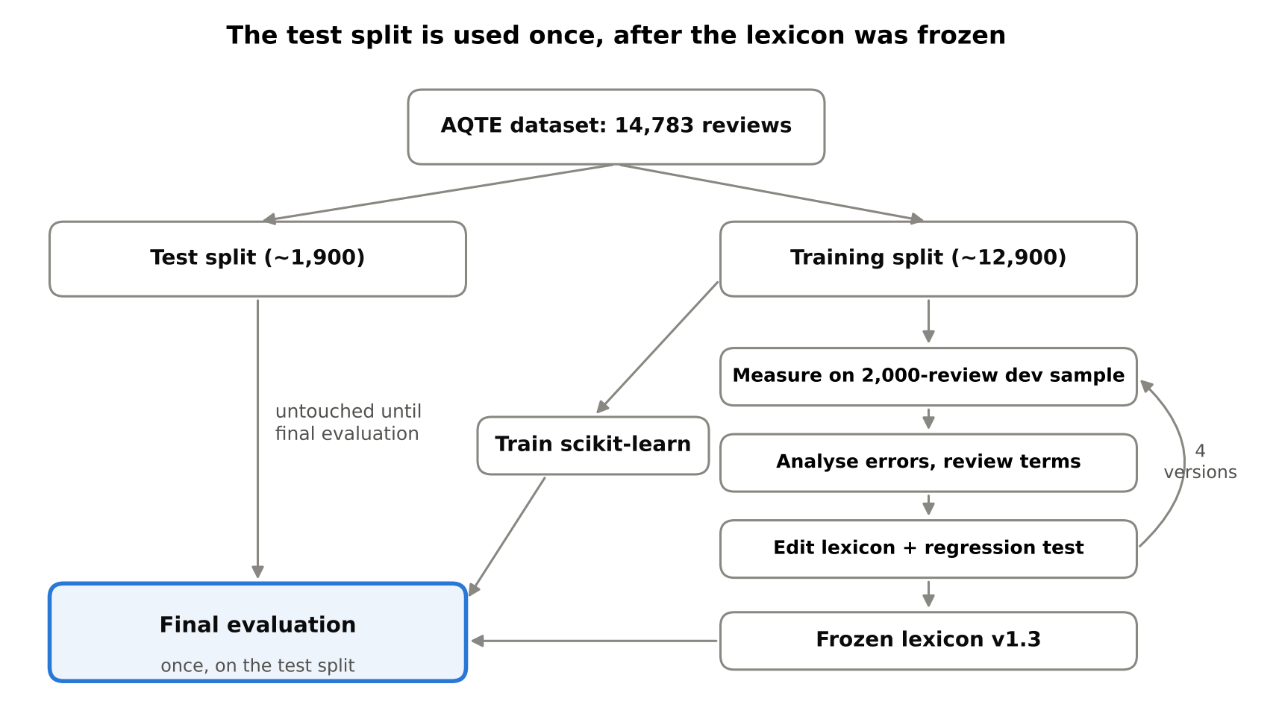
Figure 3.1: Development and evaluation design: an improvement cycle on the training split and a single evaluation on the test split
Table 3.1 shows how the work was organised over the project period.
Table 3.1: Project phases
Phase | Main activities | Output
1. Analysis | Requirements, research questions, review of literature and tools | Requirements and design decisions
2. Core development | Database, importer, text processing, lexicon analyser, dish extractor | Tested analysis core
3. Interface | Eight Streamlit pages, charts, Excel and PDF reports | Working platform
4. Data | Exploration and integration of the AQTE dataset; evaluation tools | Evaluation pipeline
5. Iterative improvement | Four lexicon versions on a 2,000-review development sample | Frozen lexicon v1.3
6. Final evaluation | Lexicon and scikit-learn evaluated once on the test split | Results (Chapter 5)
7. Documentation | Report, user guide, presentation | This report

3.2 Data Collection Methods

3.2.1 Choice of Data Source
Several data sources were considered: collecting reviews directly from online platforms, conducting a survey in which participants write reviews, obtaining exported reviews from cooperating restaurants, and using a published research dataset. Collecting data directly from platforms was rejected because automated collection that bypasses a platform's terms of service is neither legal nor ethical, and the official interfaces that allow collection are limited and often paid. A survey was prepared as a fallback but was not needed, because a suitable public research dataset was found.
The project uses AQTE (Arabic Quote and Triplet Extraction), a dataset published on Hugging Face under the Creative Commons Attribution 4.0 (CC BY 4.0) licence (bayandashnan, 2026). According to its documentation, AQTE contains 14,783 real customer reviews of 774 restaurants across Saudi Arabia, collected from Google Maps and written in multiple Arabic dialects, with 63,620 annotated opinion triplets spanning 29 aspect categories and three sentiment polarities. It was chosen because it matches the domain and region of the project exactly, and because its aspect-level annotations make it possible to evaluate not only overall sentiment but also aspect detection and aspect sentiment.

3.2.2 Structure of the Dataset
The dataset is distributed as a training split of about 12,900 reviews and a test split with the remaining reviews (about 1,900) [insert the exact split sizes from the dataset page]. Its structure was inspected before any import code was written; no column names were assumed. Each record contains the fields in Table 3.2.
Table 3.2: Fields of an AQTE record
Field | Content
place_id | Google Maps identifier of the restaurant (no restaurant name)
review_id | Identifier of the review
rate | Star rating given by the customer, from 1 to 5
review_text | Text of the review, from 3 to about 2,230 characters
opinions | List of opinions; each has an aspect category (aspect), a sentiment value (avg_sentiment) and the verbatim opinion text (quotes)

For example, the review ‎"حلو الاكل و حلو خبز التشباتي لذيذ كان بس ماعطوني الا بخمسة وانا كان ودي ب ٢٠"‎ (the food is nice and the chapati bread was tasty, but they only gave me five when I wanted twenty) carries three opinions: two about the food with value 1 and one about the price with value 0.

3.2.3 Sentiment Scale
In the training split, avg_sentiment takes only three values: 0 (14,035 opinions), 0.5 (5,161) and 1 (36,421). These were interpreted as negative, neutral and positive respectively; opinions with value 0 are explicit complaints such as ‎"اكلهم سيء"‎ (their food is bad). The evaluation tool detects the scale automatically and prints the values it observed on every run, and each value v is converted to a common signed scale:
s = 2v − 1 so that negative = −1, neutral = 0, positive = +1

3.2.4 Reference Labels
Three kinds of reference (gold) labels were derived from the dataset:
- Overall sentiment from the opinions (primary reference): the sign of the sum of s over all the opinions of a review. It is grounded in the text, because every opinion is tied to a verbatim quote.
- Overall sentiment from the star rating (secondary reference): ratings of 1 to 2 are negative, 3 is neutral and 4 to 5 are positive. This reference is approximate, because a customer may give five stars while still complaining about something in the text.
- Sentiment per aspect: after mapping the AQTE categories to the platform's aspects (Table 3.3). If the same aspect appears with both positive and negative opinions in one review, it is marked as conflicting and excluded from the aspect-sentiment accuracy.

3.2.5 Mapping of Aspect Categories
AQTE uses 29 aspect categories, while the platform analyses seven aspects. The categories were mapped as shown in Table 3.3. This mapping is a methodological decision of the researcher. General categories such as ‎"المطعم"‎ (the restaurant) and ‎"التجربة"‎ (the experience) are not mapped to any aspect; they contribute to overall sentiment but are not used in the aspect evaluation.
Table 3.3: Mapping of AQTE aspect categories to platform aspects
Platform aspect | AQTE categories
Food quality and taste | الطعام (food), المشروبات (drinks), الجودة (quality)
Price and value | السعر (price)
Quantity and portion size | الكمية (quantity)
Service | الخدمة (service), طاقم العمل (staff), التعامل (treatment), السرعة (speed), الإدارة (management), التنظيم (organisation)
Delivery | الطلب عن بعد (remote ordering), التغليف (packaging)
Cleanliness | النظافة (cleanliness), الرائحة (smell)
Ambiance | الديكور (decor), الأجواء (atmosphere), مواقف السيارات (parking), الترفيه (entertainment)
Not mapped (general) | المطعم, التجربة, التنوع, التوفر, الأمان, المقهى, المخبز, الكافتيريا, الفندق, المتجر

3.2.6 Other Data Sources and Ethical Considerations
- The platform imports any CSV, Excel, JSON or Parquet file. The user chooses which column contains the review text, restaurant, date, rating, city and label; column names are never assumed.
- Social-media data can be imported only from files exported by official tools or through official, authorised APIs. A connector for the official X API v2 is included; it reads the key from an environment variable, never from the code, and stores no user names or identifiers.
- AQTE contains no reviewer names or identifiers; place_id identifies a business, not a person. On import, the platform also masks phone numbers, e-mail addresses and @mentions.
- A synthetic demonstration dataset (631 template-generated reviews of fictional restaurants) is used only for software testing and demonstrations. It is clearly labelled as synthetic everywhere in the platform and was never used for any research result.

3.3 Text Preprocessing
Preprocessing standardises the text for matching without removing anything that may carry sentiment. The original text is kept and shown as evidence; matching is performed on a normalised copy.

3.3.1 Cleaning
- URLs are removed and repeated white space is collapsed; missing values are treated as empty text, and reviews shorter than two characters are excluded.
- Personal data is masked: Saudi mobile numbers, numbers of nine or more digits, e-mail addresses and @mentions. Short numbers such as prices are kept.
- Duplicates are detected with a SHA-1 fingerprint of the normalised text, so that ‎"الأكلُ لذيذ"‎ and ‎"الاكل لذيذ!"‎ are recognised as the same review. A review is a duplicate if its text, restaurant and date all match.

3.3.2 Normalisation
Each rule in Table 3.4 can be switched off in the configuration.
Table 3.4: Normalisation rules
Rule | Example
Unify alef forms (أ إ آ ٱ → ا) | أكل → اكل
Alef maqsura to ya (ى → ي) | أغلى → اغلي
Ta marbuta to ha (ة → ه) | وجبة → وجبه
Hamza on carriers (ؤ → و، ئ → ي) | بطيئة → بطييه
Remove diacritics and tatweel | مُمـتاز → ممتاز
Reduce runs of three or more identical letters to two | حلوووو → حلوو
Arabic-Indic digits to Western digits | ٥ → 5

When matching against the lexicon, a fully squeezed form in which every repeated letter becomes one letter is also tried (‎"حلوو"‎ → ‎"حلو"‎). The original elongation is treated as a sign of emphasis, and the score of the opinion word is multiplied by 1.2.

3.3.3 What Is Deliberately Kept
- Negation words (لا، ما، مو، مب، مش، ليس، غير، بدون): removing them would reverse the meaning, turning ‎"مو حلو"‎ (not good) into ‎"حلو"‎ (good).
- Emojis and exclamation and question marks: they carry sentiment; 29 emojis have scores in the lexicon.
- Stop words: they are not removed for sentiment analysis. They are removed only when counting the most frequent keywords.

3.3.4 Segmentation and Light Morphology
- Clause splitting: each review is split at punctuation (. ، , ؛ ! ؟ and line breaks) and at contrast words (بس، لكن، ولكن، بينما، مع أن، أما). A clause that follows a contrast word is marked.
- Tokenisation: clauses are split into words and emojis, and two-word negations are merged (ما فيه → مافيه، لا يوجد → لايوجد).
- Candidate forms: prefixes (وبال، وال، بال، فال، كال، ولل، لل، ال، و، ف، ب، ل، ك) and suffixes (هم، ها، كم، نا، ين، ات، ه، ي) are stripped with a minimum stem length. The full word is always tried first, so the initial ب of ‎"بارد"‎ (cold) is never removed by mistake.
- Restoring ta marbuta: when a stem ends in ت after a pronoun suffix is removed, the form with ة is also tried (خدمتهم → خدمت → خدمة).

3.4 The Lexicon-Based Aspect Sentiment Analyser
The core analyser is rule- and lexicon-based. It needs no training data, and every decision can be explained: it reports the opinion words it used and the clause that supports each aspect decision. For every review it returns an overall sentiment with a confidence score, and a sentiment for each of the seven aspects that is mentioned. Figure 3.2 summarises the process.
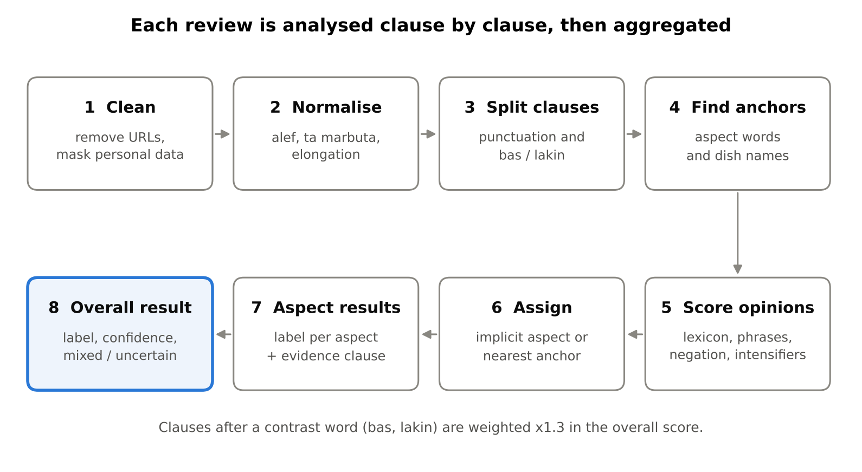
Figure 3.2: Processing steps of the aspect-based sentiment analyser

3.4.1 Lexicon Composition
The lexicon covers Modern Standard Arabic, Saudi and Gulf dialect and a few common English words. Entries are written in natural spelling and normalised automatically when the lexicon is loaded. Table 3.5 shows the composition of the final version (v1.3).
Table 3.5: Composition of the lexicon (version 1.3)
Component | Count | Examples
Positive words | 144 | ممتاز، لذيذ، رهيب، كويس، بطل
Negative words | 94 | سيء، زفت، ماصخ، غالي، وصخ
Explicit neutral words | 2 | متوسط، متوسطة
Aspect-dependent (conditional) words | 33 | كبير، قليل، بارد، سريع، تأخير
Fixed phrases | 47 | يفتح النفس، ماله طعم، ما قصروا، لا بأس
Negators | 19 | لا، ما، مو، مب، مش، غير
Absence markers | 16 | مافي، بدون، ماله، يحتاج
Intensifiers / diminishers | 12 / 7 | مرة، جدا، وايد / شوي، نوعا ما
Emojis | 29 | 😍 👍 😡 🤮
Aspect keywords (7 aspects) | 135 | الأكل، السعر، الموظف، المندوب، الجلسات

Each opinion word has a weight: 1.0 for an ordinary opinion, 1.5 for a strong one and 2.0 for a very strong one. Some words carry an implicit aspect: ‎"غالي"‎ (expensive) always refers to price and ‎"وصخ"‎ (dirty) to cleanliness. Conditional words change polarity with the aspect: ‎"كبير"‎ (big) is positive for quantity but negative for price, and ‎"بارد"‎ (cold) is negative for food but positive for the atmosphere.

3.4.2 Analysis Steps Within a Clause
- Aspect anchors are identified: dish names (anchors for food quality), then multi-word aspect keywords, then single-word aspect keywords.
- Fixed phrases are matched first, longest first, and their words are consumed. This prevents ‎"ما قصروا"‎ (they did not fall short, which is praise) from being negated because of ‎"ما"‎.
- Single-word opinions are found: lexicon entries matched through the candidate forms, attached negation (‎"ماعجبني"‎، ‎"موزين"‎) and emojis.
- Negation: a negator up to three words before an opinion, with no other opinion in between, reverses it. Negating a positive opinion gives a strong negative (−0.9 × the score); negating a negative gives a weak positive (0.5 × the score), because ‎"مو سيء"‎ (not bad) does not mean ‎"ممتاز"‎ (excellent).
- Intensifiers and diminishers within two words multiply the score; each modifier applies only to the nearest opinion, preferring the preceding one, as in ‎"لذيذ مرة"‎ (very tasty).
- Conditional words take their polarity from the nearest aspect, or from their default when the nearest aspect is not in their table.
- Absence: an absence marker before an aspect word with no opinion (‎"مافي نظافة"‎، ‎"يحتاج نظافة"‎) creates a negative opinion (−1.2) for that aspect.
- Assignment: an opinion with an implicit aspect is assigned to it; otherwise it is assigned to the nearest anchor in the clause, preferring the preceding one. Consecutive anchors share an opinion (‎"الأكل والخدمة ممتازين"‎). An opinion with no anchor counts only towards overall sentiment.
- Aspect sentiment: the scores of an aspect within a clause are summed; above 0.2 is positive, below −0.2 is negative, and anything in between is neutral. An aspect mentioned without any opinion is recorded as "mentioned without opinion" and excluded from statistics and evaluation.

3.4.3 Overall Sentiment and Confidence
P (the sum of positive scores) and N (the sum of the absolute values of negative scores) are accumulated over all clauses. A clause that follows ‎"بس"‎ or ‎"لكن"‎ is weighted by 1.3, because it usually carries the writer's main point. The net score P − N gives a positive label above 0.3, a negative label below −0.3, and a neutral label in between. The confidence score is:
confidence = 0.5 + 0.45 × ( |P − N| / (P + N) ) × min(1, (P + N) / 2)
The value is clipped to the range 0.34 to 0.95. The middle factor measures how one-sided the opinions are and the last factor measures how strong the evidence is. Three further rules apply: a review with no opinion word is neutral with confidence 0.45; a result with confidence below 0.6 is shown as uncertain rather than as a definite label; and a review is flagged as mixed when both P and N are at least 0.5. The confidence score is a rule-based estimate, not a statistically calibrated probability.

3.4.4 Worked Example
Table 3.6 shows the analyser's actual output for the review ‎"الكبسة لذيذة مرة بس الخدمة بطيئة"‎ (the kabsa is very tasty, but the service is slow).
Table 3.6: Worked example of the analyser
Clause | Anchor | Opinion | Score | Result
الكبسة لذيذة مرة | الكبسة (dish) | لذيذة 1.5 × مرة 1.5 | +2.25 | Food quality: positive, linked to kabsa
الخدمة بطيئة (after ‎"بس"‎) | الخدمة | بطيئة (conditional: service −1.2) | −1.2 | Service: negative

Overall, P = 2.25 and N = 1.2 × 1.3 = 1.56, so the net score is 0.69 and the review is positive. The confidence is 0.581, so the result is flagged as uncertain and mixed. This accurately describes a review that praises the food and complains about the service.

3.5 Dish Extraction
Dishes are extracted by matching against an editable dictionary of 57 dishes and 154 synonyms and spelling variants, grouped into categories: Saudi and Gulf dishes, fast food, grills, appetisers, desserts, drinks and breakfast items. Only dishes in the dictionary can be extracted, so the system cannot attribute to a review a dish that it does not mention. Matching works on normalised text in which repeated letters are merged, so ‎"شاورماااا"‎ and ‎"شاورمه"‎ both match ‎"شاورما"‎. Prefixes are supported (‎"بالكبسة"‎، ‎"والمندي"‎), the longest match wins (‎"دجاج مقلي"‎ is one dish rather than ‎"دجاج"‎), and ambiguous variants are excluded on purpose; for example ‎"تميز"‎ was rejected as a spelling of ‎"تميس"‎ because it is a common word meaning "excellence".
A dish acts as an anchor for food quality and is linked to any aspect expressed in the same clause, since the same clause is sufficient textual evidence of the link. In ‎"الكبسة غالية"‎ (the kabsa is expensive), the price aspect is recorded as negative and linked to the kabsa. When a dish appears in several clauses, its signals are merged and the clause that contains an opinion becomes the supporting evidence. The number of mentions of a dish is reported as a preference indicator inferred from reviews, not as a number of purchases, because no independent sales data is available.

3.6 Machine-Learning Baseline
To answer RQ2, a supervised model classifies the overall sentiment of a review as positive, negative or neutral. Its configuration is shown in Table 3.7.
Table 3.7: Configuration of the scikit-learn model
Stage | Setting
Preprocessing | The same cleaning and normalisation as Section 3.3
Features: character TF-IDF | Character n-grams of 2 to 5 within word boundaries (char_wb), sublinear term frequency
Features: word TF-IDF | Unigrams and bigrams; short words such as ‎"لا"‎, ‎"ما"‎ and ‎"مو"‎ are kept
Classifier | Logistic regression, class_weight = balanced, max_iter = 2000

Character n-grams were chosen because they tolerate dialectal spelling variation (حلو / حلوه / حلوو), and balanced class weights because the neutral class is much smaller than the positive class. The model is trained on the AQTE training split with the opinion-derived labels of Section 3.2.4; training requires at least two classes and five examples per class. It is evaluated on the same test split and with the same metrics as the lexicon analyser. The model classifies whole reviews only, so aspects and dishes are always extracted by the lexicon analyser. Pre-trained Transformer models such as CAMeLBERT are supported by the platform as an option but were not part of this evaluation, because fine-tuning them requires GPU resources beyond the scope of the project.

3.7 Iterative Development of the Lexicon
The lexicon was developed in four versions on a development sample of 2,000 reviews taken from the training split only. Over these versions, aspect-detection F1 rose from 0.775 to 0.814 (Figure 3.3).
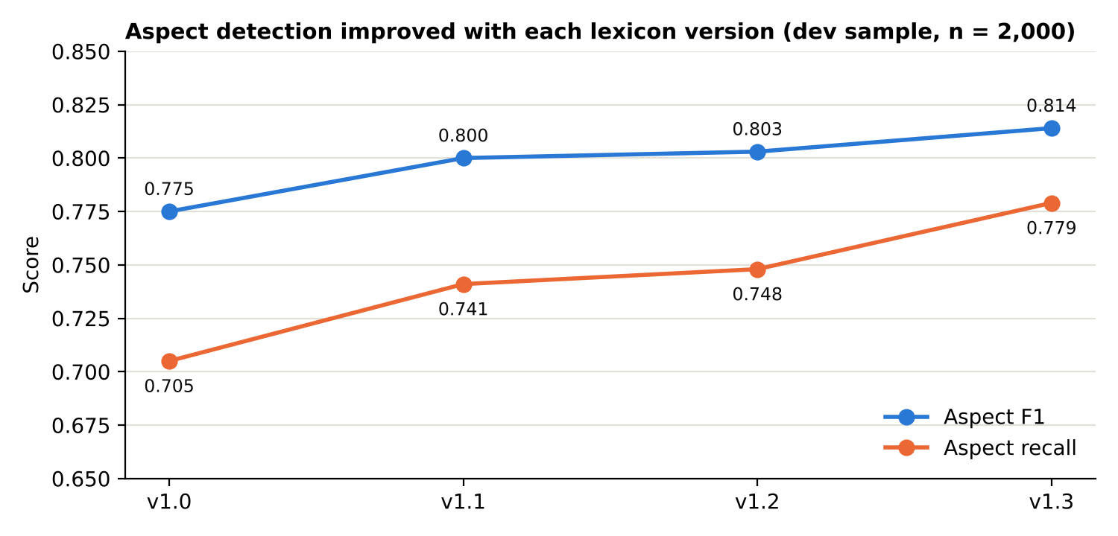
Figure 3.3: Aspect-detection F1 and recall across lexicon versions on the development sample

3.7.1 The Improvement Cycle
- Run the analyser on the development sample and measure its performance.
- Analyse the errors automatically: aspects annotated in AQTE but missed by the analyser, together with their quotes; sentiment errors; and the most frequent words in missed quotes that are not in the lexicon.
- Review the suggested words manually: accept words that express an opinion or indicate an aspect, and reject the others.
- Edit the lexicon or the rules, and add an automated regression test for every fix.
- Measure again on the same sample, and revert any change that makes the results worse.

3.7.2 Lexicon Versions
Table 3.8: Lexicon versions and development-sample results
Version | Main change | Aspect F1 | Aspect recall | Macro-F1 (AQTE opinions) | Macro-F1 (stars)
1.0 | Initial lexicon | 0.775 | 0.705 | — | 0.603
1.1 | Common missing words (جيد، كويس، اخلاق); speed words made conditional | 0.800 | 0.741 | — | 0.584
1.2 | Correction of the label scale in the evaluator; ‎"عادي"‎ and ‎"زحمة"‎ restored | 0.803 | 0.748 | 0.614 | 0.580
1.3 | Two software defects fixed; new terms for quantity, delivery and cleanliness | 0.814 | 0.779 | 0.614 | 0.583

On the development sample, a majority-class baseline that always predicts "positive" achieves a macro-F1 of 0.275 against the AQTE opinions and 0.274 against the star ratings.

3.7.3 Main Findings of the Error Analysis
- Missing common words: ‎"جيد"‎ (good) was the most frequent word in the missed quotes (31 times in the sample).
- Two software defects: single-word phrases such as ‎"ماقصروا"‎ were never matched, because the phrase loop started at two words; and ta marbuta changing to ت before a pronoun (خدمة → خدمتهم) prevented aspects from being recognised. Fixing both raised aspect recall from 0.748 to 0.779.
- Criteria for rejecting suggested words: function words (عندهم، جربت، فقط), names (ابو، حسن), and words that are ambiguous between aspects (‎"الطلب"‎, the order, which is used for service, delivery and food alike) were rejected. The full list of accepted and rejected words is given in Appendix B.

3.7.4 Correction of the Evaluation Tool
In versions 1.0 and 1.1 the evaluation tool interpreted avg_sentiment incorrectly as a scale from −1 to 1, so negative opinions (value 0) were counted as neutral. The error was detected because the negative class appeared with a count of zero among the reference labels, which is implausible for 2,000 restaurant reviews. The error did not affect aspect-detection metrics or the comparison with star ratings, so those values are kept in Table 3.8; the values against the AQTE opinions are omitted for the two affected versions. Because the removal of ‎"عادي"‎ and ‎"زحمة"‎ in version 1.1 had been justified using the misread labels, both words were restored in version 1.2.

3.7.5 Separation of Development and Test Data
Before development started, version 1.0 was run once on 300 reviews from the test split to verify that the tools worked. Only the aggregate results were viewed (aspect F1 0.749 and macro-F1 against star ratings 0.553), and no errors were analysed. After that, the test split was frozen until the final evaluation, and the lexicon was frozen at version 1.3 before that evaluation.

3.8 Evaluation Methodology
The final evaluation was performed once on the complete test split, using the frozen lexicon (version 1.3) and the scikit-learn model trained on the complete training split. It measures three things: overall sentiment, aspect detection and the sentiment of detected aspects.

3.8.1 Overall Sentiment
The prediction of each model is compared with the two references of Section 3.2.4. For each class c:
Precision_c = TP_c / (TP_c + FP_c) Recall_c = TP_c / (TP_c + FN_c)
F1_c = 2 × Precision_c × Recall_c / (Precision_c + Recall_c) Macro-F1 = (F1_pos + F1_neg + F1_neu) / 3
Macro-F1 is the primary measure rather than accuracy, because the classes are imbalanced: in the development sample 70% of the reviews are positive, so a model that always predicts "positive" reaches 70% accuracy without understanding the text. Every result is therefore reported together with a majority-class baseline and a confusion matrix.

3.8.2 Aspect Detection
For every review and each of the seven aspects, two questions are asked: is the aspect present in the AQTE annotations, and did the analyser detect it with an opinion? Table 3.9 shows how the answers are classified.
Table 3.9: Classification of aspect-detection outcomes
In AQTE annotations | Detected by analyser | Outcome
Yes | Yes | True positive (TP)
No | Yes | False positive (FP)
Yes | No | False negative (FN)

Precision, recall and F1 are computed per aspect, and overall (micro-averaged) by summing TP, FP and FN over all aspects. Aspects mentioned without an opinion do not count as detections.

3.8.3 Aspect Sentiment
Aspect sentiment is measured only on correctly detected aspects (true positives), excluding aspects with conflicting reference labels. Aspect-sentiment accuracy is the number of these aspects whose predicted sentiment matches the AQTE sentiment, divided by their total. The predicted sentiment of an aspect is the sign of its total score in the review (above 0.2 positive, below −0.2 negative).

3.8.4 Reproducibility
The complete final evaluation is reproduced by a single command, which trains the scikit-learn model, evaluates both models and saves all results to an Excel workbook:
python scripts/evaluate_aqte.py test_split.json --train train_split.json

3.9 Tools and Technologies
The platform is written entirely in Python and runs locally, without cloud services or paid keys. Table 3.10 lists the main tools.
Table 3.10: Tools and technologies
Purpose | Tool | Reason for choice
Programming language | Python 3.10+ (developed on 3.13, tested by the user on 3.15) | Rich NLP and data ecosystem
Data processing | Pandas, NumPy | Standard tabular data tools
Machine learning and metrics | scikit-learn | Reliable TF-IDF, logistic regression and metrics
Database | SQLite | Zero-configuration, file-based relational database
Web interface | Streamlit | Interactive data apps in pure Python
Charts | Plotly | Interactive charts with hover details
Excel reports | OpenPyXL | Writes right-to-left Excel sheets
PDF reports | ReportLab, arabic-reshaper, python-bidi, Amiri font | Correct Arabic shaping and right-to-left order in PDF
Testing | Pytest | 129 automated tests
Optional models | Hugging Face Transformers | Support for pre-trained Arabic models
Version control | Git and GitHub | History of every change and lexicon version

Chapter 4: System Design and Implementation
This chapter presents the platform from the system point of view: its overview and stakeholders, the analysis of its requirements, the feasibility study, the design of its architecture, analysis pipeline, database and interface, and finally its implementation and testing.

4.1 System Overview
The Saudi Restaurant Sentiment & Food Preference Analytics Platform is a local web application that turns Arabic restaurant reviews into structured insight. A user imports a file of reviews, chooses which columns contain the text and the other fields, and runs the analysis. The platform then shows the overall sentiment of every review with a confidence score, the sentiment towards seven aspects, the dishes mentioned and the sentiment towards them, comparisons between restaurants and cities, trends over time and the most frequent keywords and topics. Results can be exported as Excel workbooks with right-to-left sheets and as Arabic PDF reports with recommendations.
The system is organised in three layers (Figure 4.1). The presentation layer consists of eight Streamlit pages (Streamlit Inc., 2026) in Arabic with a right-to-left layout. The application core is a Python package named sra that contains the importer, text processing, the aspect-based analyser, dish extraction, the machine-learning models, analytics, reports and data connectors. The data layer is a SQLite database together with a few files: the editable dish dictionary, the trained model and the Arabic font used in PDF reports.
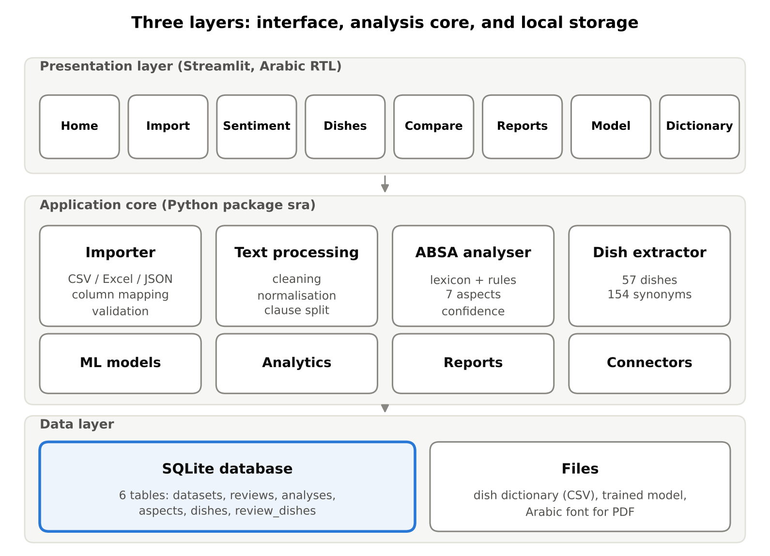
Figure 4.1: Three-layer architecture of the platform
The platform runs on an ordinary personal computer with Windows, macOS or Linux, needs no internet connection after installation, and uses only free, open-source software.

4.2 Stakeholders
The main stakeholders of the system include:
- Restaurant owners and managers, who use the platform to understand customer satisfaction, detect recurring complaints, compare branches and export reports for management meetings.
- Researchers and students in consumer behaviour, food studies and Arabic NLP, who use it to analyse review datasets, evaluate models against annotated data and reproduce results.
- Marketing and quality teams, who monitor how changes in menu, price or service affect customer opinion over time.
- The project supervisor and examiners, who assess the quality of the system and the validity of its evaluation.
- The developer, who maintains the lexicon, the dish dictionary and the code, and extends the platform with new models or data sources.

4.3 System Analysis

4.3.1 Introduction
System analysis identified what the platform must do (functional requirements) and the qualities it must have (non-functional requirements). The requirements were derived from the project objectives in Chapter 1, the needs of the stakeholders above, and the methodological principles in Chapter 3, in particular the need to explain results, show uncertainty and avoid misleading comparisons.

4.3.2 Functional Requirements
Table 4.1: Functional requirements
ID | Requirement
FR1 | Import reviews from CSV, Excel, JSON and Parquet files, trying several Arabic text encodings automatically.
FR2 | Let the user choose the columns for review text (required), restaurant, date, rating, city, label and source; suggest columns but never assume them.
FR3 | Validate imported data and report empty texts, duplicates, invalid dates and ratings, unknown labels and unrecognised cities.
FR4 | Store reviews and results in a relational database, avoiding duplicate records.
FR5 | Classify the overall sentiment of each review as positive, negative or neutral with a confidence score, and flag mixed and uncertain results.
FR6 | Determine the sentiment towards seven aspects and show the supporting clause for each decision.
FR7 | Extract dish names from an editable dictionary and link them to the sentiment expressed about them.
FR8 | Show distributions, dish rankings, aspect strengths and complaints, keywords and topics, with filters by dataset, restaurant, city, period and model version.
FR9 | Compare restaurants and cities with numerators and denominators shown, ranking only those with enough reviews.
FR10 | Show sentiment trends over time when dates are available.
FR11 | Generate reports with a statistical summary, examples, recommendations and caveats, exportable to Excel, PDF and CSV.
FR12 | Train and evaluate a scikit-learn model, and optionally use a pre-trained Transformer model.
FR13 | Let the user edit the dish dictionary from the interface.
FR14 | Provide synthetic demonstration data, clearly labelled as synthetic.

4.3.3 Non-Functional Requirements
Table 4.2: Non-functional requirements
Category | Requirement
Usability | Arabic interface with a right-to-left layout; usable by a non-technical person; clear messages in Arabic.
Transparency | Every sentiment decision shows its opinion words and supporting clause; uncertainty is shown, not hidden.
Honest reporting | Percentages are shown with numerator and denominator; no ranking on insufficient data; dish mentions are presented as preference indicators, not sales.
Privacy | No user names or identifiers stored; phone numbers, e-mail addresses and mentions masked; no keys in the code.
Legality | No scraping; only files and official, authorised APIs.
Portability | Runs locally on Windows, macOS and Linux without paid services.
Reliability | Database integrity enforced with primary keys, foreign keys, check constraints and cascades; 129 automated tests.
Accessibility | Chart colours chosen to remain distinguishable for colour-blind users (blue for positive, red for negative).
Performance | Analysis of the 630 demonstration reviews takes well under a second on an ordinary laptop.
Maintainability | Modular code; editable lexicon and dictionary; documented change log for every lexicon version.

4.3.4 Use Cases
Table 4.3: Main use cases
Use case | Actor | Description
Import reviews | Owner / researcher | Upload a file, map columns, review the validation report and import.
Analyse sentiment | Owner / researcher | Choose datasets and engine, run the analysis, browse results and details.
Try a single review | Any user | Type a review and see its sentiment, aspects and dishes immediately.
Explore dishes | Owner / researcher | See most-mentioned dishes, sentiment per dish and related aspects.
Compare restaurants | Owner / researcher | Compare restaurants, aspects, trends and cities with fair ranking.
Export a report | Owner | Choose restaurant and period and download Excel, PDF or CSV.
Train and evaluate a model | Researcher | Train scikit-learn on labelled data and view metrics and confusion matrix.
Edit the dish dictionary | Owner / developer | Add dishes and spelling variants and test extraction.
Manage datasets | Owner / researcher | List datasets and delete one with all its reviews and results.

4.4 Feasibility Study

4.4.1 Technical Feasibility
All the technologies required are mature, free and well documented: Python, Pandas, scikit-learn, SQLite, Streamlit, Plotly, OpenPyXL and ReportLab. Arabic shaping and right-to-left ordering in PDF, which ReportLab does not provide by itself, are handled by the arabic-reshaper and python-bidi libraries with the open-licence Amiri font. The analyser runs on an ordinary laptop without a GPU. The only technically demanding option, fine-tuning a Transformer model, was deliberately left optional. The project is therefore technically feasible with the skills and resources of a final-year IT student.

4.4.2 Economic Feasibility
The platform uses only open-source software and a public dataset, so its development and running costs are minimal (Table 4.4).
Table 4.4: Estimated costs
Item | Cost | Note
Software licences | 0 SAR | Python and all libraries are open source
Dataset | 0 SAR | AQTE is published under CC BY 4.0
Hardware | 0 SAR | Existing personal laptop
Hosting | 0 SAR | Runs locally; no server required
Optional official social-media API | Varies | Only if live data from a paid API tier is needed
Developer time | One semester | Student project

For a restaurant, the benefit, a structured view of customer feedback that would otherwise take many hours to read, clearly outweighs the cost of installing the platform on an existing computer.

4.4.3 Operational Feasibility
The platform is designed for users who are not programmers. After a one-time installation, which is documented step by step in Arabic, the user starts it with one command and works entirely in the browser in Arabic. Data import guides the user through choosing columns and reports problems in plain language. Results are presented with explanations, warnings and examples rather than raw numbers. Restaurant staff can therefore operate the system as part of their routine, for example by importing the latest exported reviews each month and downloading a report.

4.5 System Design

4.5.1 Architecture
The layered architecture in Figure 4.1 separates concerns: the interface pages never access the database directly but call functions in the core package, and the core is independent of Streamlit, so it can be reused from command-line scripts and tests. The command-line scripts (prepare_aqte.py, evaluate_aqte.py, error_analysis_aqte.py, train_model.py, explore_hf_dataset.py and generate_demo_data.py) use the same core as the interface, which guarantees that the evaluation measures exactly the analyser that the users see.

4.5.2 Analysis Pipeline
When an analysis is run, the pipeline reads the selected reviews from the database, analyses them in batches of 64 with the lexicon analyser, optionally replaces the overall label with the prediction of the chosen machine-learning model, and saves each result with its aspects and dishes in one transaction per batch. Each result records the model name and version, so results of different engines or lexicon versions can be stored side by side and compared; re-running the same version replaces the previous result.

4.5.3 Database Design
The database is created automatically on first use. It contains six tables (Figure 4.2 and Table 4.5).
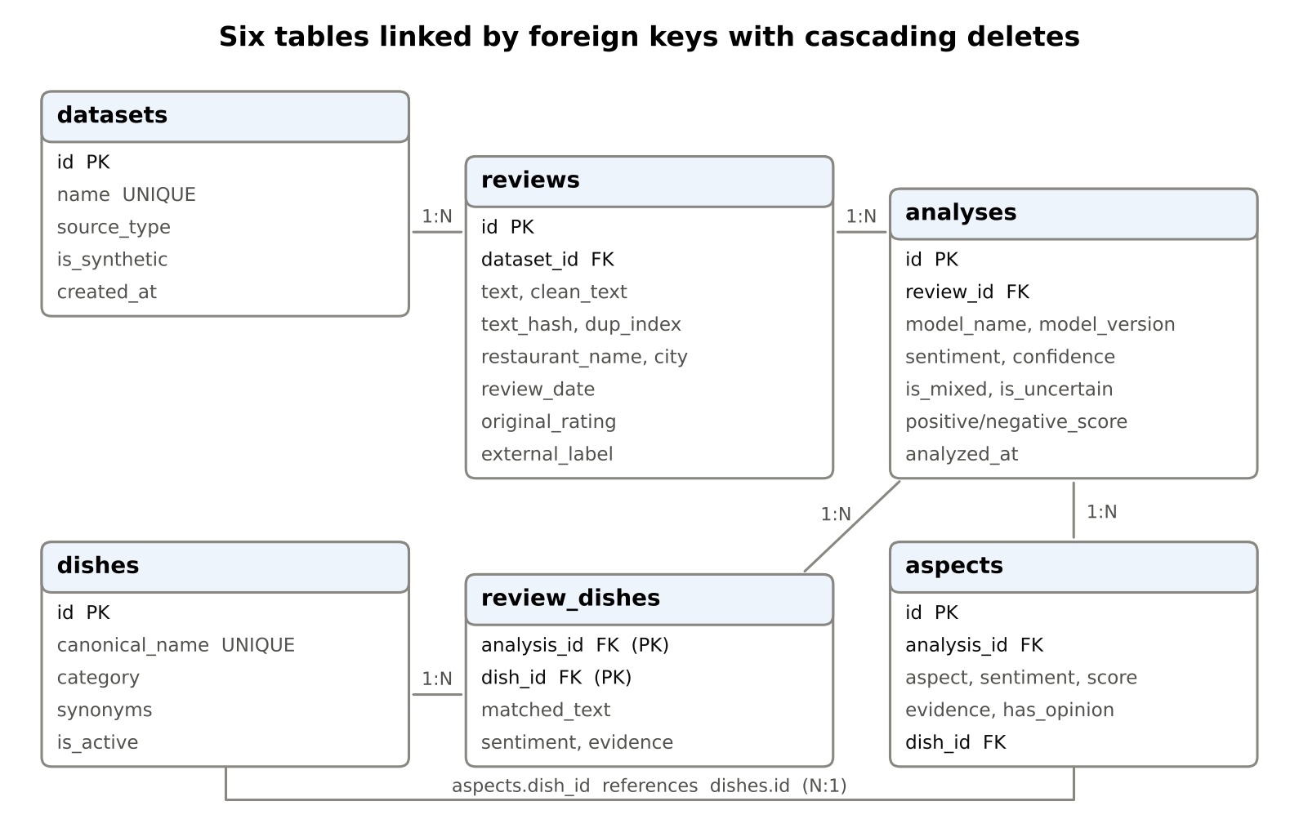
Figure 4.2: Entity-relationship diagram of the database
Table 4.5: Database tables
Table | Purpose | Key constraints
datasets | Imported datasets, their source type and whether they are synthetic | Unique name; is_synthetic in {0, 1}
reviews | Original and cleaned text, source, date, restaurant, city, original rating and label | FK to datasets with cascade; unique index on dataset, restaurant, text fingerprint, date and duplicate index; non-empty text
analyses | Overall sentiment, confidence, mixed and uncertain flags, scores, model and version, date | FK to reviews with cascade; unique (review, model version); sentiment and confidence checks
aspects | Aspect, sentiment, score, confidence, supporting clause, opinion flag, linked dish | FK to analyses with cascade; FK to dishes (set null); aspect and sentiment checks
dishes | Canonical dish name, category, synonyms, active flag | Unique canonical name
review_dishes | Dishes mentioned in each analysed review with their sentiment and evidence | Composite primary key; FKs to analyses and dishes with cascade

Foreign keys are enforced on every connection, so deleting a dataset removes all its reviews, analyses, aspects and dish links automatically. The home page runs an integrity check (PRAGMA foreign_key_check) and reports the result to the user. A view named latest_analyses returns the most recent analysis of each review, which is what the dashboards show by default.

4.5.4 Interface Design Principles
- Arabic and right-to-left: all text, menus and tables are Arabic and aligned right to left; horizontal bar charts grow from the right.
- Explain, do not just label: every result can be opened to see the opinion words and the supporting clause.
- Show uncertainty: low-confidence results are labelled "uncertain" and mixed reviews are labelled "mixed".
- Honest numbers: every percentage is shown as a fraction, for example ‎"12 من 40 (30.0%)"‎, and chart labels show the sample size (n).
- Fair comparison: restaurants with fewer than 20 reviews (configurable) are shown but not ranked; ranking uses the lower bound of the Wilson 95% interval.
- Accessible colours: blue for positive and red for negative, with grey for neutral. This pair stays distinguishable for colour-blind readers, unlike green and red.
- Clear labelling of synthetic data: a red warning banner appears wherever synthetic demonstration data is shown.

4.6 Implementation

4.6.1 Project Structure
The implementation contains about 5,000 lines of Python, of which about 3,600 are in the core package. Table 4.6 summarises the modules.
Table 4.6: Main modules of the core package
Module | Responsibility
config.py | Paths, thresholds, labels, colours and model versions
text_processing.py | Cleaning, normalisation, personal-data masking, duplicate fingerprints, clause splitting, morphological variants
lexicon.py | Sentiment, conditional, phrase, negation and aspect dictionaries; indexed lookup
sentiment.py | The aspect-based analyser, confidence, mixed and uncertain flags
dishes.py | Dish dictionary loading and saving, longest-match extraction
database.py | Schema creation, inserts with de-duplication, saving analyses, integrity checks
importer.py | Reading files, suggesting columns, validation and preparation
pipeline.py | Running an engine over the database in batches
analytics.py | Distributions, Wilson intervals, comparisons, trends, keywords and topics
reports.py | Report data, recommendations, Excel and Arabic PDF export
ml_model.py / transformer_model.py | scikit-learn baseline; optional Hugging Face adapter with label verification
aqte.py | Loading AQTE, detecting its sentiment scale, mapping aspects, evaluation and error analysis
connectors.py / demo_data.py | Official API connector; synthetic demonstration data

4.6.2 Key Implementation Details
The following excerpt shows how negation is applied inside the analyser. It is a short example of the rule-based logic described in Chapter 3:
@staticmethod
def _negate(score: float) -> float:
"""Negated positive becomes strongly negative; negated negative
becomes weakly positive ("not bad" is not "excellent")."""
return -0.9 * score if score > 0 else 0.5 * -score
Other notable implementation details include:
- Encoding detection on import: CSV files are read with UTF-8, UTF-8 with BOM and Windows-1256 in turn, because Arabic files saved from Excel often use the latter.
- De-duplication with an option to keep duplicates: each review has a duplicate index, so identical short reviews from different people (such as ‎"ممتاز"‎) can be kept when the user chooses.
- Arabic PDF: ReportLab draws text left to right without shaping, so each line is wrapped in logical order first, then shaped with arabic-reshaper and reordered with python-bidi; otherwise long paragraphs appear with their lines in reverse order.
- Safe optional models: the Transformer adapter reads the model's label names from its configuration and refuses models whose labels cannot be mapped clearly to positive, negative and neutral, instead of guessing.
- Automatic scale detection for AQTE: the evaluator detects whether sentiment values use a 0-to-1 or a −1-to-1 scale and prints the values observed, a safeguard added after the scale error described in Section 3.7.4.

4.6.3 User Interface
The interface consists of eight pages, reached from a side menu. The screenshots in this section were taken with the built-in synthetic demonstration dataset (fictional restaurants marked ‎"تجريبي"‎); they illustrate the interface only and are not research results.
The home page (Figure 4.3) describes the platform, shows the number of reviews, restaurants, analysed reviews and dishes in the dictionary, the overall sentiment distribution with numerators and denominators, the data status and the result of the database integrity check.
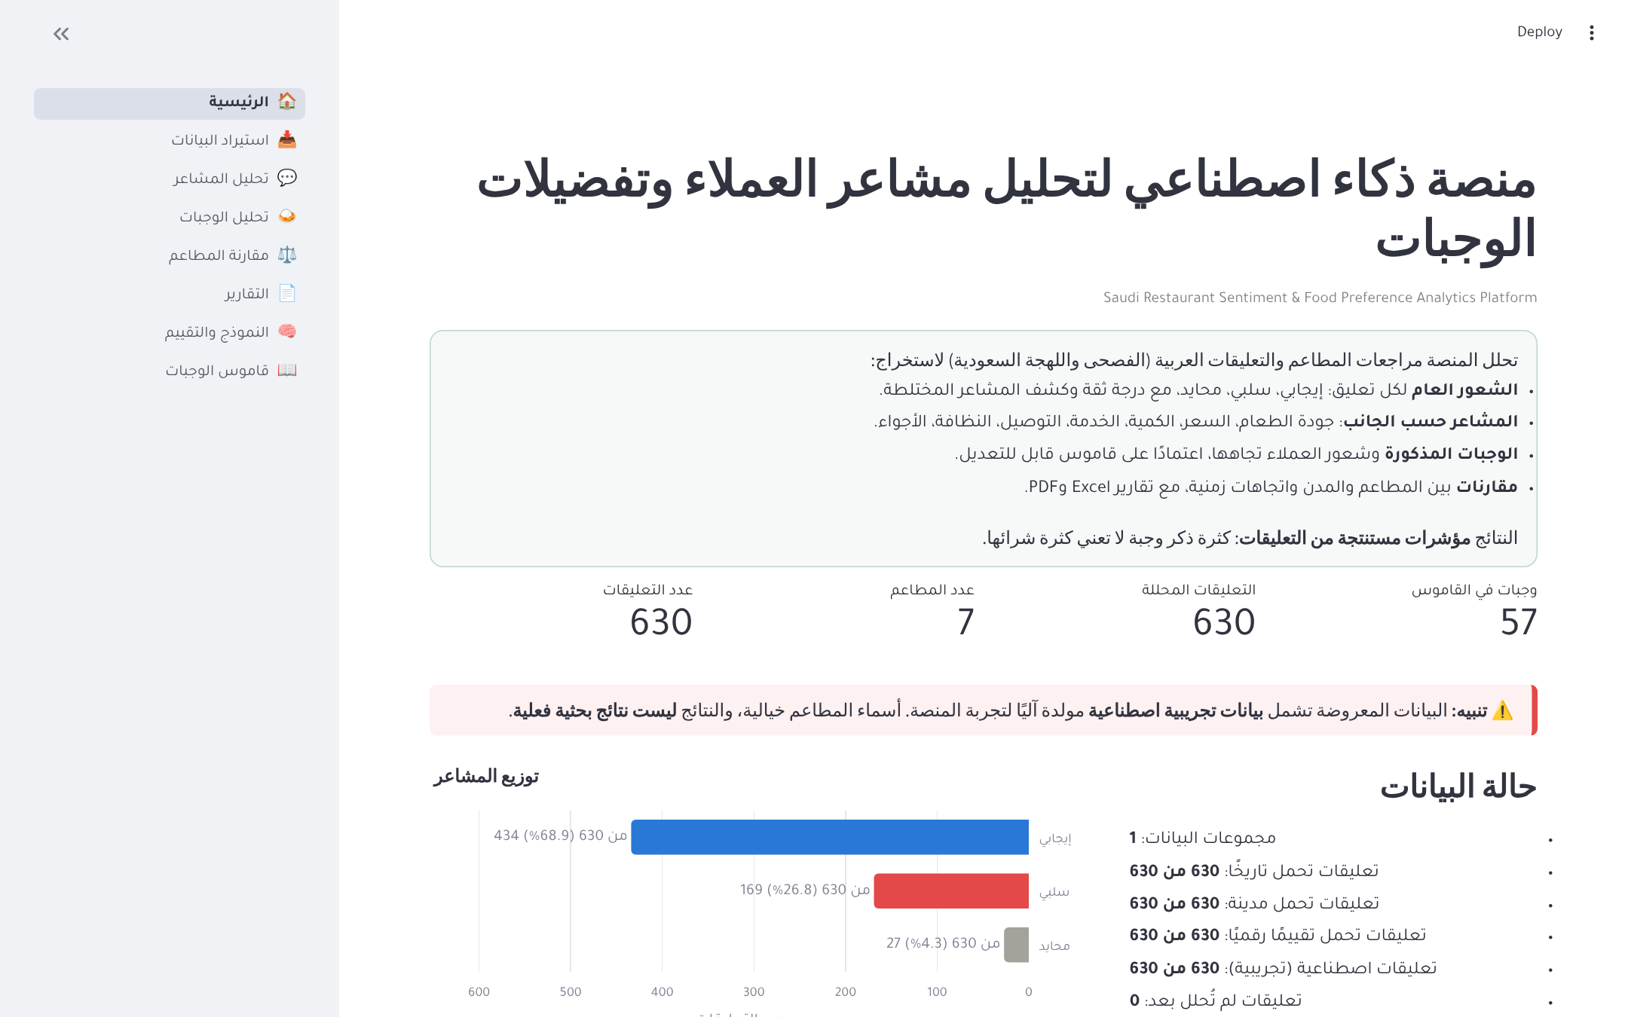
Figure 4.3: Home page with overview counts, sentiment distribution and data status
The data import page accepts CSV, Excel, JSON and Parquet files, shows a preview, lets the user map columns, and reports the validation results before anything is written to the database. Separate tabs offer the official API connector and dataset management.
The sentiment analysis page lets the user try a single review instantly (Figure 4.4). The result shows the overall label with its confidence, the mixed and uncertain flags, the opinion words, and a table of aspects with their score, confidence, supporting clause and linked dish.
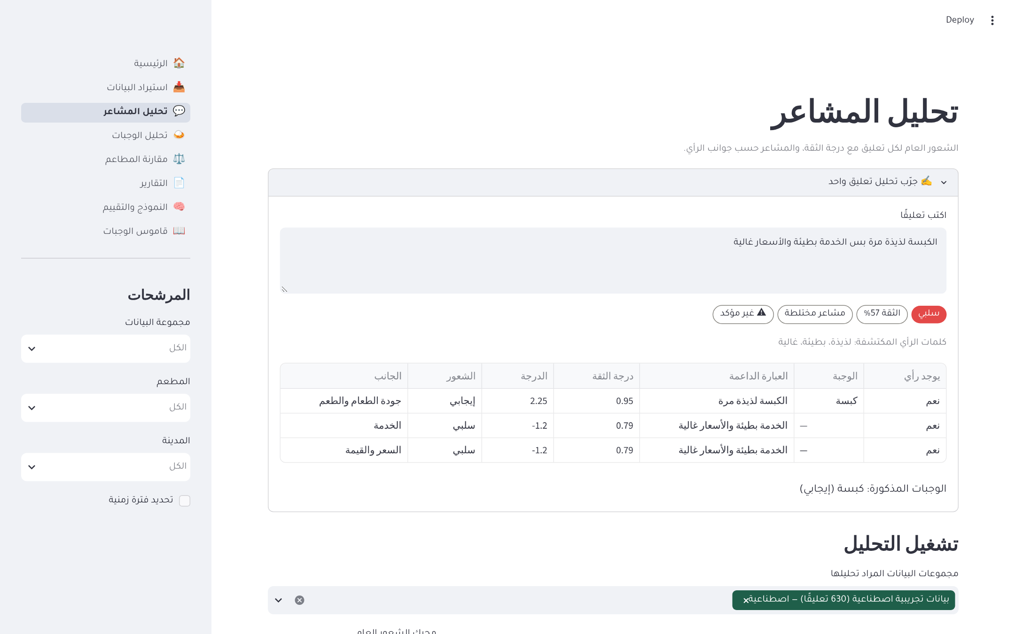
Figure 4.4: Analysing a single review: overall result, flags, aspects and dishes
The same page runs the analysis over whole datasets and shows the sentiment distribution, the sentiment by aspect as 100% stacked bars with the number of mentions, and a filterable table of reviews with their results (Figure 4.5).
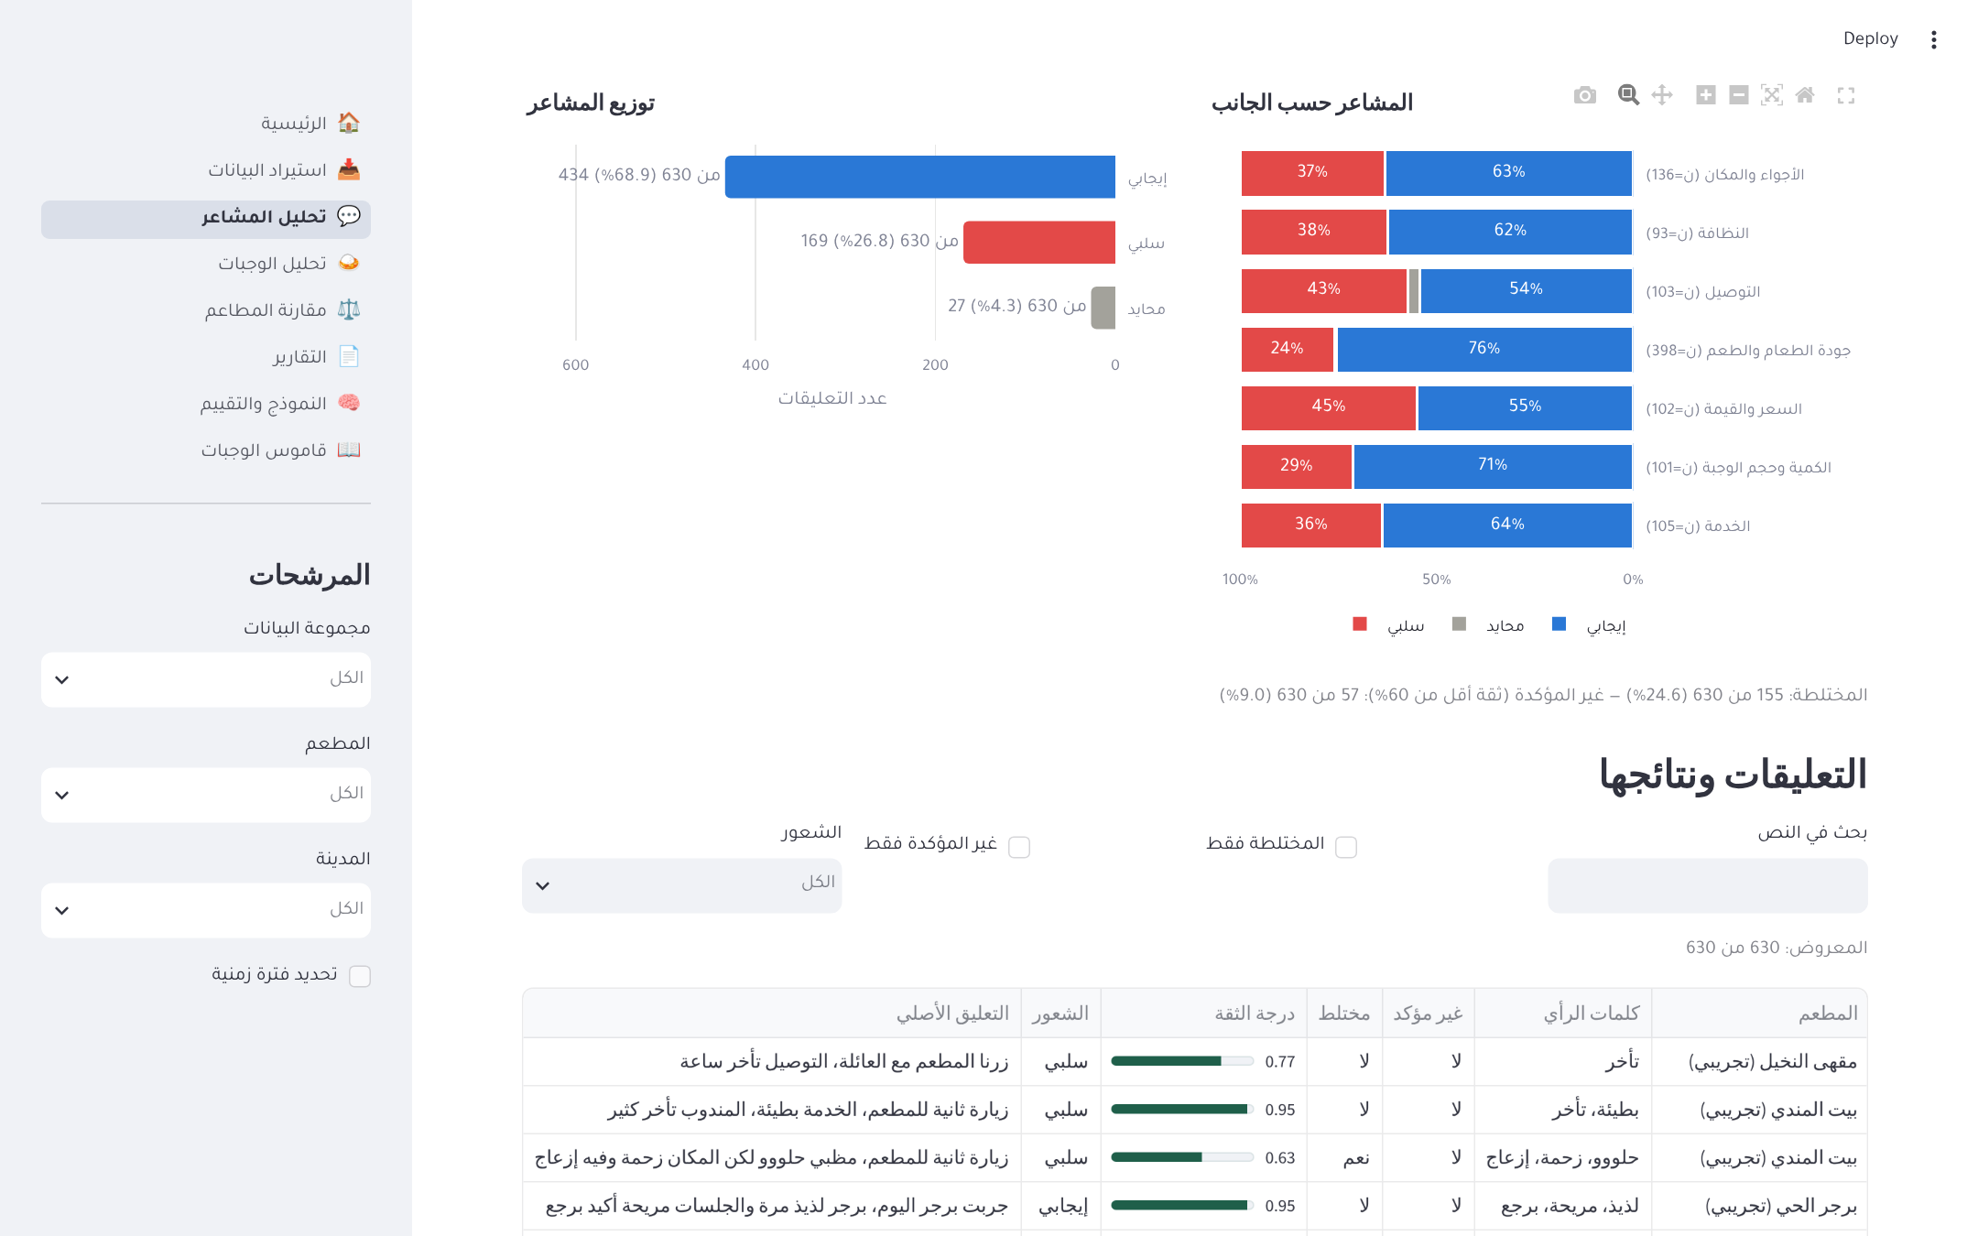
Figure 4.5: Sentiment distribution, sentiment by aspect and review results
The dish analysis page (Figure 4.6) shows the most-mentioned dishes, the sentiment towards each dish, a search for a single dish with the aspects linked to it, the strongest satisfaction and complaint aspects, the most frequent words and bigrams, and topics extracted automatically with non-negative matrix factorisation.
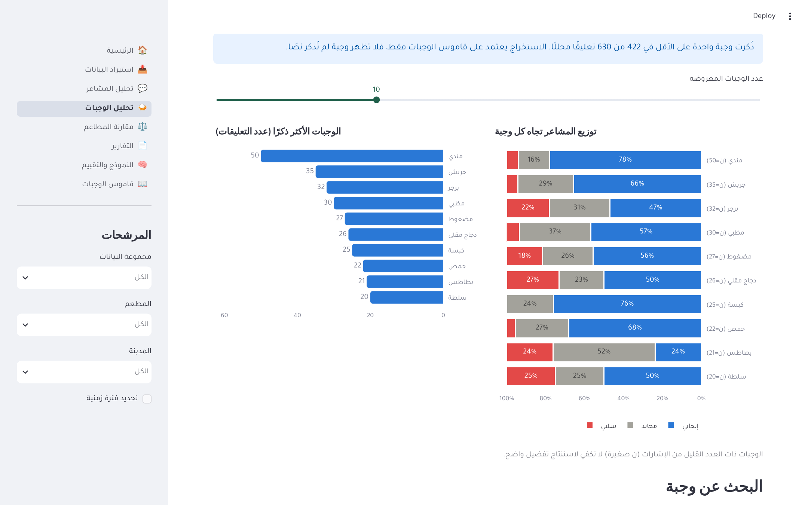
Figure 4.6: Dish analysis: most-mentioned dishes and sentiment towards each dish
The restaurant comparison page compares selected restaurants overall and by aspect (Figure 4.7), with a table of positive shares written as fractions (Figure 4.8). Below these, it shows the Wilson-based ranking, trends over time, and a comparison between cities restricted to recognised Saudi city names.
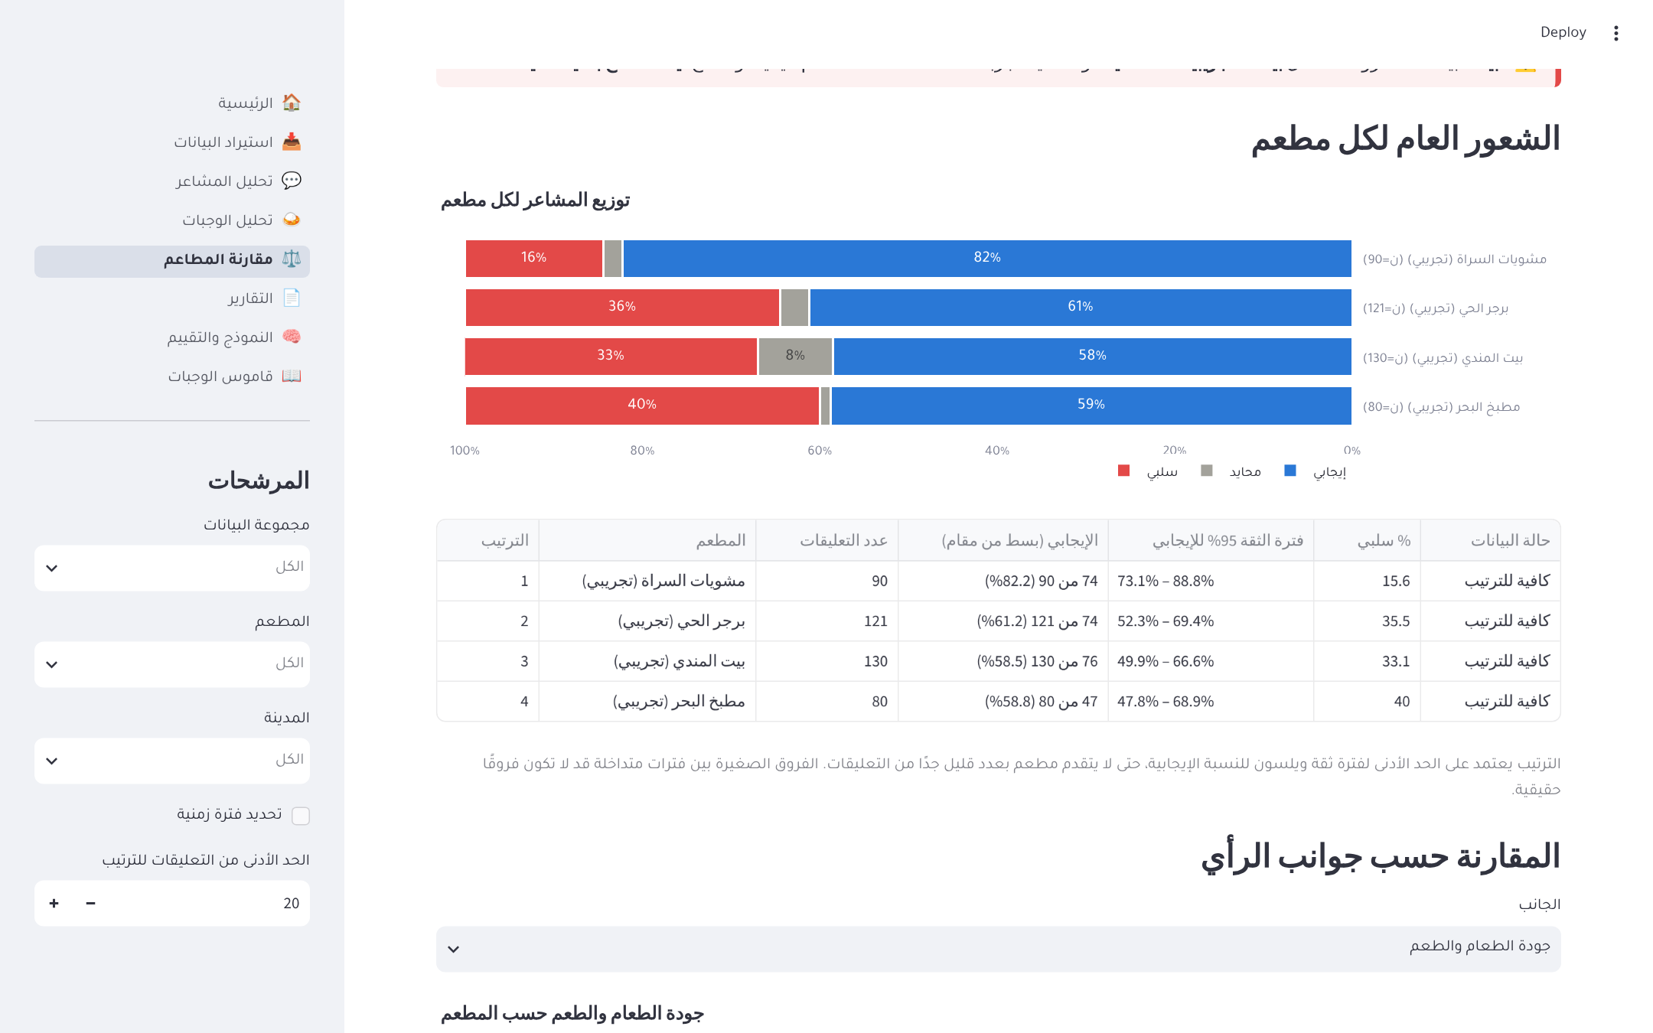
Figure 4.7: Restaurant comparison by aspect
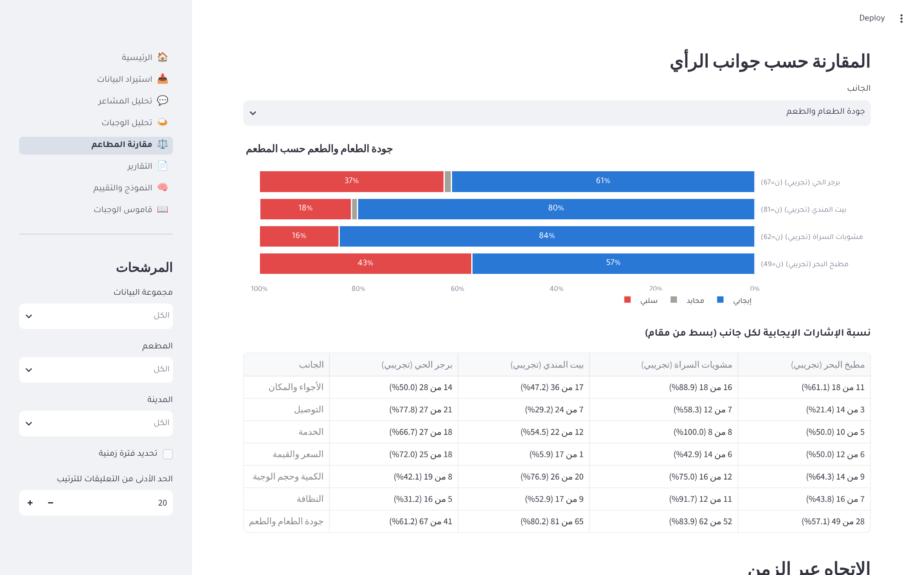
Figure 4.8: Positive share per aspect and restaurant, shown as numerator out of denominator
The reports page (Figure 4.9) lets the user choose restaurants and a period, shows the statistical summary, aspect and dish tables, examples of complaints and praise, recommendations and methodological caveats, and exports the report. Figure 4.10 shows the first page of a generated Arabic PDF report.
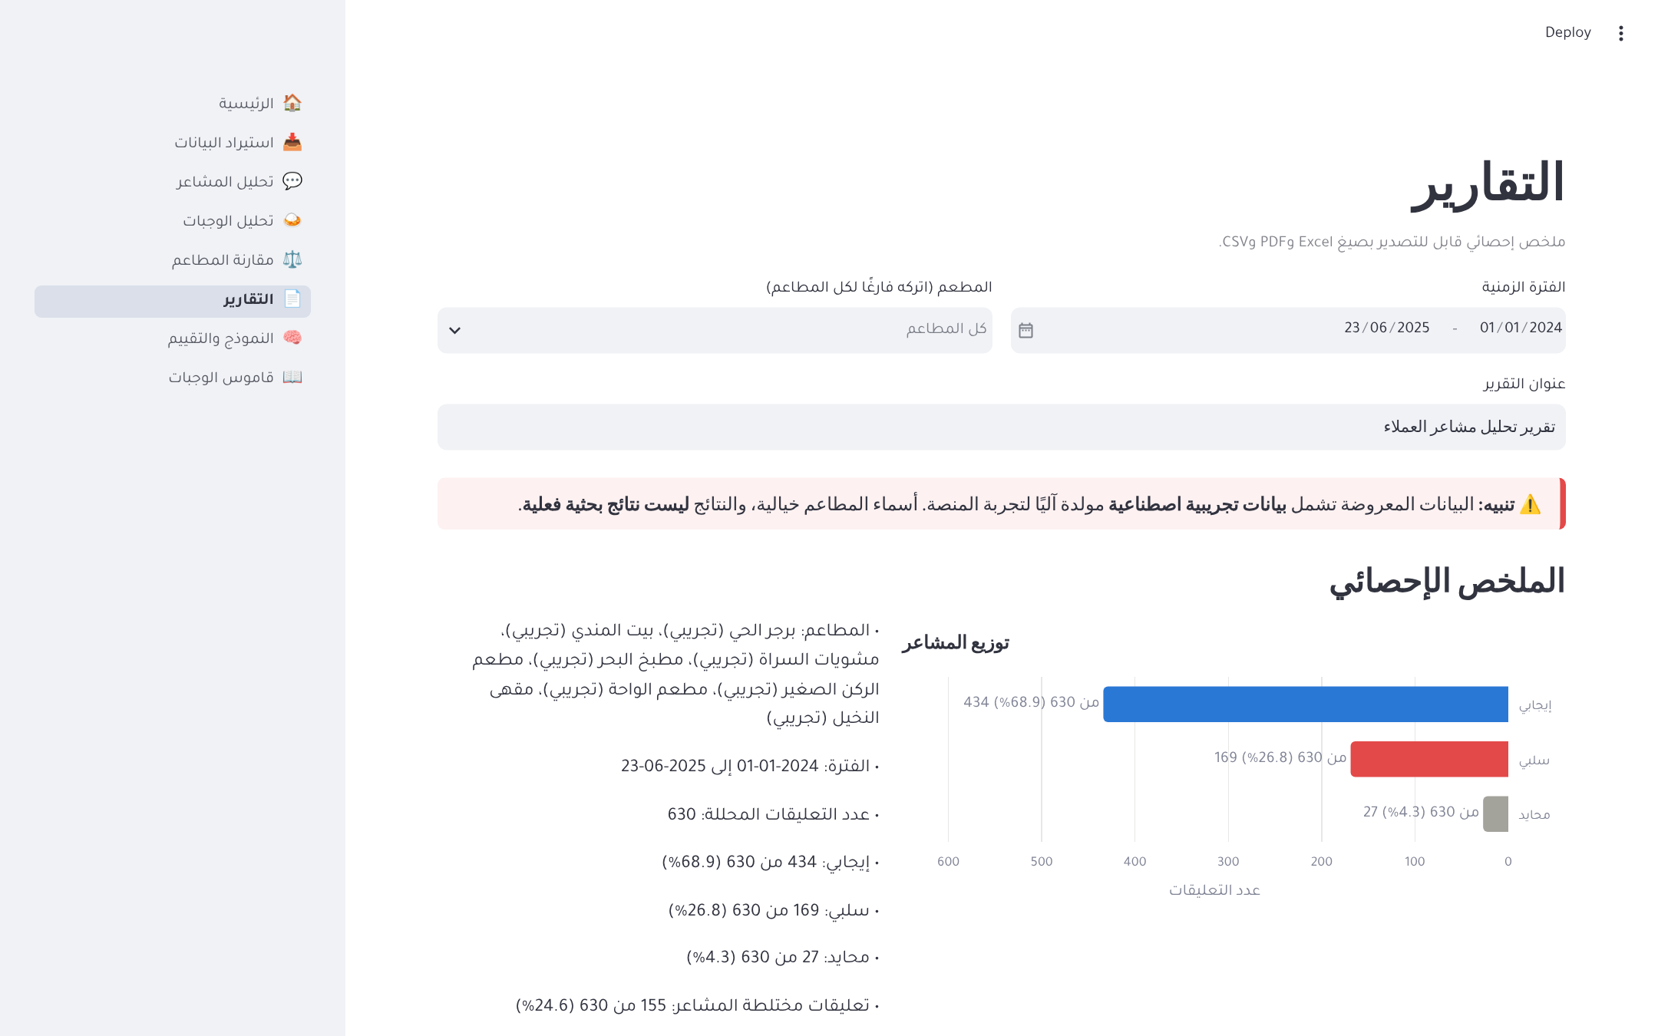
Figure 4.9: Reports page
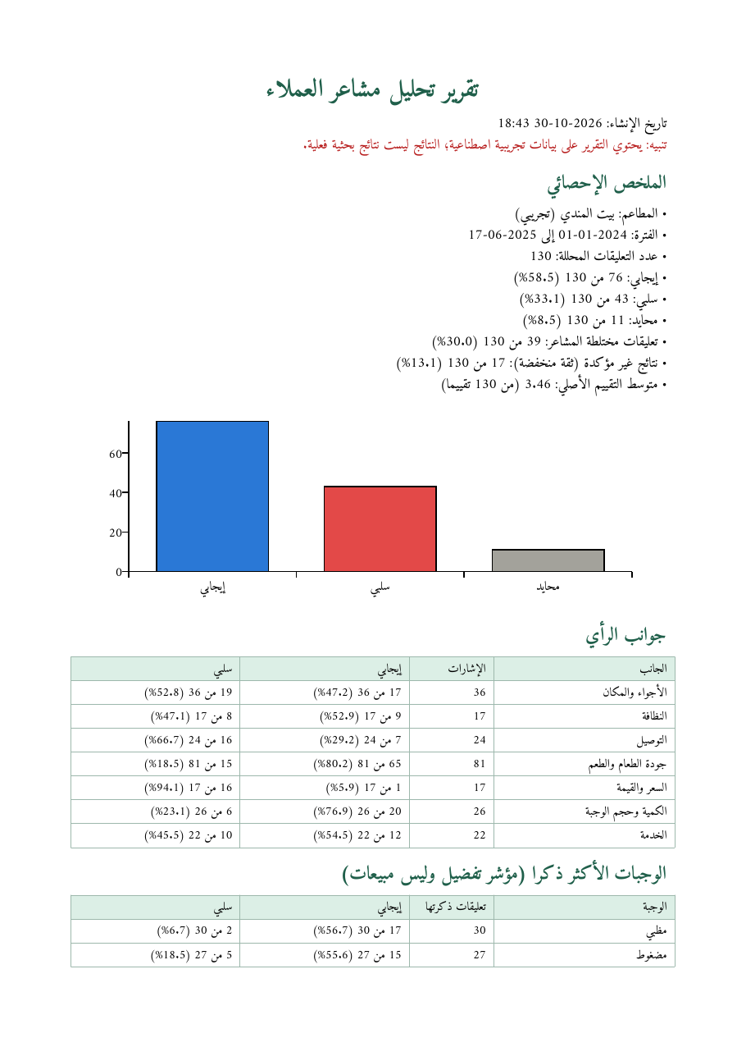
Figure 4.10: First page of a generated Arabic PDF report
The model and evaluation page (Figure 4.11) trains the scikit-learn model with labels from a label column or derived from star ratings, reports accuracy, macro-F1, per-class metrics and the confusion matrix on held-out data, compares stored results with original labels, and explains the optional Hugging Face model. The dish dictionary page lets the user edit dishes, categories and synonyms and test extraction on any sentence.
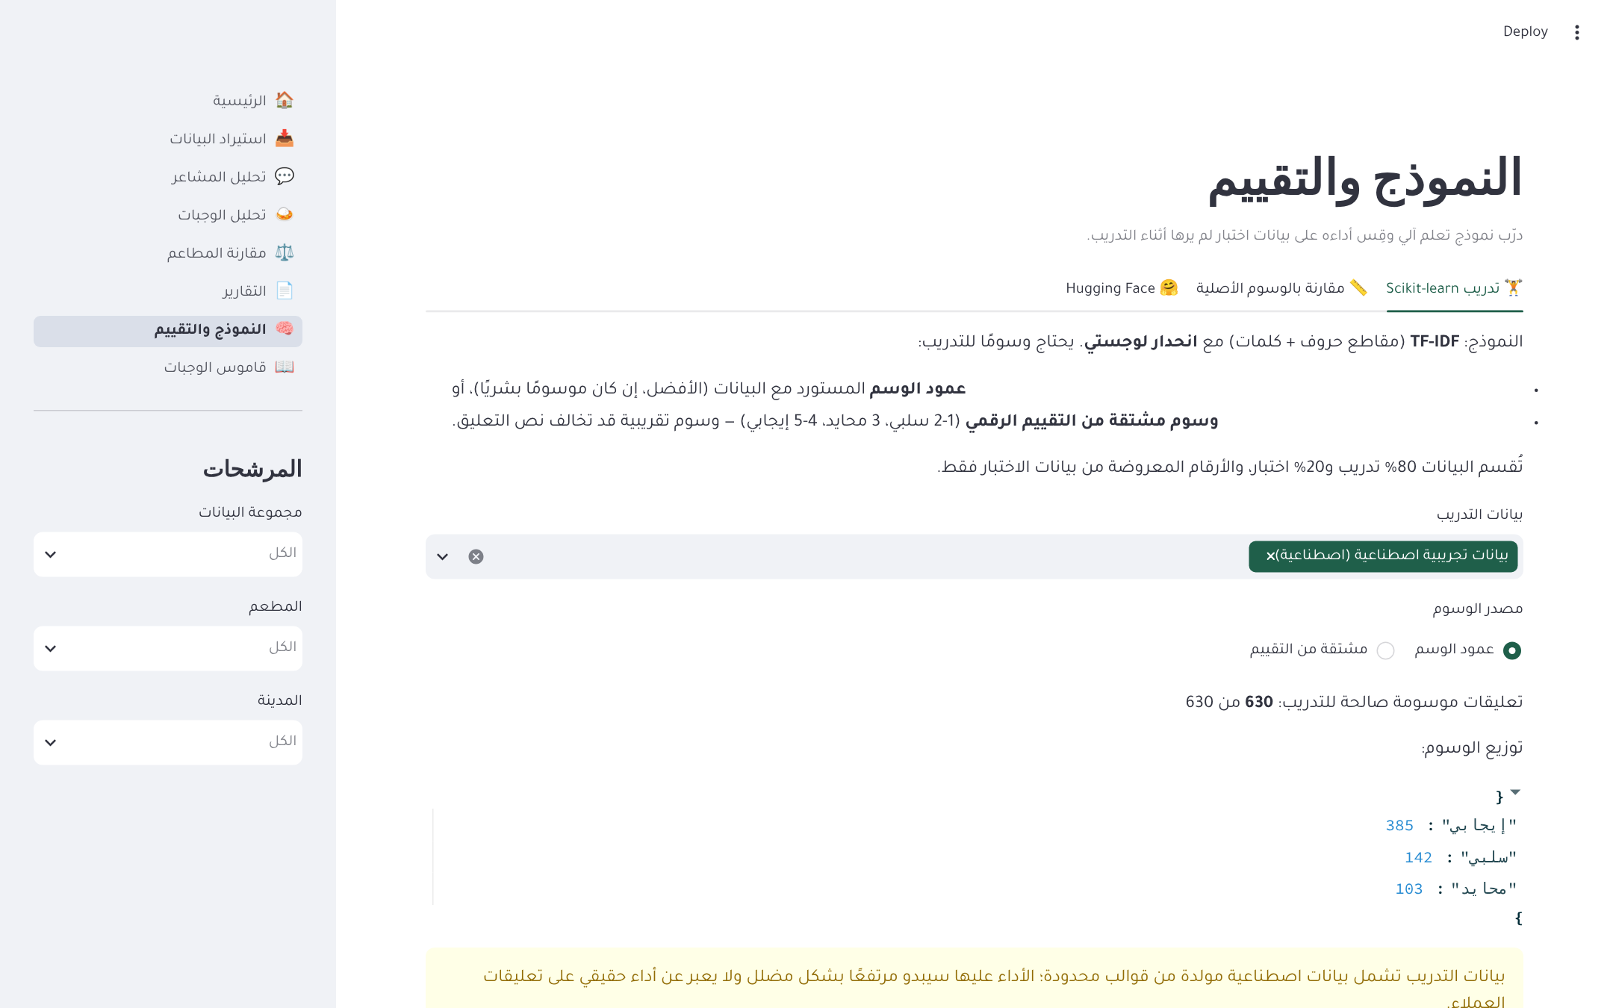
Figure 4.11: Model training and evaluation page

4.6.4 Testing
The platform has 129 automated tests written with Pytest (Table 4.7). They use a temporary database for every test, so they never touch the user's data. Every defect found during development, including the two found by the error analysis, received a regression test that prevents it from returning.
Table 4.7: Automated tests by area
Test file | Tests | What is tested
test_sentiment.py | 34 | Overall labels, negation, mixed reviews, multiple aspects, implicit and conditional words, absence, dish linking, evidence, confidence, lexicon additions and fixed defects
test_ui_smoke.py | 17 | Every page renders without error with an empty database and with data; the demo button works
test_aqte.py | 12 | Loading all file formats, scale detection, aspect mapping of all 29 categories, gold labels, evaluation, error analysis
test_reports_connectors.py | 12 | Excel (right-to-left) and PDF export, report content, API connector with mocked responses, dataset profiling
test_importer.py | 11 | Encodings, delimiters, Excel, Parquet and JSON, column suggestion, validation counts, label and rating conversion
test_pipeline_analytics.py | 11 | End-to-end analysis, filters, distributions, Wilson ranking, minimum-sample rule, cities, trends, keywords, topics
test_text_processing.py | 11 | Cleaning, normalisation options, negation kept, emojis kept, masking, duplicates, clause splitting, morphological variants
test_database.py | 8 | Schema, foreign keys, check constraints, de-duplication, name unification, cascades, integrity report
test_dishes.py | 7 | Synonyms, prefixes, elongation, longest match, no invented dishes, custom dictionaries
test_models.py | 6 | Training, saving and loading, rejection of invalid labels, Transformer label mapping
Total | 129

In addition to the automated tests, the interface was checked visually by rendering every page in a headless browser and inspecting screenshots, and the generated PDF reports were rendered to images to verify Arabic shaping and right-to-left order.

4.6.5 Installation and Running
The platform requires Python 3.10 or later. After the project is downloaded, it is installed and started with the following commands on Windows (Appendix A gives the full guide):
cd saudi_restaurant_analytics
python -m venv .venv
.venv\Scripts\activate
pip install -r requirements.txt
streamlit run app.py
The browser then opens the platform at http://localhost:8501. The database is created automatically on first use.

Chapter 5: Results and Discussion
This chapter summarises what the project delivered, reports the evaluation results on the AQTE dataset, answers the three research questions, discusses the errors and limitations of the analyser, and evaluates the project against its objectives.

5.1 Project Summary
The project delivered a complete, tested platform for analysing Arabic restaurant reviews. Its main components are an Arabic text-processing module, a lexicon- and rule-based aspect-based sentiment analyser for Modern Standard Arabic and Saudi dialect, a dictionary-based dish extractor, a scikit-learn baseline, a SQLite database with enforced integrity, an Arabic right-to-left web interface of eight pages, Excel and Arabic PDF reports, and a set of command-line tools for evaluation and error analysis on the AQTE dataset. The analyser was improved over four versions on training data only, frozen at version 1.3, and evaluated once on the held-out test split.

5.2 Evaluation Results

5.2.1 What Customers Write About
Before evaluating the models, the AQTE annotations themselves show which aspects customers write about. Figure 5.1 maps the 63,620 annotated opinions to the platform's aspects. Food quality dominates with 30,261 opinion mentions, followed by service with 11,985; price, ambiance and cleanliness follow at a distance; and quantity (1,110) and delivery (676) are rare. A further 9,720 opinions belong to general categories such as ‎"المطعم"‎ (the restaurant) and ‎"التجربة"‎ (the experience). In the training split, 65.5% of the opinions are positive (36,421), 25.2% negative (14,035) and 9.3% neutral (5,161).
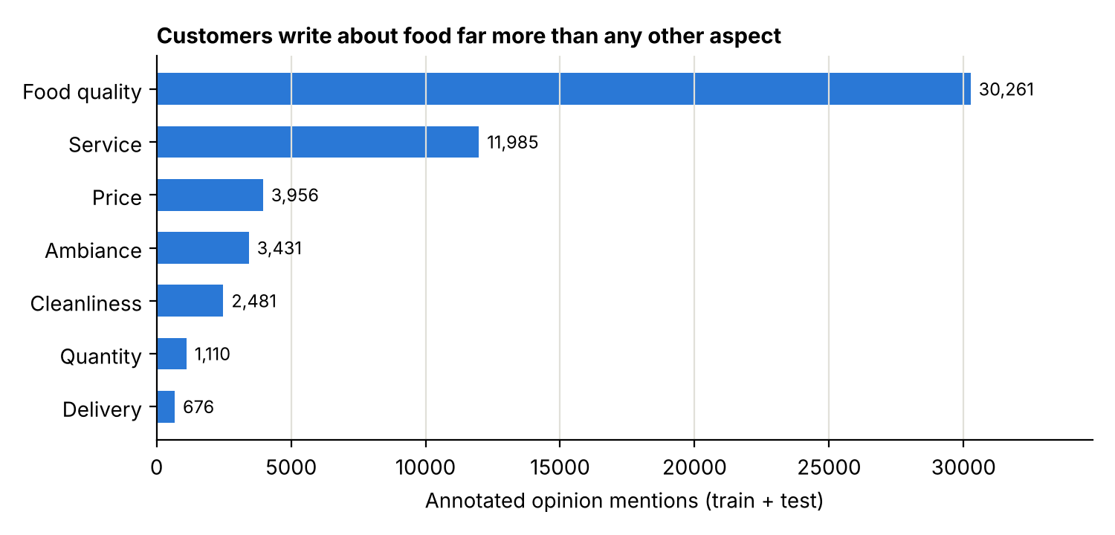
Figure 5.1: Annotated opinion mentions per platform aspect in AQTE (training and test splits)
This imbalance shapes everything that follows. The analyser has many examples of food and service language to learn from during development but very few of delivery and quantity, and a classifier that ignored the neutral class would lose little accuracy, which is why macro-F1 is the primary measure.

5.2.2 Development Results
On the development sample of 2,000 training reviews, the final lexicon (version 1.3) achieved an overall-sentiment accuracy of 0.820 and a macro-F1 of 0.614 against the AQTE opinions, compared with 0.703 and 0.275 for the majority-class baseline. Per class, F1 was 0.91 for positive, 0.74 for negative and 0.19 for neutral. Aspect detection reached a micro-averaged precision of 0.853, recall of 0.779 and F1 of 0.814, and the sentiment of correctly detected aspects was right in 89.9% of cases. Figure 5.2 shows aspect-detection F1 per aspect.
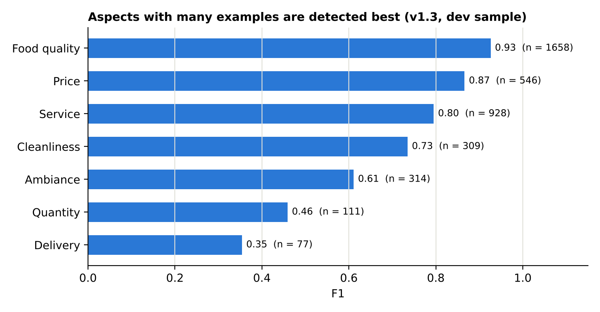
Figure 5.2: Aspect-detection F1 per aspect on the development sample (lexicon v1.3)

5.2.3 Final Results on the Test Split
The final evaluation was run once on the 1,908 reviews of the test split. Table 5.1 reports overall sentiment against the primary reference (AQTE opinions), and Table 5.2 against the secondary reference (star ratings).
Table 5.1: Overall sentiment on the test split against AQTE opinions
Model | Accuracy | Macro-F1 | F1 positive | F1 negative | F1 neutral
Majority baseline (always positive) | 0.688 | 0.272 | 0.82 | 0.00 | 0.00
Lexicon analyser v1.3 | 0.819 | 0.595 | 0.91 | 0.73 | 0.14
scikit-learn (TF-IDF + logistic regression) | 0.869 | 0.684 | 0.93 | 0.86 | 0.26

Table 5.2: Overall sentiment on the test split against star ratings
Model | Accuracy | Macro-F1
Majority baseline (always positive) | 0.691 | 0.273
Lexicon analyser v1.3 | 0.794 | 0.567
scikit-learn (TF-IDF + logistic regression) | 0.823 | 0.643

Table 5.3 reports aspect detection and aspect sentiment on the test split.
Table 5.3: Aspect detection and aspect sentiment on the test split (lexicon v1.3)
Aspect | Reference mentions | Precision | Recall | F1 | Sentiment accuracy
Food quality | 1,561 | 0.956 | 0.895 | 0.925 | 0.925
Price | 492 | 0.900 | 0.807 | 0.851 | 0.827
Quantity | 156 | 0.506 | 0.776 | 0.613 | 0.775
Service | 1,018 | 0.970 | 0.697 | 0.811 | 0.941
Delivery | 61 | 0.500 | 0.344 | 0.408 | 0.800
Cleanliness | 304 | 0.804 | 0.730 | 0.766 | 0.954
Ambiance | 340 | 0.581 | 0.788 | 0.669 | 0.837
All aspects (micro) | 3,932 | 0.859 | 0.797 | 0.827 | 0.903

The test results are very close to the development results: accuracy 0.819 against 0.820, macro-F1 0.595 against 0.614, aspect-detection F1 0.827 against 0.814, and aspect-sentiment accuracy 0.903 against 0.899. Because the lexicon was built only on training data and the test split was used once, this agreement indicates that the lexicon did not over-fit the development sample and that its performance generalises to unseen reviews. The small drop in macro-F1 comes almost entirely from the neutral class (F1 0.14 against 0.19). Against star ratings both models score lower than against the AQTE opinions, as expected for a noisier reference, but their ranking does not change. Per aspect, food quality, price and service exceed an F1 of 0.80; service has the highest precision (0.97) but misses about 30% of its mentions; quantity and ambiance are detected too eagerly (precision 0.51 and 0.58); and delivery, with only 61 reference mentions, remains the weakest (F1 0.41).

5.3 Answers to the Research Questions

RQ1: Accuracy of the lexicon-based analyser
On the held-out test split the lexicon analyser reached an accuracy of 0.819 and a macro-F1 of 0.595 against the AQTE opinions, compared with 0.272 for the majority baseline, and an aspect-detection F1 of 0.827 (precision 0.859, recall 0.797). The sentiment of correctly detected aspects was right in 90.3% of cases. The analyser is strong where language is frequent and explicit (food, price and service) and on clearly positive or negative reviews. It is weak on the neutral class and on rarely mentioned aspects (delivery and quantity). The answer to RQ1 is therefore that a transparent, dialect-aware lexicon analyser is accurate enough to be useful for positive, negative and frequent aspects, but its neutral judgements and its results for rare aspects should be read with caution.

RQ2: Lexicon versus machine learning
For overall sentiment, the supervised scikit-learn model outperformed the lexicon analyser on the test split: macro-F1 0.684 against 0.595 and accuracy 0.869 against 0.819 (Table 5.1), with the same ranking against star ratings (0.643 against 0.567, Table 5.2). The largest gap is in the negative class (F1 0.86 against 0.73): the confusion matrices show that the lexicon labelled 100 of the 472 negative reviews as positive and 80 as neutral, whereas the model misclassified only 47. Trained on about 12,900 labelled reviews, the model learns complaint vocabulary and phrasings that the lexicon does not contain, including implicit complaints without opinion words. The lexicon, however, needs no labelled data, produces aspect-level results with an aspect-sentiment accuracy of 90.3%, and explains every decision with its evidence, none of which the model provides. The answer to RQ2 is therefore that machine learning is more accurate for the overall label, while the lexicon remains necessary for aspect analysis and explainability; the two are complementary, which motivates the hybrid approach proposed in Chapter 6.

RQ3: Aspects and dishes associated with satisfaction and complaints
The annotations show that food is by far the most discussed aspect, followed by service (Figure 5.1). [Insert from the platform, after analysing the training split: which aspects have the highest share of positive mentions (strengths), which have the highest share of negative mentions (complaints), and which dishes are mentioned most and with what sentiment. Present dish mentions as preference indicators, not sales.]

5.4 Discussion

5.4.1 Why the Neutral Class Is Difficult
The neutral class was the weakest in every measurement (F1 of 0.19 on the development sample and 0.14 on the test split for the lexicon, and 0.26 for the scikit-learn model). Three factors explain this. First, neutral reviews are rare (about 8% of the development sample), so few errors cost a large share of the class. Second, the boundary between neutral and mildly positive is blurred in practice: ‎"عادي"‎ (ordinary) or ‎"لا بأس"‎ (not bad) can be read either way. Third, a review annotated as neutral overall often contains both praise and complaints that cancel out in the reference labels, while the analyser weights the clause after ‎"بس"‎ more heavily and therefore leans to one side. The confusion matrices show that most neutral reviews were predicted as positive (87 of 123 on the test split). The neutral class is also the hardest in shared evaluations of Arabic sentiment, which is why some benchmarks report F1 over the positive and negative classes only (Abu Farha et al., 2021); it is a known limitation of lexicon methods.

5.4.2 Rare Aspects
Delivery and quantity had the lowest F1 because they have few examples and varied vocabulary. Delivery language often names applications or describes events (‎"وصل بارد"‎, it arrived cold) rather than using a fixed keyword, and words such as ‎"يكفي"‎ (enough) improved quantity recall but also produced false positives, lowering its precision. With more examples, or with a supervised aspect classifier, these aspects would likely improve.

5.4.3 Other Sources of Error
- Sarcasm: a sentence such as ‎"يا سلام على السرعة"‎ (what wonderful speed!) after a long wait is read literally as positive.
- Implicit opinions: statements of fact such as ‎"ماعطوني الا بخمسة وانا كان ودي ب ٢٠"‎ (they only gave me five when I wanted twenty) express a complaint without any opinion word.
- Ambiguous words: ‎"الطلب"‎ (the order) refers to service, delivery and food alike, so it was deliberately not used as an aspect keyword, which lowers recall slightly.
- Reference labels: the star rating is an approximate reference; customers often give five stars while complaining in the text, which is why it was used only as a secondary reference.

5.4.4 Lessons From the Development Process
Two lessons stand out. First, systematic error analysis found real software defects, not only missing words: single-word phrases were never matched, and aspect words with pronoun suffixes were missed because of the ta marbuta change. Fixing them gave the largest single improvement in recall. Second, evaluation tools need the same scrutiny as models. The misread sentiment scale (Section 3.7.4) was detected only because a result was implausible, a negative class of size zero; the tool now prints the scale and the values it observed on every run. Both lessons were recorded in a change log and protected by regression tests.

5.5 System Benefits
- Time saved: thousands of reviews are analysed in seconds instead of being read by hand.
- Actionable detail: results by aspect and by dish show not only whether customers are satisfied, but with what.
- Explainability: every decision is backed by opinion words and the supporting clause, which builds trust and makes errors easy to spot.
- Honest reporting: uncertainty and mixed opinions are shown, comparisons show their sample sizes, and restaurants with too few reviews are not ranked.
- Low cost, privacy and Arabic-first design: the platform runs locally with free software, stores no personal identifiers, needs no cloud account, and is designed for Arabic and Saudi dialect from the start.
- Reproducible research: evaluation and error analysis are single commands, and every lexicon version is documented.

5.6 Challenges Faced During Development
Table 5.4: Challenges and how they were addressed
Challenge | How it was addressed
The development environment could not access the Hugging Face website, so the dataset structure could not be inspected there | No column names were assumed; the importer was made fully configurable; the dataset was inspected through screenshots of its viewer and files before any code relied on its structure
The optional libraries had no prebuilt packages for the newest Python version on Windows | Core functionality kept free of these libraries; the importer was extended to read Parquet and JSON so datasets can be used without them
ReportLab does not shape Arabic or order it right to left | Lines wrapped in logical order, then shaped with arabic-reshaper and reordered with python-bidi, using the Amiri font
Mixed Arabic and Latin text displayed in the wrong order in diagrams | Diagrams explicitly set to right-to-left direction and checked visually
The sentiment scale of AQTE was initially misread | Detected from an implausible result, corrected, documented and protected by automatic scale detection
Dialectal and spelling variation | Normalisation, prefix and suffix variants, ta marbuta restoration, squeezed forms for elongation, and iterative lexicon development
Risk of over-fitting the lexicon to the test data | Strict separation: development on training data only, test split frozen and used once
21 duplicate reviews found when importing the training split | De-duplication with an option to keep duplicates; the decision is documented and does not affect evaluation, which reads the original files

5.7 Project Evaluation and Impact
Table 5.5 evaluates the project against the objectives set in Chapter 1.
Table 5.5: Achievement of the project objectives
Objective | Status | Evidence
1. Arabic text processing that keeps sentiment signals | Achieved | Section 3.3; 11 tests
2. Aspect-based sentiment analyser for MSA and Saudi dialect | Achieved | Sections 3.4 and 5.2; 34 tests
3. Dish extraction without invented dishes | Achieved | Section 3.5; 7 tests
4. Machine-learning baseline and comparison | Achieved | Sections 3.6 and 5.3
5. Relational database with integrity | Achieved | Section 4.5.3; 8 tests
6. Arabic RTL interface and reports | Achieved | Section 4.6.3; 17 interface tests
7. Evaluation on real annotated Saudi data | Achieved | Section 5.2; held-out test split

The project's main impact is to show that Saudi restaurant reviews can be analysed at the aspect level with a transparent, low-cost and locally running system whose strengths and weaknesses are measured honestly on real data. For restaurant owners it offers a practical decision-support tool; for researchers it offers a reproducible evaluation framework and a documented dialect lexicon that can serve as a baseline for future models.

Chapter 6: Conclusion and Future Work

6.1 Conclusion
This project set out to help Saudi restaurants and researchers make use of the large volume of informal Arabic reviews that customers publish online. It designed, implemented and evaluated an AI platform that analyses these reviews at the aspect level, extracts the dishes customers mention, and presents the results in an Arabic, right-to-left interface with dashboards, comparisons and reports.
The core of the platform is a transparent lexicon- and rule-based analyser built for Modern Standard Arabic and Saudi dialect. It handles negation, intensification, contrast, implicit and aspect-dependent opinions, and it reports the evidence and the uncertainty of every decision. It was developed iteratively on training data from AQTE, a public dataset of 14,783 real Saudi restaurant reviews from Google Maps, and evaluated once on a held-out test split. Over four lexicon versions, aspect-detection F1 on the development sample rose from 0.775 to 0.814. When an aspect was detected, its sentiment was right in about nine cases out of ten, and the analyser clearly outperformed a majority-class baseline for overall sentiment. On the held-out test split it reached an aspect-detection F1 of 0.827 and an overall-sentiment macro-F1 of 0.595, close to its development results; a supervised scikit-learn model was more accurate for the overall label (macro-F1 0.684) but cannot provide aspects or explanations, which makes the two approaches complementary.
The evaluation also showed where the approach is weak: the neutral class, rarely mentioned aspects such as delivery and quantity, sarcasm, and opinions expressed without opinion words. These limitations are reported openly in the platform itself, which flags uncertain and mixed results, shows sample sizes and refuses to rank restaurants with too few reviews.
Beyond its results, the project demonstrates a development practice that matters for applied NLP: inspect the data before writing code, keep the test data untouched, analyse errors systematically, protect every fix with a test, and scrutinise the evaluation tools as carefully as the models. Following this practice uncovered two software defects and one evaluation error that would otherwise have distorted the results.

6.2 Limitations
- The analyser is lexicon-based, so it cannot recognise opinion words that are not in its lexicon, and it misreads sarcasm.
- The neutral class and the delivery and quantity aspects have low accuracy.
- AQTE identifies restaurants only by their Google Maps identifiers and has no dates or cities, so comparisons between named restaurants, cities and periods could be demonstrated only with other data.
- The mapping of the 29 AQTE categories to seven aspects is a researcher's decision that affects the aspect results.
- Dish mentions are preference indicators inferred from text; without sales data, they cannot measure what customers actually buy.
- Pre-trained Transformer models were supported but not fine-tuned or evaluated, because of time and hardware limits.

6.3 Future Improvements
- Fine-tune an Arabic Transformer model such as CAMeLBERT or AraBERT on AQTE, both for overall sentiment and as an aspect classifier, using a GPU environment such as Google Colab, and compare it with the current results.
- Hybrid analysis: combine the lexicon analyser, which provides evidence and aspects, with a supervised model, which provides vocabulary coverage, for example by using the model when the lexicon is uncertain.
- Improve the neutral class with explicit neutral expressions, calibrated thresholds tuned on the training data, and possibly a separate "mixed" category in the evaluation.
- Expand rare aspects by adding delivery and quantity expressions from more data and by learning aspect keywords automatically from annotated quotes.
- Sarcasm and numeric prices: detect sarcasm using resources such as ArSarcasm-v2 (Abu Farha et al., 2021), and interpret prices written as numbers (for example ‎"300 ريال"‎) so that price complaints without opinion words are recognised.
- Richer data: collect reviews with restaurant names, dates and cities through official channels, with consent, to enable trend and city analysis on real data.
- Deployment: provide a hosted version with user accounts for restaurant chains, scheduled imports from official exports, automatic monthly reports, and confidence scores calibrated on annotated data.

References
Abdelgwad, M. M., Soliman, T. H. A., Taloba, A. I., & Farghaly, M. F. (2022). Arabic aspect based sentiment analysis using bidirectional GRU based models. Journal of King Saud University – Computer and Information Sciences, 34, 6652–6662. https://doi.org/10.1016/j.jksuci.2021.08.030
Abdul-Mageed, M., Elmadany, A., & Nagoudi, E. M. B. (2021). ARBERT & MARBERT: Deep bidirectional transformers for Arabic. In Proceedings of the 59th Annual Meeting of the Association for Computational Linguistics and the 11th International Joint Conference on Natural Language Processing (ACL-IJCNLP 2021) (pp. 7088–7105). Association for Computational Linguistics. https://doi.org/10.18653/v1/2021.acl-long.551
Abu Farha, I., Zaghouani, W., & Magdy, W. (2021). Overview of the WANLP 2021 shared task on sarcasm and sentiment detection in Arabic. In Proceedings of the Sixth Arabic Natural Language Processing Workshop (pp. 296–305). Association for Computational Linguistics.
Al-Dabet, S., Tedmori, S., & Al-Smadi, M. (2021). Enhancing Arabic aspect-based sentiment analysis using deep learning models. Computer Speech & Language, 69.
Alharbi, L. M., & Qamar, A. M. (2022). Arabic sentiment analysis of eateries' reviews using deep learning. Ingénierie des Systèmes d'Information, 27(3), 503–508.
AlMasaud, A., & Al-Baity, H. H. (2023). AraMAMS: Arabic multi-aspect, multi-sentiment restaurants reviews corpus for aspect-based sentiment analysis. Sustainability, 15(16), 12268. https://doi.org/10.3390/su151612268
Almuqren, L., & Cristea, A. (2021). AraCust: A Saudi telecom tweets corpus for sentiment analysis. PeerJ Computer Science, 7, e510. https://doi.org/10.7717/peerj-cs.510
Al-Thubaity, A., Alkhereyf, S., Murayshid, H., Alshalawi, N., Omirah, M., Alateeq, R., Almutairi, R., Alsuwailem, R., Alhassoun, M., & Alkhanen, I. (2023). Evaluating ChatGPT and Bard AI on Arabic sentiment analysis. In Proceedings of ArabicNLP 2023 (pp. 335–349). Association for Computational Linguistics. https://doi.org/10.18653/v1/2023.arabicnlp-1.27
bayandashnan. (2026). AQTE: Arabic Quote & Triplet Extraction dataset [Data set]. Hugging Face. https://huggingface.co/datasets/bayandashnan/AQTE-Arabic-Quote-Triplet-Extraction [replace with the citation given on the dataset page, if any]
Bensoltane, R., & Zaki, T. (2022). Aspect-based sentiment analysis: An overview in the use of Arabic language. Artificial Intelligence Review, [volume(issue), pages]. https://doi.org/10.1007/s10462-022-10215-3
Inoue, G., Alhafni, B., Baimukan, N., Bouamor, H., & Habash, N. (2021). The interplay of variant, size, and task type in Arabic pre-trained language models. In Proceedings of the Sixth Arabic Natural Language Processing Workshop (pp. 92–104). Association for Computational Linguistics.
Jurafsky, D., & Martin, J. H. (2026). Speech and language processing (3rd ed. draft). Stanford University. https://web.stanford.edu/~jurafsky/slp3/
Khondaker, M. T. I., Waheed, A., Nagoudi, E. M. B., & Abdul-Mageed, M. (2023). GPTAraEval: A comprehensive evaluation of ChatGPT on Arabic NLP. In Proceedings of the 2023 Conference on Empirical Methods in Natural Language Processing (pp. 220–247). Association for Computational Linguistics.
scikit-learn developers. (2026). scikit-learn: Machine learning in Python [Documentation]. https://scikit-learn.org/stable/
Shi, Z., & Agrawal, R. (2025). A comprehensive survey of contemporary Arabic sentiment analysis: Methods, challenges, and future directions. In Findings of the Association for Computational Linguistics: NAACL 2025 (pp. 3760–3772). Association for Computational Linguistics.
Streamlit Inc. (2026). Streamlit documentation. https://docs.streamlit.io/
Zhang, W., Li, X., Deng, Y., Bing, L., & Lam, W. (2023). A survey on aspect-based sentiment analysis: Tasks, methods, and challenges. IEEE Transactions on Knowledge and Data Engineering, 35(11), 11019–11038. https://doi.org/10.1109/TKDE.2022.3230975

Appendices

Appendix A: Installation and User Guide
Requirements: Python 3.10 or later and Git (optional). The steps below are for Windows; on macOS or Linux use python3 and source .venv/bin/activate.
1. Download the project from the GitHub repository (branch claude/practical-shannon-77t9ub), either as a ZIP file or with:
git clone -b claude/practical-shannon-77t9ub https://github.com/Amer-omran/biobank.git
2. Create and activate a virtual environment, and install the libraries (once):
cd biobank\saudi_restaurant_analytics
python -m venv .venv
.venv\Scripts\activate
pip install -r requirements.txt
3. Start the platform (each time):
cd biobank\saudi_restaurant_analytics
.venv\Scripts\activate
streamlit run app.py
4. Use it: the browser opens at http://localhost:8501. To try it quickly, press ‎"تحميل البيانات التجريبية وتحليلها"‎ on the home page. To analyse real data, import a file on the ‎"استيراد البيانات"‎ page, choose the columns, run the analysis on the ‎"تحليل المشاعر"‎ page, and explore the other pages.
5. Reproduce the evaluation (after downloading train_split.json and test_split.json from the AQTE page into the project folder):
python scripts/evaluate_aqte.py test_split.json --train train_split.json
python scripts/error_analysis_aqte.py train_split.json --limit 2000
python scripts/prepare_aqte.py train_split.json
6. Run the automated tests:
python -m pytest

Appendix B: Lexicon Change Log
Table 6.1: Lexicon changes by version
Version | Changes | Reason
1.1 | Added جيد، كويس، اخلاق، احترام، ترحيب، اشكر، بطل، تجنن، فاخر; the phrases ‎"لا بأس"‎ and ‎"زي العسل"‎; raised ‎"معقول"‎ to 0.8; made speed words conditional (delivery if mentioned, otherwise service); new aspect keywords طعام، قهوة، مشروبات، حلويات، معمار، تصميم | Most frequent words in missed quotes on the training sample
1.2 | Restored ‎"عادي"‎ (−0.3) and ‎"زحمة"‎ (−0.7) | Their removal relied on misread labels and lowered macro-F1 against star ratings (0.603 → 0.584)
1.3 | Single-word phrases now matched (لاباس، ماشاءالله، ماقصروا، لايفوتكم); ta marbuta restored before suffixes (خدمتهم → خدمة) | Two software defects revealed by the second error analysis
1.3 | Quantity: راهية، يكفي، تكفي، كافي، موزونة، بخيل. Price: متناول، أغلى; aspect words شارج، مينيموم، ضريبة. Service: لطيف; waiting phrases; إدارة، صاحب المحل. Delivery: تغليف، سفري، أكياس، تطبيقات، يوصل. Cleanliness: نضيف، وصخ، ذبان، شعر، مكشوف، رائحة. Ambiance: هدوء، أجمل، مزدحم، قديم (place only). Neutral: متوسط. Rule: ‎"يحتاج + aspect"‎ treated as absence. Dishes: شوربة، بيض | Second error analysis (210 suggested terms)
1.3 (rejected) | Function words (عندهم، جربت، ولا، فقط، كله، يوجد، صراحه، يعتبر، عشان، ايش); names (ابو، حسن); ambiguous words (الطلب، ساعة alone، زيت، داخلية، خارجية); numeric prices | Not opinion or aspect words, or ambiguous between aspects

Appendix C: Example Analyser Outputs
The following outputs were produced by the final analyser (version 1.3):
Table 6.2: Example outputs of the analyser
Review | Overall | Aspects
الأكل لذيذ والخدمة سيئة | Neutral (mixed, uncertain) | Food quality: positive; Service: negative
ما عجبني الأكل بس الخدمة ممتازة | Positive (mixed) | Food quality: negative; Service: positive
الكبسة غالية مرة | Negative | Price: negative (linked to kabsa)
المكان مافي نظافة | Negative | Cleanliness: negative
الأكل والخدمة ممتازين | Positive | Food quality: positive; Service: positive
الاسعار متوسطة | Neutral | Price: neutral
الكمية ما تكفي | Negative | Quantity: negative
خدمتهم ممتازة | Positive | Service: positive
طلبت شاورما | Neutral (uncertain: no opinion) | Dish: shawarma, no opinion

Appendix D: Source Code Repository
The complete source code, tests, dish dictionary, lexicon change log and evaluation scripts are available in the project repository: https://github.com/Amer-omran/biobank (branch claude/practical-shannon-77t9ub, folder saudi_restaurant_analytics).

