**Simulation of a controlled water heating system with demand response remunerated on imbalance market pricing.**

M. Peeters1,2, T. Compernolle4, S. Van Passel5

1Antwerp Management School Boogkeers 5, 2000 Antwerpen, Belgium  
2Universiteit Antwerpen Prinsstraat 13, 2000 Antwerpen, Belgium [mp@smartbuilding.io](mailto:mp@smartbuilding.io)  
3AP Hogeschool Ellermanstraat 33, 2000 Antwerpen, Belgium [michael.peeters01@ap.be](mailto:michael.peeters01@ap.be)

4Universiteit Antwerpen Prinsstraat 13, 2000 Antwerpen, Belgium [tine.compernolle@uantwerpen.be](mailto:tine.compernolle@uantwerpen.be)

5Universiteit Antwerpen Prinsstraat 13, 2000 Antwerpen, Belgium [steven.vanpassel@uantwerpen.be](mailto:steven.vanpassel@uantwerpen.be)

Declarations of interest: none

April 2019

**Abstract**

Buildings are responsible for 40% of our worldwide energy consumption and 50% of this energy is converted for HVAC systems in buildings (e.g. for hot water). In this paper, we simulated the participation of a water heating system in the balancing of the electricity net. Here, the goal was to change the setpoint of the water heater and thus adapt the power consumption. The transmission system operator rewards active participation in delivering balanced energy. In our simulations, we replaced a standard on/off controller with an economic model predictive control (MPC) controller that takes its optimisation, energy cost, and reward for delivering balanced power into account. The outcome shows that the economic benefits of participating in delivering balanced power is significant. We show that the choice of an MPC controller is valid as it allows the setpoint to change if certain conditions are met. Simulations show that the controller often decides not to participate in delivering balanced power because the conditions are not optimal. With a normal controller, this choice would not be possible, which would lead to a sub-optimal revenue stream from selling flexibility. Simulations also show that the energy consumption goes up, which is permitted as the participation in net stabilisation allows the macro-system to integrate more renewable energy sources. Another conclusion is that the poorer the energy performance of the system, the more flexibility can be sold. From a policy point of view, a minimal energy performance should be determined before allowing participation in net stabilisation.

Keywords: demand response; economic model predictive control; flexibility

**Contents**

1. Introduction 3

2. Simulation Setups 8

2.1 Overview 9

2.2 Economic analysis 14

3. Results and Discussion 15

3.1 Conventional boiler and advanced control: Analysis of monthly net cash flows 15

3.2 Highly insulated boiler and advanced control: Analysis of monthly net cash flows 19

3.3 Net present value analysis 21

4. Conclusion 24

Bibliography 28

**List of figures and tables**

Figure 1. Consumption pattern over 24 hours. 15

Figure 2. POS unity price for 2017.. 21

Figure 3. NEG unity price for 2017.. 21

Table 1. Overview of results for the year 2017. 15

Table 2. Impact of augmenting the energy efficiency of the boiler. 20

Table 3*.* CaPex and OpEx overview 21

Table 4*.* Overview of the NPV for different scenarios 24

# Introduction

Buildings are responsible for about 40% of our worldwide energy consumption and about 50% of this energy is converted by the buildings HVAC (heating, ventilation, and air conditioning) systems. Part of this energy is sourced from renewable energy and the share is ever increasing (Razmara et al., 2017; Torriti, Hassan, & Leach, 2009). According to the European Union’s (EU) directive on renewable energy targets, 20% of energy should be sourced from renewable energy (European Commission, n.d., Renewable Energy). This objective has been translated into national action plans, where member states define how they will achieve this goal. A new target has now been set for 2030 that states that at least 27% of the EU’s final energy consumption needs to be sourced from renewable energy (European Commission, n.d., 2030 Energy Strategy).

The increasing share of renewable energy sources creates challenges to guaranteeing the stability of the net. While renewable energy sources are more environmentally friendly than the classical, carbon-based energy sources, they are more volatile, which could lead to an imbalance in the transmission grid. This imbalance relates to a difference between the supply and demand of power that could lead to a ‘brownout’ if left uncorrected. Meanwhile, a brownout is when the voltage drops enough to cause visible effects, such as, for example, the dimming of old-fashioned lightbulbs. If the energy shortage is severe, a brownout can become a blackout, which is when the system shuts down and no power is transported at all.

Power imbalances can also occur due to a sudden peak or drop in energy production (e.g. due to clouds blocking the sun, a drop in the wind, etc.). To keep supply and demand in equilibrium, balance responsible parties (BRP) or the transmission system operators (TSO) need to compensate for this sudden drop or peak in power (Xue, Wang, Sun, & Xiao, 2014). This compensation can be achieved on the supply side by modulating the active production units. However, for technological and economic reasons, classical power generation (nuclear or fossil fuel based) has limited and slow steering possibilities. The implementation of more flexible and faster fossil fuel-based generation units will involve higher economic costs and increase the environmental impact associated with their use. Due to the rigid supply side, a paradigm shift towards demand response (DR) has been introduced, the idea of which is to change the power consumption profile of different consumers, and as such, to compensate for the imbalance of the grid. One of these consumers are the HVAC systems in a building (Afram & Janabi-Sharifi, 2014; Ma, Qin, Salsbury, & Xu, 2011; Ma, Qin, & Salsbury, 2014).

The adoption of the HVAC system with a response to the grid’s demand is mostly realised with a form of advanced control of the system (Afram & Janabi-Sharifi, 2014; Ellis, Durand, & Christofides, 2014).The studies from Afram and Janabi-Sharifi, (2014) and Ellis, Durand and Christofides (2014) have shown that model predictive control (MPC) is applicable to different HVAC systems in terms of minimising the energy consumption and/or maximising comfort. MPC enhances the control of the technical installations in buildings by allowing the measurement of the state of the installation and predicting its future state based on a given model and data from different sources (e.g. weather forecasts, pricing information, etc.) (Prívara, Sirok´y, Ferkl, & Cigler, 2011). MPC carries out this simulation based on an embedded model of the system in the controller. In the controller, an optimisation of the control signal – which takes constraints into account – can be calculated before applying the control signal to the real system. Next to a cost savings potential of 17% to 24% on energy (Prívara et al., 2011), it is shown that it is possible to adapt the use of power where the technical constraints are given. Hence, by fine-tuning the set points of the installation, energy consumption can be minimised.

Optimising energy consumption for economic benefit triggered the development of an EMPC (economic model predictive control) controller. As shown in Ma et al. (2011), the difference between an EMPC and an MPC controller is that the optimisation for the former is calculated using economic data integrated with technical information. This makes it possible to take time of use (i.e. pricing based on when energy is used) and other time-dependent parameters (e.g. state of the net) into account while minimising the economic cost function. This means that the most optimal point is not always the lowest energy consumption, but the weighing of different technical and economic parameters.

The need for data to enable the optimisation and the functioning of the (E)MPC controller leads to smart buildings. Smart buildings generate data that can be used to more accurately predict the future state of the building’s technical installation. Here, not only can the state of the technical installation be predicted but also the future use of the building. The combination of these data sources reveals that a building’s technical installation can deliver flexibility in energy use without interfering with the activities in the building. The possibility of maximising the flexibility leads to a maximal effect of the control strategy (Avci, Erkoc, Rahmani, & Asfour, 2013). Hence, because of the flexibility they offer, smart buildings have the ability to resolve any imbalance in the net (Tang, Wang, & Yan, 2018).

Flexibility in buildings (i.e. the extent to which a building has the possibility to adapt its energy profile) is estimated and analysed using different models (De Coninck & Helsen, 2016; Klein, Herkel, Henning, & Felsmann, 2017; Razmara et al., 2017; Weber, 2017; Yin et al., 2016). Here, the common idea is that different parameters (e.g. temperature, airflow, cooling/heating power, etc.) can be changed to adapt the energy usage of technical installations in a building. While different definitions of flexibility are proposed, it is quantified throughout the literature as the ability of a system to lower or augment its power usage that leads to a change in energy consumption. However, the various studies only quantify flexibility in technical terms (i.e. the change in power usage) and do not value flexibility in economic terms.

In fact, flexibility could be a cure for imbalance within the net. When imbalance in the net occurs, the last resort for buying energy to compensate for the difference in supply and demand (imbalance) is an energy imbalance market. In this market, power can be bought to adjust the power usage profile in real time and restore balance. Every balance responsible party has the obligation to keep supply and demand in equilibrium for its portfolio. The energy imbalance market is the last means to achieve this without the intervention of the TSO. Given the real-time character of the market, the energy traded is extremely costly and can be many times the energy cost on the regular markets (future and day-ahead markets).

The EMPC designs in Ma et al. (2011) do not consider the option to sell flexibility on the imbalance market. The optimisation is in the energy cost minimisation achieved by the setpoint choice. Selling flexibility on an imbalance market would be a significant source of revenue. In practice, for a hot water heating system, flexibility is found in the change of the setpoint. A higher setpoint temperature would lead to an increase in power consumption and is desirable in cases of excess energy within the net. Meanwhile, a lower setpoint temperature would result in a postponed energy consumption and would be appreciated in cases of energy shortages within the net. We consider the possible revenue from changing the setpoint temperature and being compensated for that change at the rate of the imbalance pricing.

In their research, Kepplinger et al. (2015) focused on the optimal control for demand response for domestic hot water heaters. A linear optimisation strategy was determined and applied to domestic hot water heaters. In the optimisation, the day-ahead pricing was taken into account to plan ahead for the consumption of the heater. The consumption was controlled by changing the setpoint of the controller. In the objective function, an optimisation was conducted in terms of energy usage and cost. However, the authors ignored the real-time market and the hidden economic potential in selling flexibility and optimising for that.

To optimise the amount of flexibility without interfering with the user’s activities, there is a need to know the current and future usage of the technical installation. This information is taken into account while optimising for maximal flexibility within defined boundaries. Next to the usage of the technical installation (omitting the influence on the building’s users), the state of the transmission net should be part of the optimisation. The transmission grid operator is able to send a continuous control signal to the controller to indicate the system imbalance.

In this research paper, we use an EMPC controller on a hot water system, where we not only take energy cost into account, but also the revenue generated from DR (demand response) on the imbalance market. If the revenue generated through incorporating DR is greater than the additional energy cost, then we will follow through with this incorporation. By using an EMPC controller, the future energy usage for consumption can be taken into account and will subsequently influence the energy cost, on which the decision as whether to incorporate DR will be based. The amount of flexibility traded is maximised while ensuring that no building user experiences any inconvenience (e.g. lack of hot water). Maximising flexibility is achieved by changing the setpoint (water temperature) as a function of the state of the net. What is shown is that by taking the revenue from selling flexibility on the imbalance market into account, the return on investment in smart technologies (EMPC) increases. To the best of our knowledge, taking this aspect into account and maximising for flexibility to optimise the generated revenue, has not, as yet, been researched. Further, it is shown that by lowering the insulation of the boiler, which leads to a worse energy performance, the revenue from flexibility increases. This remarkable conclusion makes it necessary to regulate the participation in demand response.

# Simulation Setups

Here, we simulate the demand-side control of an electric water heater of a residential building. The consumption profile is assumed to be fixed and that it repeats itself on a daily basis. An EMPC controller receives information about the future energy demand of the heater, the cost of electricity, and the compensation from delivering network balance (i.e. flexibility). In contrast to previous research, the revenue from trading energy on the imbalance market is central to our analysis and the EMPC controller does not minimise costs but maximises net revenues. The controller decides to either maintain the current operation of the heater, or to change the set-point temperature of the tank to 40℃ in case of an energy shortage in the transmission net (negative system unbalance), 60℃ (standard operations), or 90℃ in case of a positive system imbalance.

### 2.1 Overview

Similar to Ericson (2009), the status and operations of the electric heater is modelled in TRNSYS and represents the heater of a residential building interacting with the EMPC controller, which is programmed in Matlab. The model implemented in the EMPC controller is a state space model, formulated as follows:

$$\dot{x}=\left[A\right]*x+ \left[B\right]*u$$

$$y=\left[C\right]*x+ \left[D\right]*u$$

Where $x$ is the state vector of the system in terms of temperature and energy stored at time t, $\dot{x}$ dot is the state vector of the system at time t, [A] is the state matrix of the system in terms of temperatures and energy flows at time t, [B] is the control matrix, regulating the energy supply towards the tank at time t, u is the maximal electric energy delivered to the tank, y is the output vector of the system at time t+1, [C] is the output matrix, selecting the states to communicate towards the real system controller, [D] is the feedthrough matrix and is the null-matrix in this case.

The states of the temperatures and the state of the energy stored are represented by x:

$$x=\left[\begin{matrix}T_{av} \\ T_{in} \\ \begin{matrix}T_{out} \\ Q_{tank}\end{matrix}\end{matrix}\right]$$

where $T_{av }$ is the average temperature of the tank, $T_{in}$ is the temperature of the mass flow into the tank, $T_{out}$ is the temperature of the mass flow out of the tank, and $Q_{tank}$ is the energy stored in the tank.

The state matrix A is defined as:

$$A=\left[\begin{matrix}0 & 0 & 0 & \frac{1}{m_{tank}*c} \\ 0 & 1 & 0 & 0 \\ 0 & 0 & 1 & 0 \\ 0 & m_{out}*c & {-m}_{out}*c & 1\end{matrix}\right]$$

where $m_{out}$ is the mass flow out, $m_{tank}$ is equal to the mass stored in the tank, and $c$ is the specific heat of the fluid in the tank.

The general equation that is used to calculate the temperatures or energy content is given by the first law of thermodynamics, which is given as follows:

$$∆Q=m c ∆T$$

The maximal electrical energy that is delivered to the electrical heater is defined as the input u:

$$u= \left[Q_{E}\right]$$

where $Q_{E}$ is the maximal electrical energy that feeds the electrical heater, which then feeds heat to the tank with a defined efficiency of 100 %. This means that the energy that is fed to the electrical heater is transferred without any loss towards the water in the tank.

The control matrix B (here depicted as the transpose B’) is defined as:

$$B^{'}=\left[\begin{matrix}0 & 0 & 0 & \min\left(\frac{\left(T_{set}- T_{tank}\right)* m_{tank}*c}{Q_{E}},1\right)\end{matrix}\right]$$

where $T_{set}$ is the setpoint temperature defined by the outcome of the choice described below (pseudo-code).

In the control matrix B, we calculate the modulation of the maximal power of the heater.

The output of the system ($y$) is the future average temperature of the tank. As such, output matrix C (here in its transposed form C’) is defined as:

$$C^{'}=\left[1 0 0 0\right]$$

From this predicted temperature, the control signal towards the heater in TRNSYS is calculated. This control signal towards the electrical heater of the TRNSYS model (simulating the real system) modulates the amount of energy delivered to the tank. The output is the effect of the EMPC decision on the states of the system (i.e. the consumption on the average temperature of the tank (Tav) and the energy stored in the tank (Qheat)). The output is calculated iteratively at each time step during the prediction horizon.

From these future states, the future energy consumption of the heater is calculated. This calculation is then combined with information on the cost of energy, the status of the grid, and the revenues for delivering balancing power. The status of the net can be ‘positive imbalance’, which means that there is too much energy on the net (the state of the net is long), or ‘negative imbalance’ when the net is short on energy. The EMPC calculates whether it is economically favourable to change the setpoint temperature of the tank (Tset) to 40℃ in case of an energy shortage in the transmission net (negative system unbalance), 60℃ (standard operations), or 90℃ in case of a positive system imbalance. The scenario that results in the highest net revenue is used as input to the electric heater.

$C_{set40,i}= {((T}_{av,i}-40)+{(T}_{av,i}-60))* P_{e}$ (1)

$R_{set40,i}= {((T}_{av,i}-40)+{(T}_{av,i}-60))* {NEG}_{i}$ (2)

$C_{set90,i}= {((-T}_{av,i}+90)+{(-T}_{av,i}+60))* P_{e}$ (3)

$R_{set90,i}= {((-T}_{av,i}+90)+{(-T}_{av,i}+60))* {POS}_{i}$ (4)

$V=\left\{\begin{aligned} \sum_{i=0}^{t}{{R_{set40,i}-C}_{set40,i}}, state net=short \\ \sum_{i=0}^{t}{{R_{set90,i}-C}_{set90,i}}, state net=long\end{aligned}\right.$ (5)

Where $T_{av,i}=$ the average temperature of the tank on timestep i, $C_{set40,i}=$ the energy cost for changing the setpoint to 40℃ with a threshold of 60℃ at timestep i, $P_{e}=$ unit price of energy, $NEG=$ the compensation for delivering balancing efforts when the net is short at timestep i, $R_{set40,i}=$ the revenue for delivering balancing power to a net that is short, $C_{set90,i}=$ the energy cost for changing the setpoint to 90℃ with a threshold of 60℃, $R_{set90,i}=$ the revenue for delivering balancing power to a net that is long, $POS=$ the compensation for delivering balancing efforts when the net is long at timestep i, V = value of the action, the net cashflow for participating on balancing the net.

The cost of electrical energy is chosen to be 0.25 euros/kWh, while the compensation for delivering balanced power (POS for long net state and NEG for short net state) is determined using quart-hourly published values from 2017, made available by ELIA, the TSO for Belgium (ELIA, n.d., Data Download).

The controller is programmed to only change its setpoint temperature if this option is economically worthwhile. This means that the controller will only change the setpoint when selling the flexibility will be worth more than the energy cost of changing the setpoint while taking future usage (predicted) into account.

It is important to note that the imbalance compensation is only calculated for the gain with respect to standard operations (a setpoint of 60℃). For instance, when the temperature of the tank is higher than the new setpoint (e.g. the tank is at 80℃ and the setpoint is changed to 40℃), the compensation for imbalance is only calculated for energy usage that is avoided. This means we only consider the energy that is needed to reheat the boiler to 60℃. The reasoning behind this is that standard operation is 60℃ and that, normally, there would be a power demand for heating the boiler to this setpoint. It is only this power that is a gain for the BRP/TSO and that needs to be compensated for as a deviation of normal behaviour. With this, the economic feasibility is shown for the imbalance market, as this is only interested in the power profile that is being adapted and not the energy consumption.

In the simulations, we assume that the TSO continuously activates our system. As such, the state of the net is constantly communicated by the TSO. The boiler will only adapt its setpoint when the compensation is potentially favourable. The hot water boiler will be too inert to deliver the required power. This has no influence on the economic analysis as the simulation calculates the gains relative to the 60℃ normal operation setpoint. In the simulation, we assume that once activated, the system remains activated for at least 15 minutes, which is the simulation’s timestep.

The mass flow of water is defined as a fixed consumption profile (see Figure 1).

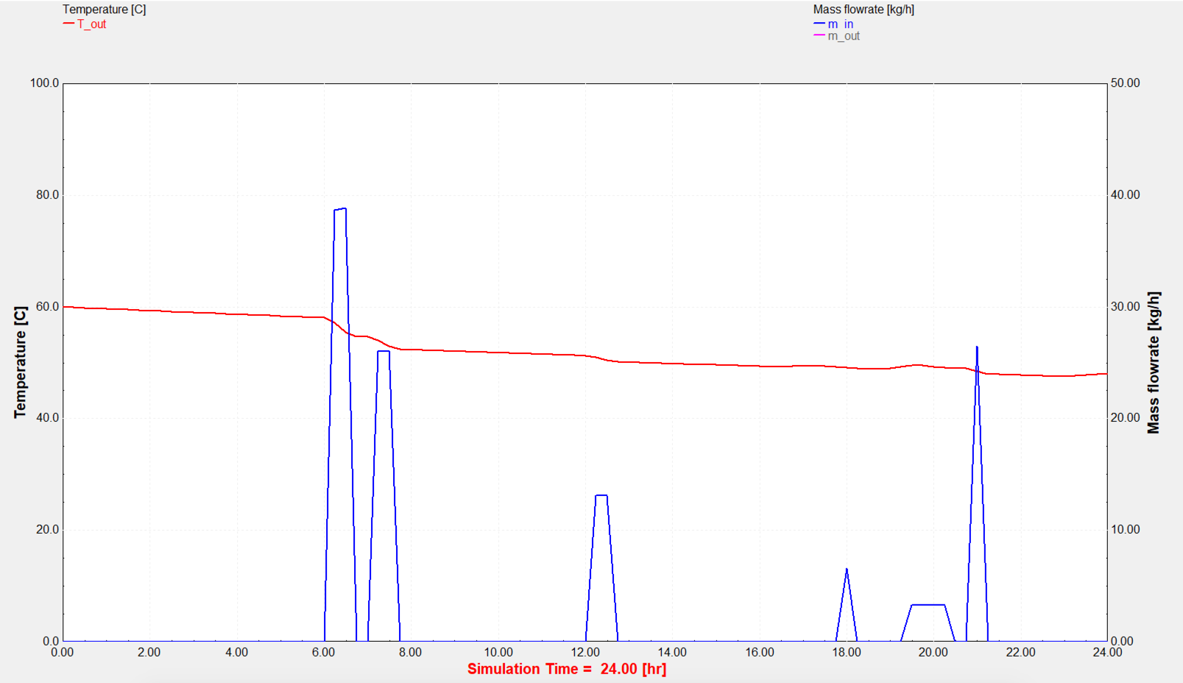

*Figure 1. Consumption pattern over 24 hours. For these simulations, the choice is made to repeat the same pattern every day. The chosen pattern is the pattern of a modal family’s hot water consumption. This pattern is based on Ericson (2009) and adapted to our own measurements. The blue lines are linked to the right scale and depict the water flow. The red line depicts the average temperature of the tank and is linked to the left axis.*

The pattern is assumed to be fixed and repeats itself on a daily basis. As the consumption of the hot water depends on the temperature of the hot water (constant energy flow), there is a need to adapt the mass flow as a function of the temperature in the tank. To compensate for the fluctuating temperature of the tank, the mass flow is recalculated based on the actual average temperature of the storage tank for each timestep in the simulation (15 minutes each).

$$m_{out}=\frac{m_{demand}*123}{T_{tank}+273}$$

Different simulations were run with the above setup. The results of being able to sell the flexibility and not being able to do this are compared. Note that while the same controller is used, in one case, it is allowed to sell the flexibility while in the other, it is not.

### 2.2 Economic analysis

For the investment analysis, the NPV is calculated out of the simulated cashflows. Further different scenarios are described that influence the cashflows and thus the NPV.

The basic formula that is used is:

$NPV=\sum_{t=0}^{n}{\frac{{CF}_{in}-{CF}_{out}}{{(1+i)}^{t}}}$ (6)

where CFin = cash inflowduring a single period t, CFout = cash outflow during a single period t, *𝚤* = discount rate, *t* = number of time periods (n = 12)

The NPV is the sum of the discounted future cashflows that are the result from an initial investment. The NPV has to be greater than zero for the investment to be considered profitable.

# Results and Discussion

The result section is divided into three parts. The first part shows the difference in energy usage and revenue from selling flexibility for an EMPC controlled boiler, while the second shows the effect of better insulating the boiler in terms of energy losses and revenue from selling flexibility. The last section summarises the economic feasibility of the solution and the robustness of the investment.

### 3.1 Conventional boiler and advanced control: Analysis of monthly net cash flows

For the year 2017, the quart-hourly values of the net regulation volume were processed with the assumption that a domestic boiler with constant usage pattern, controlled by an advanced controller (EMPC), delivers stabilisation energy towards the net. The results are summarised in Table 1.

|  |  |  |  |  |  |  |
| --- | --- | --- | --- | --- | --- | --- |
| **Month** | **Cost energy without flex [euros]** | **Cost energy with flex [euros]** | **Increase in energy cost [%]** | **Revenue imbalance participation [euros]** | **Cashflow with flex [euros]** | **Total net to gain [euros]** |
|  | **A** | **B** | **C** | **D** | **B-D** | **|A| + (B-D)** |
| January | 96.84 | 92.61 | -4.37% | 166.50 | 73.89 | 170.73 |
| February | 86.48 | 118.10 | +36.56% | 209.80 | 91.70 | 178.18 |
| March | 96.84 | 126.40 | +30.52% | 234.40 | 108.00 | 204.84 |
| April | 93.56 | 115.9 | +23.88% | 213.20 | 97.30 | 190.86 |
| May | 96.84 | 90.61 | -6.43% | 166.20 | 75.59 | 172.43 |
| June | 93.57 | 111.10 | +18.73% | 199.20 | 88.10 | 181.67 |
| July | 96.84 | 122.10 | +26.08% | 229.00 | 106.90 | 203.74 |
| August | 96.82 | 109.00 | +12.58% | 202.20 | 93.20 | 190.02 |
| September | 93.57 | 111.70 | +19.38% | 205.30 | 93.60 | 187.17 |
| October | 96.84 | 109.90 | +13.49% | 203.50 | 93.60 | 190.44 |
| November | 93.57 | 85.94 | -8.15% | 155.50 | 69.56 | 163.13 |
| December | 96.82 | 94.85 | -2.03% | 165.90 | 71.05 | 167.87 |
| **Total** | **1138.59** | **1288.21** | **+13.14%** | **2350.70** | **1062.49** | **2201.08** |

Table . Overview of results for the year 2017.

Column A shows the cost of energy in case the flexibility offered by the system is not sold. Differences in cost across the different months are only due to the different number of days in the respective months. This is because of the fixed consumption pattern that we assumed. Column B (Cost energy with flex), however, is not only dependent on the amount of days in the respective month but also on the choices the controller made with respect to the state of the net. Where functioning of the net is long (too much energy) or short (to little energy), this value will change as the controller will change the setpoint of the boiler if profitable from a flexibility selling point of view. Column C explicates the increase or decrease in energy cost between the system that delivers flexibility and the one that is not participating in balancing the net. The increase (or decrease) of energy cost will be a driver in the optimisation carried out by the controller to make the choice to change setpoint. If the cost of the energy is higher than the value of the flexibility, then the controller will not adapt the setpoint and it will not participate in net balancing.

Note that in general, the energy use of residential buildings equipped with an electric boiler is steered by a standard on/off controller. While in the case of advanced control, the temperature needs to be maintained at 60℃, a standard on/off controller aims for an *average* temperature of 60℃ and the controller controls the electrical heater with a dead band of 5℃. The results of these simulations are not included in Table 1, and are only mentioned here to create a baseline with respect to standard practice in a domestic building today. The simulation shows that the expected energy cost for an on/off controlled boiler is 516 euros per year. The lowest temperature measured was 54.8℃ and the highest was 62.4℃. For the simulation of advanced control, the choice was made to control the temperature as strictly as possible to simulate the worst-case scenario with respect to the energy usage in order to stabilise the temperature (keeping it as close to its setpoint at all times). However, it would be feasible to make the EMPC controller less strict and, as such, lower the energy consumption. The optimisation of the controller was not in scope of this research.

Column D shows the revenue from the action (V, value of the action, in equation (5)). This revenue depends on the state of the net and the variable pricing that is paid for delivering balanced energy. This value is generally published in quart-hourly terms. Here, the published values from 2017, made available by ELIA, the TSO for Belgium, are used (ELIA, n.d., Data Download). For 2017, the distribution of the positive imbalance pricing is depicted in Figure 2, while the negative imbalance pricing can be seen in Figure 3. Positive imbalance pricing is paid when a consumer is using more energy than nominated and, as such, aids to restore balance. Negative imbalance pricing is paid when the net is short of energy and the consumer uses less energy than nominated. As is clear from figures 2 and 3, pricing can be negative. If a balance responsible party (BRP) was using more energy than nominated and the net was long, then they are compensated for ‘accidently’ helping in restoring the balance. If, however, the BRP was using less energy than nominated and the net was long, they will need to pay the TSO a fine. In this research, however, we will never encounter this situation as we assume to be actively steered by the TSO in terms of adapting the state as a function of the state of the net.

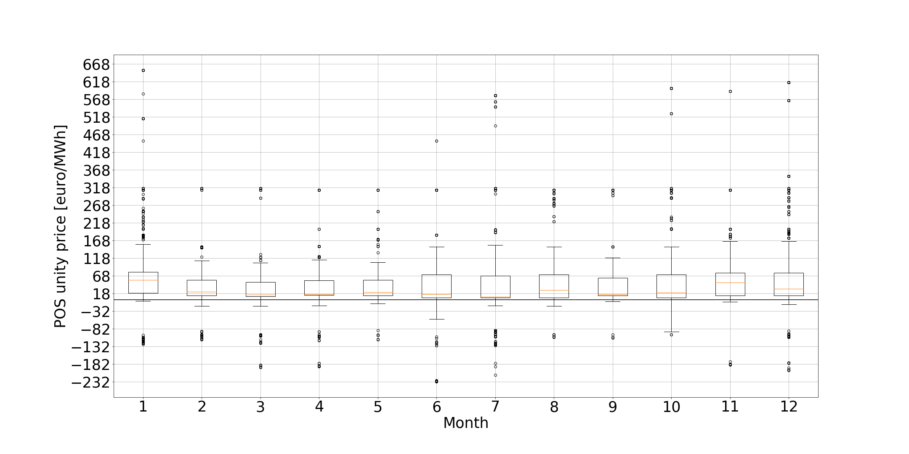

*Figure 2. POS unity price for 2017. The figure shows the distribution per month for the positive imbalance pricing (generation surplus or consumption shortage).*

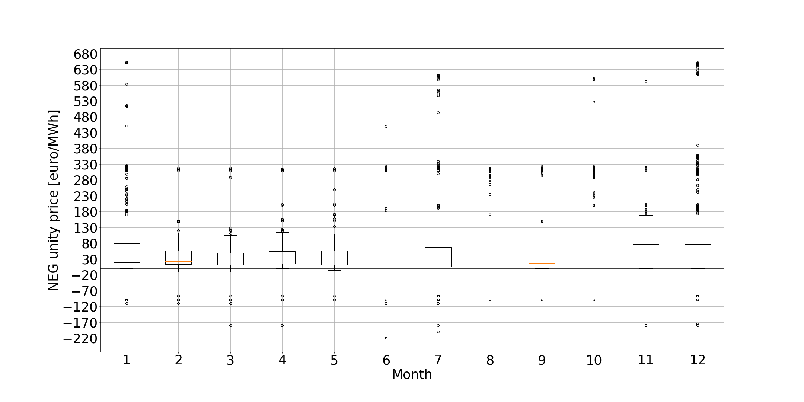

*Figure 3. NEG unity price for 2017. The figure shows the distribution per month for the negative imbalance pricing (generation shortage or consumption surplus).*

Table 1 above provides a comparison of the different simulation results for a domestic usage pattern controlled by an EMPC controller. The energy cost rises but is fully compensated for by the payment for imbalance participation. This is unsurprising, as the controller is programmed to only allow participation in grid balancing when the gain is higher than the energy cost associated with participation. The energy cost rises because if the grid is long on energy, the boiler will start heating beyond its normal operation setpoint and thus store energy. With this, from an economical point of view it makes sense to control the boiler. Meanwhile, from an environmental point of view, the energy usage will be higher. However, this does not mean that there is a definite negative impact on the environment as the surplus of energy can be due to a sudden peak in renewable energy generation, which is then converted and stored as heat. If the excess of energy is not caused by a peak of renewables but because other phenomena on the net (e.g. sudden drop in load, the ramp up of a production unit, etc.), care must be taken that the systems are not going to reward irresponsible energy usage.

### 3.2. Highly insulated boiler and advanced control: Analysis of monthly net cash flows

Because the link between energy usage and the revenue for flexibility is present, the same simulation setup was used with a better insulated boiler. Because the boiler is better insulated, it loses energy more slowly and thus has less ‘capacity’ to store energy from a flexibility point of view. Because of this ‘lower capacity’, the revenue from selling flexibility is less. From an economical point of view then, it makes sense to look for an optimal value between energy usage and insulation when selling flexibility.

|  |  |  |  |  |  |
| --- | --- | --- | --- | --- | --- |
|  | **Normal setup** | | **Energy optimised setup** | |  |
| **Month** | **Cost energy [euros]** | **Revenue imbalance participation [euros]** | **Cost energy [euros]** | **Revenue imbalance participation [euros]** | **Overall decrease in revenue [euro]** |
|  | **A** | **B** | **C** | **D** | **(-A+B) – (-C+D)** |
| January | 92.61 | 166.50 | 84.37 | 157.40 | 0.86 |
| February | 118.10 | 209.80 | 94.68 | 170 | 16.38 |
| March | 126.40 | 234.40 | 102.10 | 190.70 | 19.40 |
| April | 115.9 | 213.20 | 98.22 | 180 | 15.52 |
| May | 90.61 | 166.20 | 90.71 | 165 | 1.3 |
| June | 111.10 | 199.20 | 95.45 | 174.20 | 9.35 |
| July | 122.10 | 229.00 | 102.20 | 192.60 | 16.50 |
| August | 109.00 | 202.20 | 98 | 181.70 | 9.50 |
| September | 111.70 | 205.30 | 96.52 | 175.90 | 14.22 |
| October | 109.90 | 203.50 | 100.30 | 184.60 | 9.3 |
| November | 85.94 | 155.50 | 86.23 | 158.50 | -2.71 |
| December | 94.85 | 165.90 | 83.97 | 148 | 7.02 |
| **Total** | **1288.21** | **2350.70** | **1132.75** | **2078.60** | **116.64** |

Table 2. Impact of augmenting the energy efficiency of the boiler with respect to the revenue generated from selling flexibility. In these results the insulation of the boiler is 3 times as efficient as in the first setup leading to a net decrease in energy cost and revenue from flexibility.

Table 2 shows that when we augment the energy efficiency of the boiler by insulating the vessel three times as efficiently as before (insulation goes from 3.3 kJ/h.m2.K to 1 kJ/h.m2.K), the energy consumption drops as well as the revenue from flexibility.

Columns A and B show the energy cost and revenue from selling flexibility for the setup as used previously. Meanwhile, columns C and D give the energy cost and revenue from selling flexibility for a setup where the storage tank is insulated three times as efficiently. It should be noted that because of the variable setpoints, which are the function of the previous state of the boiler and the imbalance of the net, Table 1 and Table 2 are not comparable for individual results. In fact, only the overall system performance can be compared for a specific period of time. In the last column of Table 2, the net difference in revenue from the normal setup in comparison with the energy-optimised version is presented. In total, the more efficient system has a net cashflow that is 117 euros less than the less energy-optimised setup. This means that the more energy-efficient the setup, the less revenue is generated. This remarkable fact should lead to a regulation that sets minimal energy performance levels before being allowed to participate in selling flexibility. Otherwise, revenue can be created from wasting energy.

### 3.3 Net present value analysis

### To steer the boilers from a central location, the necessary equipment is needed to communicate bi-directionally with the boiler in order to control the setpoint settings. To react on the setpoint changes, a local controller and actuator is installed onto the boiler. These investments need to be taken into account when analysing the economic feasibility of the system. Table 3 gives an overview of the capital and operational expenditure of the system:

|  |  |  |
| --- | --- | --- |
| **Item** | **CapEx [euros]** | **OpEx [euros/year]** |
| EMPC controller hardware | 28.00 | 4.85 |
| Communication (over 4G) | 90.00 | 180.00 |
| Cloud based control platform (AZURE based) |  | 255.00 |
| **Total** | **118.00** | **439.85** |

Table *.* CaPex and OpEx overview

The EMPC controller was programmed using an Arduino Leonardo 65163 development board. The price of these boards varies between 24 euros and 32 euros. The 4G network was chosen for the communication module as it can be used with deep indoor coverage. If there is no public coverage, a private LoRa network should be set up using a 4G modem. This modem can communicate via Wi-Fi to the Arduino and through 4G to the device management platform and data processing stack. The data processing stack can be set up on Azure.

Based on the revenues presented in Table 1 and the annual operational cost, the net annual cash flow can be calculated. However, the energy cost and the revenues will not be constant in time. Due to the increased power of renewable energy sources connected to the grid, the need for flexibility has also grown, and this growth is expected to continue.

The integration of renewables in Belgium has witnessed a ramp up since 2004, accelerating up until 2015 before it subsequently cooled down. In fact, 2004 is a logical date as this signalled the beginning of the EPBD regulation (Energy Performance and Building Directive). The implementation actually started in 2006 and the flemish governement subsidised the installation of PV and wind energy sources, leading to a rapid growth in energy generation and usage.

Together with the increase of the renewable generation capacity and renewable energy usage, the need for regulation volume in the downward sense (too much energy on the net) is lowering, while the upward regulation volume shows an upward trend. These trends can be explained in terms of the technical difficulty of storing electrical energy, while it is relatively easier to add energy to the net. However, adding energy to the net is expensive and has a greater environmental impact. If we could, from a technical perspective, adapt the usage of energy (using flexibility by demand response), we could lower the baseload setpoint of classical energy production even more and eventually ‘turn off’ classical energy production altogether. The increasing use of flexibility would lead to the possibility to run entirely on renewable energy sources. The need for flexibility is thus ever increasing.

However, as more flexibility becomes available, the value of flexibility will become lower. Therefore, we consider three different scenarios. In the first, we assume that the revenue from flexibility remains constant, while in the second, we assume that the need for flexibility decreases with a factor of 3 during the lifetime of the installation. A final scenario calculates the minimal flexibility needed for the investment to be profitable. All the scenarios assume a decrease in the revenue for flexibility.

For the economic valuation, a discount rate of 12% is chosen (cost of equity, being the worst case scenario), while we consider the lifetime of the boiler to be 12 years. We simulate the impact of the energy price rising by 2% every year and the effect of the revenue of flex being three times as low as the pricing on the imbalance market for the year 2017. Every time, the IRR (internal rate of return, return if NPV = 0) and NPV are calculated and appear to be positive (NPV >0 and IRR > discount rate), thereby justifying the investment to make the boiler smart and participating on the imbalance market by selling flexibility.

The cut-off would be 3.78 times less in terms of compensation for the flexibility before it would become uninteresting to make the investment. Given the increasing need for negative compensation (more energy usage where there is too much energy on the net that needs to be compensated for) and the ever-growing implementation of renewable energy sources, the worst-case scenario is very unlikely and the investment is solid.

|  |  |  |  |
| --- | --- | --- | --- |
| Scenario | Flex revenue [Euro] | NPV [Euro] | IRR [%] |
| Flex revenue is constant. | 2350.70 | 9561.94 | 1492 |
| Flex revenue 3 times less. | 783.57 | 894.61 | 163 |
| Minimal flex revenue required | 621.81 | 0 | 12 |
| Better insulated boiler | 2078.60 | 19625.33 | 1394 |

Table *.* Overview of the NPV for different scenarios

# Conclusion

From an economic perspective, it makes sense to participate in DR using electrical boilers. The assumption is made that the electrical boiler receives the state of the net continuously. The controller then calculates the possibility of participating and participates when it is economically favourable. Given the increasing implementation of renewable energy sources and given that the policy that is being enforced will increase the need for regulation, a volume from different sources is needed.

In practice, there will no doubt be competition. This competition will come from different installations that compete with each other in trying to sell their flexibility, which will influence the pricing in relation to where imbalance compensation is bought due to market functioning. To cope with this, the analysis needs to be extended with the use of a game theory model to estimate the feasibility under competition. For now, we assumed that the pricing can be 3.78 times lower as the current pricing and still make it interesting to participate in demand response and sell the flexibility, while this scenario is, given the current trends, very unlikely.

In our simulations, we knew the future consumption, which allows the controller to optimise the costs. This knowledge means that the controller does not sell energy that is needed later on. The assumption of knowing the future state is possible in practice as smart technology in buildings allows the usage of hot water to be monitored and predicted. Here, residential usage was assumed, which means the consumption pattern can be considered stable and predictable, as was shown by Ericson (2009). Smart technology and artificial intelligence will enable the selling of flexibility for a broader range of applications with less risk of hindering the normal operations of a building and/or having the need to buy expensive energy after selling flexibility.

The worse the energy performance of the electrical boiler, the more flexibility there is to sell, and the bigger the revenue. The less inert the boiler (the less it is insulated), the faster it cools down and the faster it enters the region where it is compensated for not using energy (below 60℃). Meanwhile, the faster it cools down, the more energy it needs to attain a certain temperature. If we imagine the temperature has a setpoint of 40℃ or 90℃, it would then consume more energy and thus participate more in balancing the net than an energy-optimised system. This would subsequently generate more revenue. With this, policies should be put in place to set the minimum standards of energy performance before technical installations are allowed to participate in DR.

It would not be unimaginable to develop an algorithm – especially when taking the predicted state of the net into account – that maximises profits in terms of selling flexibility by adapting the consumption of hot water. This would mean that it could become interesting to start using hot water (or letting it go to waste) in order to be able to sell more flexibility. Thus, policies should be put in place to monitor the user’s behaviour before being allowed to participate in DR.

Aside from the above conclusions, there are also more favourable balancing assets. The more favourable balancing assets exist because in the process researched in this paper (water heating), highly exergetic energy (electricity) is converted into heat and subsequently stored. From an energy point of view, this is unfavourable as it destroys exergy. Therefore, the steering of the production of hot water production should only be activated when there are no processes left with a higher exergetic return (e.g. production process, battery storage, etc.). The activation of assets should be (also) prioritised based on exergetic returns to avoid using the cheapest balancing resource.

In terms of further research, it would be interesting to look for an optimality between the selling of flexibility and the energy usage. In this research, the EMPC is very strict in terms of tracking its setpoint. However, it could be designed to more closely resemble the behaviour of an on/off controller while retaining the advantages of the EMPC controller. In this optimisation, it is worth noting that in the simulations performed in this research, we do not consider the cashflows for being on standby (the value of having the option; we only count for the execution of the option).

**Acknowledgements**

Tine Compernolle thanks the Research Foundation Flanders (FWO) for funding her postdoctoral mandate [grant number 12M7417N]

# Bibliography

Afram, A., & Janabi-Sharifi, F. (2014). Theory and applications of HVAC control systems: A review of model predictive control (MPC). https://doi.org/10.1016/j.buildenv.2013.11.016

Avci, M., Erkoc, M., Rahmani, A., & Asfour, S. (2013). Model predictive HVAC load control in buildings using real-time electricity pricing. *Energy and Buildings*, *60*, 199–209. https://doi.org/10.1016/j.enbuild.2013.01.008

De Coninck, R., & Helsen, L. (2016). Quantification of flexibility in buildings by cost curves - Methodology and application. *Applied Energy*, *162*. https://doi.org/10.1016/j.apenergy.2015.10.114

ELIA (n.d.). Data download. Retrieved from http://www.elia.be/en/grid-data/data-download

Ellis, M., Durand, H., & Christofides, P. D. (2014). A tutorial review of economic model predictive control methods. *Journal of Process Control*, *24*, 1156–1178. https://doi.org/10.1016/j.jprocont.2014.03.010

Ericson, T. (2009). Direct load control of residential water heaters. *Energy Policy*, *37*, 3502–3512. https://doi.org/10.1016/j.enpol.2009.03.063

European Commission. (n.d.). 2030 Energy Strategy. Retrieved from https://ec.europa.eu/energy/en/topics/energy-strategy-and-energy-union/2030-energy-strategy

European Commision. (n.d.). Renewable Energy. Retrieved from https://ec.europa.eu/energy/en/topics/renewable-energy

Kepplinger, P., Huber, G., & Petrasch, J. (2015). Autonomous optimal control for demand side management with resistive domestic hot water heaters using linear optimisation. *Energy and Buildings*, *100*, 50–55. https://doi.org/10.1016/J.ENBUILD.2014.12.016

Klein, K., Herkel, S., Henning, H. M., & Felsmann, C. (2017). Load shifting using the heating and cooling system of an office building: Quantitative potential evaluation for different flexibility and storage options. *Applied Energy*. https://doi.org/10.1016/j.apenergy.2017.06.073

Ma, J., Qin, J., Salsbury, T., & Xu, P. (2011). Demand reduction in building energy systems based on economic model predictive control. https://doi.org/10.1016/j.ces.2011.07.052

Ma, J., Qin, S. J., & Salsbury, T. (2014). Application of economic MPC to the energy and demand minimisation of a commercial building. *Journal of Process Control*, *24*, 1282–1291. https://doi.org/10.1016/j.jprocont.2014.06.011

Prívara, S., Sirok´y, J., Ferkl, L., & Cigler, J. (2011). Model predictive control of a building heating system: The first experience. *Energy and Buildings*, *43*, 564–572. https://doi.org/10.1016/j.enbuild.2010.10.022

Razmara, M., Bharati, G. R., Hanover, D., Shahbakhti, M., Paudyal, S., & Robinett, R. D. (2017). Building-to-grid predictive power flow control for demand response and demand flexibility programs. *Applied Energy*, *203*, 128–141. https://doi.org/10.1016/j.apenergy.2017.06.040

Tang, R., Wang, S., & Yan, C. (2018). A direct load control strategy of centralised air-conditioning systems for building fast demand response to urgent requests of smart grids. *Automation in Construction*, *87*, 74–83. https://doi.org/10.1016/j.autcon.2017.12.012

Torriti, J., Hassan, M. G., & Leach, M. (2009). Demand response experience in Europe: Policies, programmes and implementation. https://doi.org/10.1016/j.energy.2009.05.021

Weber, C. (2017). Modeling the Value of Flexible Heat Pumps, (09).

Xue, X., Wang, S., Sun, Y., & Xiao, F. (2014). An interactive building power demand management strategy for facilitating smart grid optimisation. https://doi.org/10.1016/j.apenergy.2013.11.064

Yin, R., Kara, E. C., Li, Y., DeForest, N., Wang, K., Yong, T., & Stadler, M. (2016). Quantifying flexibility of commercial and residential loads for demand response using setpoint changes. *Applied Energy*, *177*, 149–164. https://doi.org/10.1016/j.apenergy.2016.05.090