JS Advanced: Exam Preparation 1

Link to contest: https://judge.softuni.org/Contests/3425/JS-Advanced-Retake-Exam

Problem 1. Forum posts
Environment Specifics
Please, be aware that every JS environment may behave differently when executing code. Certain things that work in the browser are not supported in Node.js, which is the environment used by Judge.
The following actions are NOT supported:
- .forEach() with NodeList (returned by querySelector() and querySelectorAll())
- .forEach() with HTMLCollection (returned by getElementsByClassName() and element.children)
- Using the spread-operator (...) to convert a NodeList into an array
- append() in Judge (use only appendChild())
- replaceWith() in Judge
- replaceAll() in Judge
- closest() in Judge
- replaceChildren()
If you want to perform these operations, you may use Array.from() to first convert the collection into an array.
Use the provided skeleton to solve this problem.
Note: You can't and you have no permission to change directly the given HTML code (index.html file).
Write the missing JavaScript code to make the Furniture Store work as expected:
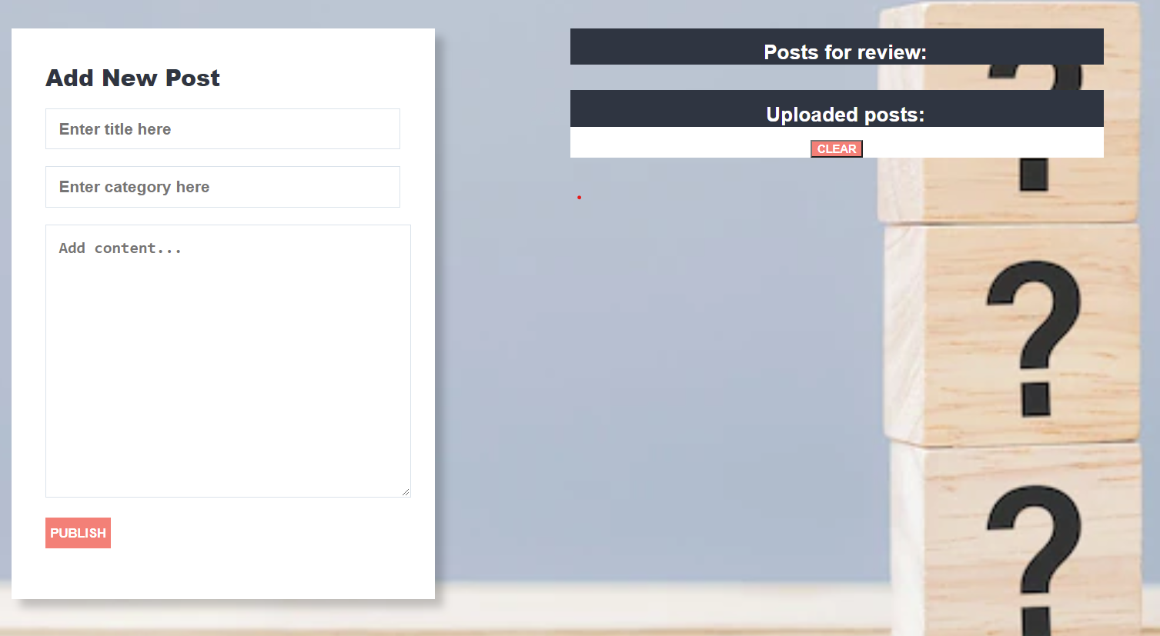

Your Task
Write the missing JavaScript code to make the Forum work as expected:
All fields (title, category, and content) are filled with the correct input
  - Title, category, and content are non-empty strings. If any of them are empty, the program should not do anything.

- Getting the information from the form

When you click the ["Publish"] button, the information from the input fields must be added to the ul with the id "review-list" and then clear input fields.
The HTML structure looks like this:

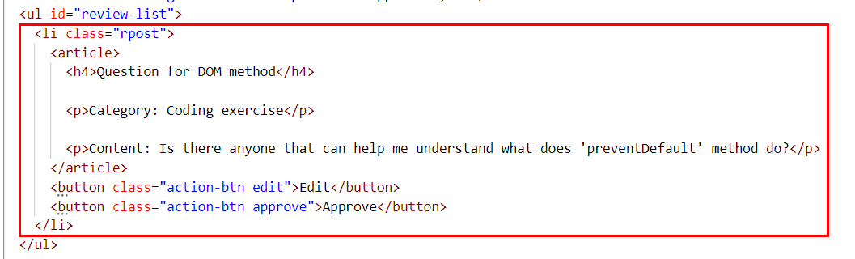

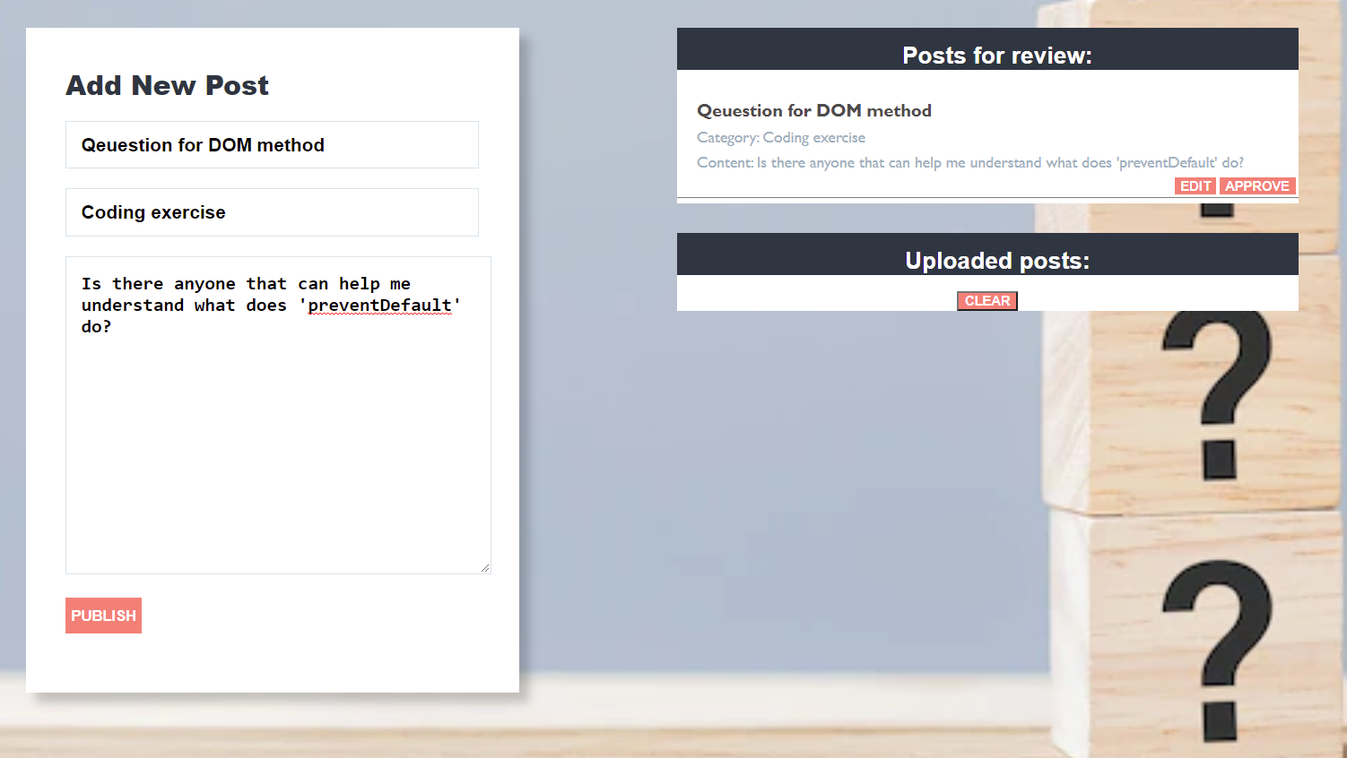

Edit information for posts
When the ["Edit"] button is clicked, the information from the post must be sent to the input’s fields and the record should be deleted from the ul "review-list".
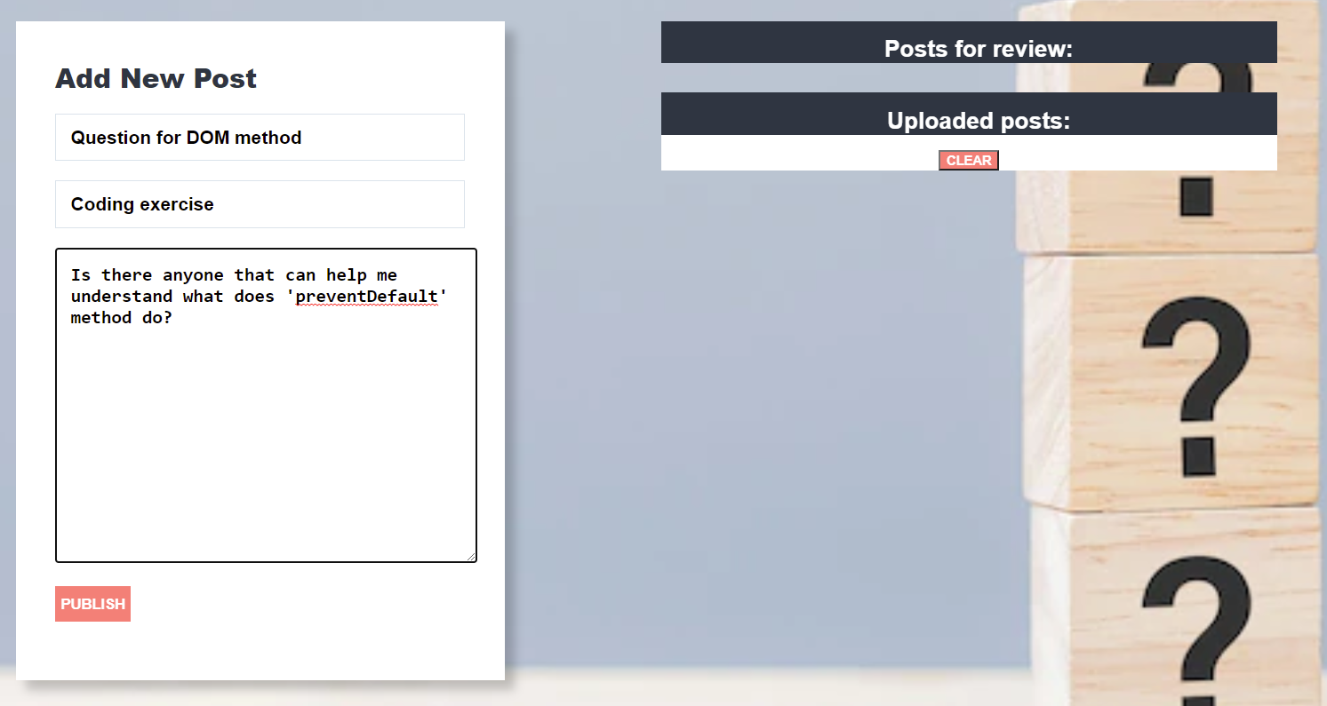
After editing the information make a new record to the ul with updated information.
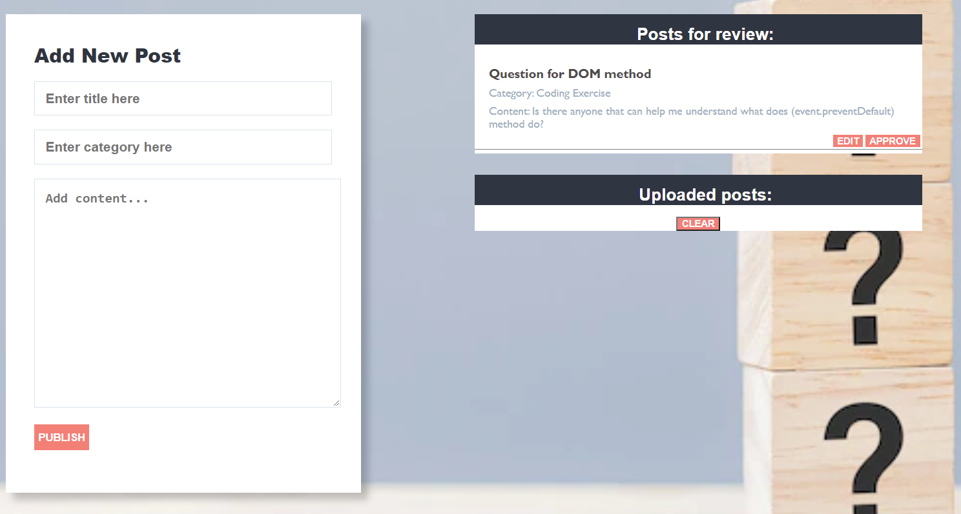

Approve posts
When you click the ["Approve"] button, the record must be deleted from the ul with id "review-list"and appended to the ul with the id "published-list"
The buttons [“Edit”] and [“Approve”] should be removed from the li element.
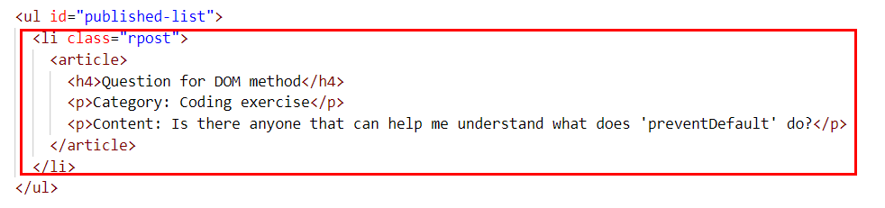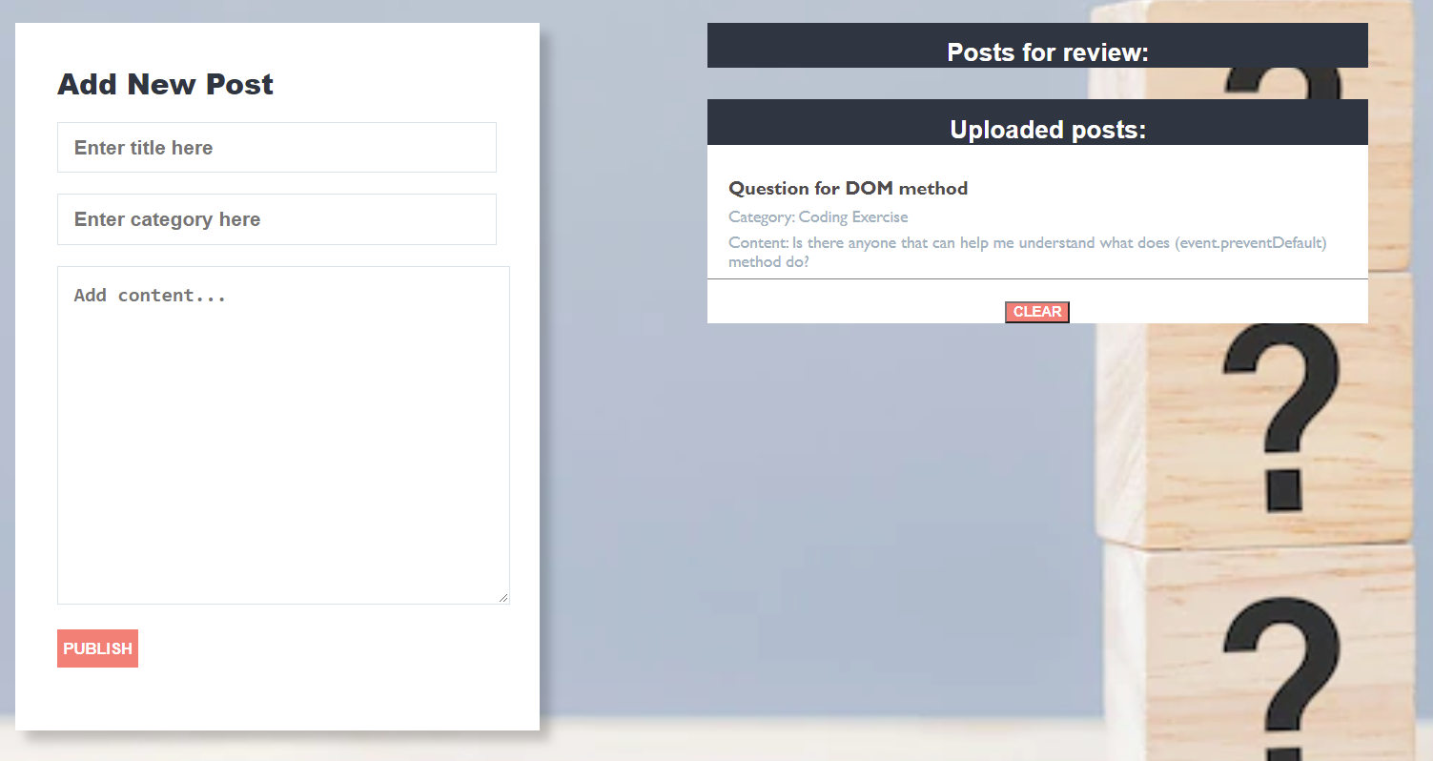

Clear posts
When you click the ["Clear"] button, the record for all posts must be deleted from the ul with the id "published-list".



Problem 2. Garden
class Garden {
//TODO Implement this class
}
Write a class Garden, which implements the following functionality:

Functionality
Constructor
Should have these 3 properties:
- spaceAvailable – Number
- plants – Array (empty)
- storage – Array (empty)
At the initialization of the Garden class, the constructor accepts the spaceAvailable.
addPlant (plantName, spaceRequired)
The plantName is of type string, while the spaceRequired is of type number.
- If there is not enough space in the garden for the new plant, throw an Error:
"Not enough space in the garden."
- Otherwise, this function should add the plant with the properties: plantName, spaceRequired, ripe: default false, quantity: default 0 to the plants array, reduce the space available with the space required by the plant, and return:
"The {plantName} has been successfully planted in the garden."
NOTE: Plant names will be unique.

ripenPlant(plantName, quantity)
The quantity is of type number.
- If the plant is not found, throw an Error:
"There is no {plantName} in the garden."
- If the plant is already ripe, throw an Error:
"The {plantName} is already ripe."
- If the received quantity is less than or equal to 0, throw an Error:
"The quantity cannot be zero or negative."
- Otherwise, this function should set the ripe property of the particular plant to true and add the quantity to the quantity property of the plant. If the quantity passed as a parameter is 1, return:
"{quantity} {plantName} has successfully ripened."
If the quantity parameter is greater than 1, return:
"{quantity} {plantName}s have successfully ripened."

harvestPlant(plantName)
- If the plant is not found, throw an Error:
"There is no {plantName} in the garden."
- If the plant is not ripe, throw an Error:
"The {plantName} cannot be harvested before it is ripe."
- Otherwise, this function should remove the plant from the plants array, add it to storage with properties plantName and quantity, free up the total space that the plant required, and return:
"The {plantName} has been successfully harvested."

generateReport()
This method should return the complete information about the garden:
- On the first line:
"The garden has { spaceAvailable } free space left."
- On the second line list all plants that are in the garden ordered alphabetically by plant name ascending in the format:
"Plants in the garden: {plant1Name}, {plant2Name}, {…}"
- On the third line add:
    - If there are no plants in the storage, print:
"Plants in storage: The storage is empty."
If there are plants in the storage list them in the format:
"Plants in storage: {plant1Name} ({plant1Quantity}), {plant2Name}, ({plant2Quantity}), {…}"

Examples

Input 1
const myGarden = new Garden(250)
console.log(myGarden.addPlant('apple', 20));
console.log(myGarden.addPlant('orange', 200));
console.log(myGarden.addPlant('olive', 50));

Output 1
The apple has been successfully planted in the garden.

The orange has been successfully planted in the garden.
Uncaught Error Error: Not enough space in the garden.

Input 2
const myGarden = new Garden(250)
console.log(myGarden.addPlant('apple', 20));
console.log(myGarden.addPlant('orange', 100));
console.log(myGarden.addPlant('cucumber', 30));
console.log(myGarden.ripenPlant('apple', 10));
console.log(myGarden.ripenPlant('orange', 1));
console.log(myGarden.ripenPlant('orange', 4));

Output 2
The apple has been successfully planted in the garden.

The orange has been successfully planted in the garden.
The cucumber has been successfully planted in the garden.
10 apples have successfully ripened.
1 orange has successfully ripened.
Uncaught Error Error: The orange is already ripe.

const myGarden = new Garden(250)
console.log(myGarden.addPlant('apple', 20));
console.log(myGarden.addPlant('orange', 100));
console.log(myGarden.addPlant('cucumber', 30));
console.log(myGarden.ripenPlant('apple', 10));
console.log(myGarden.ripenPlant('orange', 1));
console.log(myGarden.ripenPlant('olive', 30));

Output 3
The apple has been successfully planted in the garden.

The orange has been successfully planted in the garden.
The cucumber has been successfully planted in the garden.
10 apples have successfully ripened.
1 orange has successfully ripened.
Uncaught Error Error: There is no olive in the garden.

Input 4
const myGarden = new Garden(250)
console.log(myGarden.addPlant('apple', 20));
console.log(myGarden.addPlant('orange', 100));
console.log(myGarden.addPlant('cucumber', 30));
console.log(myGarden.ripenPlant('apple', 10));
console.log(myGarden.ripenPlant('orange', 1));
console.log(myGarden.ripenPlant('cucumber', -5));

Output 4
The apple has been successfully planted in the garden.

The orange has been successfully planted in the garden.
The cucumber has been successfully planted in the garden.
10 apples have successfully ripened.
1 orange has successfully ripened.
Uncaught Error Error: The quantity cannot be zero or negative.

Input 5
const myGarden = new Garden(250)
console.log(myGarden.addPlant('apple', 20));
console.log(myGarden.addPlant('orange', 200));
console.log(myGarden.addPlant('raspberry', 10));
console.log(myGarden.ripenPlant('apple', 10));
console.log(myGarden.ripenPlant('orange', 1));
console.log(myGarden.harvestPlant('apple'));
console.log(myGarden.harvestPlant('olive'));

Output 5
The apple has been successfully planted in the garden.

The orange has been successfully planted in the garden.
The raspberry has been successfully planted in the garden.
10 apples have successfully ripened.
1 orange has successfully ripened.
The apple has been successfully harvested.
Uncaught Error Error: There is no olive in the garden.

const myGarden = new Garden(250)
console.log(myGarden.addPlant('apple', 20));
console.log(myGarden.addPlant('orange', 200));
console.log(myGarden.addPlant('raspberry', 10));
console.log(myGarden.ripenPlant('apple', 10));
console.log(myGarden.ripenPlant('orange', 1));
console.log(myGarden.harvestPlant('apple'));
console.log(myGarden.harvestPlant('raspberry'));

Output 6
The apple has been successfully planted in the garden.

The orange has been successfully planted in the garden.
The raspberry has been successfully planted in the garden.
10 apples have successfully ripened.
1 orange has successfully ripened.
The apple has been successfully harvested.
Uncaught Error Error: The raspberry cannot be harvested before it is ripe.

Input 6
const myGarden = new Garden(250)
console.log(myGarden.addPlant('apple', 20));
console.log(myGarden.addPlant('orange', 200));
console.log(myGarden.addPlant('raspberry', 10));
console.log(myGarden.ripenPlant('apple', 10));
console.log(myGarden.ripenPlant('orange', 1));
console.log(myGarden.harvestPlant('orange'));
console.log(myGarden.generateReport());

Output 6
The apple has been successfully planted in the garden.

The orange has been successfully planted in the garden.
The raspberry has been successfully planted in the garden.
10 apples have successfully ripened.
1 orange has successfully ripened.
The orange has been successfully harvested.
The garden has 220 free space left.
Plants in the garden: apple, raspberry
Plants in storage: orange (1)

Problem 3. Book selection

Your Task
Using Mocha and Chai write JS Unit Tests to test a variable named bookSelection, which represents an object. You may use the following code as a template:
describe("Tests …", function() {
describe("TODO …", function() {

it("TODO …", function() {
// TODO: …
});
});

// TODO: …
});

The object that should have the following functionality:
isGenreSuitable (genre, age) - A function that accepts two parameters: string and number.
- If the value of the string genre is equal to "Thriller" or "Horror" and the value of age is less or equal to 12,
return: `Books with ${genre} genre are not suitable for kids at ${age} age`
- Otherwise, if the above conditions are not met, return the following message:
`Those books are suitable`
- There is no need for validation for the input, you will always be given string and number.

- isItAffordable (price, budget) - A function that accepts two parameters: number and number.
- You need to calculate if you can afford buying the book by subtracting the price of the book from your budget.
- If the result is lower than 0, return:
"You don't have enough money"
- Otherwise, if the above conditions are not met, return the following message:
`Book bought. You have ${result}$ left`
- You need to validate the input, if the price and budget are not a number, throw an error: "Invalid input".

- suitableTitles (books, wantedGenre) - A function that accepts an array and string.
  - The books array will store the titles and the genre of its books ([{ title: "The Da Vinci Code", genre: "Thriller" }, ...])
  - You must add the title of the book that its genre is equal to the wantedGenre.
- Finally, return the changed array of book titles.
  - There is a need for validation for the input, an array and string may not always be valid. In case of submitted invalid parameters, throw an error "Invalid input":
    - If passed books parameter is not an array.
    - If the wantedGenre is not a string.

JS Code
To ease you in the process, you are provided with an implementation that meets all of the specification requirements for the bookSelection object:
bookSelection.js
const bookSelection = {
isGenreSuitable(genre, age) {
if (age <= 12 && (genre === "Thriller" || genre === "Horror")) {
return `Books with ${genre} genre are not suitable for kids at ${age} age`;
} else {
return `Those books are suitable`;
}
},
isItAffordable(price, budget) {
if (typeof price !== "number" || typeof budget !== "number") {
throw new Error("Invalid input");
}

let result = budget - price;

if (result < 0) {
return "You don't have enough money";
} else {
return `Book bought. You have ${result}$ left`;
}
},
suitableTitles(array, wantedGenre) {
let resultArr = [];

if (!Array.isArray(array) || typeof wantedGenre !== "string") {
throw new Error("Invalid input");
}
array.map((obj) => {
if (obj.genre === wantedGenre) {
resultArr.push(obj.title);
}
});
return resultArr;
},
};

