# POSTing and Receiving Files

To better understand this exercise, lets make a URL at /receive_requests

## Receive Requests URL

### receive_requests.h File

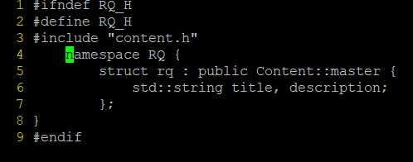

### receive_requests.tmpl file

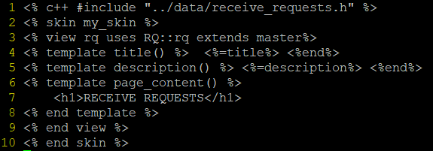

### Dispatcher and Mapper

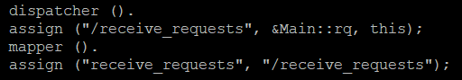

main.cpp - rq function

#include <cppcms/http_request.h>  
...  
void rq () {  
 RQ::rq r;  
 if (request ().request_method () == "POST") {  
 std::vector < booster::shared_ptr < cppcms::http::file > > files = request ().files ();  
 for (int i = 0; i < files.size (); i++) {  
 booster::shared_ptr < cppcms::http::file > file_tmp = files[i];  
 std::string file_name = file_tmp->filename ();  
 file_tmp->save_to ("./uploads/" + file_name);  
 }   
 // Optional: Return some response  
 response().out() << "Successfully Uploaded Files";  
 }  
}

### Request

CPPCMS mainly uses the request() function to do operations on any received requests.

You can view what commands request() has here: <http://cppcms.com/cppcms_ref/latest/classcppcms_1_1http_1_1request.html>

## Config

To configure request and file limits, add the following to config.js

**NOTE:**  Sizes are in KB

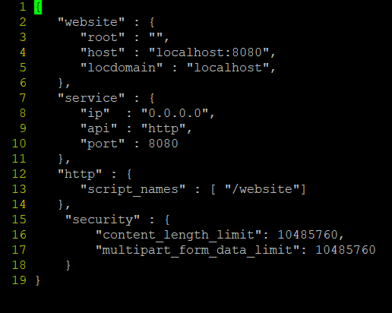

To view other config settings, go to <http://cppcms.com/wikipp/en/page/cppcms_1x_config>

## POSTing Request

On the client machine, cd to the location of the file and run the following curl command:

curl -i -X POST -H "Content-Type: multipart/form-data" -F "data=@file_name" http://192.168.0.120:8080/receive_requests

#### POSTing Multiple Files

curl -i -X POST -H "Content-Type: multipart/form-data" -F "data=@file_0" -F "data=@File_1" -F "data=@file_2" http://192.168.0.120:8080/receive_requests