

System Hotel



November 12, 2018

A’mer Ashraf

**1. Preface**

The system is still under implementation, there is the second development, so the system is currently at version 2.0.

**2. Introduction**

The hotel reservation system (HRS) should help the user to start reserving for customers their needs, the customer should have an account to be able to book an room, if not he shall register an account and then start booking, the customer may book one or more room, each room can be classified differently.

Rooms are classified into single, double, or triple bed room.

HRS can also let the customer choose his type of residence, either bed only, bed and breakfast, breakfast and dinner (half-board), full-board, or all inclusive.

Manager is the only one capable to use the full system, so he can add new receptionist’s Information, update old information, and delete receptionist’s information.

Also the manager may view all rooms data, reserved or not, empty or occupied, available to be used or not.

The manager also may see the reservations list, make decisions about them.

The manager have the ability to make discount for certain customers, such as:

-customer coming from certain agencies.

-customer reserved before with amount of 20,000 pounds.

The discount is 20%.

HRS can provide the customer with many payment choices, either cash or by credit card.

Also, the customer may attach any extra comments to be applied by the hotel if applicable.

**3. Glossary**

**\*Data:** Customer’s name, his national id, his bank account number, and his email.

**\*Function:** process or and operation.

**\*System:** the program running on user interface.

**\*Invoice:** payment bill.

**\*Usability:** easy to use by foreign users.

**\*Execution:** time of finishing process.

**\*Reliable:** the system can be depended on.

**\*Robustness:** less failure and short time to run back after failure.

**\*Dependability:** can work on any user interface.

**\*Windows:** operating system of Microsoft.

**\*Linux:** operating system.

**\*Mac:** operating system of apple.

**\*Authentication:** access to the system.

**4. User requirement definition**

*The system will be easy to be used by users and will be organized in such a way that minimizes the errors.

*The system should be fast in execution time, will always be available, its rate of failure will be small and if failure occurs, it’s time to restart after failure will be small.

*The system should be small in size.

* The system shall run on any operating system (Windows, Linux, and mac).

*The system will be secure.

*The system will support English

**5. Specific requirements**

**5.1 Functional Requirements**

**5.1.1 Search for Customer**

- a receptionist takes customer account.

-Write it in search bar.

-Click search.

-If customer is found, the system shows his data and start to serve him.

-If customer is not found move to next function (**5.1.2 Add Customer**)

**5.1.2 Add Account**

- receptionist ask customer for some data like:

His name, id (A national number),E-mail and his acceptance for hotel policies.

-Write these data in the system.

-Click add button.

**5.1.3 Update Account**

- receptionist ask customer for the data he wants to update.

- Writes these data on the system.

-click update button.

**5.1.4 Add reservations**

- Receptionist asks customer which type of room does the customer want.

-The customer decides a single, double or triple room.

-The receptionist chooses what customer needs.

-Click next button.

-The receptionist asks customer which type of specification he desires.

-The customer should specify the meal plan from bed only, bed and breakfast, half board, or full board and all inclusive.

- the customer may choose any extra needs.

-The receptionist chooses what customer decides.

-Click submit button.

**5.1.5 Update reservation**

- Customer wants to update reservation.

- Employee ask customer for his account.

- Customer gives receptionist his account number.

- receptionist ask customer for the new reservation information.

- Customer gives receptionist the new information.

- receptionist enters new information in the system.

- Clicks update button.

**5.1.6 Delete reservation**

- Customer wants to cancel reservation.

- receptionist ask customer for his account.

- Customer gives receptionist his account number.

- receptionist choose reservation to be deleted.

- Clicks delete button.

**5.1.7 Calculate invoice**

-A customer come to a receptionist and asks for check out.

-The receptionist login with customer account.

-System calculates what the customer order and generates the invoice.

-click calculate button.

**5.1.8 Payment**

-The customer pay the invoice and the receptionist take the money.

-Click paid button.

**5.1.9 manager can search for receptionist’s information**

- Manager wants to check any information about the receptionist working for him

- Manager enters receptionist’s ID.

- Manager sees the e receptionist’s information.

**5.1.10 Manager adds receptionist**

- Manager is the only one capable to use the full system, so he can add new receptionist’s Information, update old information, and delete receptionist’s information.

- Manager enters new receptionist’s information (first name, last name, Gender, username, password, receptionist ID).

**5.1.11 Manager updates receptionist**

- Manager is the only one capable to use the full system, so he can update old information of the receptionist.

- Manager enters new receptionist’s information.

**5.1.12 Manager Delete receptionist**

- Manager is the only one capable to use the full system, so he can delete the information of the receptionist.

- Manager deletes receptionist’s information.

**5.1.13 Manager views rooms**

- Manager can also view rooms reserved and empty rooms.

- Manager enters login with username and password.

-Manager can see all data about reserved rooms.

**5.1.14 Manager views reservation**

- Manager can view reservation list and all the customers reserved rooms in the hotel.

- Manager enters login with username and password.

-Manager can see all data about customers reservation.

**5.1.15 Manager Makes discount**

- Manager can make discount to certain agencies or either makes discount to customer who reserved more than once.

- Manager enters login with username and password.

-Manager makes discount 20%.

**5.2 Non-Functional Requirements**

**5.2.1 Product requirements**

**5.2.1.1 Usability requirement:**

The system should be easy to use by staff and should be organized in such a way that errors are minimized.

**5.2.1.2 Efficiency requirement:**

**5.2.1.2.1 Performance requirement:**

The system should be fast in execution time, reliability and robustness.

**5.2.1.2.2 Space requirement:**

The system should be small in size not exceed 10Mbytes.

**5.2.1.3 Dependability requirement:**

The system shall run in windows, Linux, mac and should be in android.

**5.2.1.4 Security requirement:**

No one can access the system without authentication.

**5.2.2 Organizational requirements**

**5.2.2.1 Environmental requirement:**

System shall support the English.

**5.2.2.2 Operational requirement:**

Before reserving any room must provide an ssn card.

**5.2.2.3 Development requirement:**

**5.2.3 External requirements**

**5.2.3.1 Regulatory requirement:**

When reserving room more than one person must provethe relationship of the two or more person and their ssn.

**5.2.3.2 Ethical requirement:**

There are no pictures +18 in the system.

**5.2.3.3 Legislative requirement:**

**5.2.3.3.1 Accounting requirement:**

The system must follow the Consumer Protection law at the reserving prices.

**5.2.3.3.2 Safety/security requirement:**

Keep personal information in complete protect.

**6. Scenarios:**

|  |
| --- |
| **Search For Customer** |
| **Actor initiates the use case :** Employee |
| **Preconditions :** Find Customer Account |
| **Steps in the scenario:-**  - receptionist takes customer account.  -Write it in search bar.  -Click search.  -If customer is found, the system shows his data and start to serve him. |
| **Post-condition :** Show data |
| **Actor who benefits from the use case :** Manger |

|  |
| --- |
| **Add account** |
| **Actor initiates the use case :** Employee |
| **Preconditions :**Have a new customer want to reservation |
| **Steps in the scenario:-**  - receptionist ask customer for some data like:  His name, id (A national number),email and his acceptance for hotel policies.  -Write these data in the system.  -Click add button. |
| **Post-condition :** Save a new data to new customer |
| **Actor who benefits from the use case :** customer |

|  |
| --- |
| **Update Account** |
| **Actor initiates the use case :** Employee |
| **Preconditions :** Customer want to update his information |
| **Steps in the scenario:-**  - An receptionist ask customer for the data he wants to update.  - Writes these data on the system.  -click update button. |
| **Post-condition :** Customer’s information updated |
| **Actor who benefits from the use case :** customer |

|  |
| --- |
| **Add reservations** |
| **Actor initiates the use case :** Employee |
| **Preconditions :** which room customer want |
| **Steps in the scenario:-**  - receptionist asks customer which type of room does the customer want.  -The customer decides a single, double or triple room.  -The receptionist chooses what customer needs.  -Click next button.  -The receptionist asks customer which type of specification he desires.  -The customer should specify the meal plan from bed only, bed and breakfast, half board, or full board and all inclusive.  -The receptionist chooses what customer decides.  -Click submit button. |
| **Post-condition :** Reserve a specific room to customer |
| **Actor who benefits from the use case :** Manager |

|  |
| --- |
| **Update reservation** |
| **Actor initiates the use case :** Employee |
| **Preconditions :** Customer want to change reservation |
| **Steps in the scenario:-**  - Customer wants to update reservation.  - receptionist ask customer for his account.  - Customer gives receptionist his account number.  - receptionist ask customer for the new reservation information.  - Customer gives receptionist the new information.  - receptionist e enters new information in the system.  - Clicks update button. |
| **Post-condition :** Customer’s reservation updated |
| **Actor who benefits from the use case :** Manager |

|  |
| --- |
| **Delete reservation** |
| **Actor initiates the use case :** Employee |
| **Preconditions :** Customer want to cancel reservation |
| **Steps in the scenario:-**  - Customer wants to cancel reservation.  - receptionist ask customer for his account.  - Customer gives receptionist his account number.  - receptionist choose reservation to be deleted.  - Clicks delete button. |
| **Post-condition :** Customer’s reservation cancelled |
| **Actor who benefits from the use case :** Manager |

|  |
| --- |
| **Calculate invoice** |
| **Actor initiates the use case :** Employee |
| **Preconditions :** Customer want to leave |
| **Steps in the scenario:-**  -A customer come to receptionist and asks for check out.  -The receptionist login with customer account.  -System calculates what the customer order and generates the invoice.  -Click paid button. |
| **Post-condition :** Customer leave |
| **Actor who benefits from the use case :** Manager |

|  |
| --- |
| **payment** |
| **Actor initiates the use case :** Employee |
| **Preconditions :** Customer want to leave |
| **Steps in the scenario:-**  -The customer pay the invoice and the receptionist take the money. |
| **Post-condition :** Customer leave |
| **Actor who benefits from the use case :** Manager |

|  |
| --- |
| **Search Receptionist** |
| **Actor initiates the use case :** Manager |
| **Preconditions :** Manager wants to search for receptionist |
| **Steps in the scenario:-**  - Manager wants to check any information about the receptionists working for him  - Manager enters receptionist’s ID.  - Manager sees the employee’s information. |
| **Post-condition :** manager gets receptionist’s data |
| **Actor who benefits from the use case :** Manager |

|  |
| --- |
| **Add Receptionist** |
| **Actor initiates the use case :** Manager |
| **Preconditions :** Manager wants to add new receptionist |
| **Steps in the scenario:-**  - Manager is the only one capable to use the full system, so he can add new receptionist’s Information, update old information, and delete receptionist’s information.  - Manager enters new receptionist’s information(first name, last name, Gender , username, password, receptionist ID). |
| **Post-condition :** manager added new receptionist |
| **Actor who benefits from the use case :** Manager |

|  |
| --- |
| **Update Receptionist** |
| **Actor initiates the use case :**Manager |
| **Preconditions :** Manager wants to update receptionist’s information |
| **Steps in the scenario:-**  - Manager is the only one capable to use the full system, so he can update old information of the receptionist.  - Manager enters new receptionist’s information. |
| **Post-condition :** receptionist’s information updated |
| **Actor who benefits from the use case :** Manager |

|  |
| --- |
| **Delete Receptionist** |
| **Actor initiates the use case :** Manager |
| **Preconditions :** manager want to delete receptionist’s information |
| **Steps in the scenario:-**  - Manager is the only one capable to use the full system, so he can delete the information of the receptionist.  - Manager deletes receptionist’s information. |
| **Post-condition :** receptionist’s information deleted |
| **Actor who benefits from the use case :** Manager |

|  |
| --- |
| **View Room** |
| **Actor initiates the use case :** Manager |
| **Preconditions :** manager want to see reserved and empty rooms |
| **Steps in the scenario:-**  - Manager can also view rooms reserved and empty rooms.  - Manager enters login with username and password.  -Manager can see all data about reserved rooms |
| **Post-condition :** manager sees rooms reserved |
| **Actor who benefits from the use case :** Manager |

|  |
| --- |
| **View Reservation** |
| **Actor initiates the use case :** Manager |
| **Preconditions :** manager wants to see customer’s reservation |
| **Steps in the scenario:-**  - Manager can view reservation list and all the customers reserved rooms in the hotel.  - Manager enters login with username and password.  -Manager can see all data about customers reservation. |
| **Post-condition :** manager sees all data about customer’s reservation |
| **Actor who benefits from the use case :** Manager |

|  |
| --- |
| **Make Discount** |
| **Actor initiates the use case :** Manager |
| **Preconditions :** manager wants to make discount to customer |
| **Steps in the scenario:-**  - Manager can make discount to certain agencies or either makes discount to customer who reserved more than once.  - Manager enters login with username and password.  -Manager makes discount 20%. |
| **Post-condition :** customer gets discount for reservation |
| **Actor who benefits from the use case :** customer |

**7. Use Cases:**

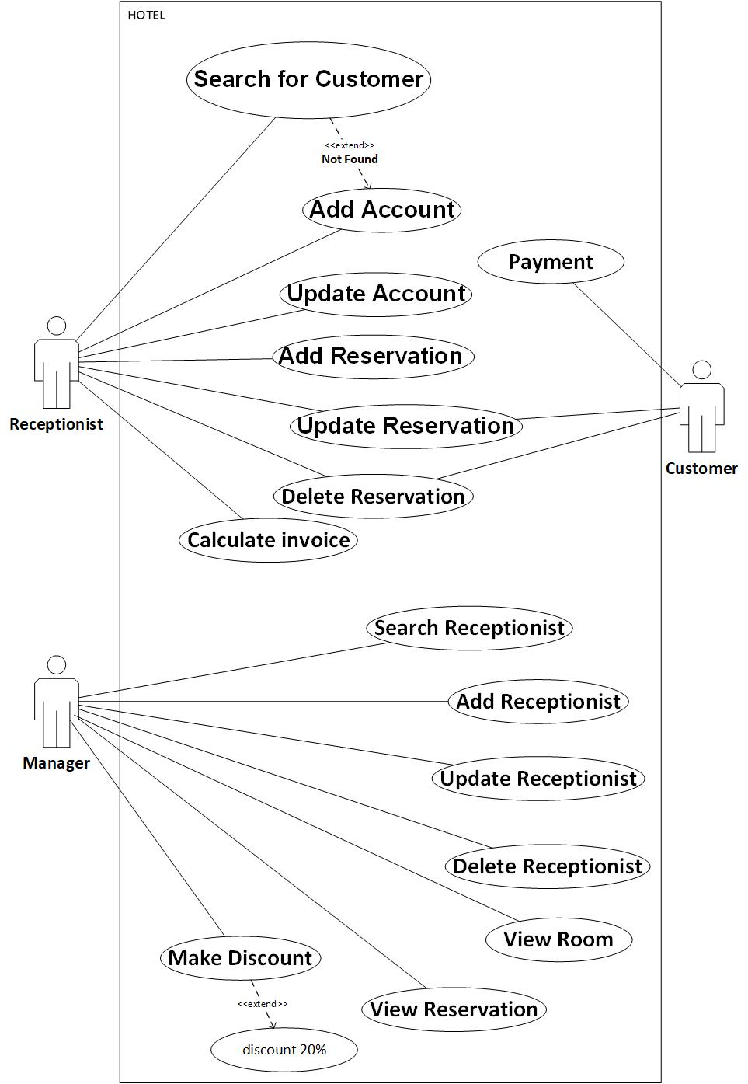

**8.activity Diagrams:**

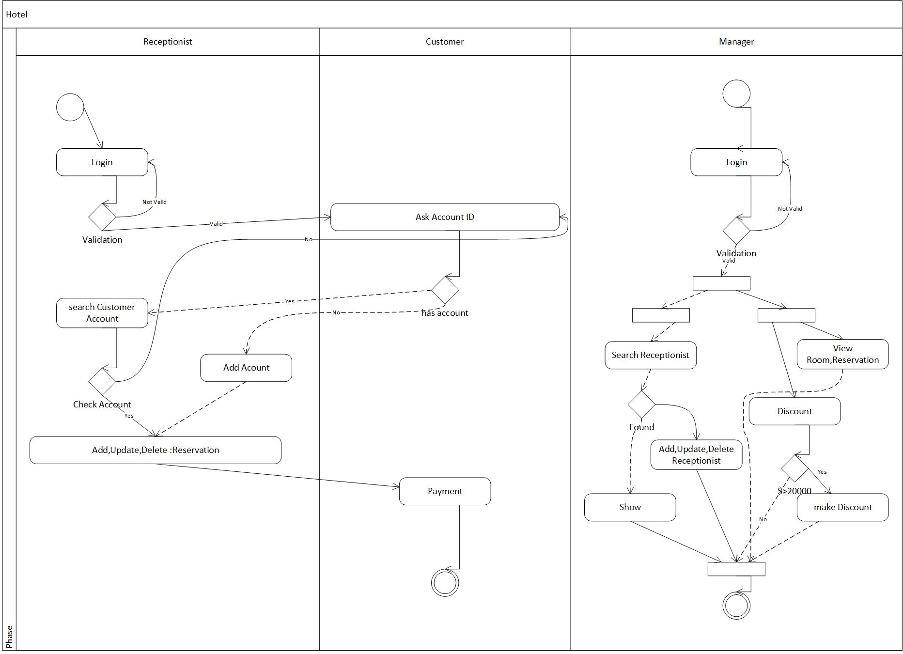

**13. System evolution:**

Ask them service from them Room.

**14. Appendices:**

PC to use system in.

A big data to store: All account of customer in, all room (Available or not).

**15. Development platform:**

Desktop Application (JAVA).

**11. Index:**

- Team Name………………………………………….. 1

- Preface & introduction………………… 3

- Glossary………………………………… 4

- User Requirements Definition………… 5

- System Requirements Specification…. 6

- Functional requirement………………... 6

- Non-functional requirement………….. 10

- Scenarios………………………………. 12

- Use Cases Diagram………………….. 19

- Activity Diagram………………….. 20

- Sequence Diagrams………………….. 21

- Collaboration Diagrams…………… 34

- Database specification…………… 41

-Class Diagram……………………….. 42

-Appendices & Development Platform… 43