Lab 4

1. Menus

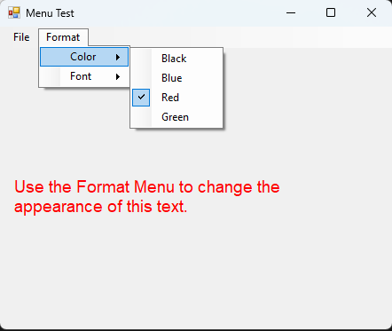

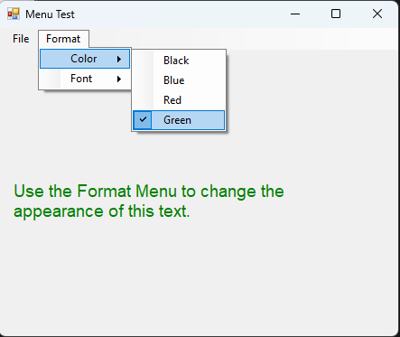

2. DateTimePicker control

3. LinkLabel control

4. ListBox control

5. CheckedListBox control

6. ComboBox control

7. TreeView control

8. ListView control

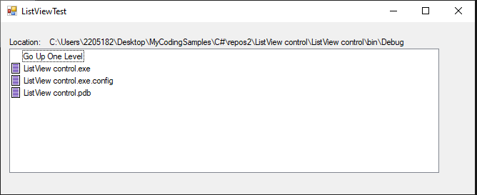

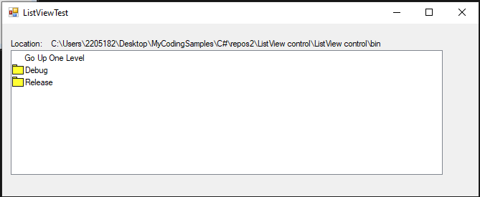

9. TabControl control

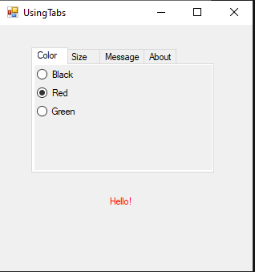

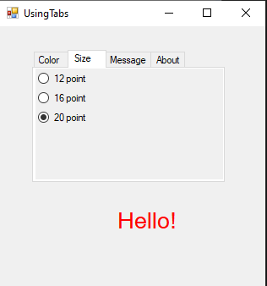

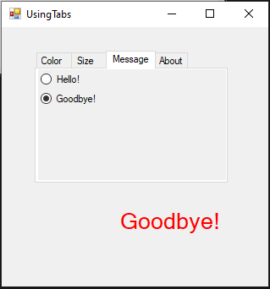

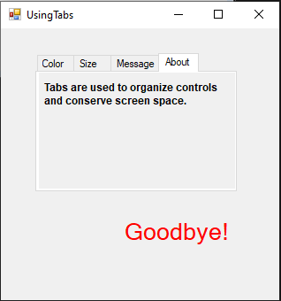

10. Multiple Document Interface (MDI) Windows

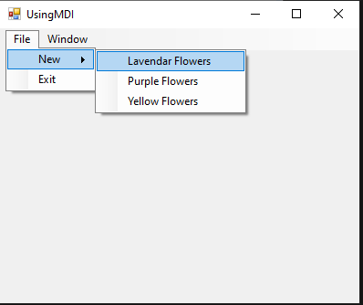

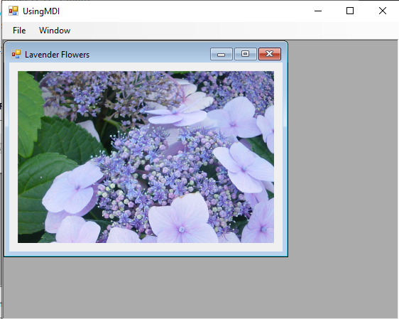

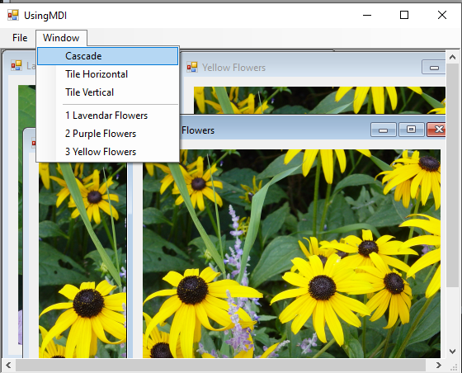

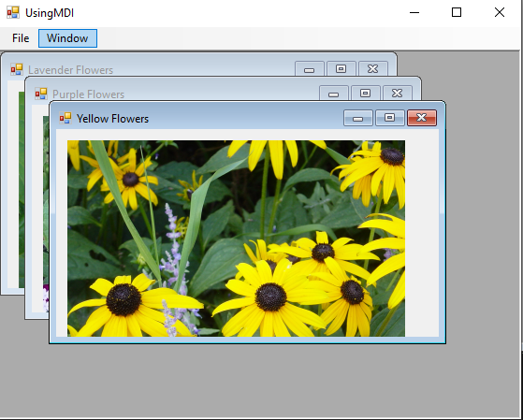

11. Visual Inheritance

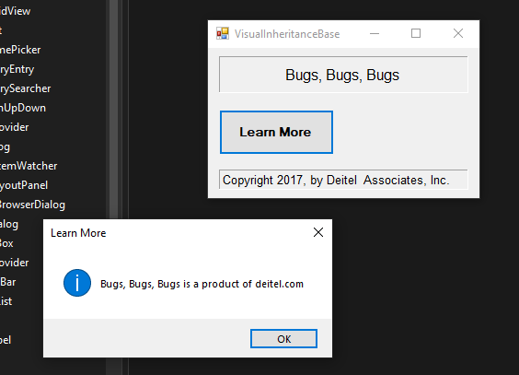

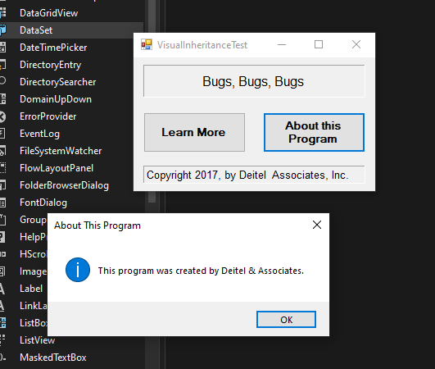

12. User‐Defined controls

