1) Watch ansible-02 video and write down notes.   
  
Done….  
  
2) Install httpd using ansible playbook, use handlers,notifiers.   
  
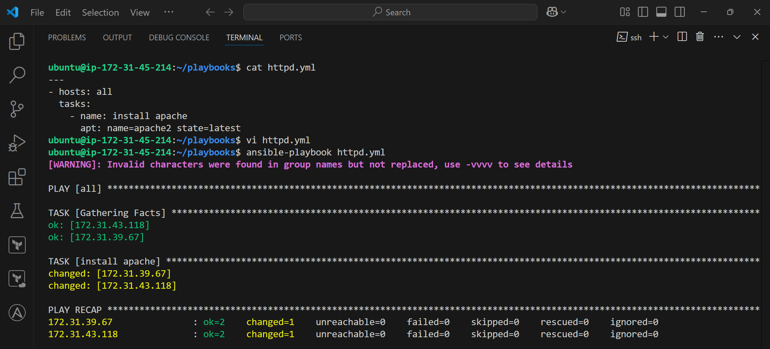  
  
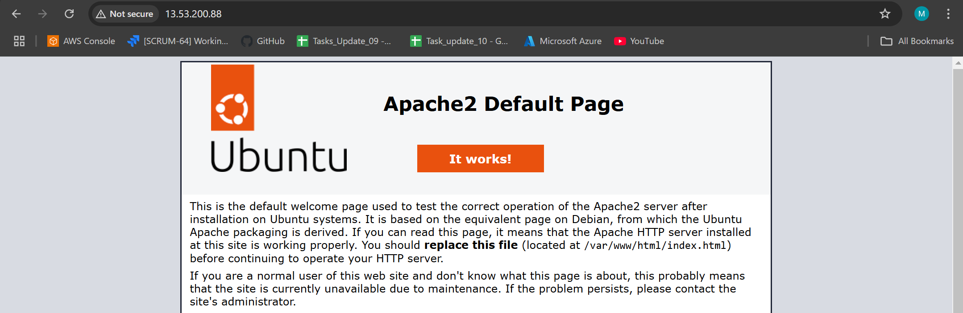  
  
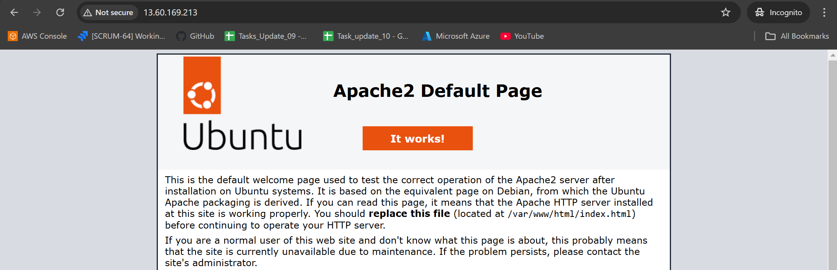  
  
  
  
  
  
  
  
  
  
  
  
>>>>> **Deploying index.html on w-1**  
  
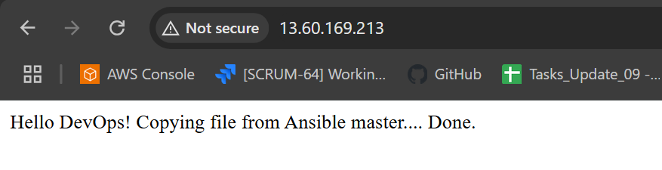  
>>>> **Deploying index.html on w-2**  
  
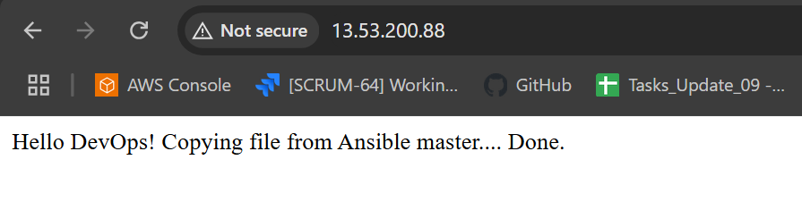  
  
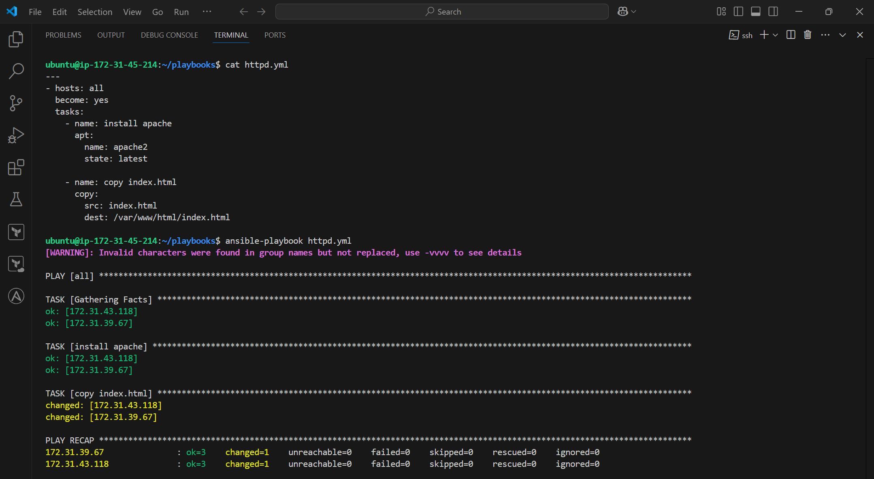  
  
  
  
  
  
  
  
  
  
  
  
  
  
  
  
----->>> **Using Notify and handlers based on conditions**  
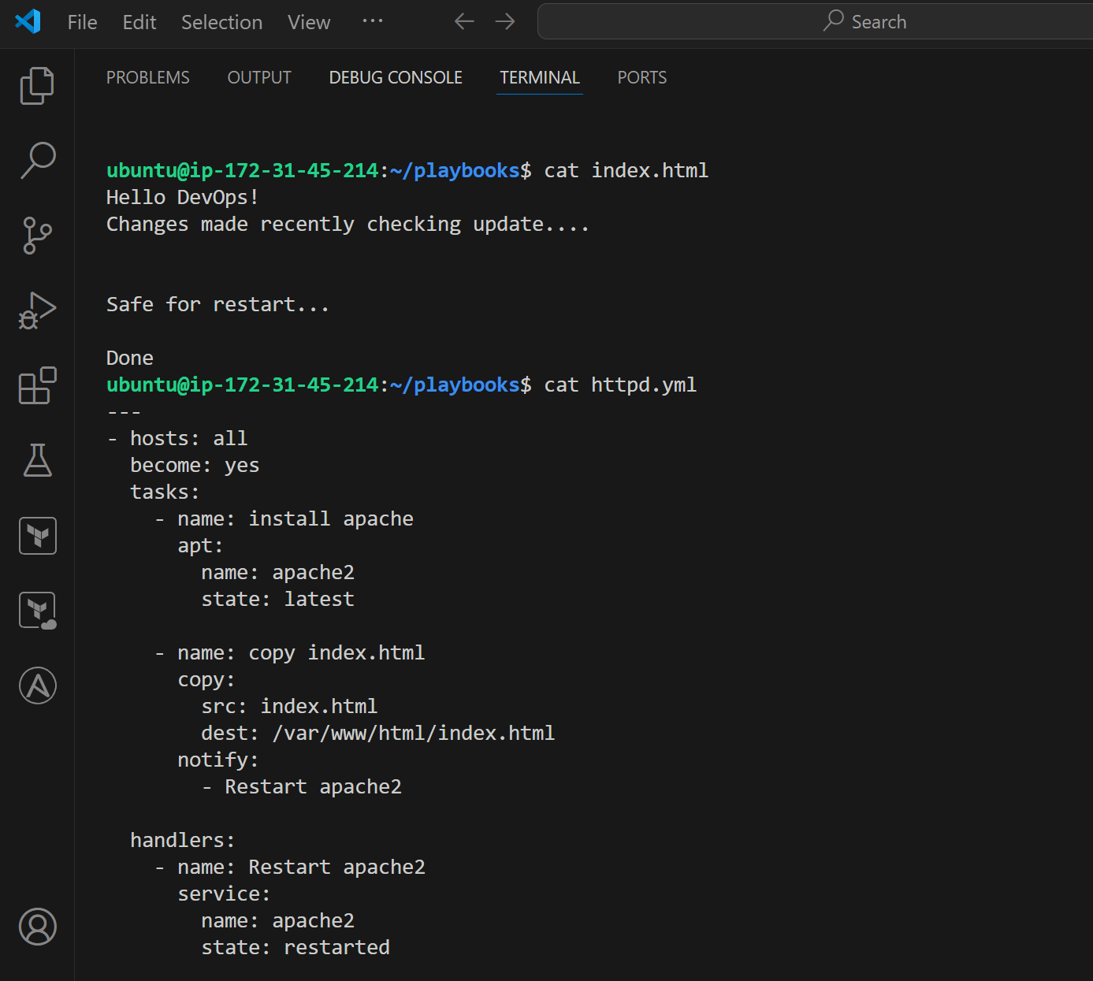  
  
  
  
  
  
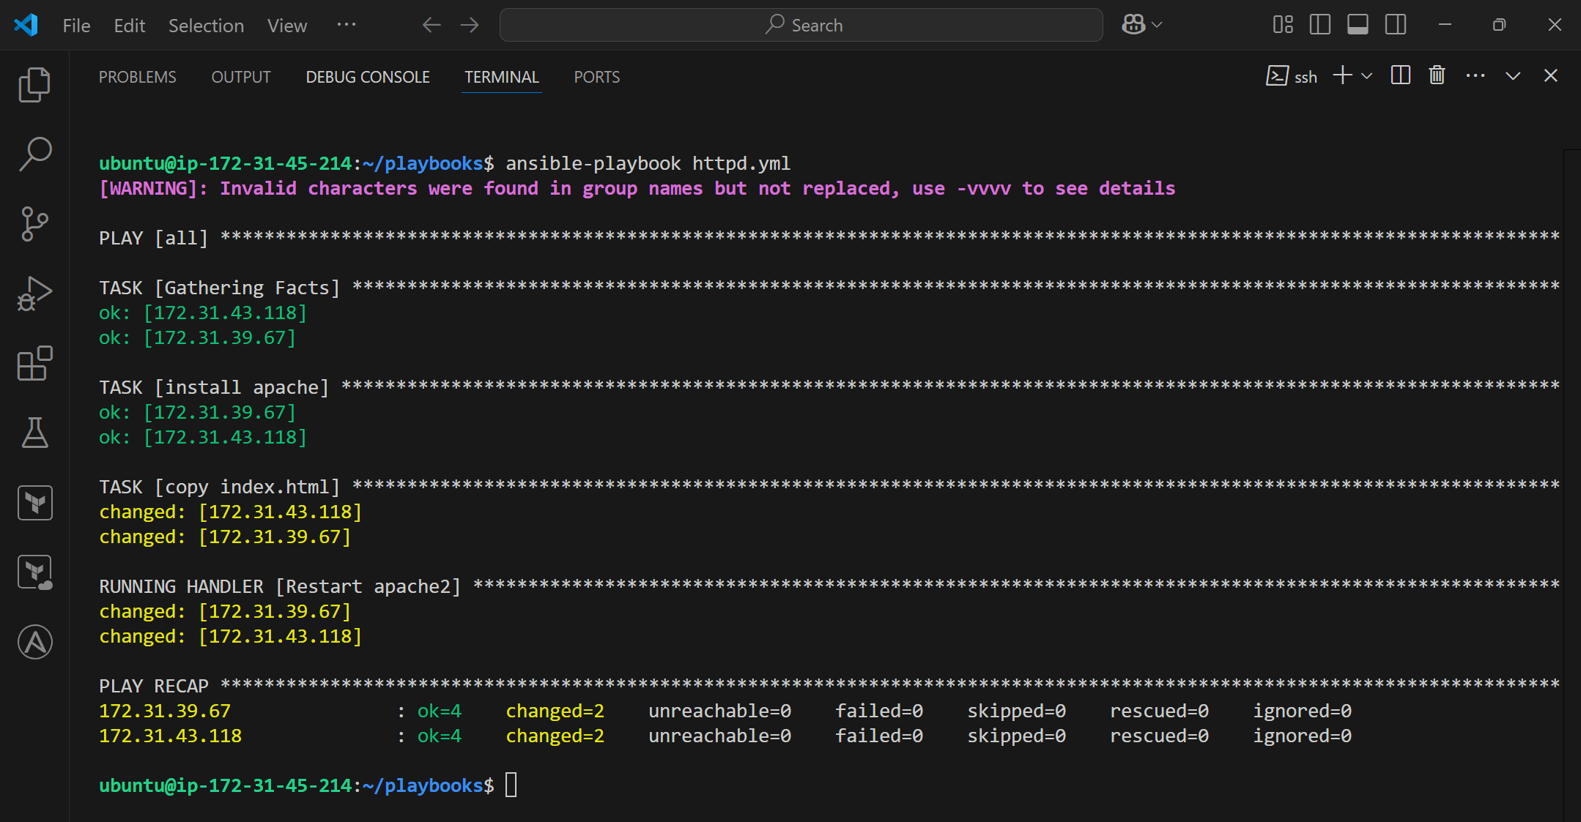  
  
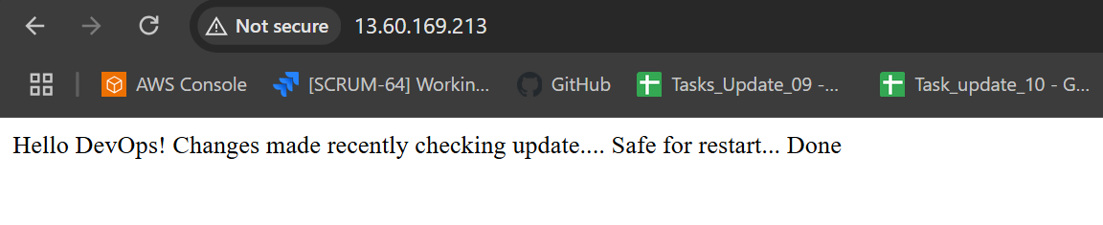  
  
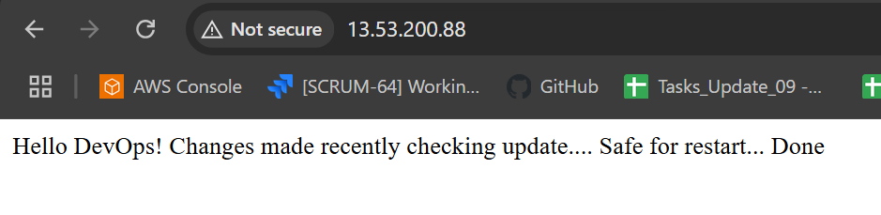  
  
  
3) Write a ansible playbook to install Apache tomcat.   
  
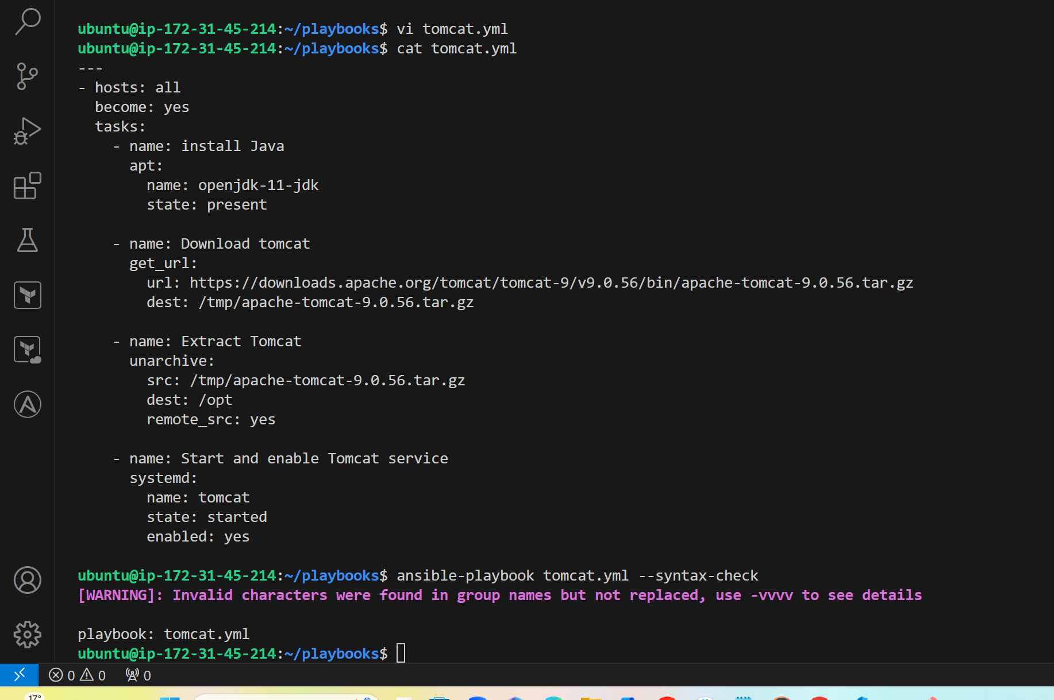  
  
  
  
  
  
  
  
  
  
  
  
  
  
4) Write a ansible playbook to provision one ec2 on AWS.   
  
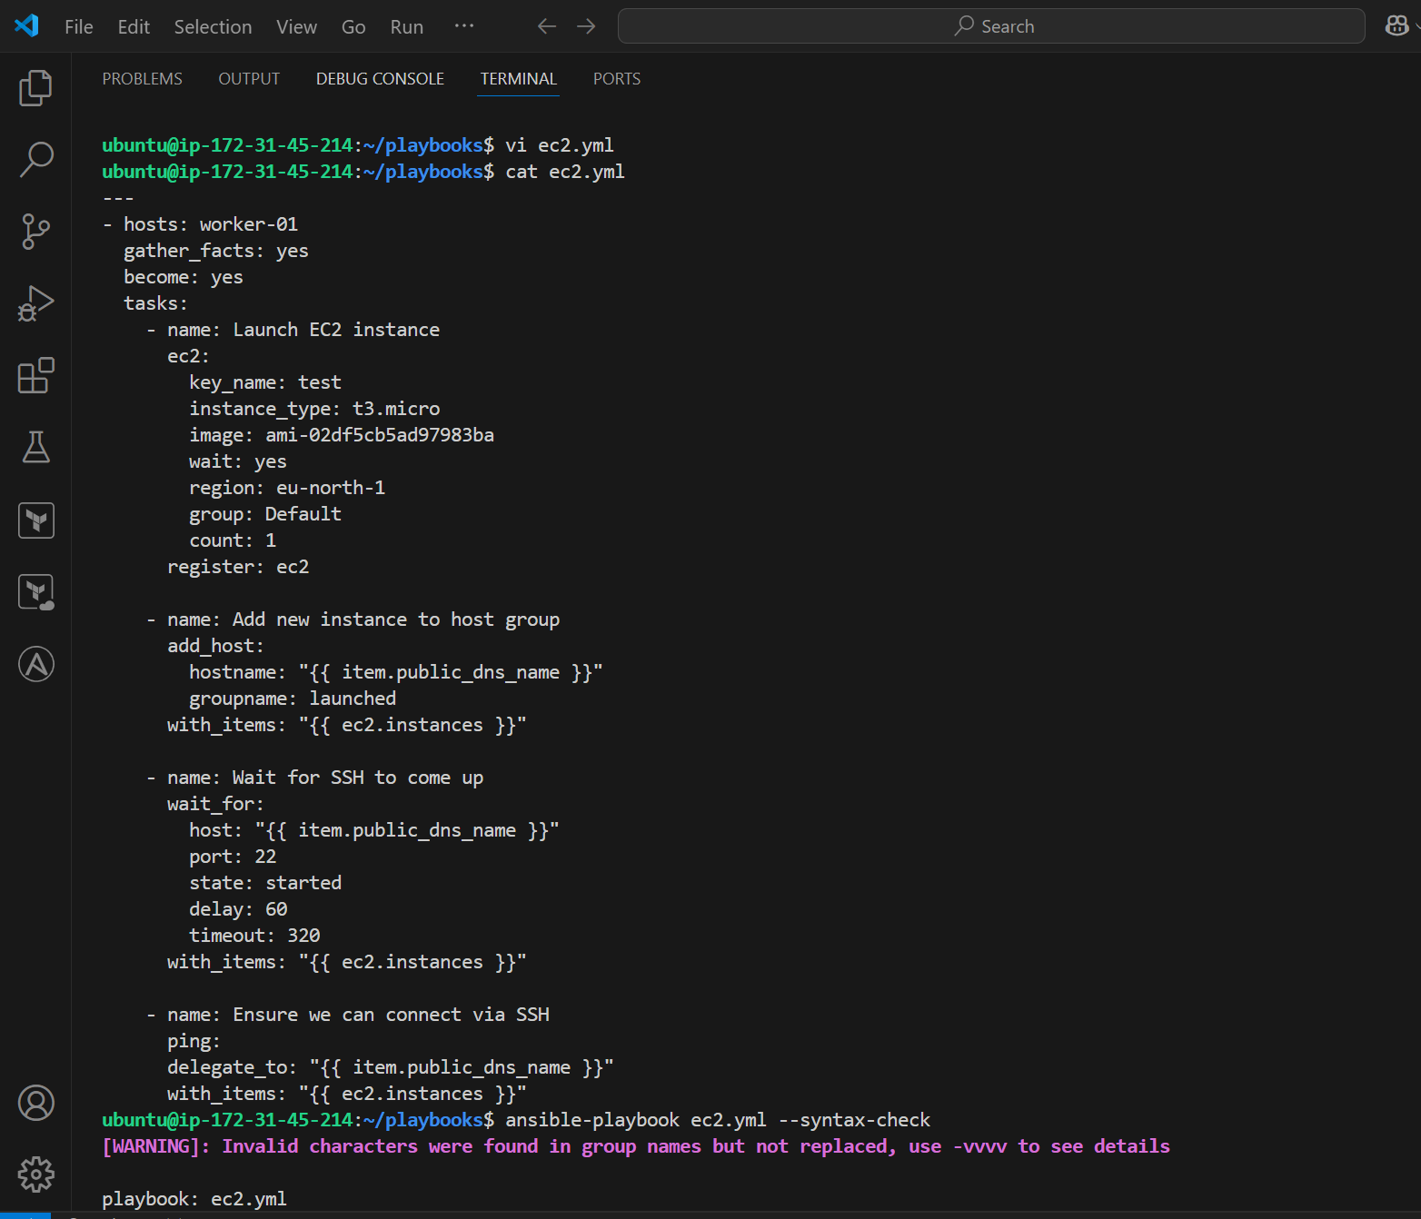  
  
  
  
5) Write a ansible playbook to copy one file from node-1 to node-2.   
  
  
  
  
  
  
  
  
  
  
  
  
  
  
  
  
  
  
  
  
6) Write a ansible playbook to create different files with different names using single playbook.  
  
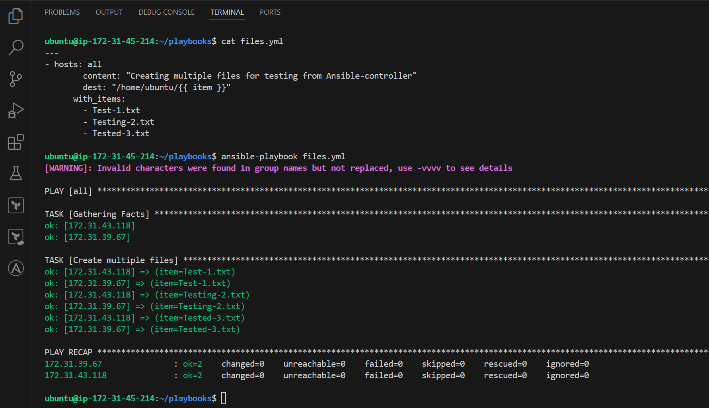  
  
Worker-01  
  
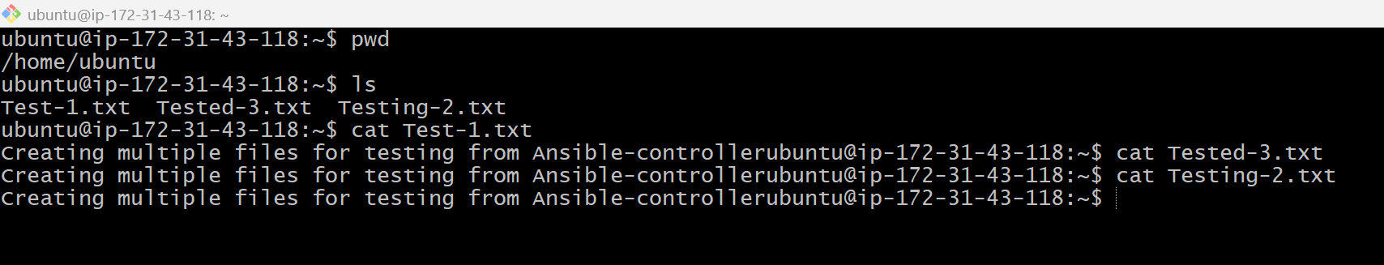  
  
Worker-02  
  
