1. Watch ansible-01 video and write down notes.   
     
   ---Done  
     
   2) Setup one master and two worker nodes in ansible.   
     
   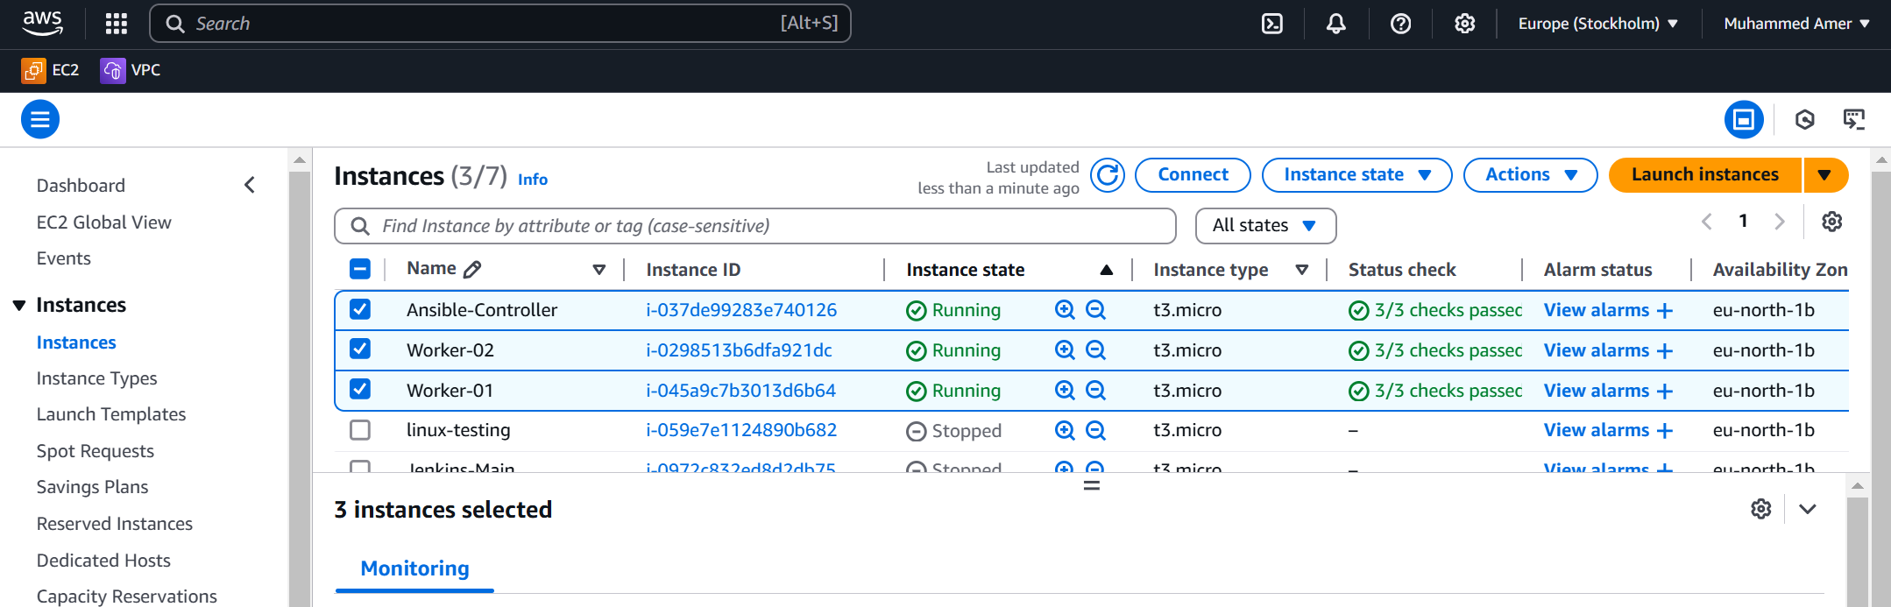  
     
     
   Create a directory (Ansible) and a file in it (hosts) >>>> /etc/Ansible/hosts  
   As config file = none is there  
     
   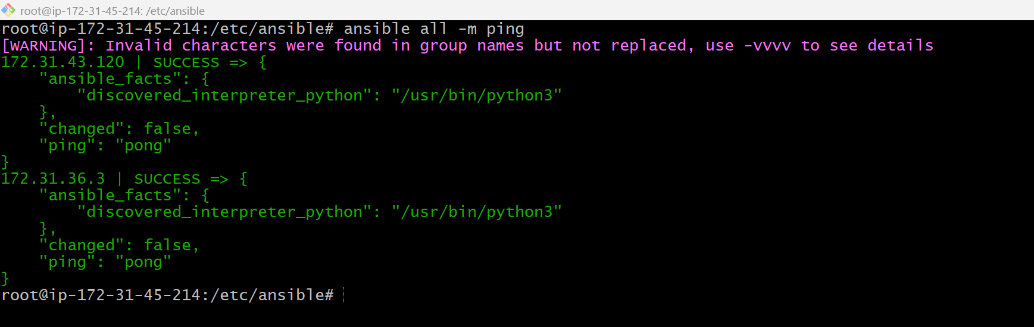  
     
     
   Worker-01 and 02  
     
   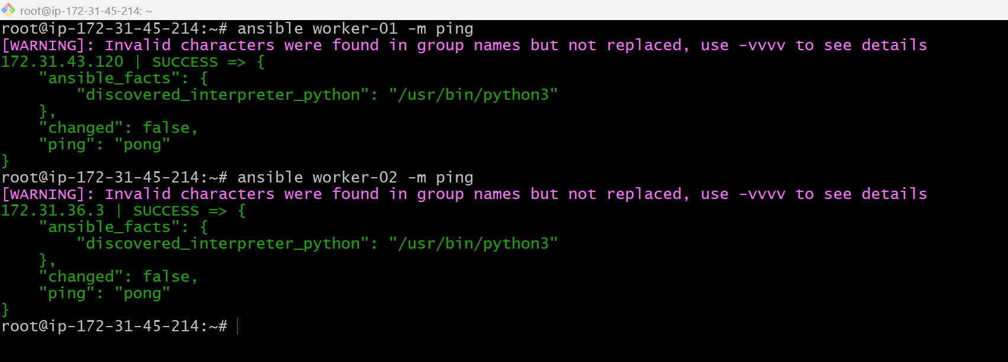  
     
     
     
     
     
     
     
     
     
     
   3) Execute the adhoc command shared in #dvps-cloud-documents Channel  
   -m Setup  
     
   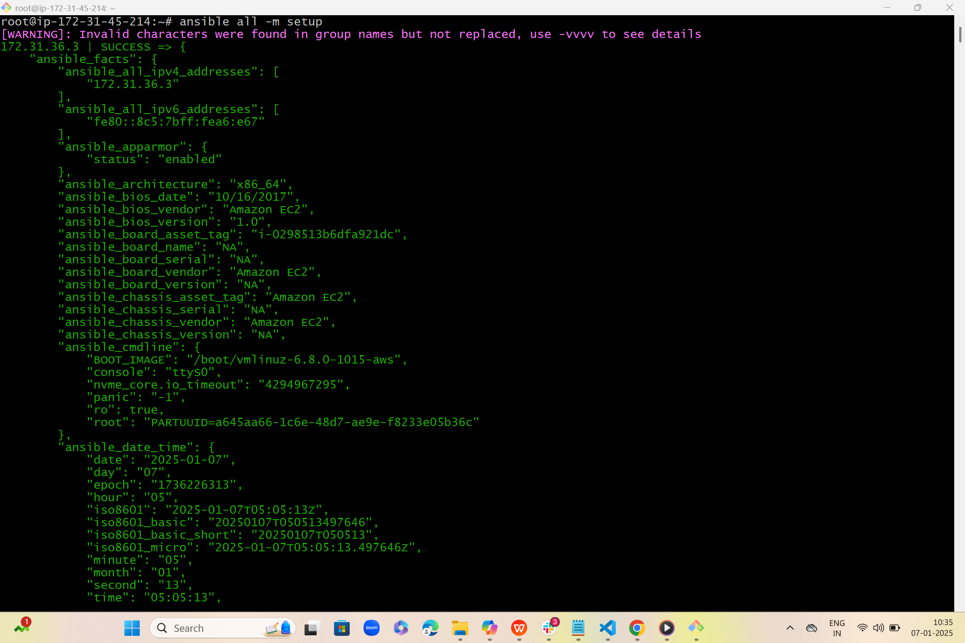  
     
     
   Uptime  
     
   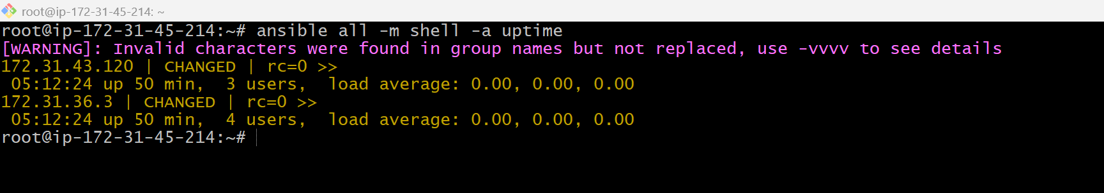  
     
     
   Free -m  
     
   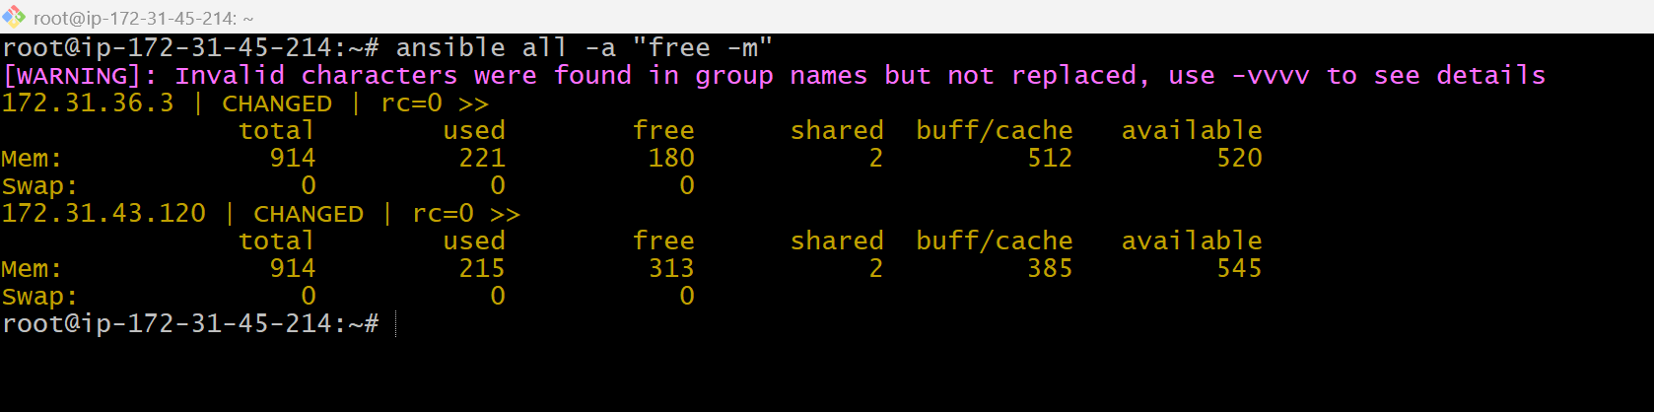  
     
     
     
     
   **New file**   
   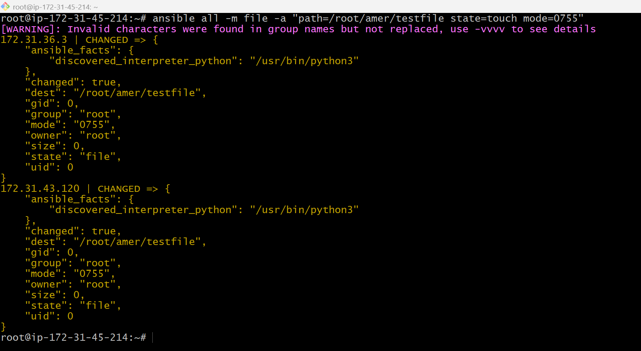  
     
     
     
   ansible all -m apt -a "name=apache2 state=latest" (Installing apache2 in workers )  
     
   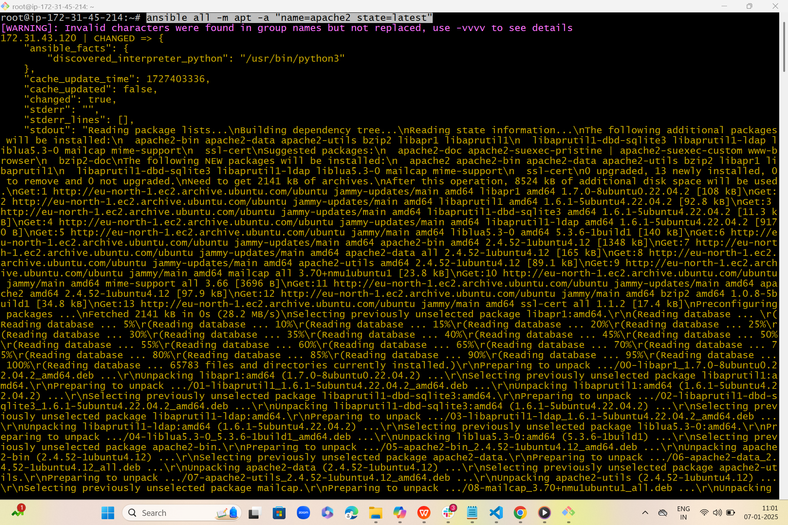  
     
   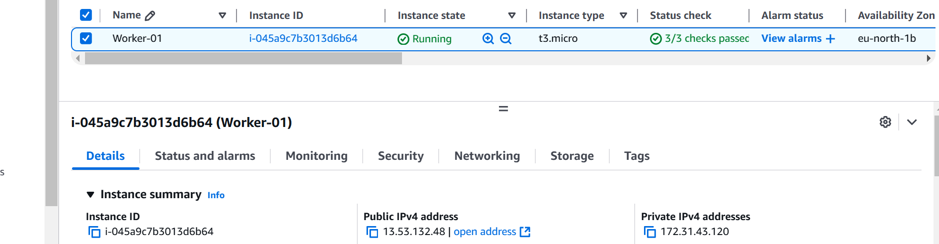

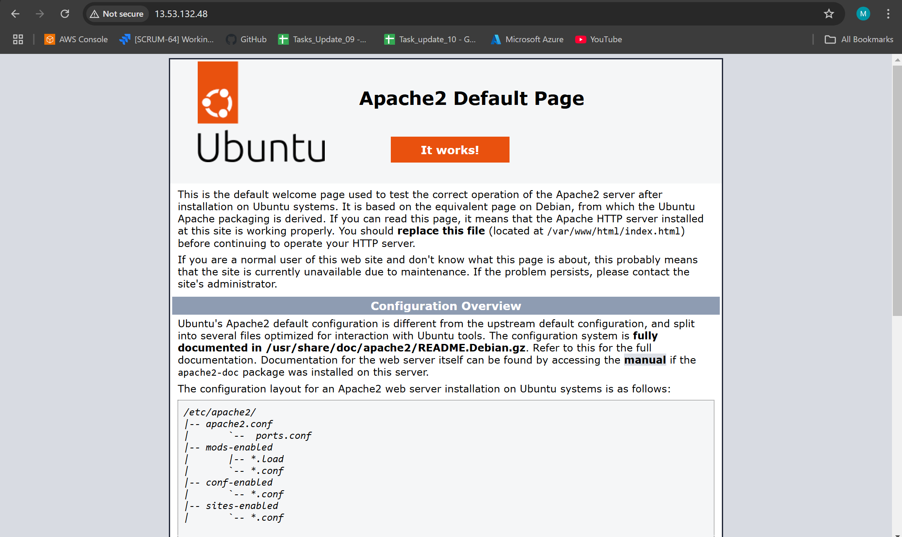  
  
  
  
Worker -02  
  
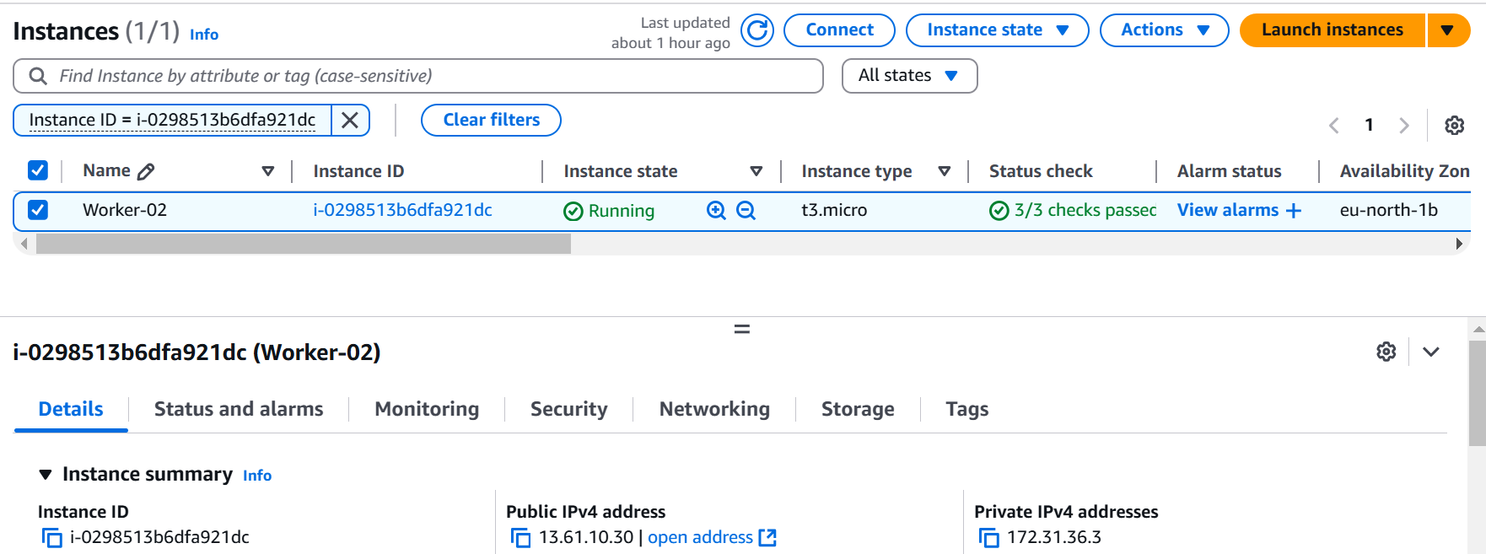  
  
  
  
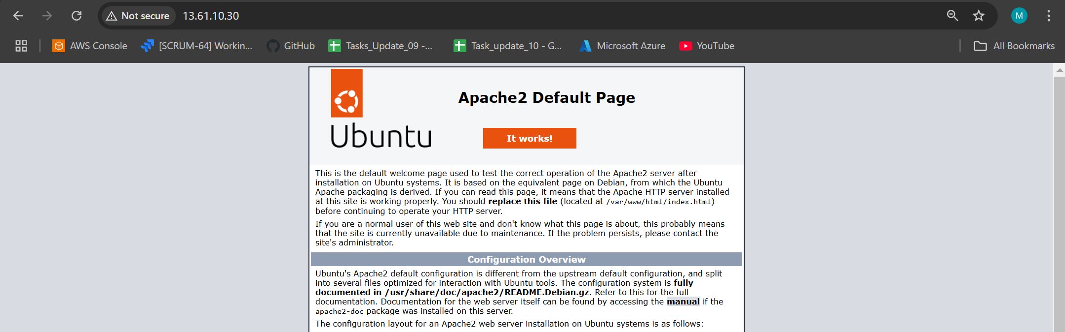  
  
  
  
  
  
Stopped separately worker-1  
  
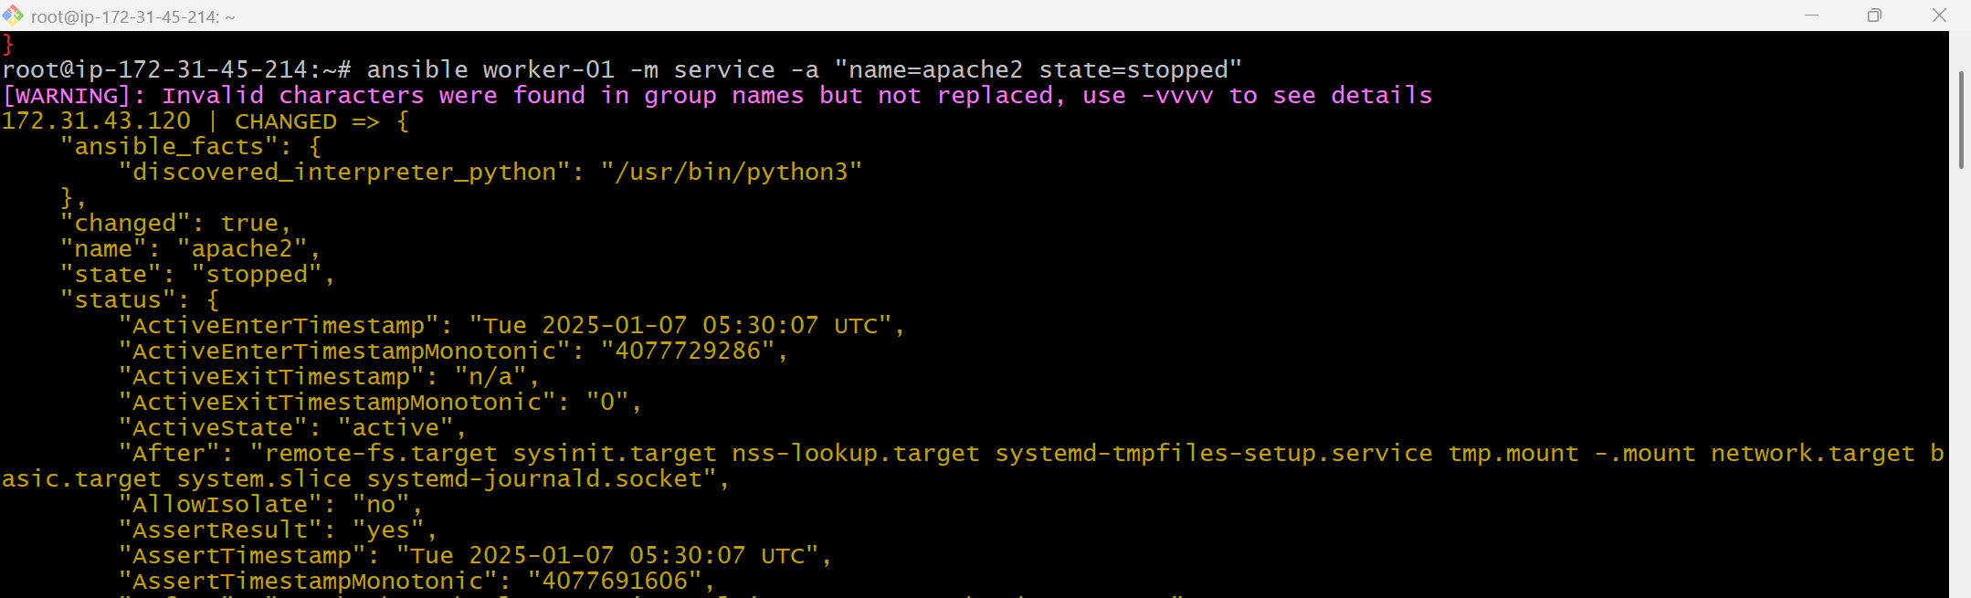  
  
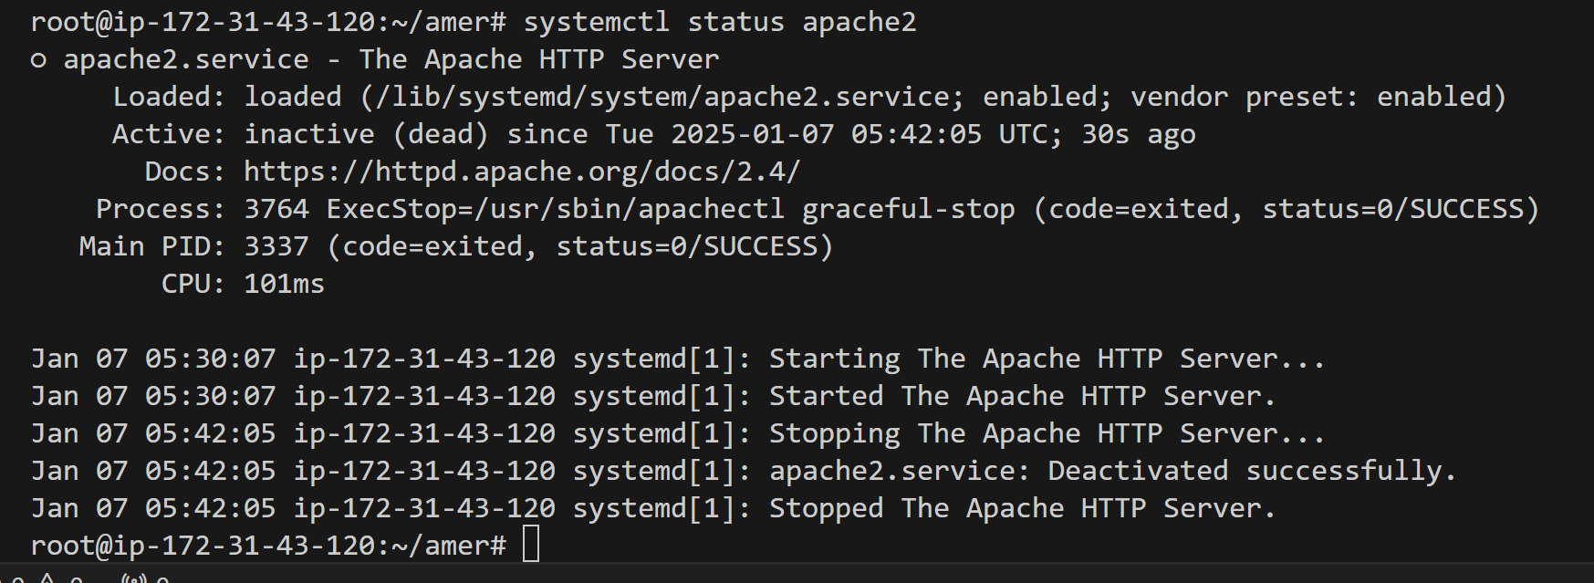  
  
Stopped separately worker-2  
  
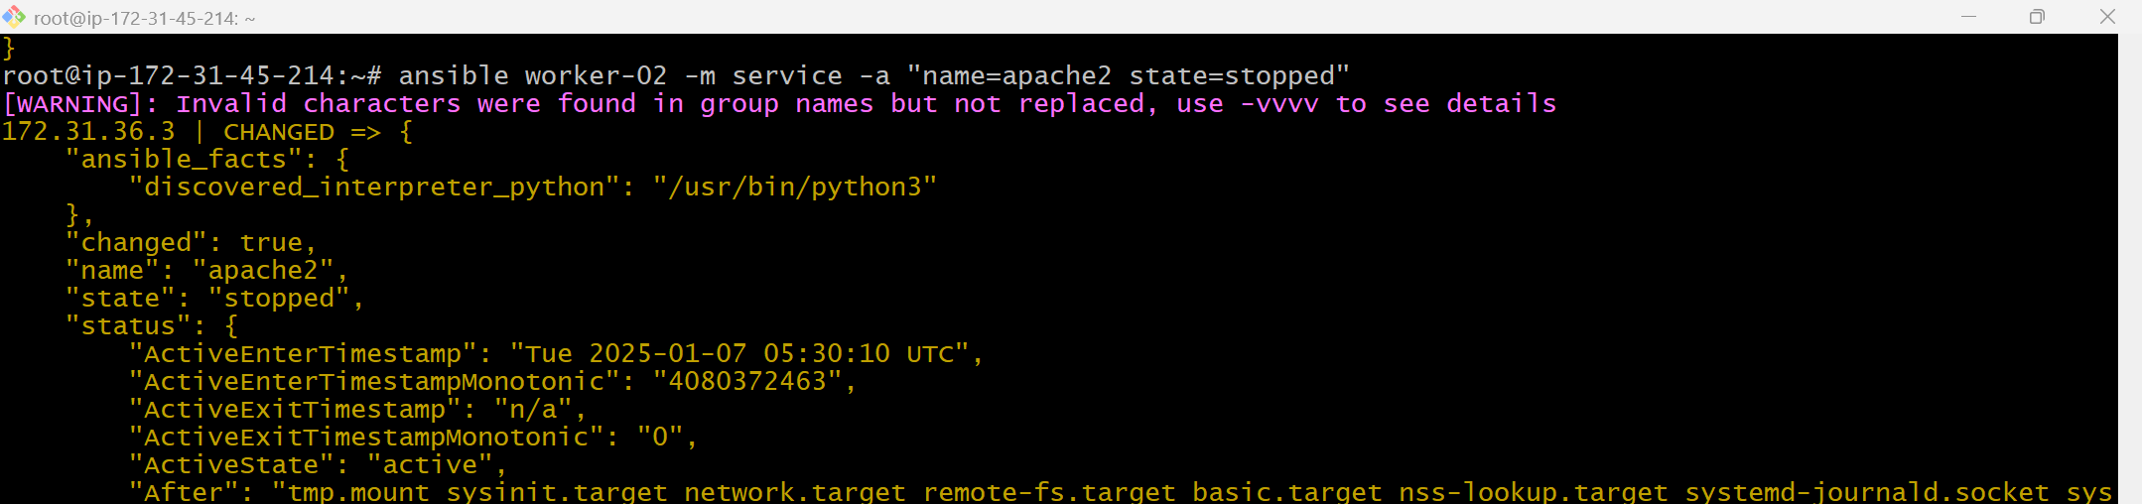  
  
  
  
  
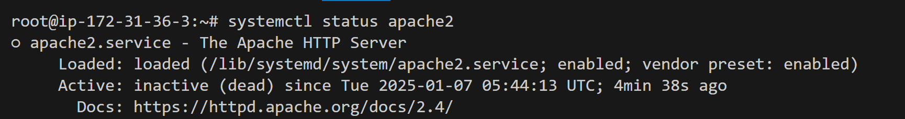  
  
  
  
  
  
  
  
  
  
  
  
Calling group(name-Amer) from home(root) location by using command  
  
