Challenge -3  
  
  
Created token on GtiHub   
  
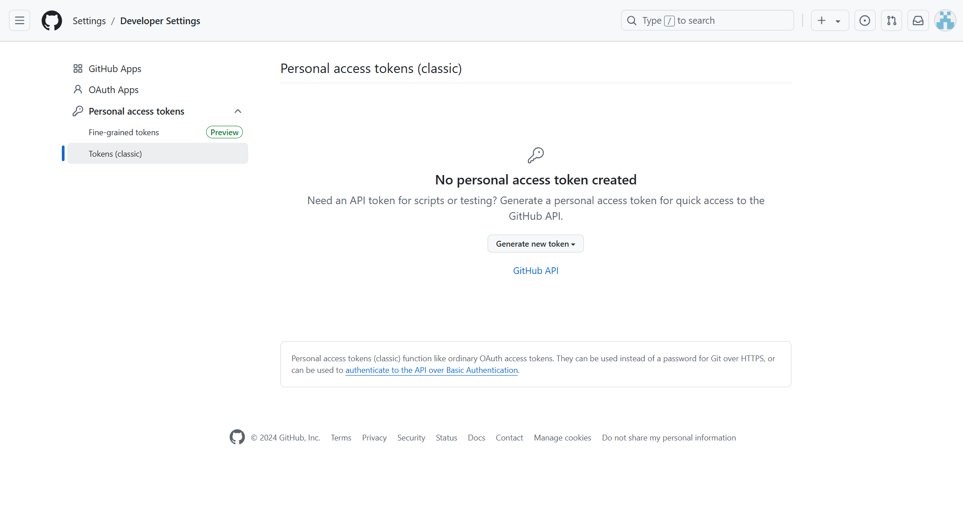  
  
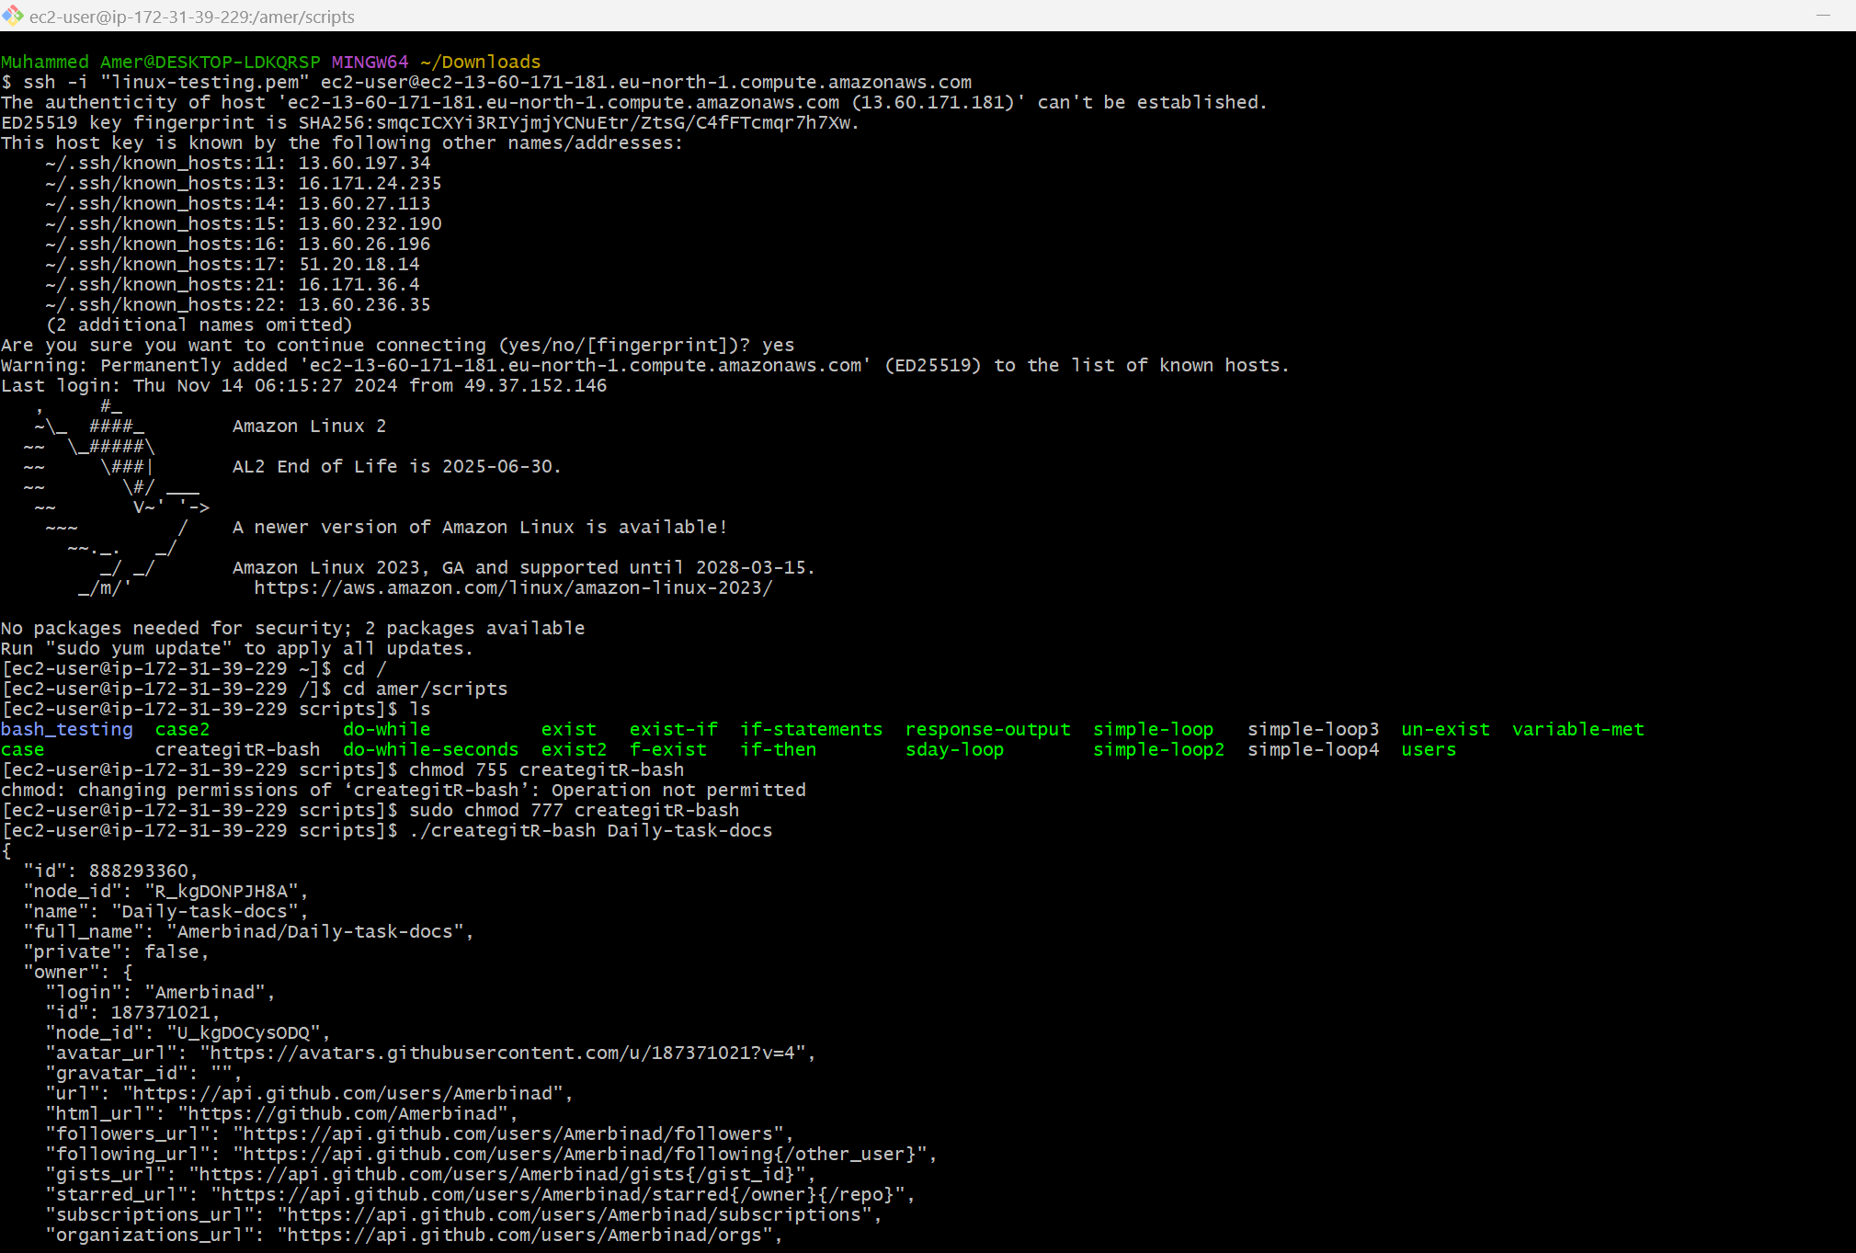  
  
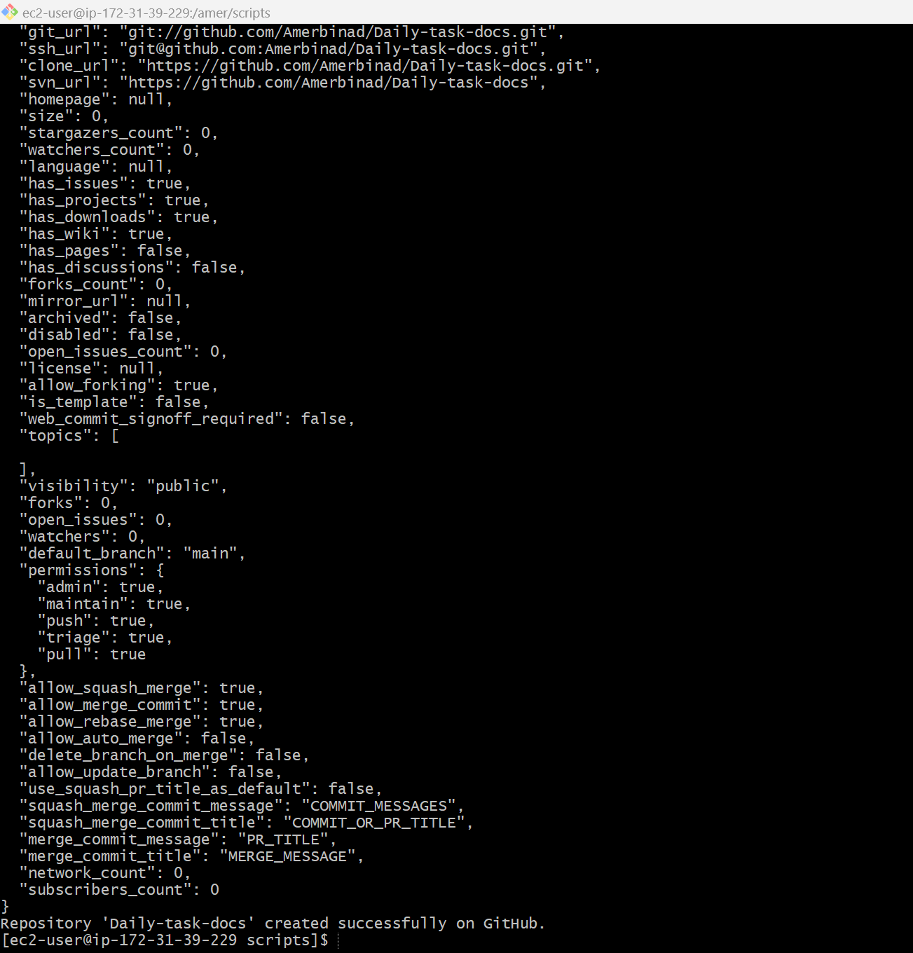  
  
  
  
Name of the repository : Daily-task-docs  
  
