**Docker -3**  
  
  
  
  
  
  
1) Create a image from running container.  
  
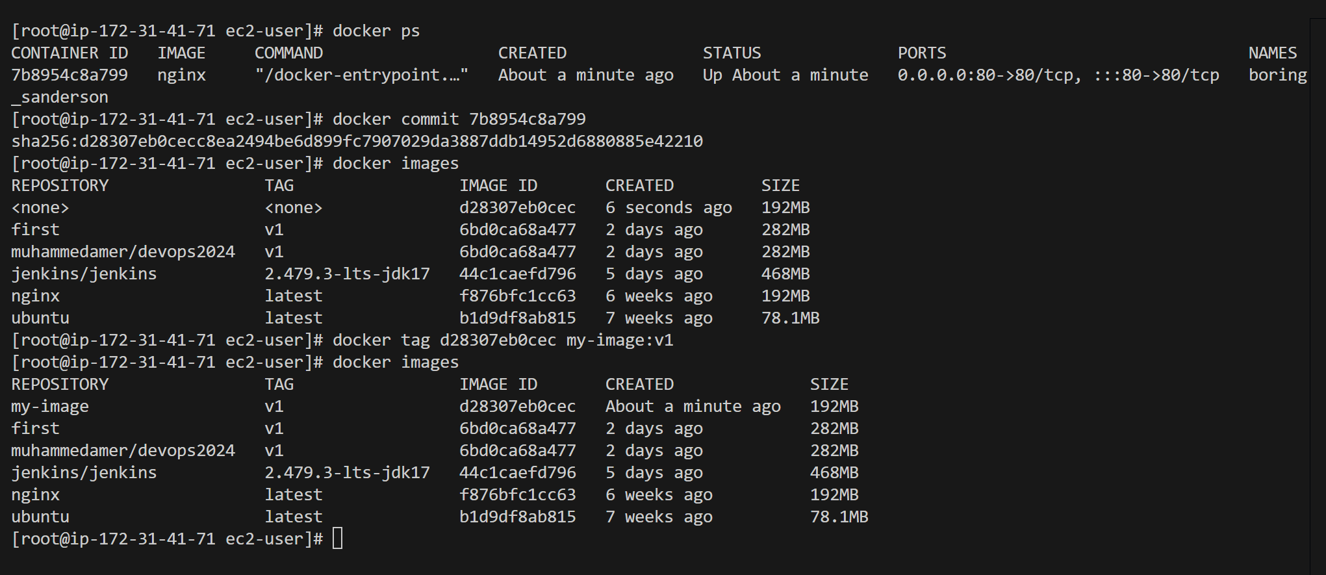  
  
  
  
2) Copy image from local machine to docker server and load the image.  
  
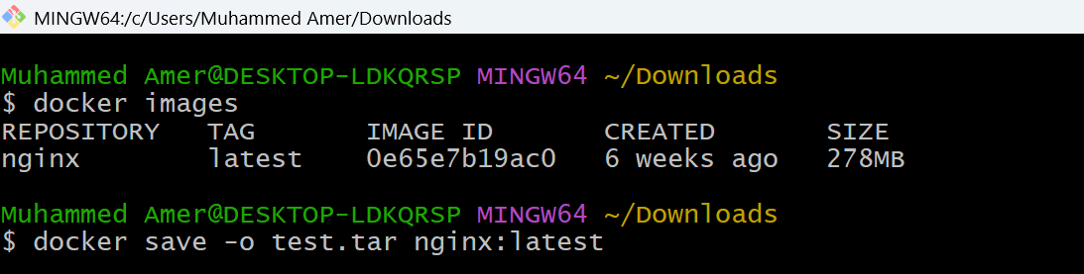  
  
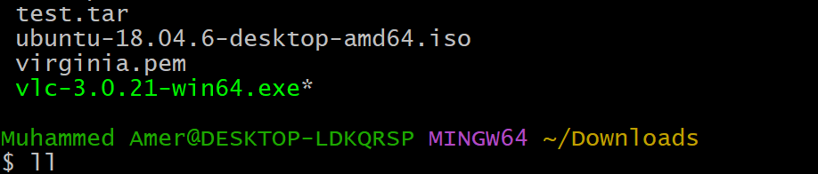  
  
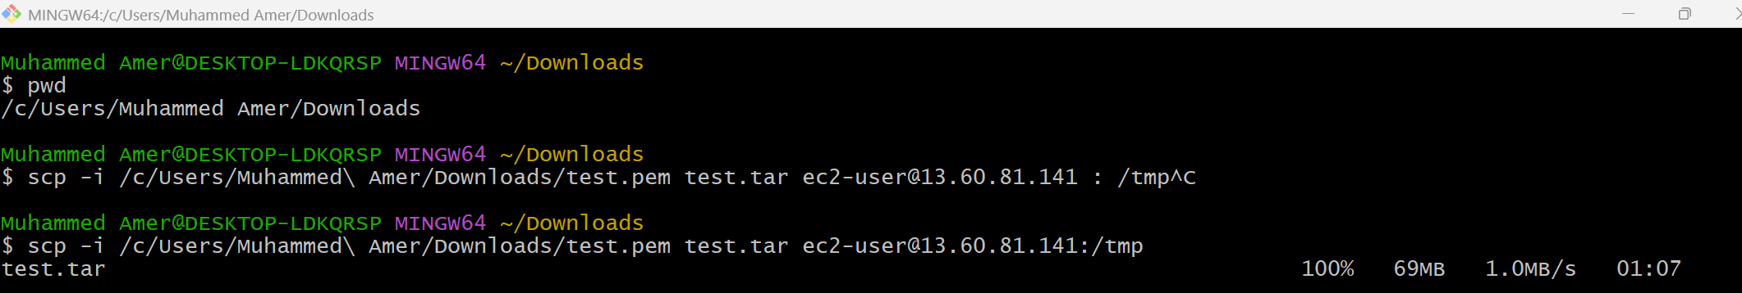  
  
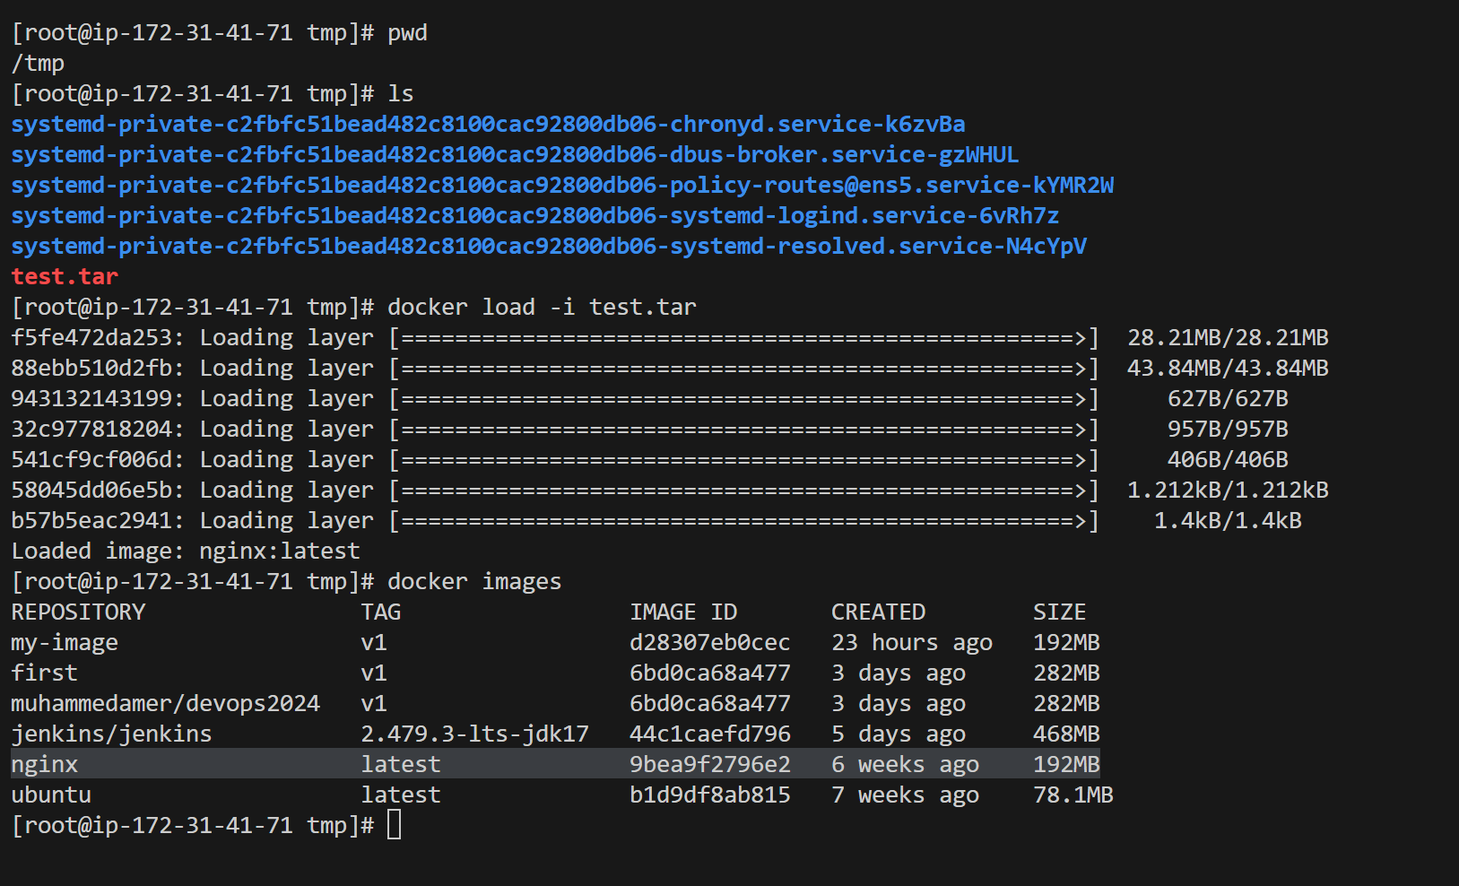  
  
  
3) Create Docker image using alpine and customize with tomcat.  
  
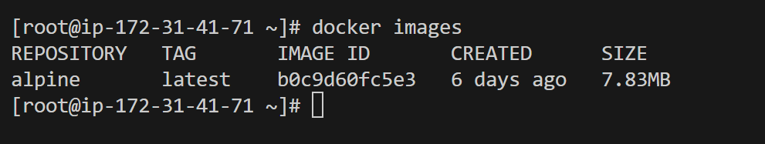  
  
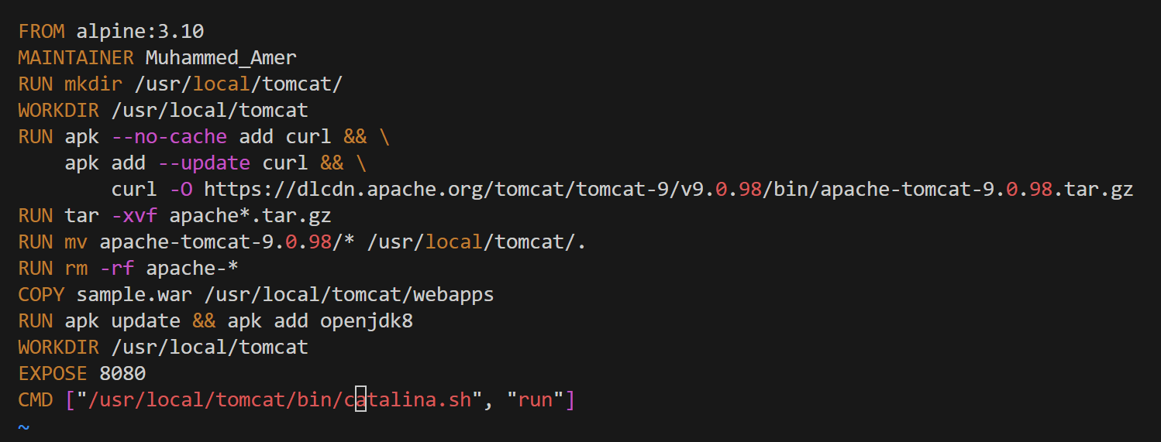  
  
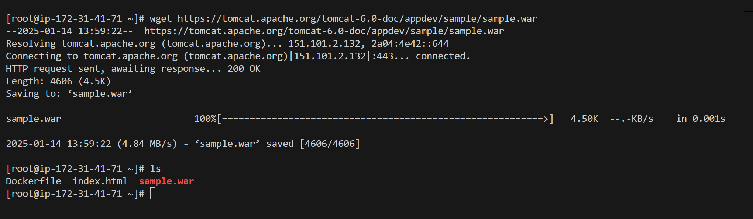  
  
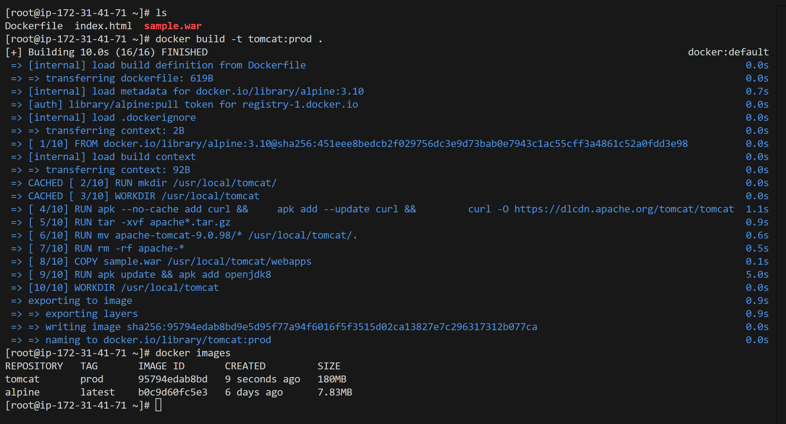  
  
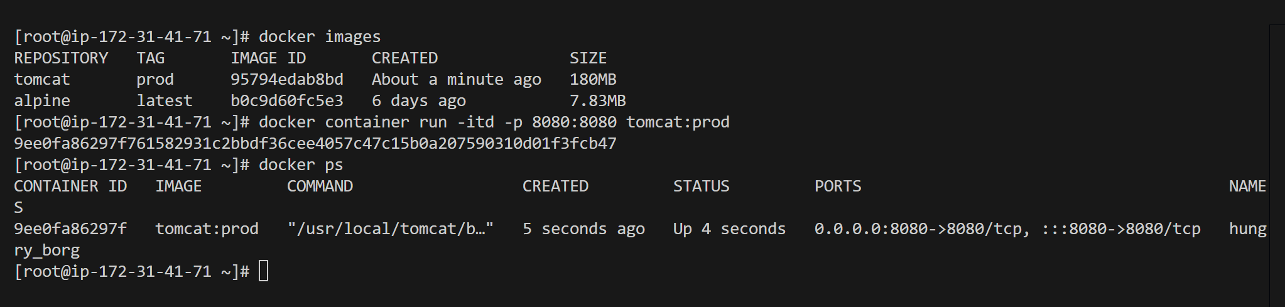  
  
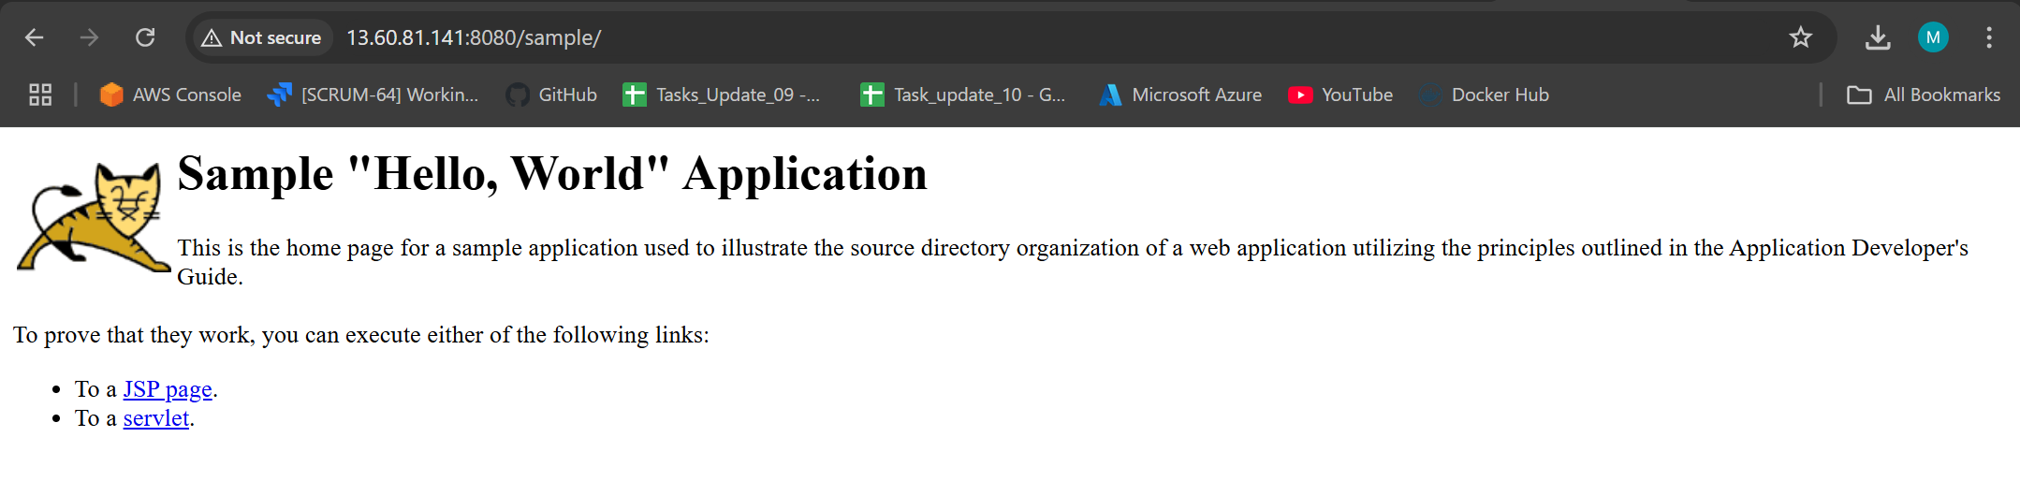  
  
4) Create single stage and multi stage docker file using the below source code.

<https://github.com/betawins/multi-stage-example.git>  
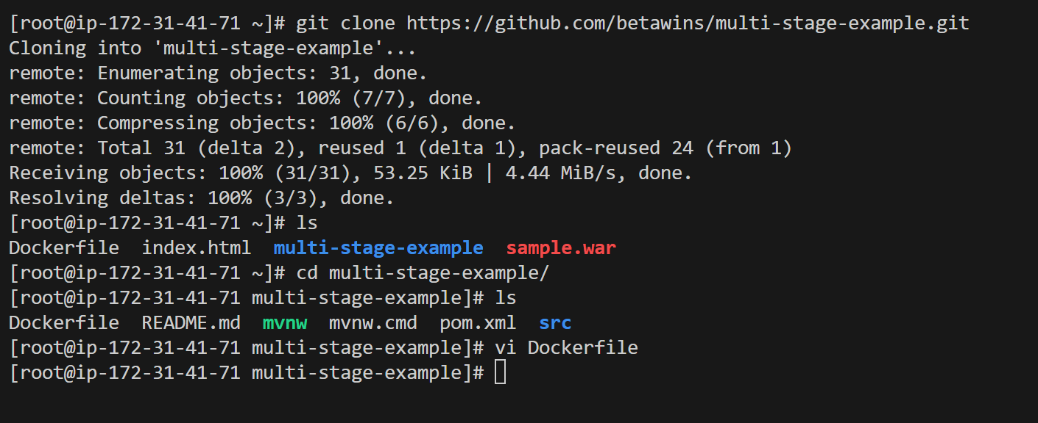  
  
Single-stage dockerfile  
  
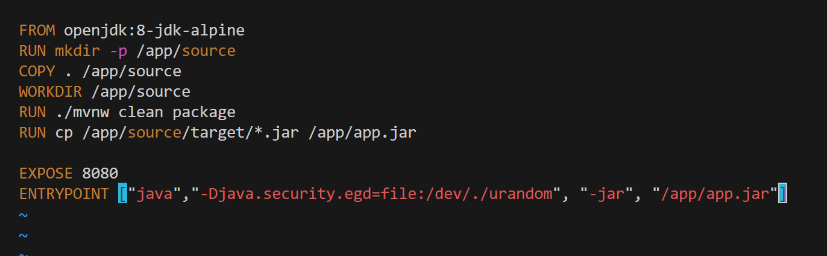  
  
Tried but not working due to memory issue in docker instance  
  
Multi-stage Dockerfile  
  
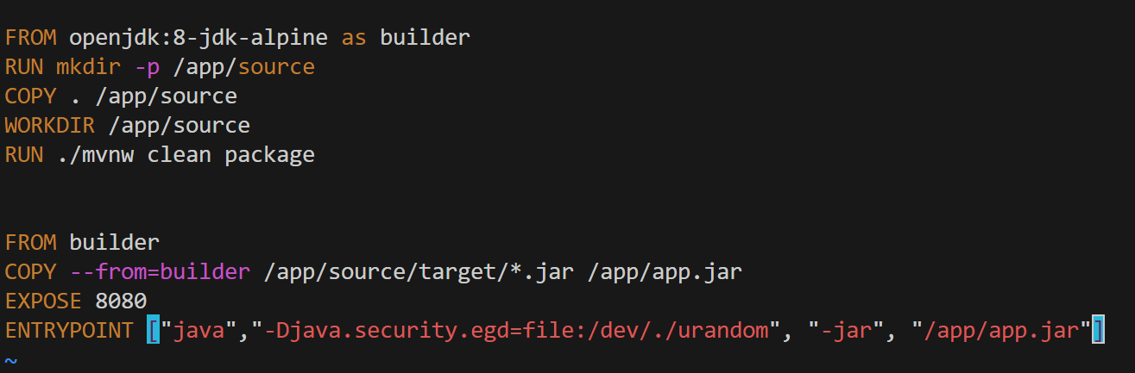  
  
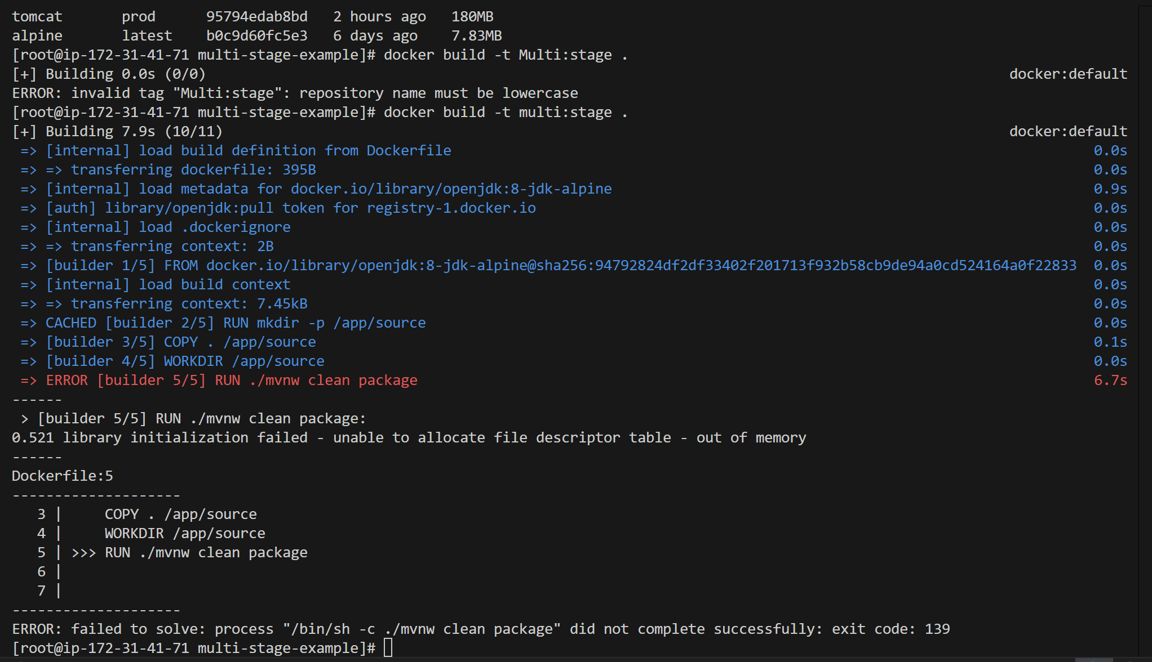  
  
This is also not working due to space issue  
  
  
  
  
  
5) Install docker compose and execute sample application.  
  
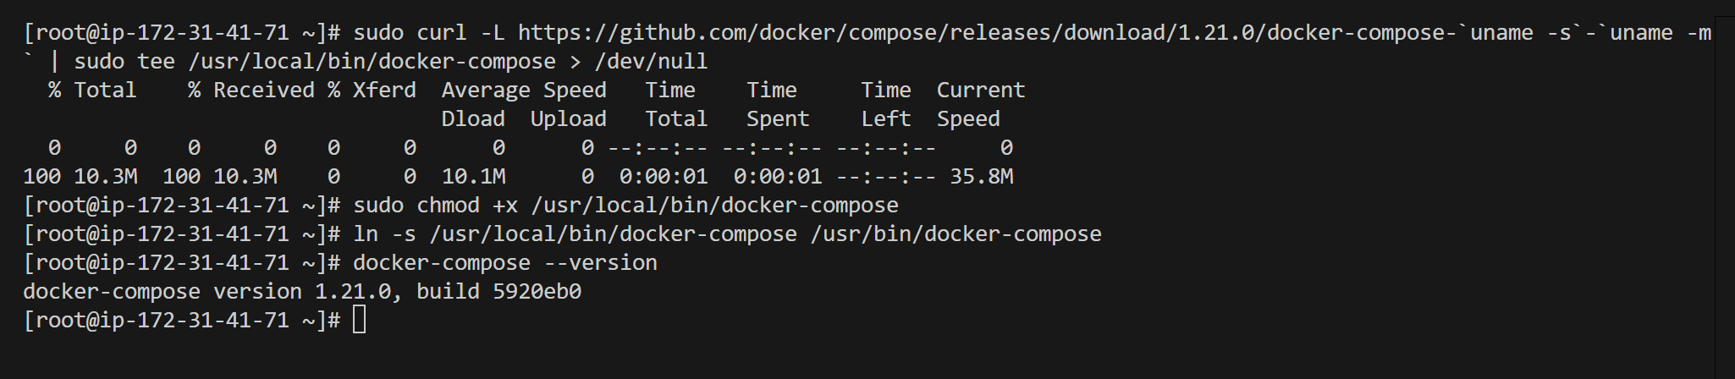  
  
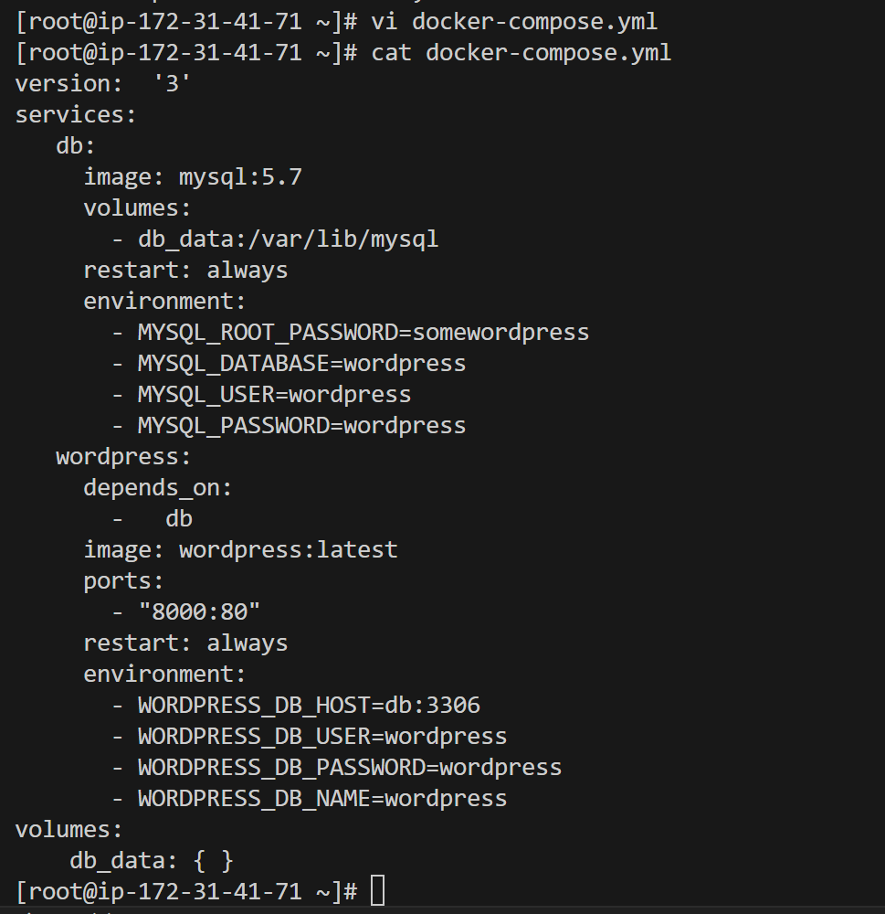  
  
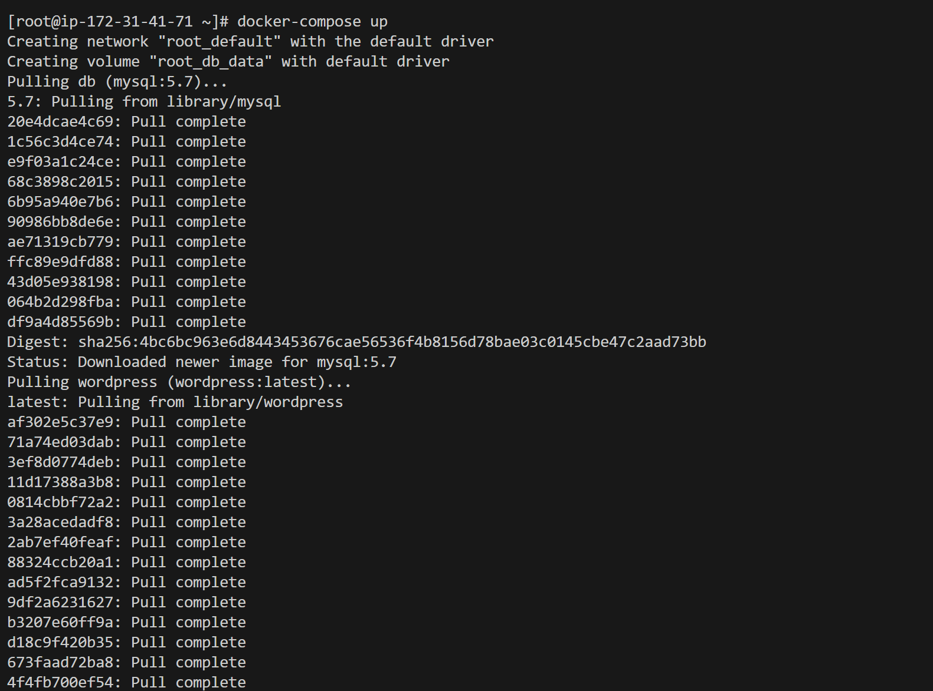  
  
  
  
  
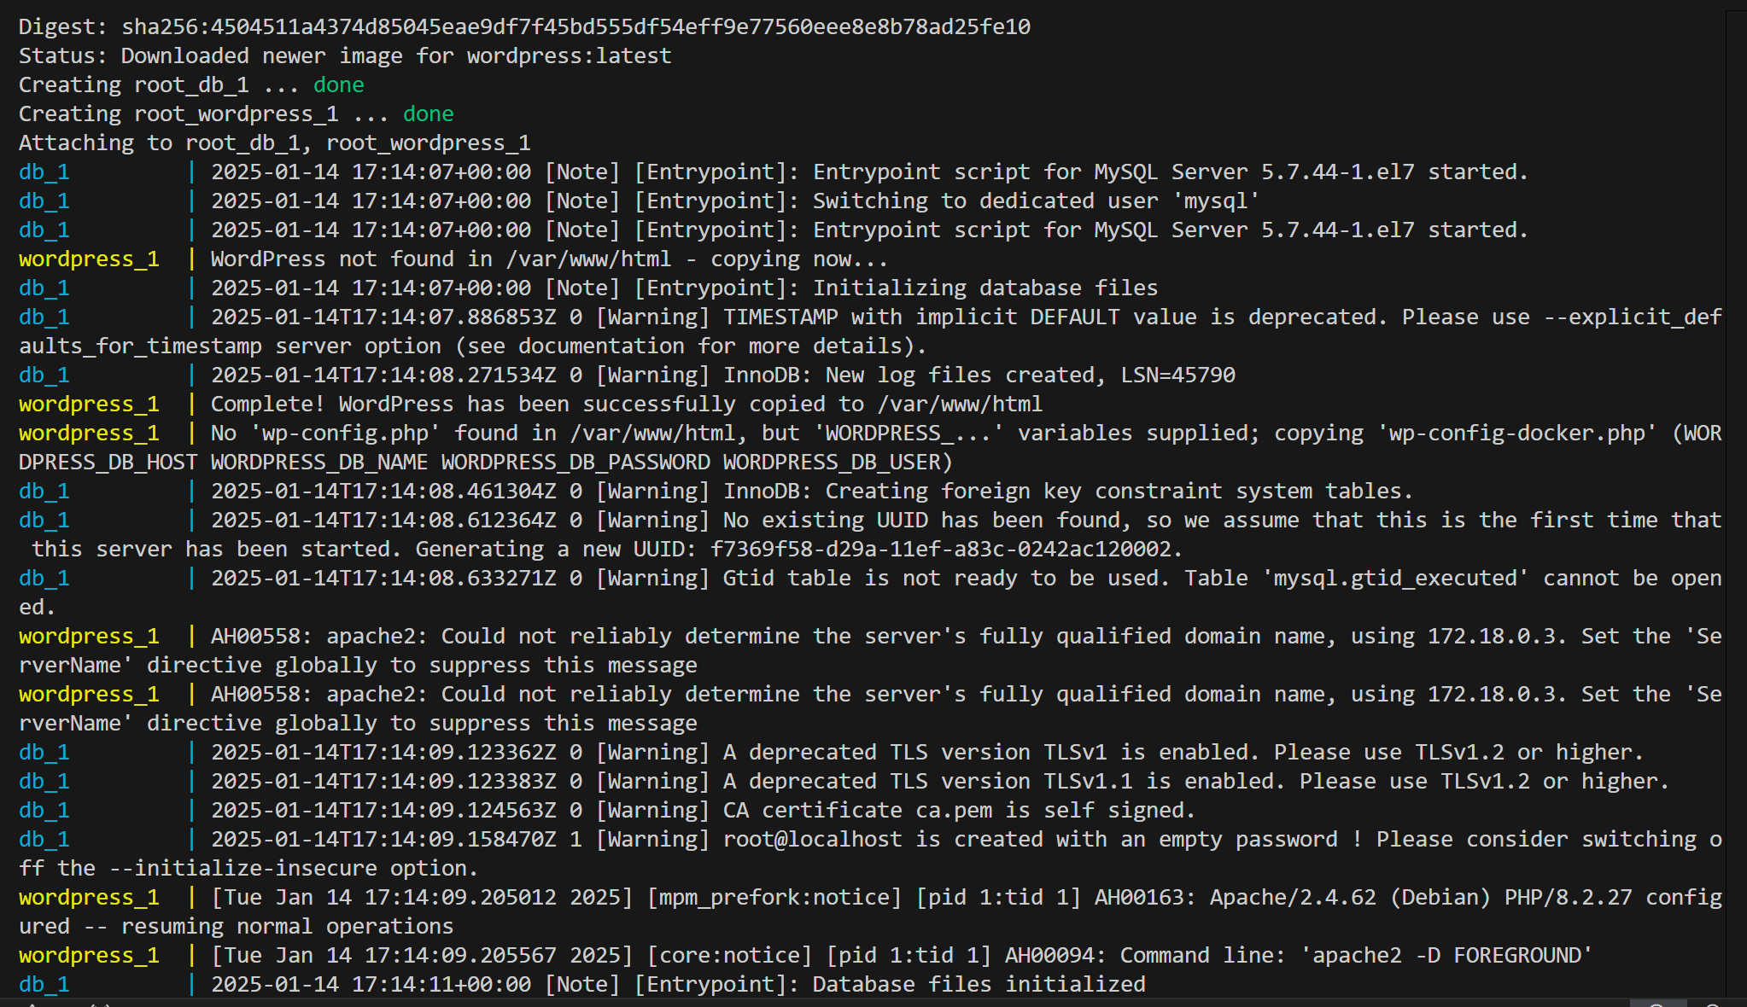  
  
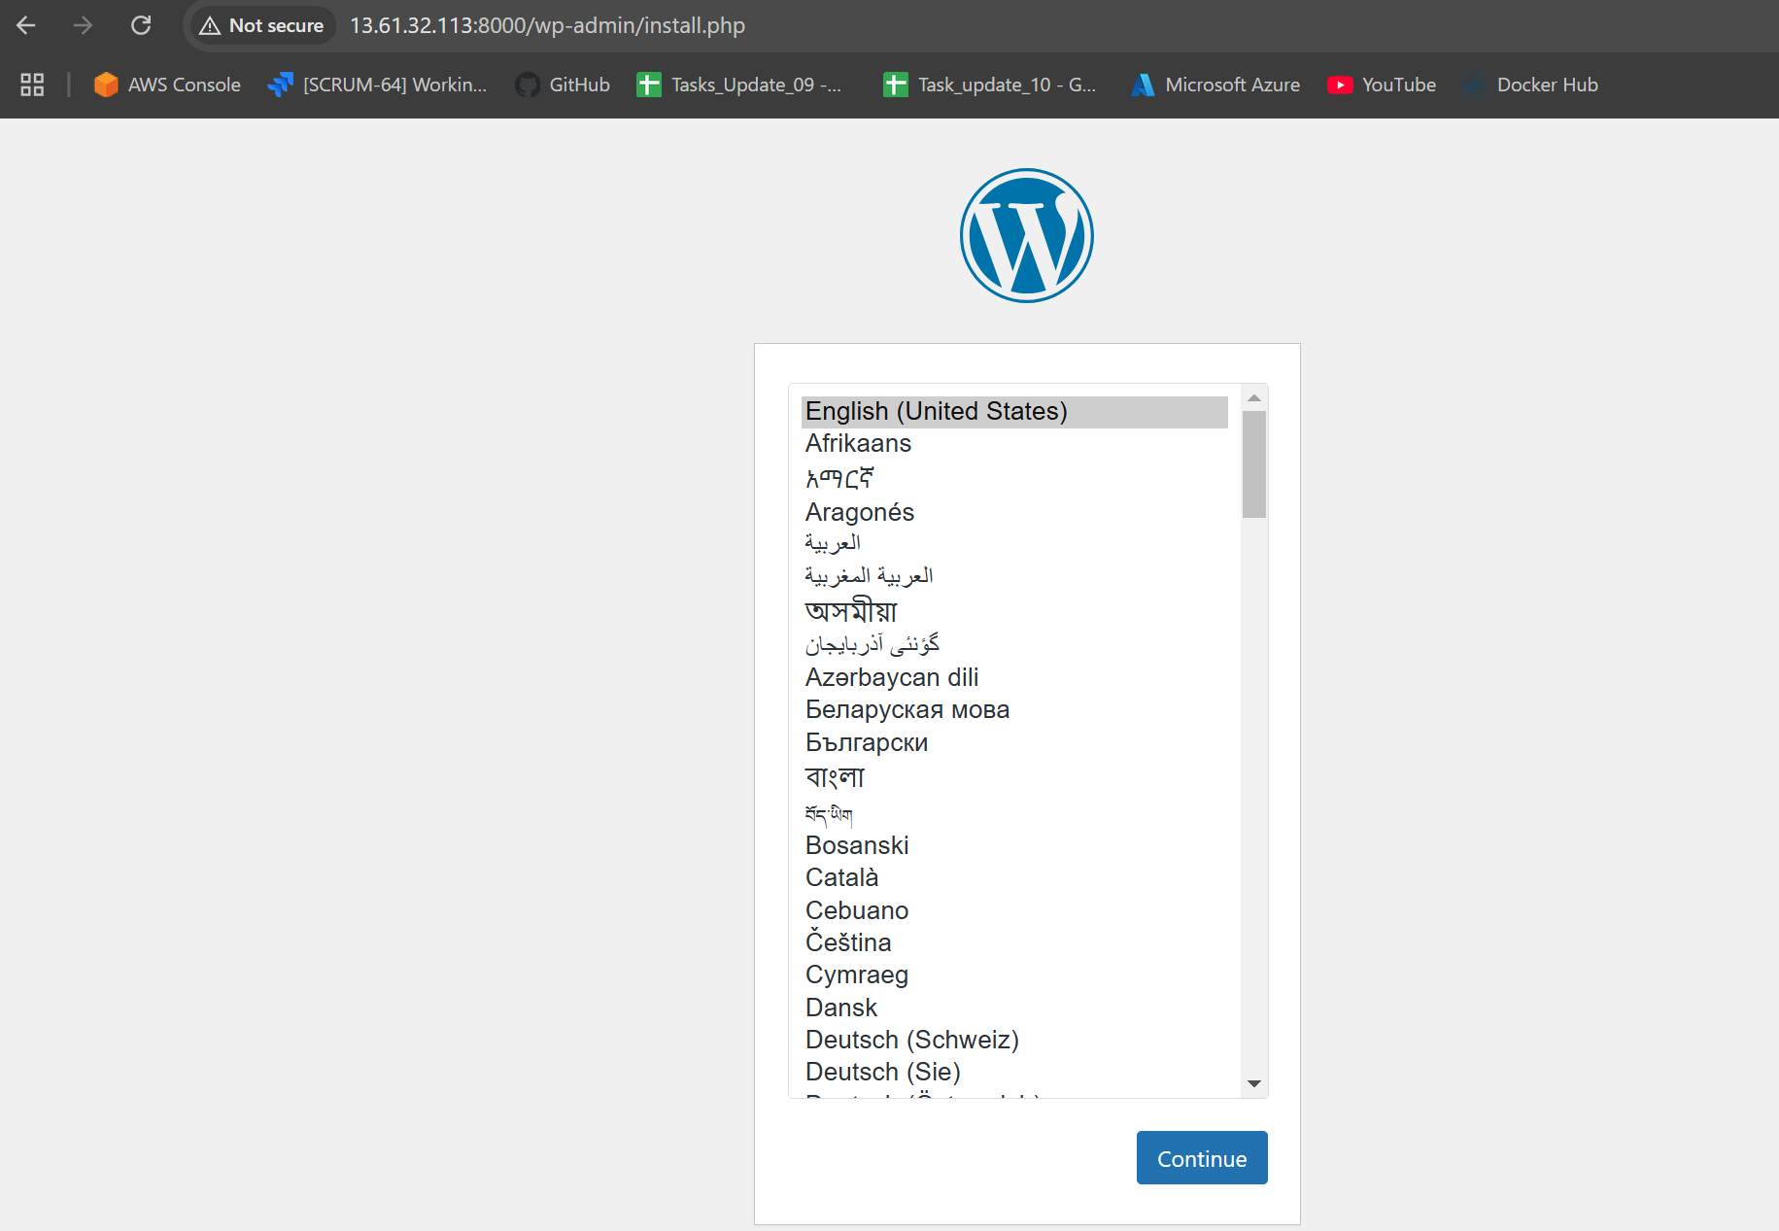  
  
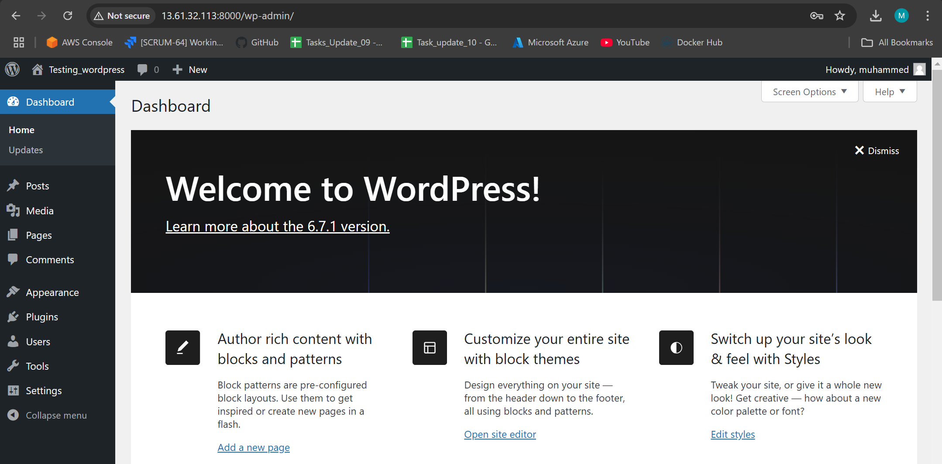  
  
  
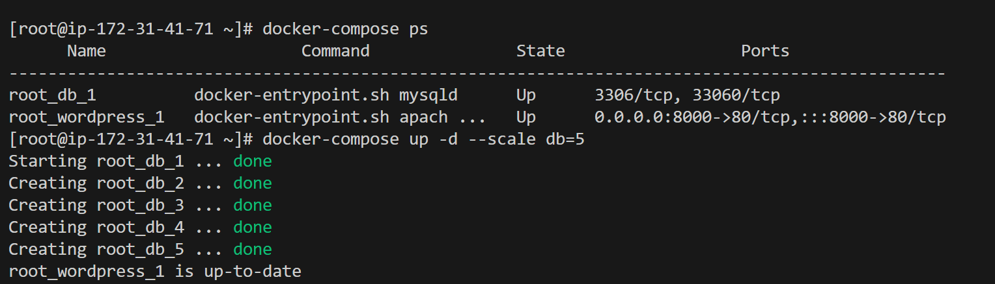

6) Implement solution to scan images when pushed to docker registry.

7) Implement solution to scan images when pushed to AWS ecr.

8) Create a Jenkins pipeline to create a docker image and push the image to docker-hub.  
GitHub

GitHub - betawins/multi-stage-example: Multi Stage docker build example