**Docker-01**  
1) Setup a virtual machine using Ubuntu image.   
  
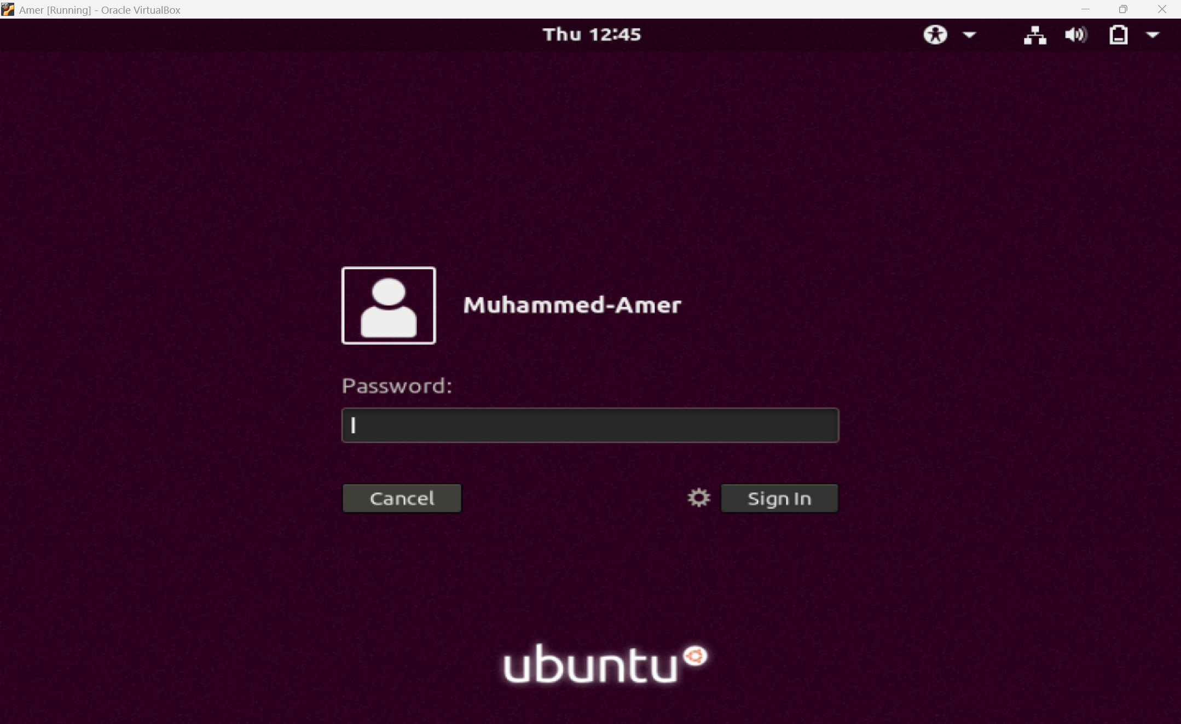  
  
  
2) Install docker on ec2.   
  
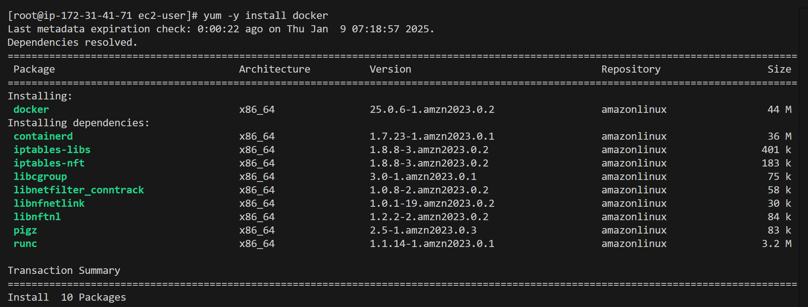  
  
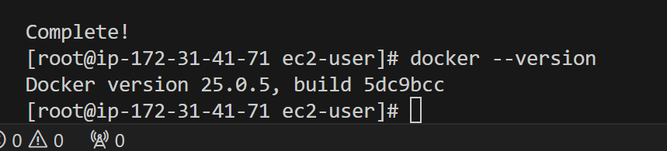  
  
3) Pull 5 docker images.(nginx,apache tomcat,ubuntu,jenkins,sonarqube)   
  
  
  
---Nginx  
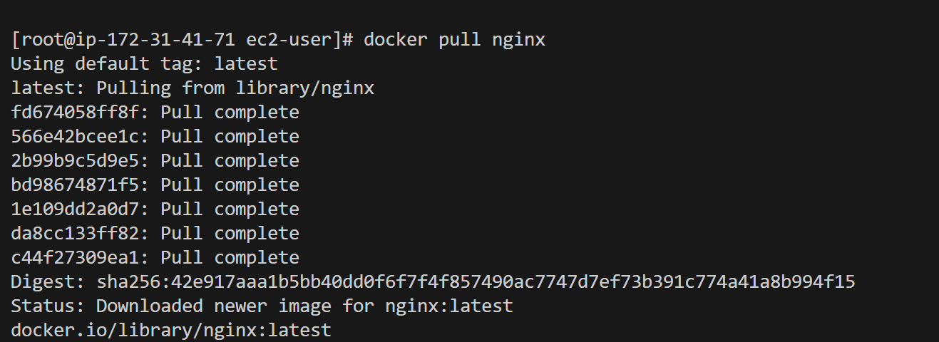  
  
  
  
---Tomcat  
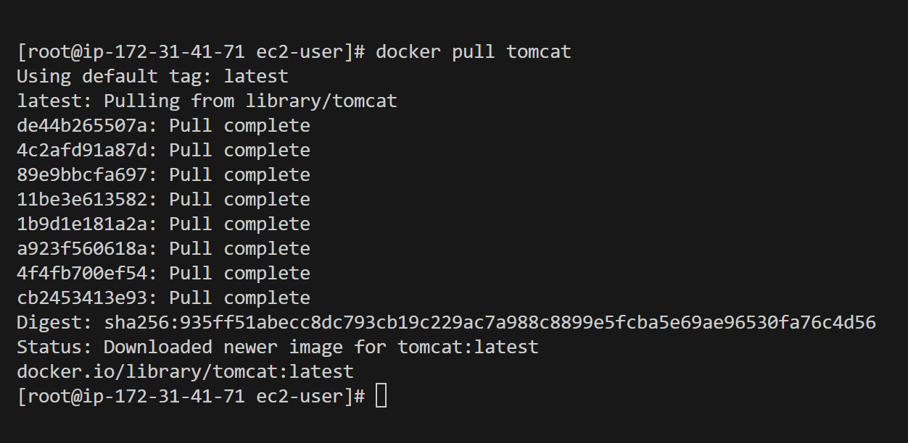  
  
  
  
  
  
  
---Ubuntu  
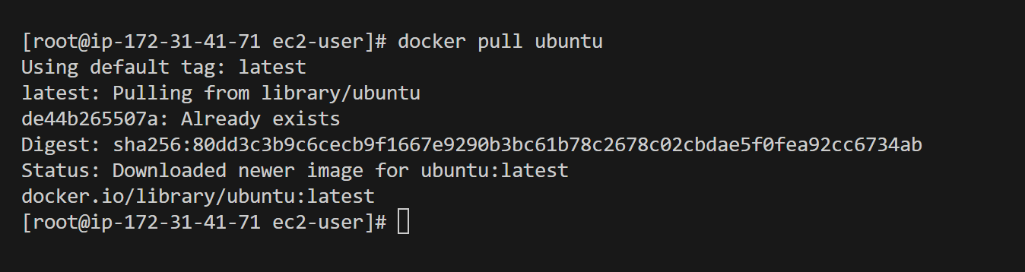  
----Jenkins  
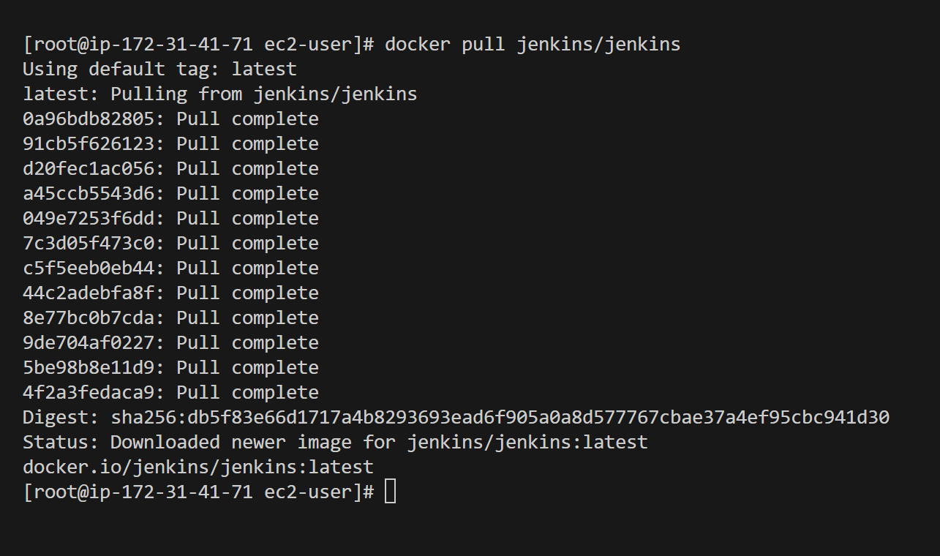  
  
  
SonarQube  
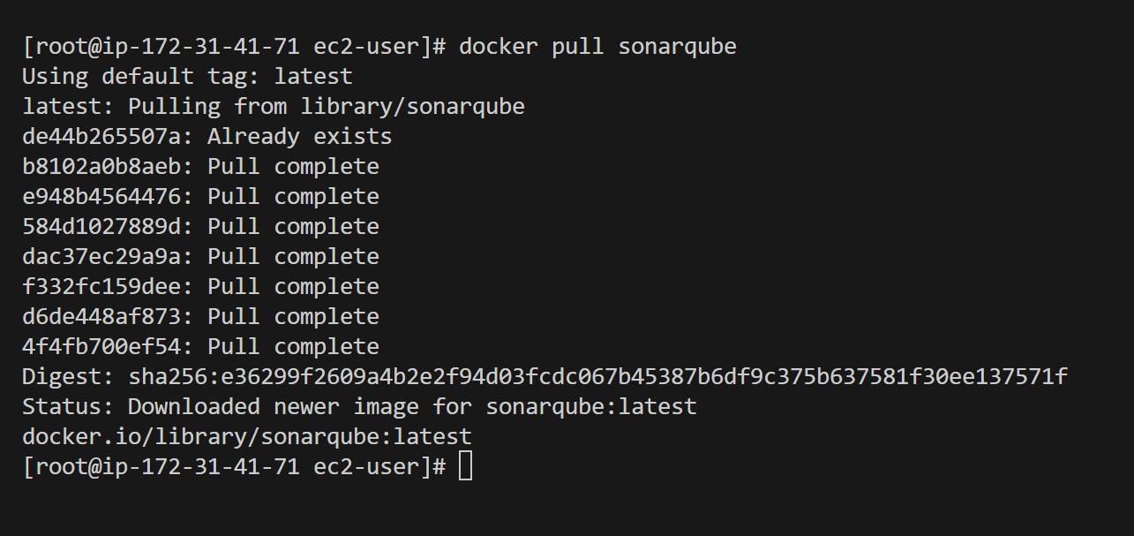  
  
  
  
  
  
-----All 5  
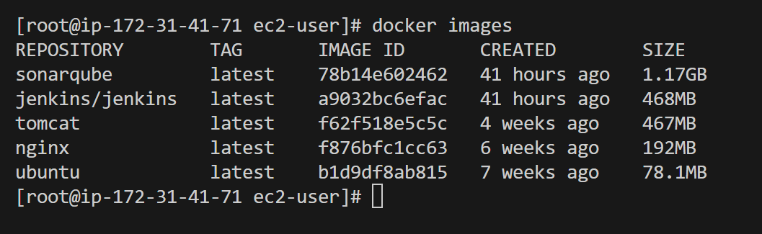4) Run nginx container and expose on port 81.   
  
  
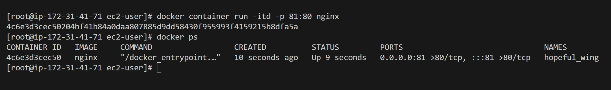  
  
  
  
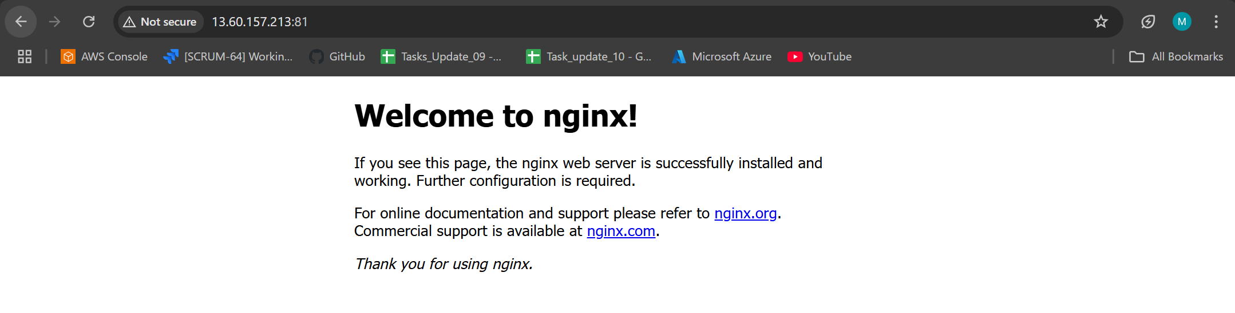  
  
  
  
  
  
5) Delete the apache tomcat image from local.   
  
  
  
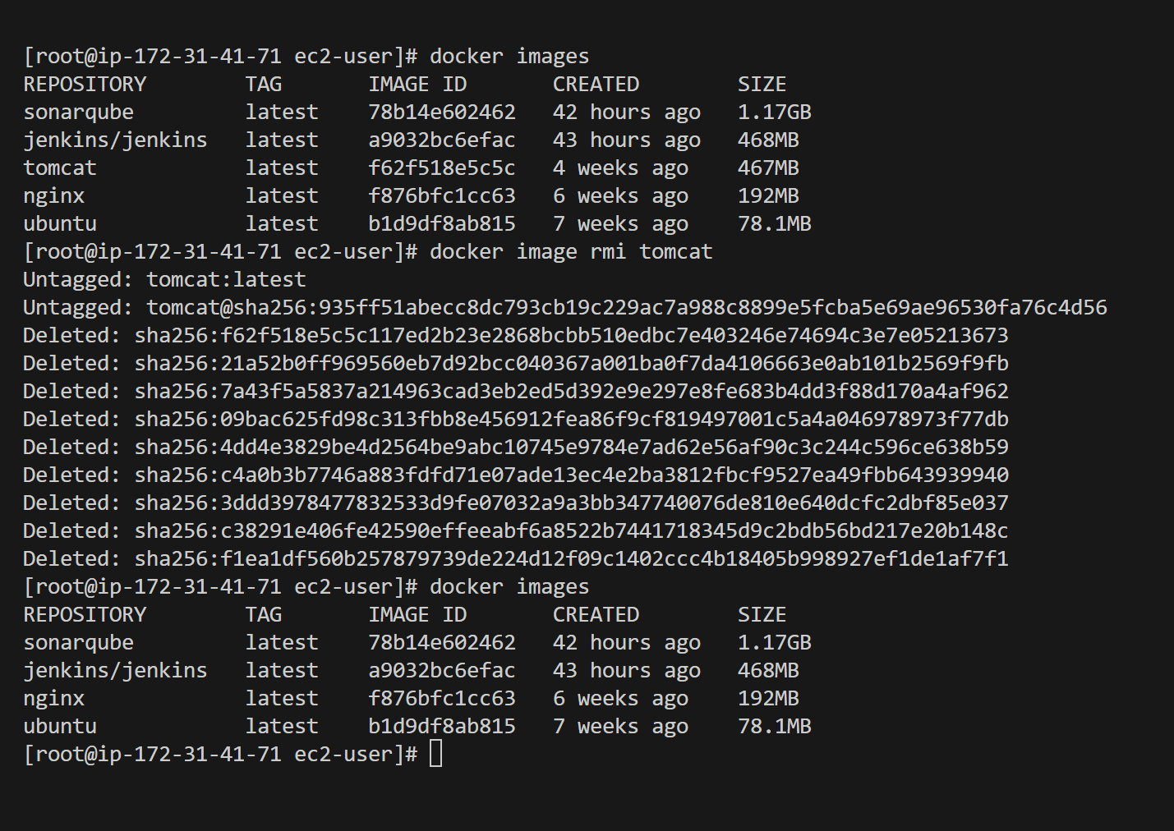  
  
  
  
6) Inspect the jenkins image,sonarqube image.  
  
Jenkins 8080:8080  
  
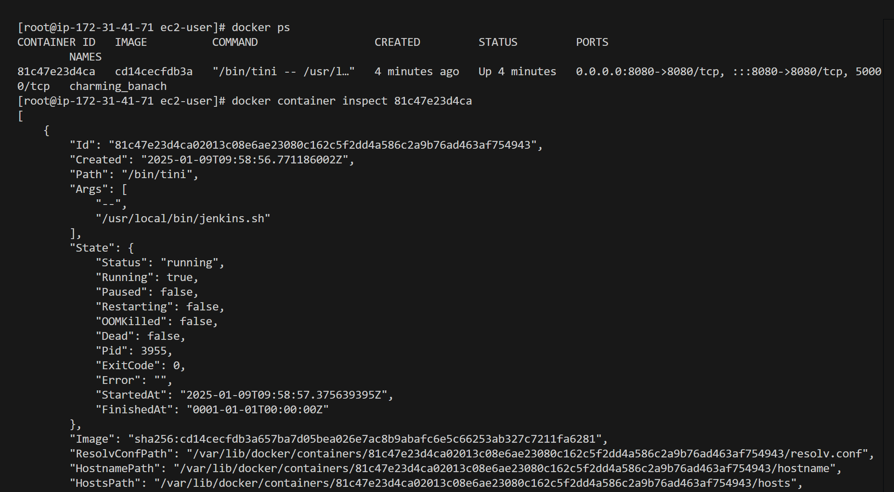  
  
  
  
7) Run jenkins container and run one sample job.  
  
---- docker container exec -it (jenkins_i.d) bash  
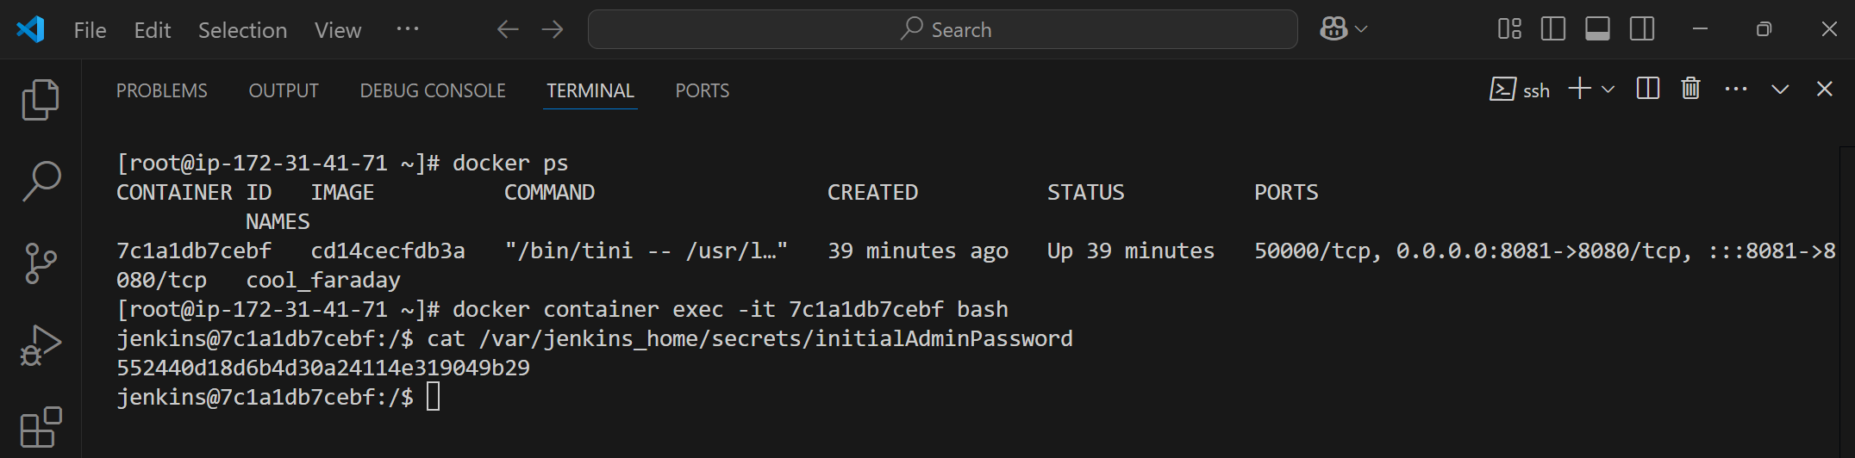  
  
  
  
  
------ /var/jenkins_home/secrets/initialAdminpassword  
