**Docker-02**1) Create a tomcat container on 8080 and deploy sample application in tomcat.   
  
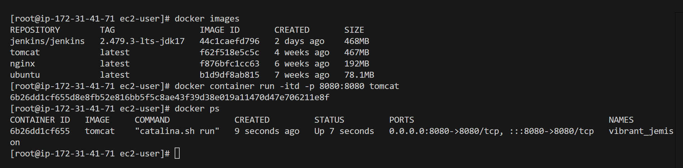  
  
  
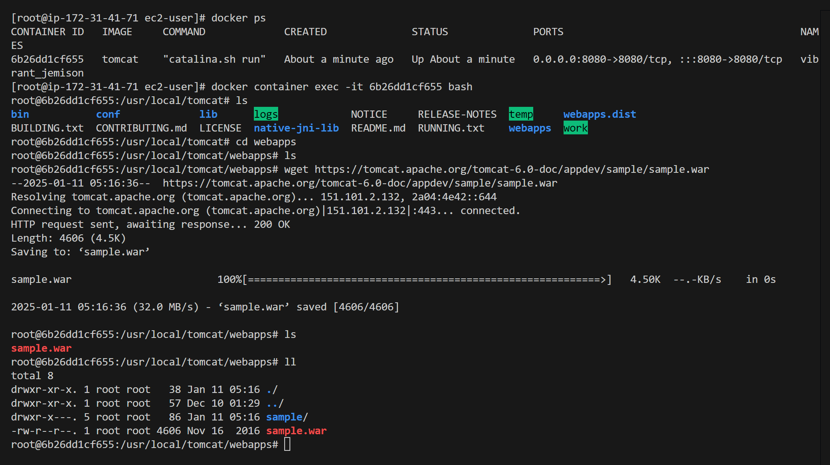  
  
  
  
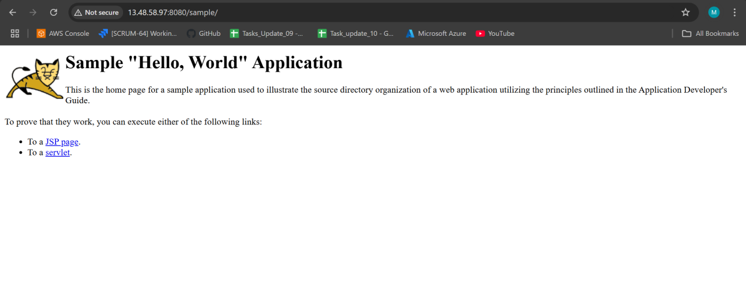  
  
  
  
2) Create volume and deploy tomcat container on port 8081.   
  
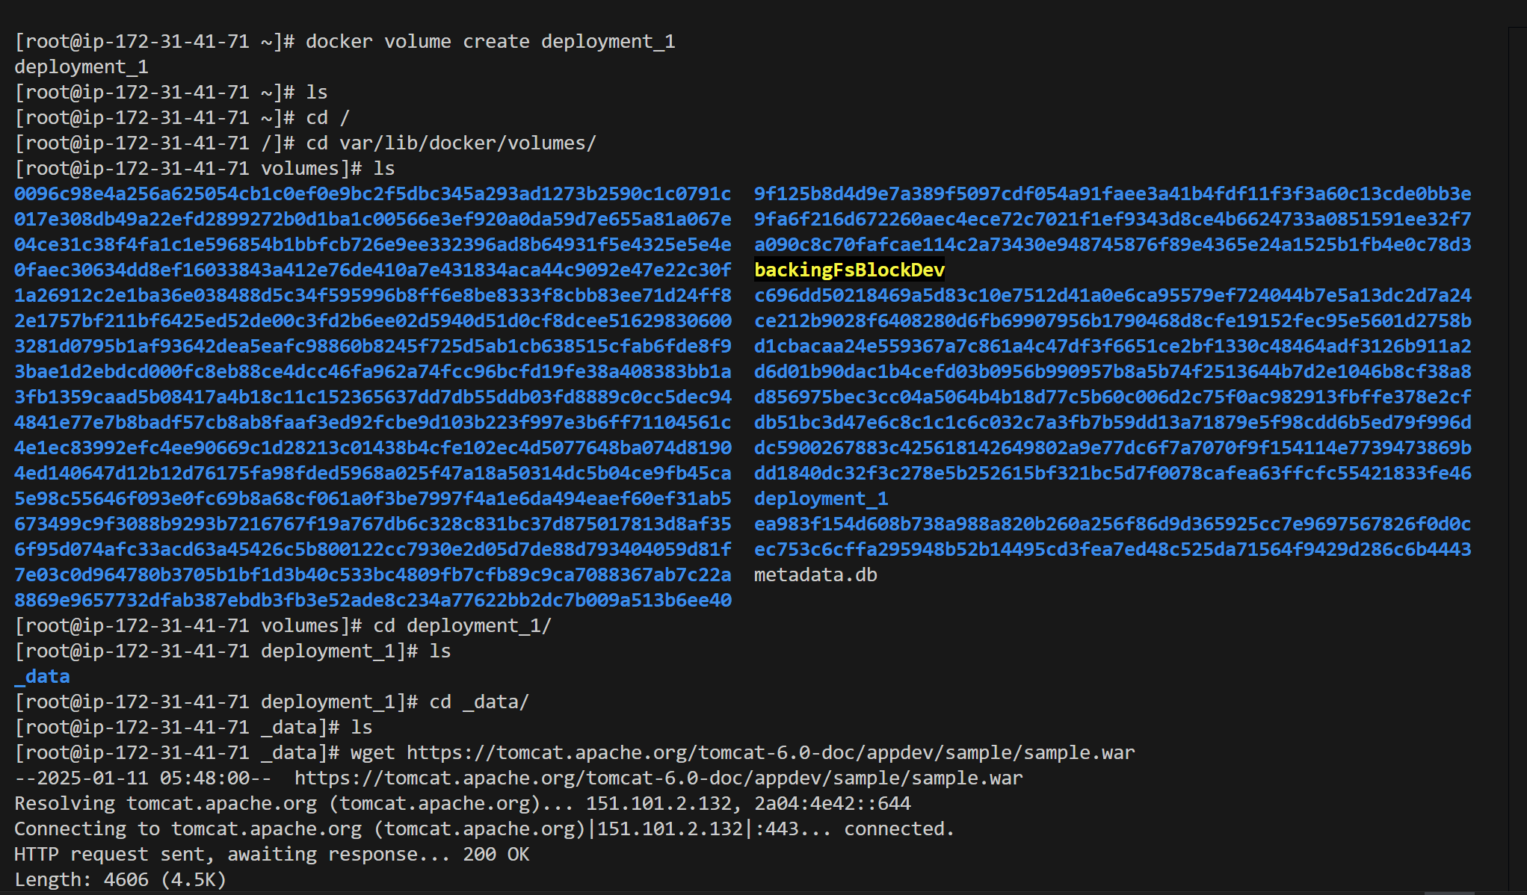  
  
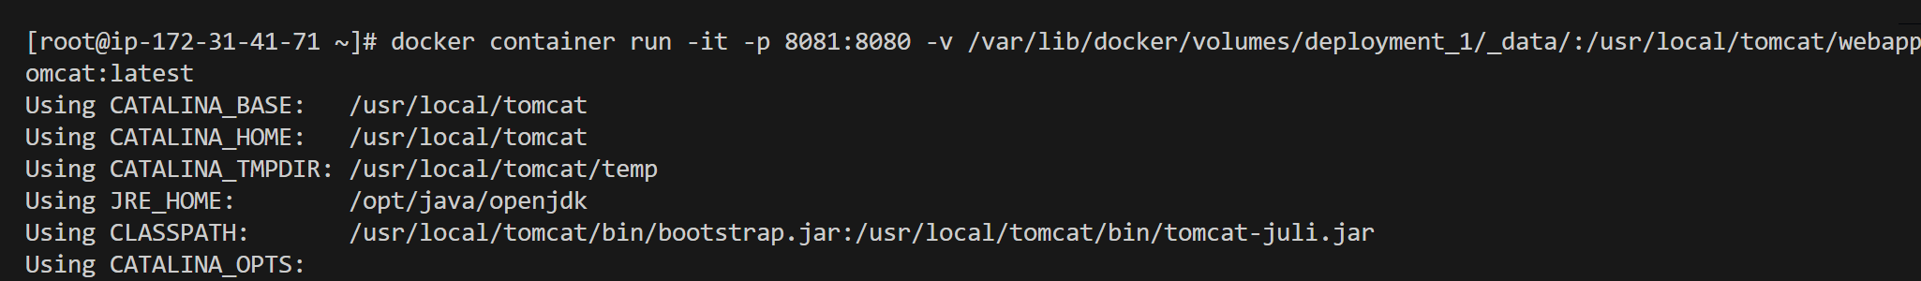

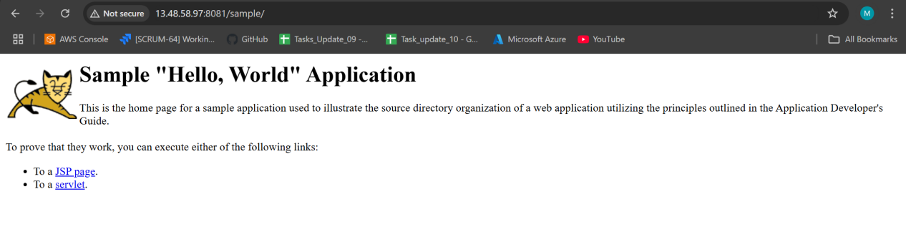  
  
  
  
3) Limit the nginx container to 500 MB.   
  
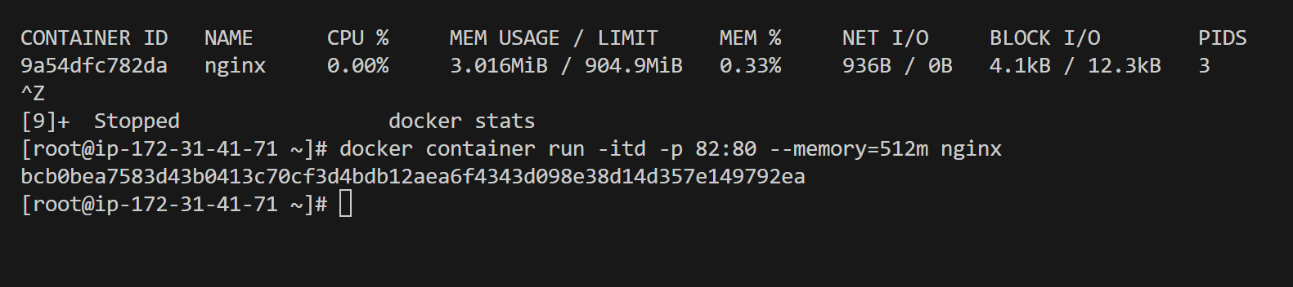  
  
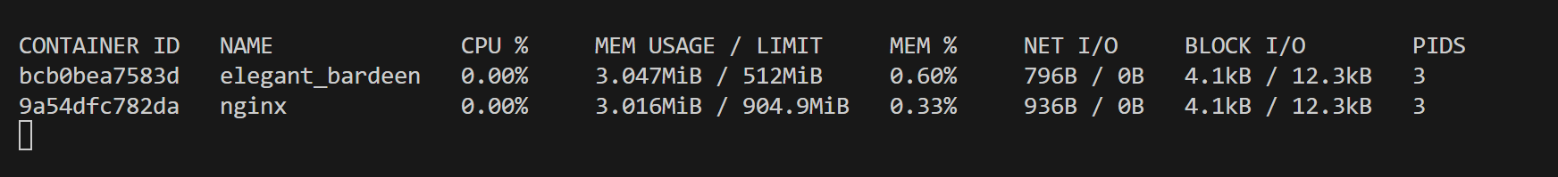  
  
4) Create a sample docker file using below instructions.   
  
---a) Base module as amazonlinux:latest   
---b) Maintainer you name   
---c) Install nginx   
---d) COPY one index.html file to image   
---e) Expose on port 80   
---f) Command to start the nginx container   
  
  
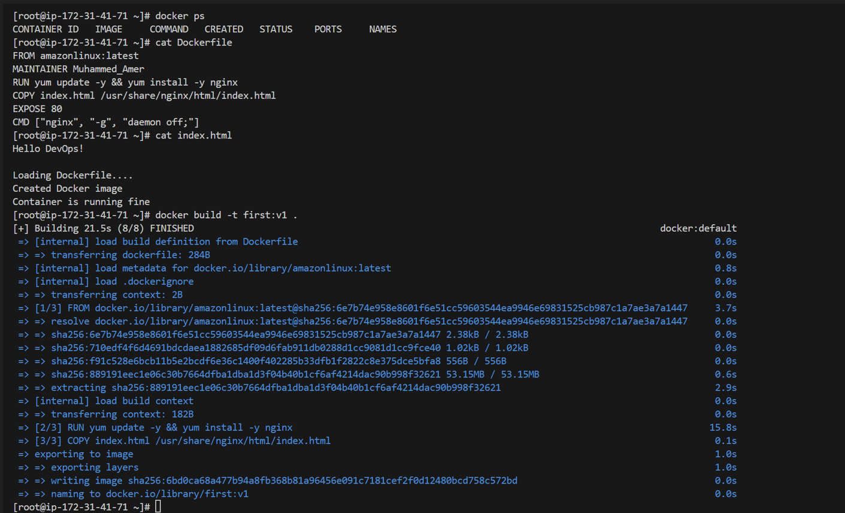  
  
  
  
  
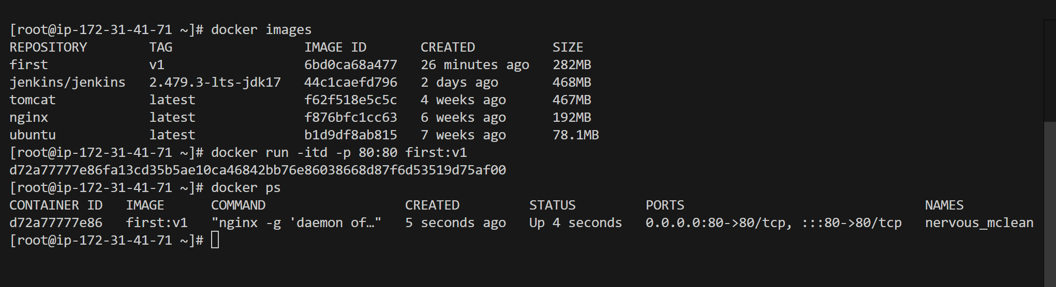  
  
  
  
  
  
  
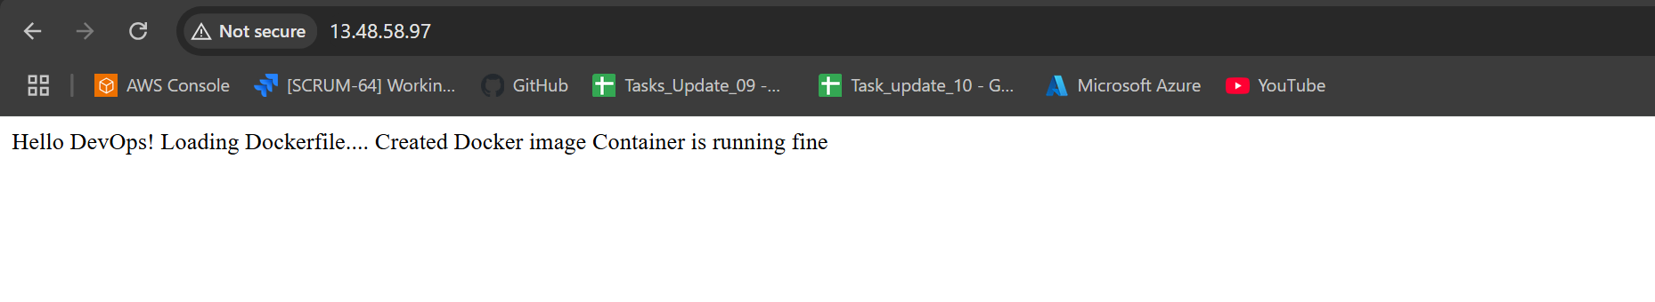5) Push image to docker-hub   
  
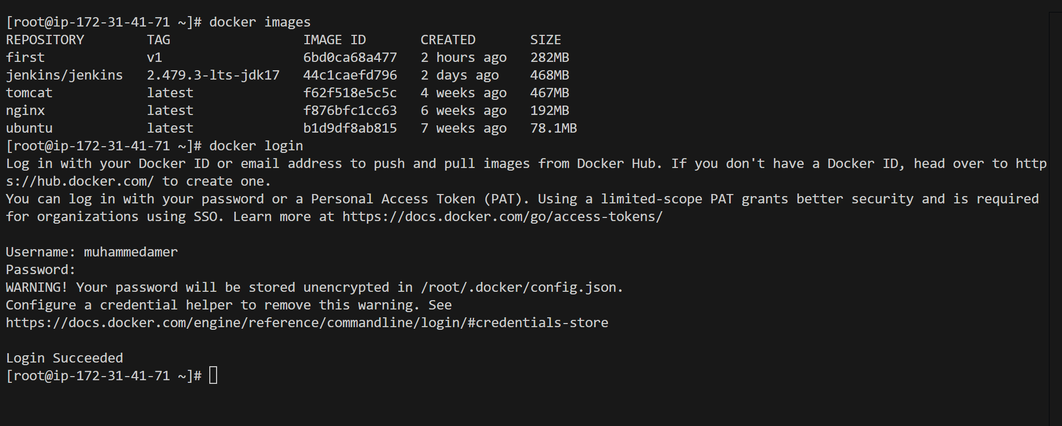  
  
  
  
  
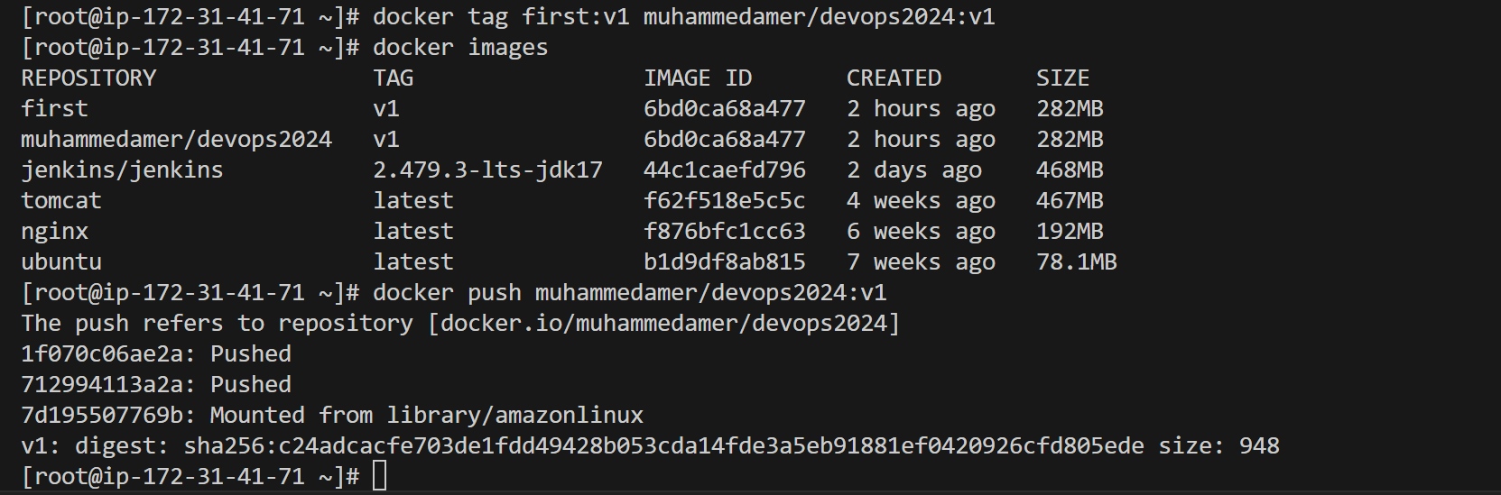  
  
  
  
  
  
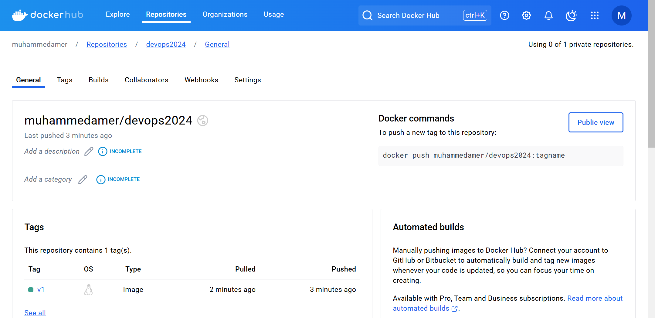  
  
  
  
  
6) push image to AWS ecr