1) Configure 2 slave machines in jenkins master.   
  
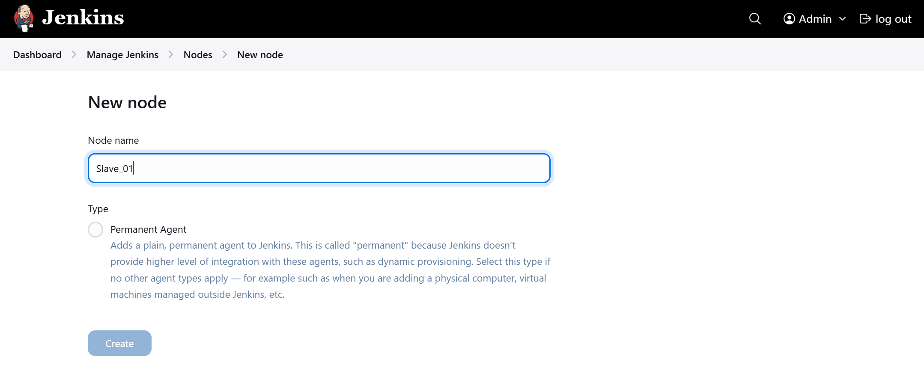  
  
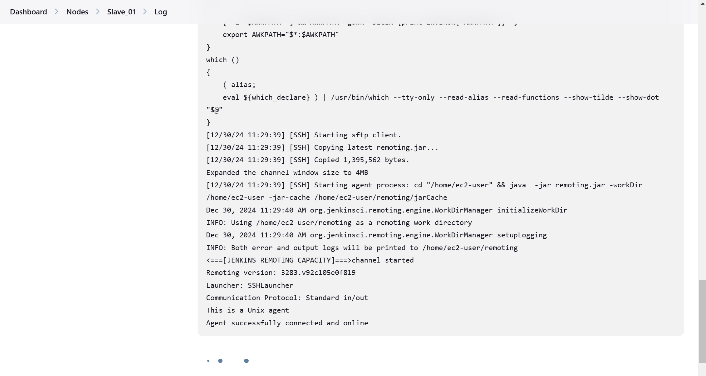  
  
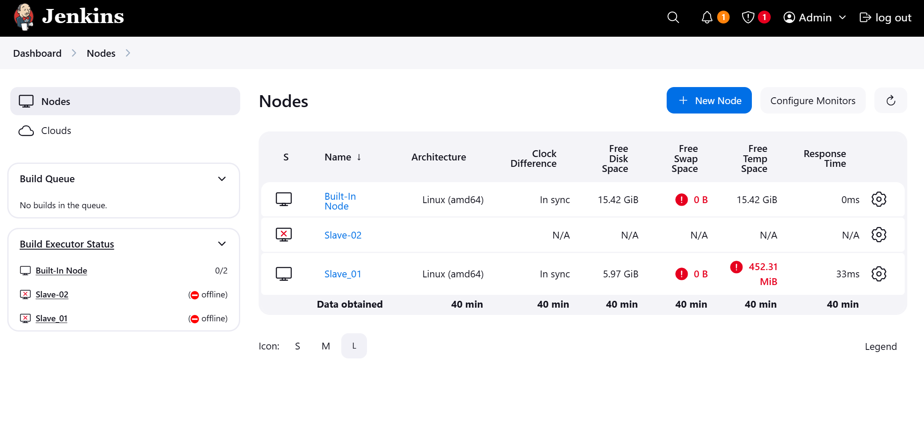  
Slave-01 is successfully connected but offline due to size issues  
Slave-02 is failed to connect   
  
  
  
2) Configure web-hooks to Jenkins job.   
  
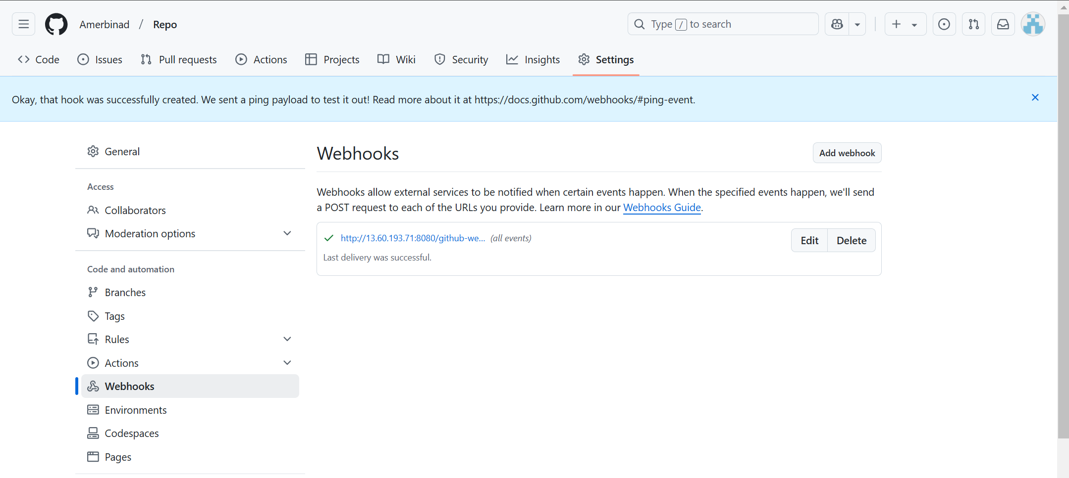  
  
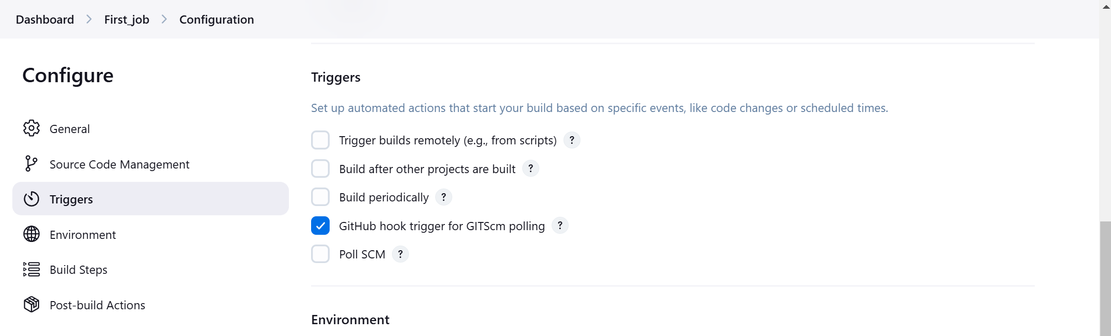  
  
  
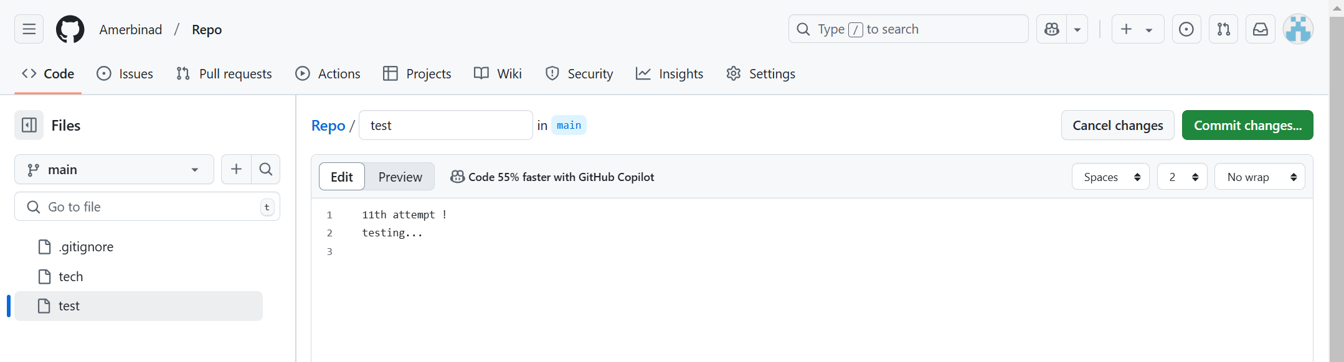  
  
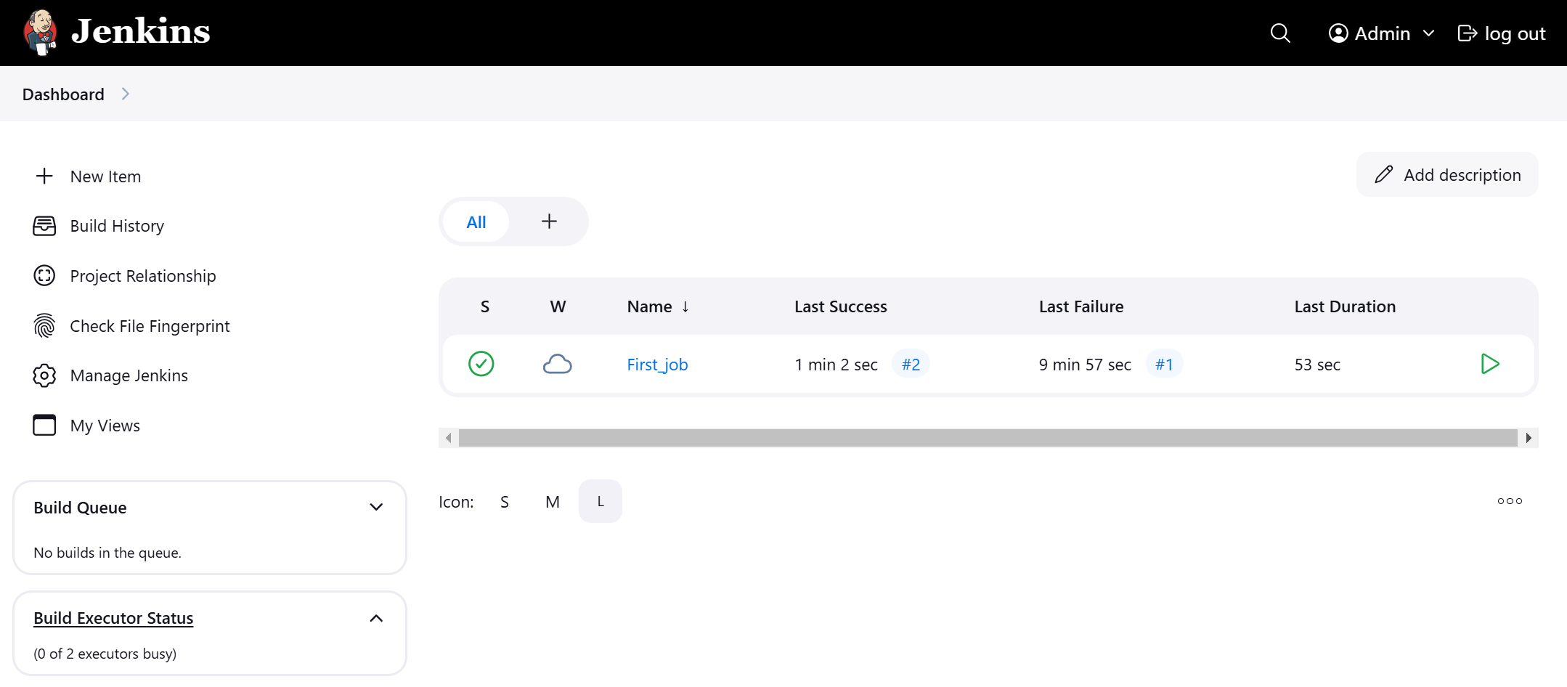  
  
3) Configure poll scm and build periodical options in Jenkins job.   
  
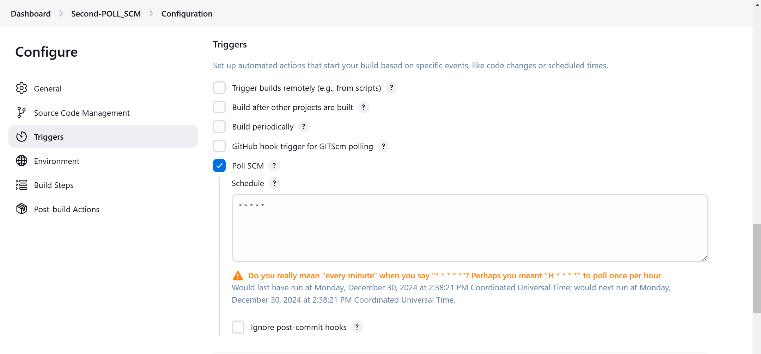  
  
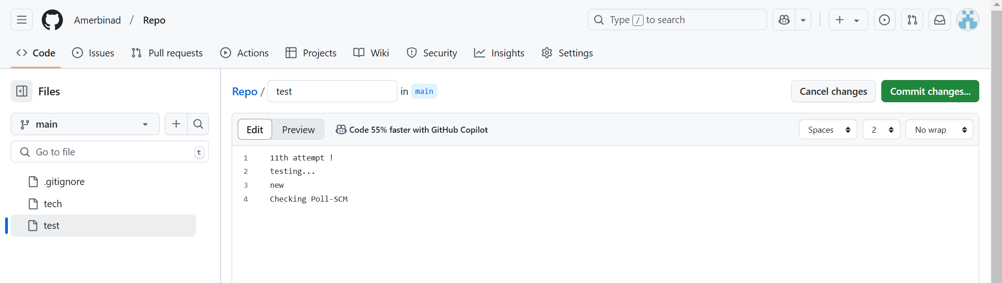  
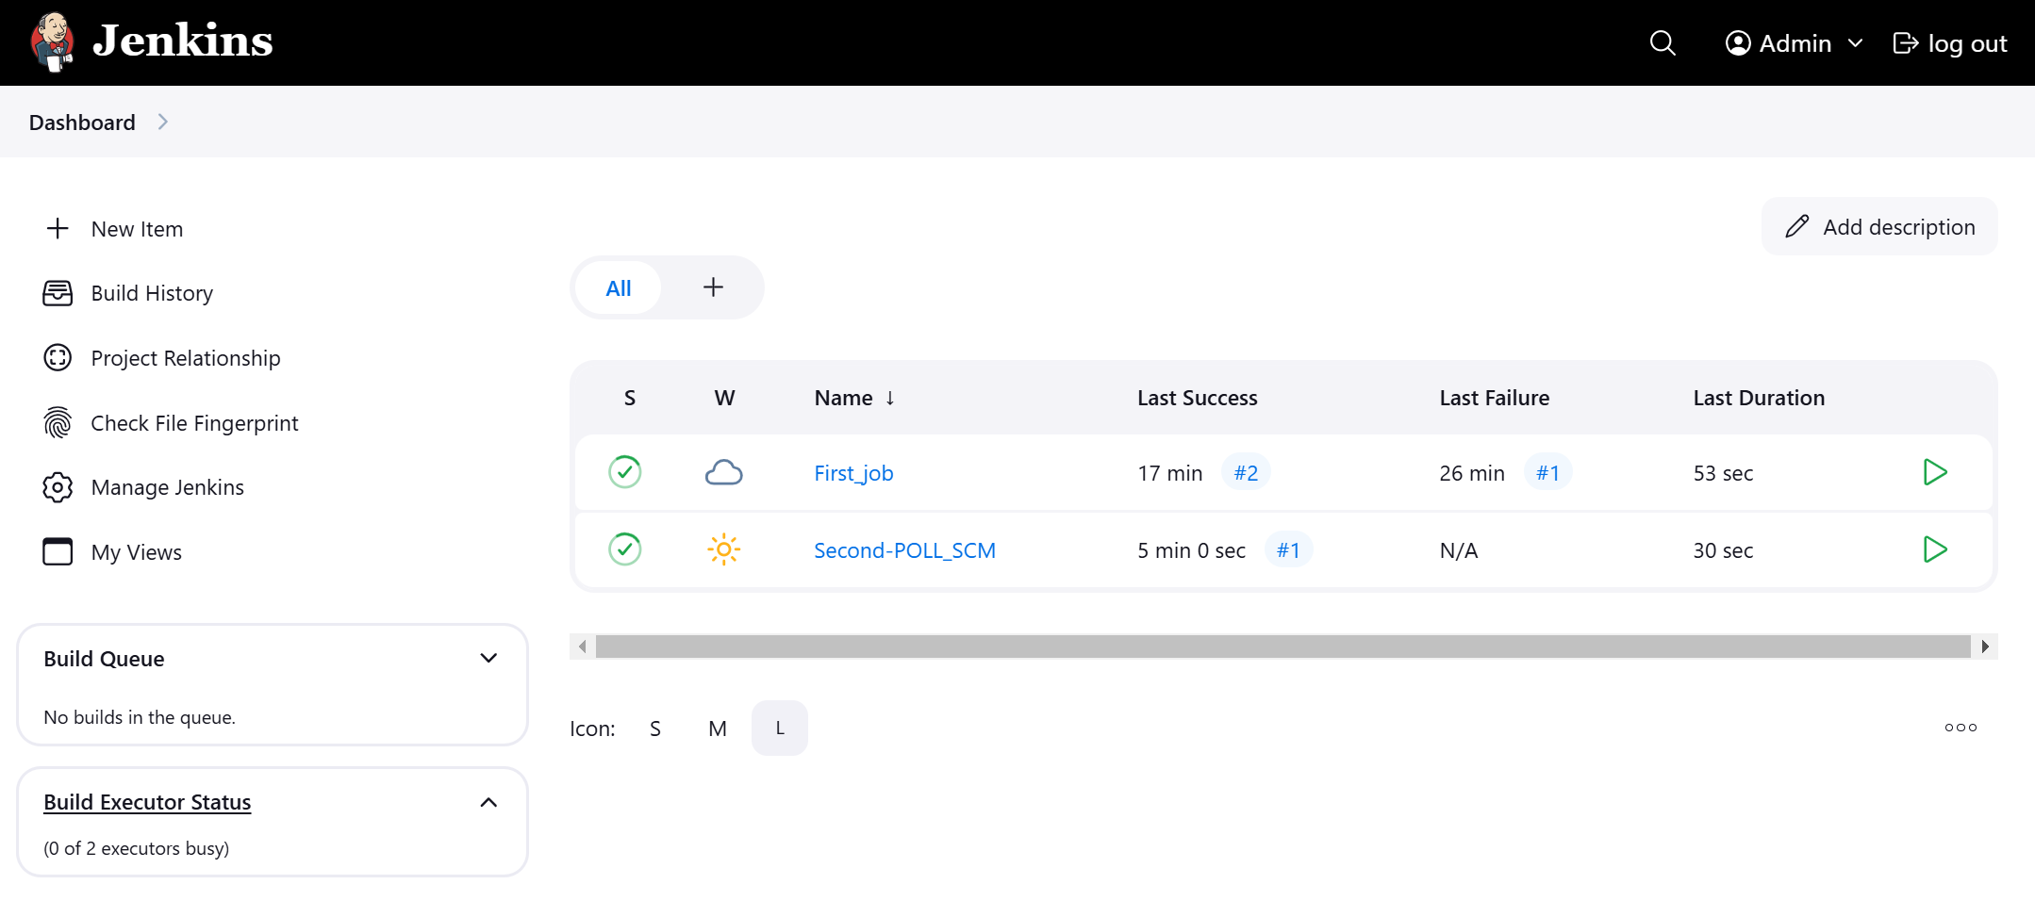  
  
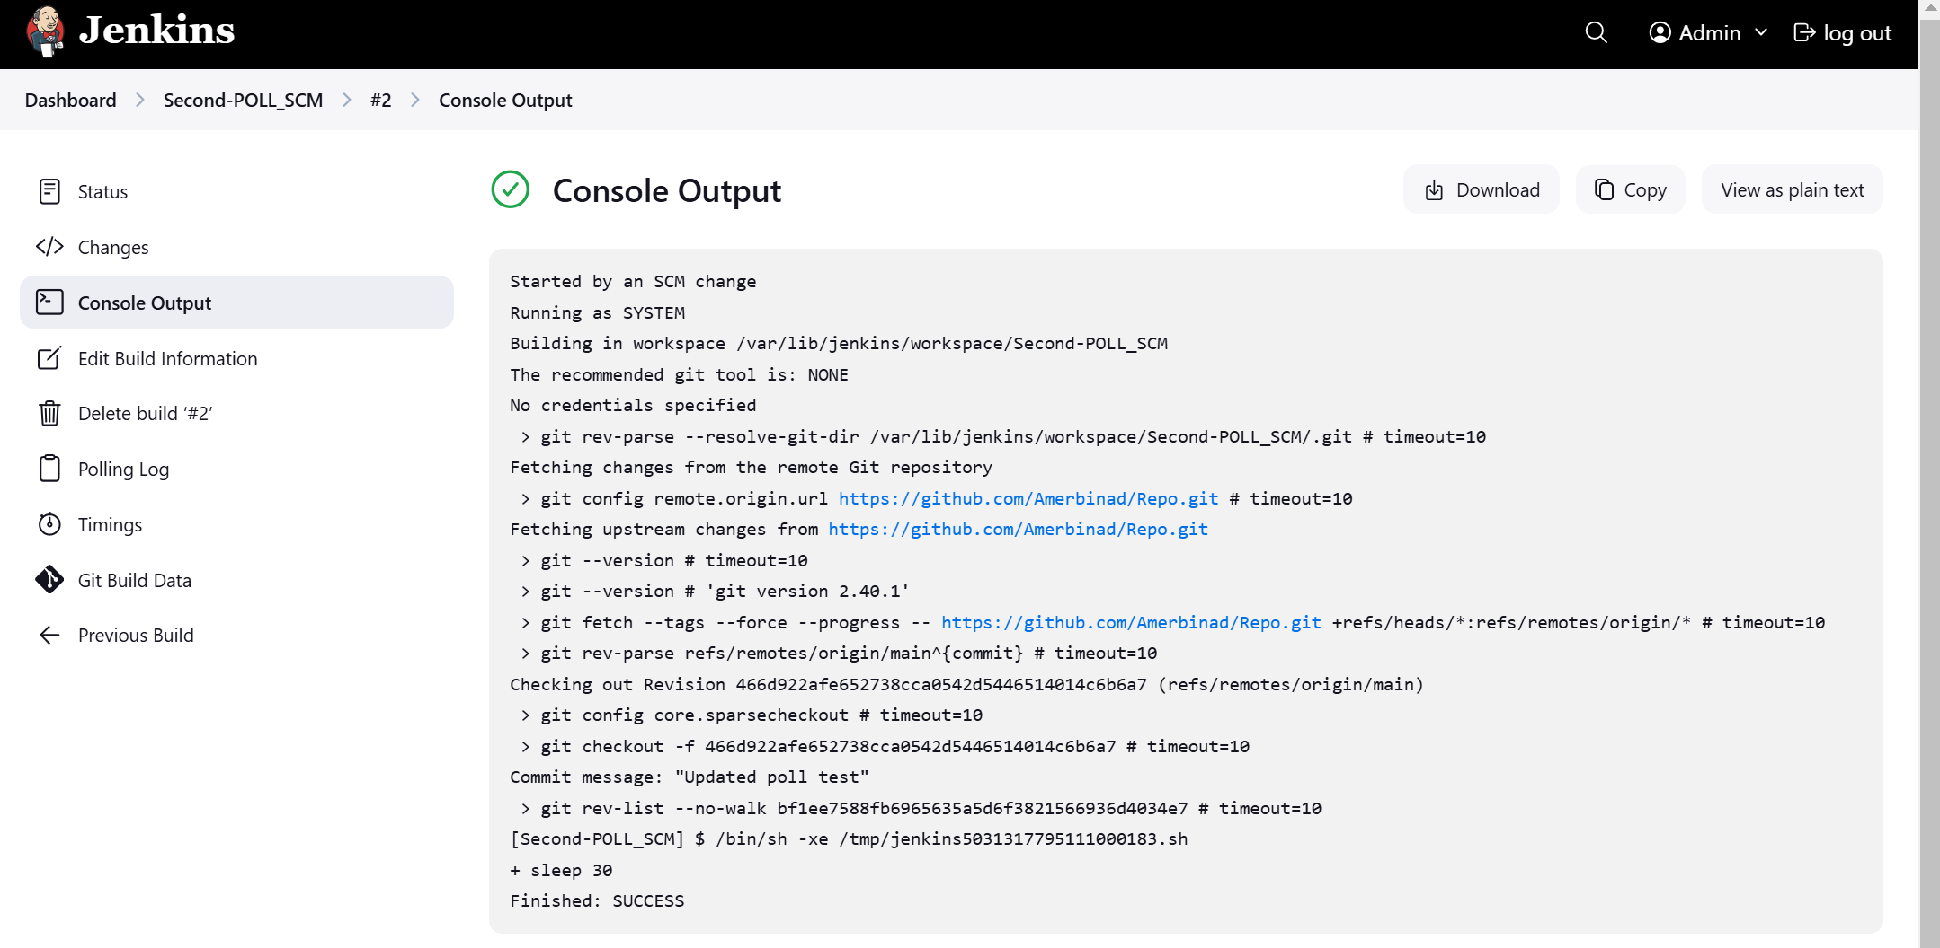  
  
  
**Periodically**  
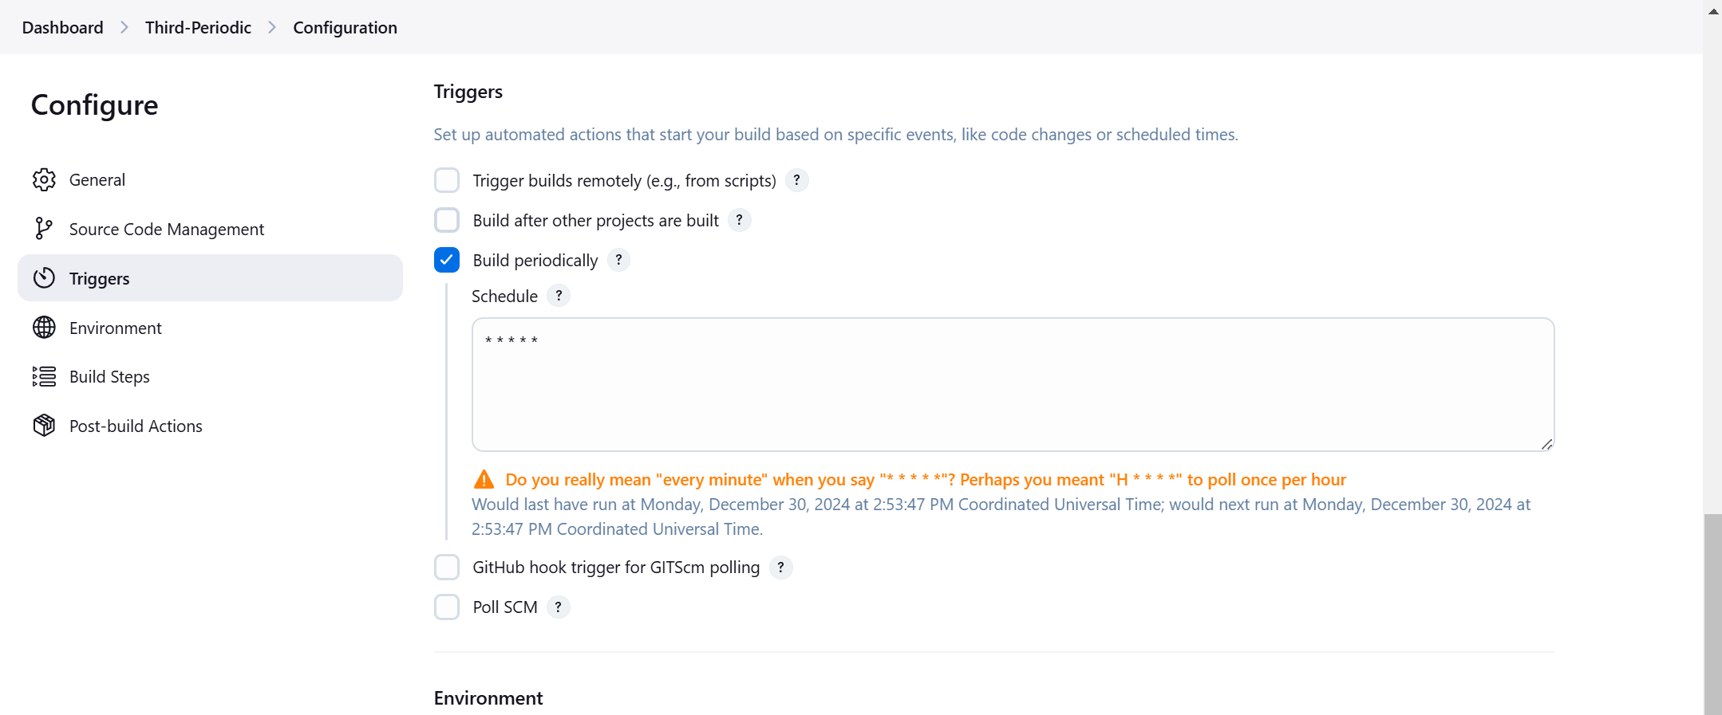  
  
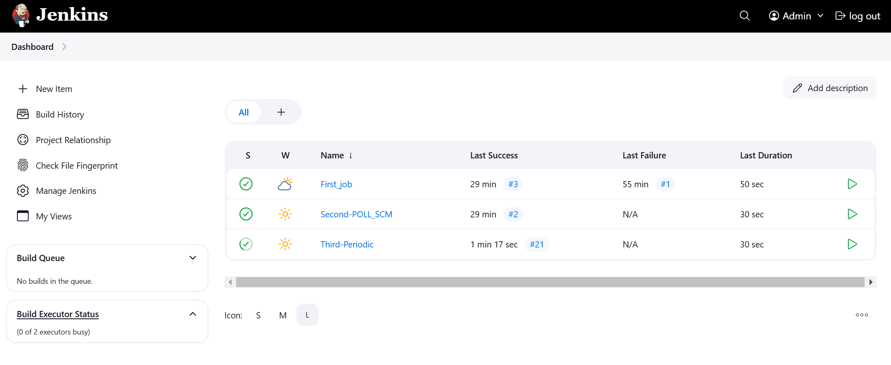  
  
  
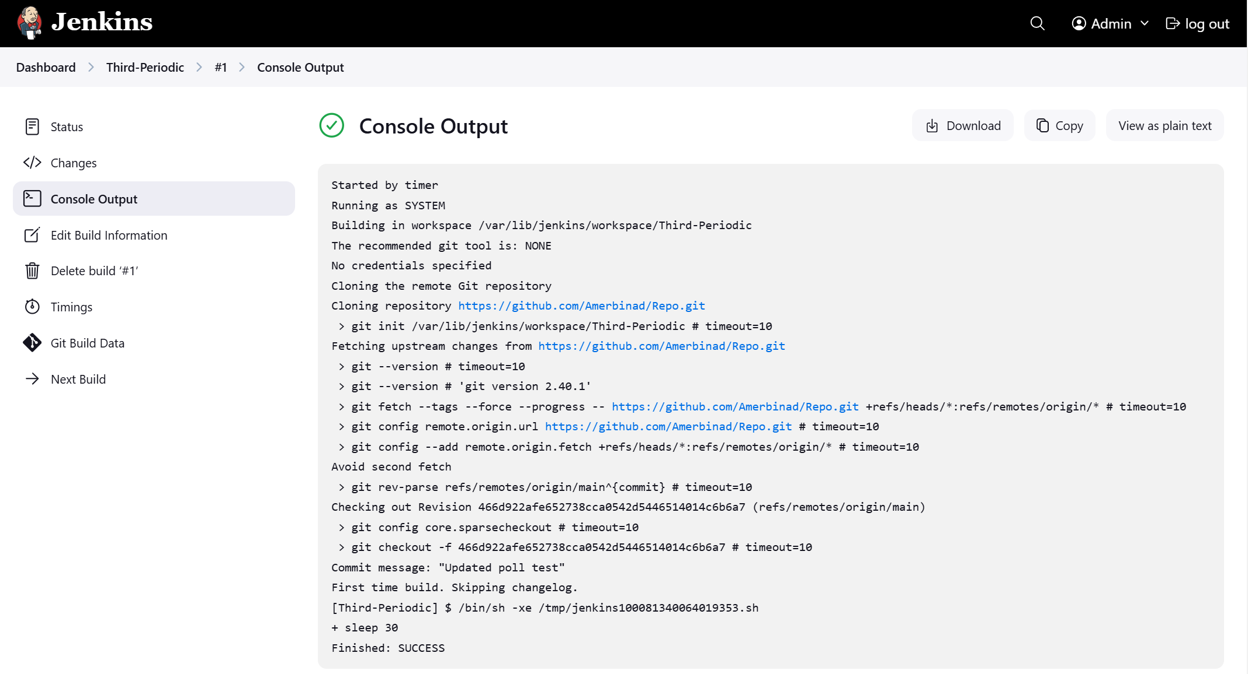  
  
  
  
  
  
  
  
  
  
  
  
  
  
  
  
  
  
  
  
  
  
4) Take backup of Jenkins server by using bash script.   
5) Take backup of Jenkins using rethin backup plugin.   
6) Setup a new Jenkins server and dump the backup taken in task4.