1) Create one Jenkins job using the below code and create three stages.   
Stage 1: Git clone to download the source code.   
  
  
  
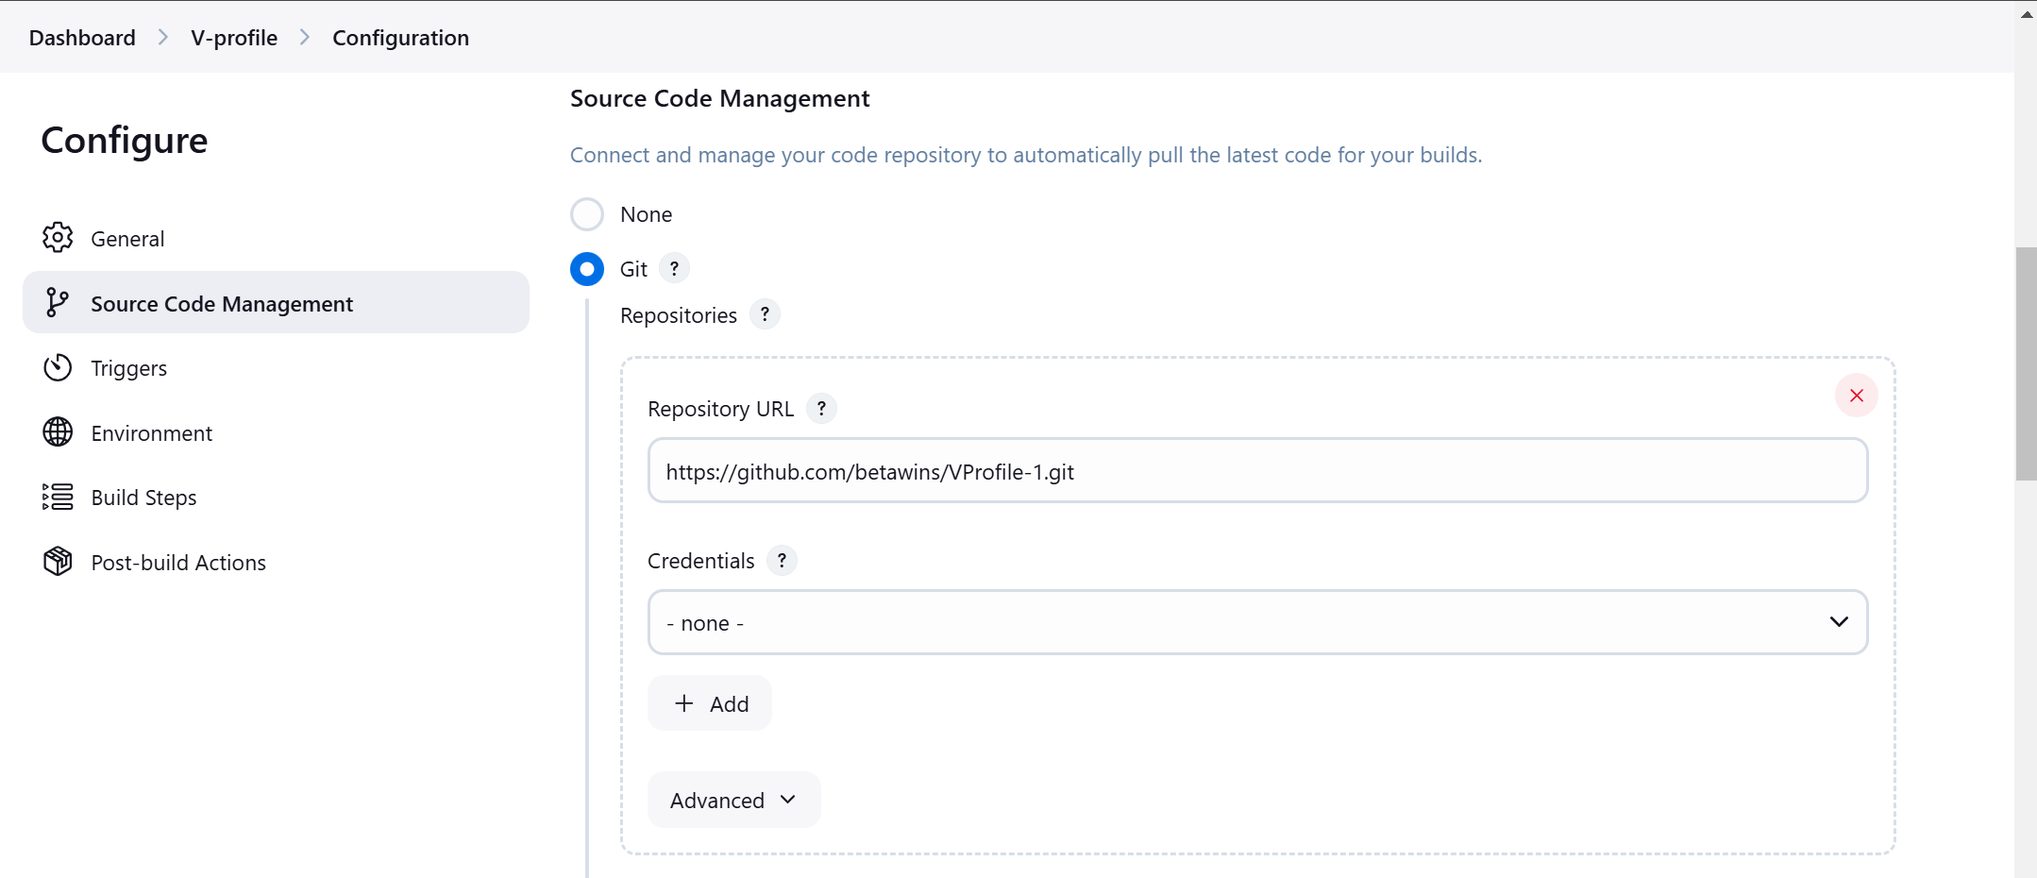  
  
  
  
  
  
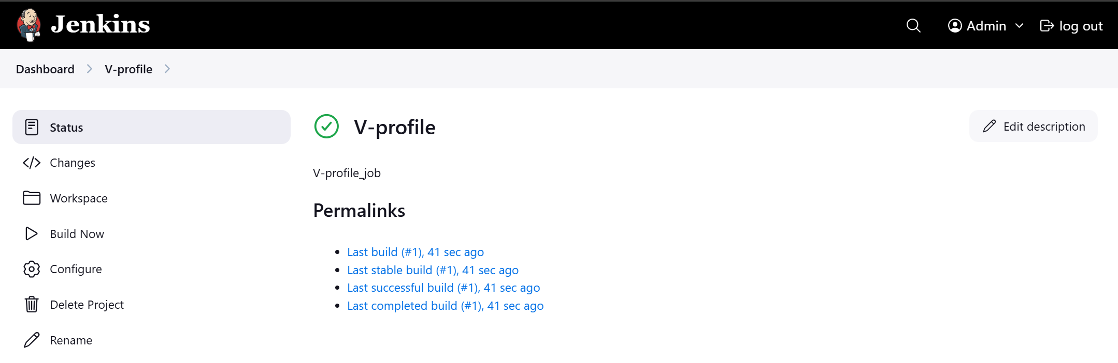  
  
  
  
  
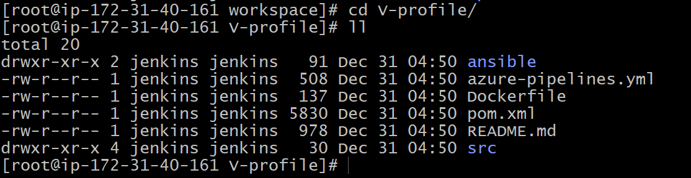  
  
  
  
  
  
  
Stage 2: Sonarqube Integration to check the quality of code   
  
  
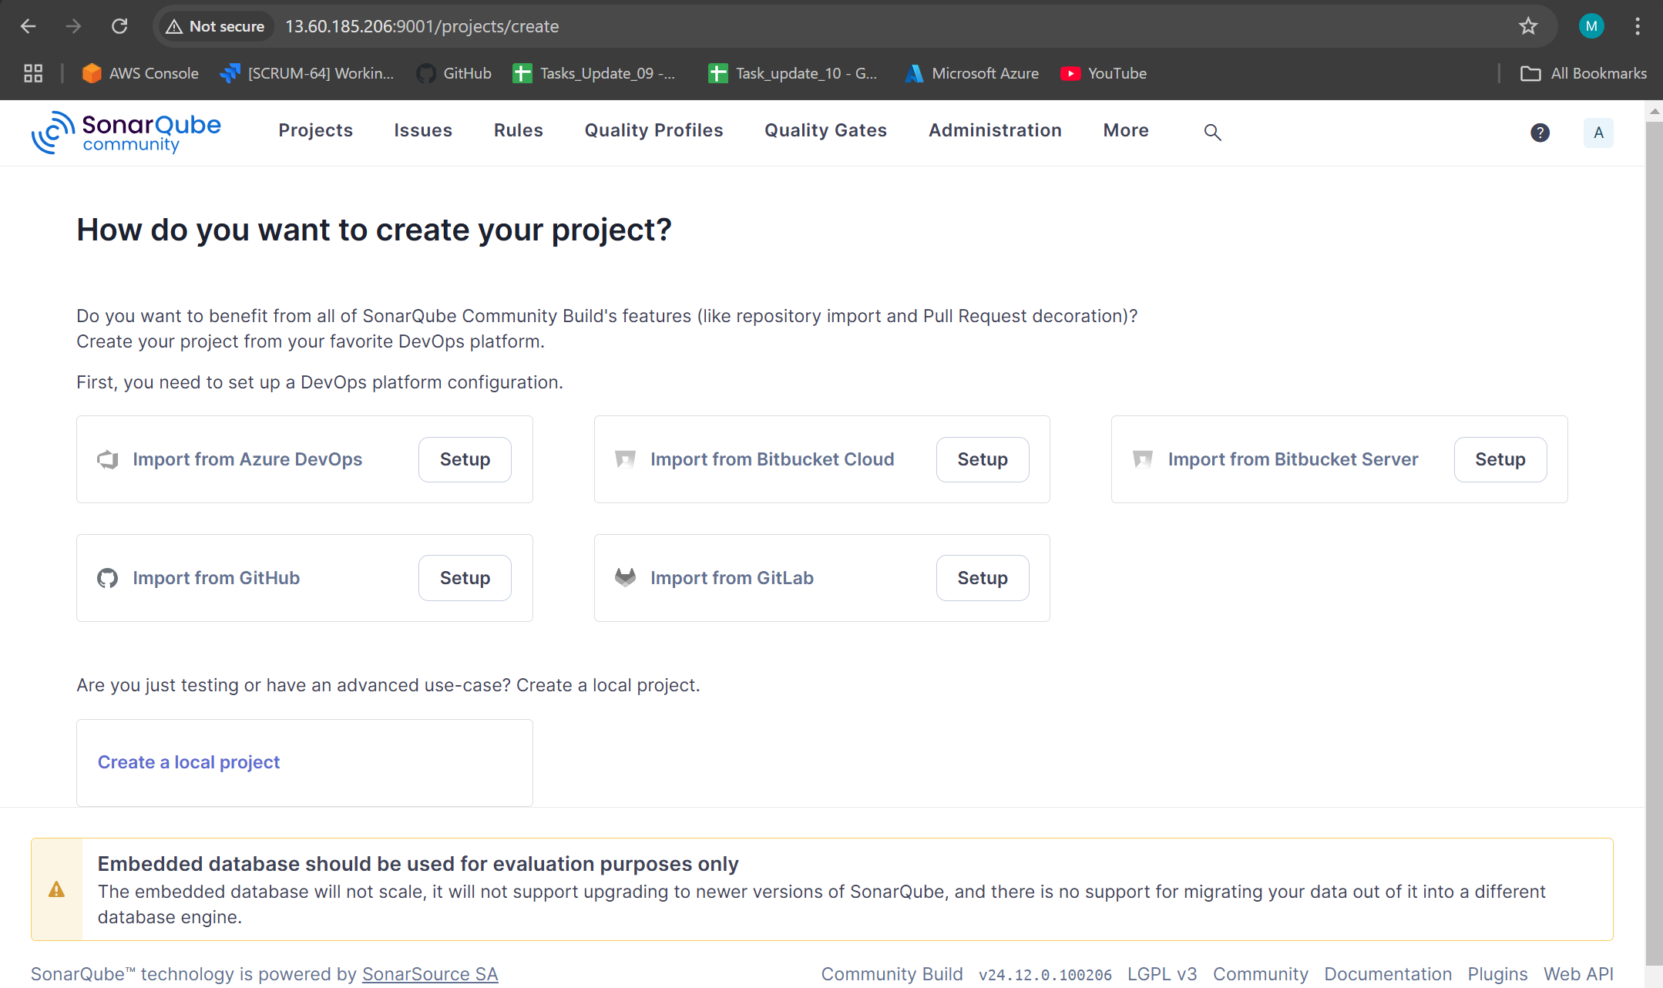  
  
  
  
  
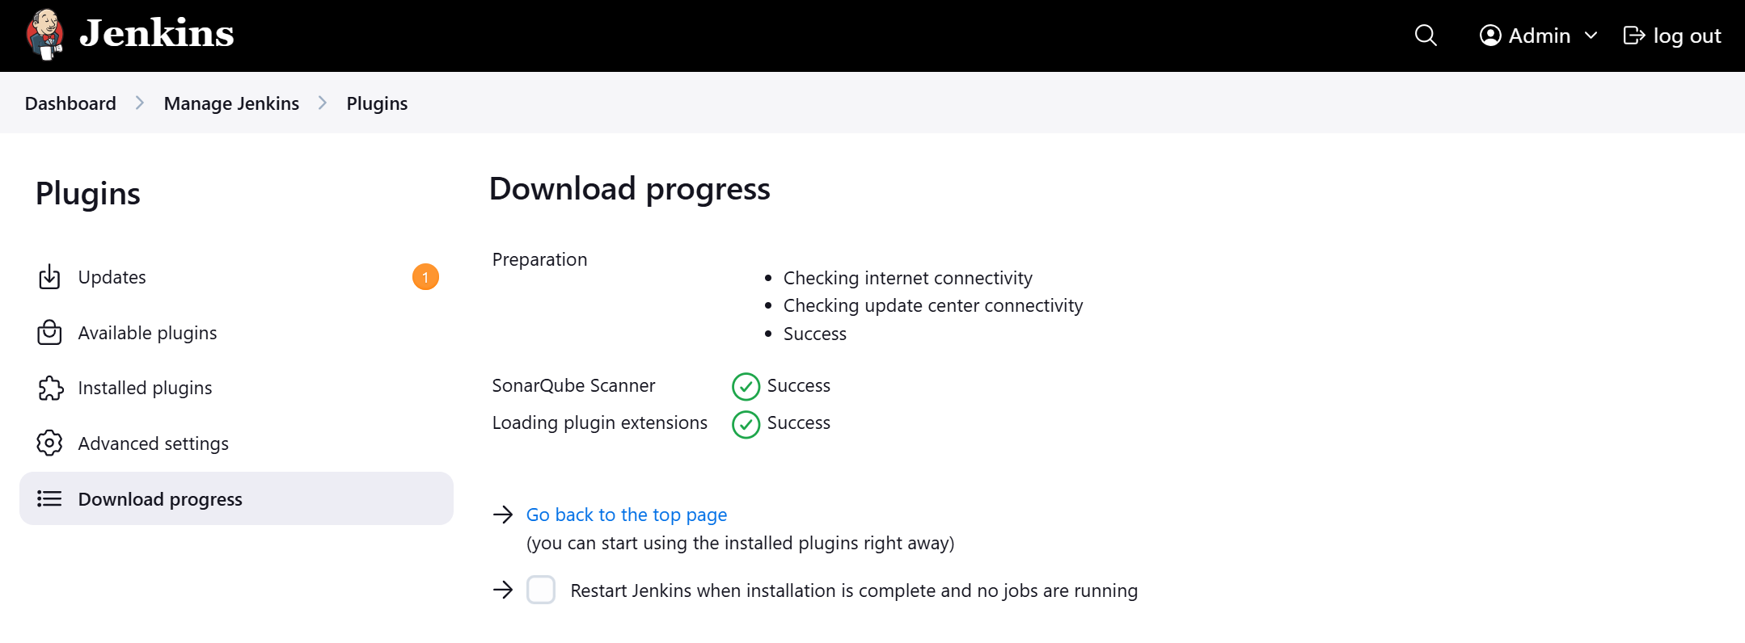  
  
  
  
  
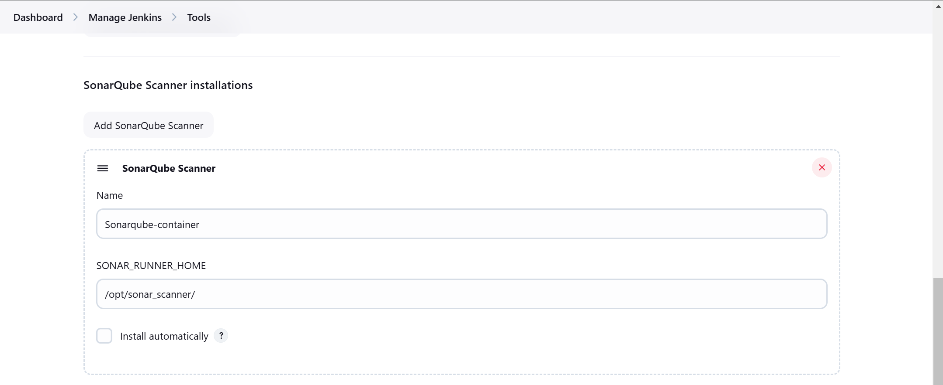  
  
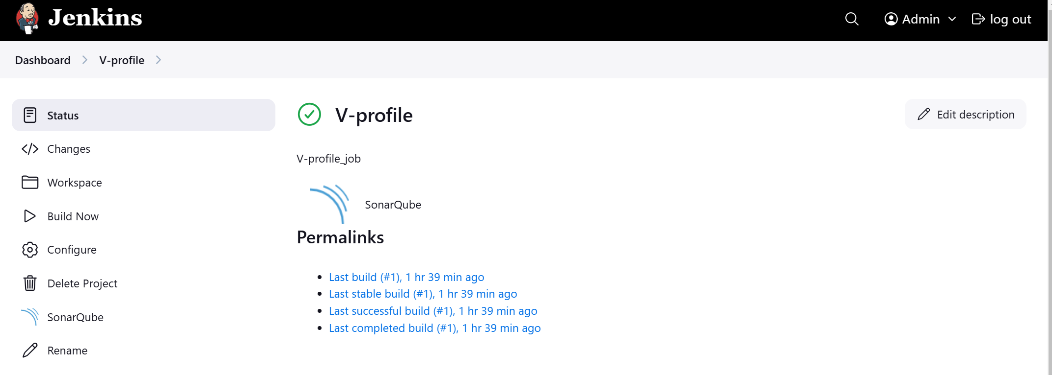  
  
  
  
  
stage 3: Slack Integration to send the alerts to slack.   
URL: [https://github.com/betawins/VProfile-1.git](https://github.com/betawins/VProfile-1.git" \t "https://app.slack.com/client/T03TRQ064Q0/_blank)  
  
  
  
  
2)----  
1) Create one Jenkins job using the below code and create three stages.   
Stage 1: Git clone to download the source code.   
Stage 2: Sonarqube Integration to check the quality of code   
stage 3: Slack Integration to send the alerts to slack.   
URL: [https://github.com/betawins/hiring-app.git](https://github.com/betawins/hiring-app.git" \t "https://app.slack.com/client/T03TRQ064Q0/_blank)