**K8’S-03**  
  
  
  
1) Create a Cluster IP service for an Apache web server pod.  
  
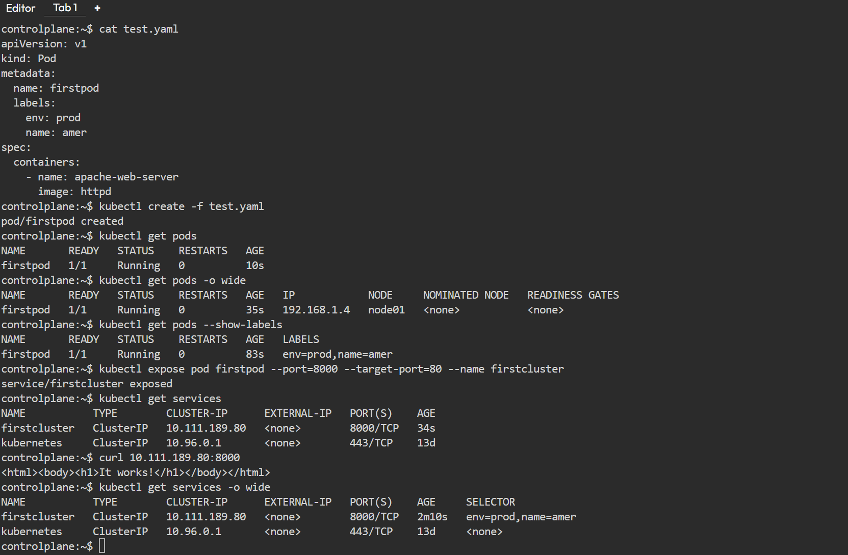  
  
  
2) Expose an Nginx pod externally using a Node Port service.  
  
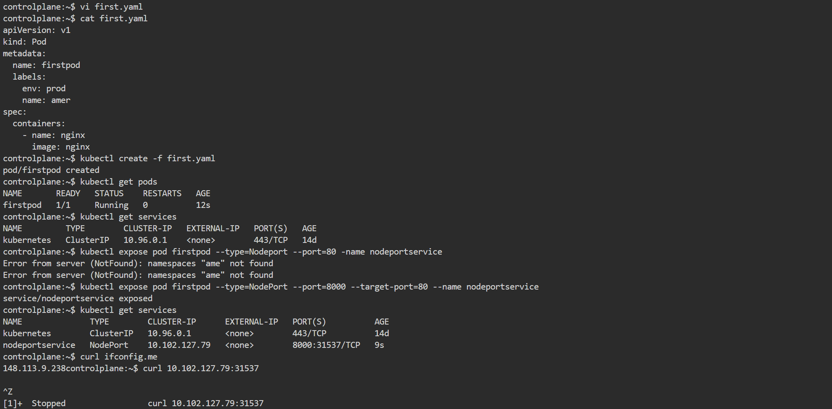  
  
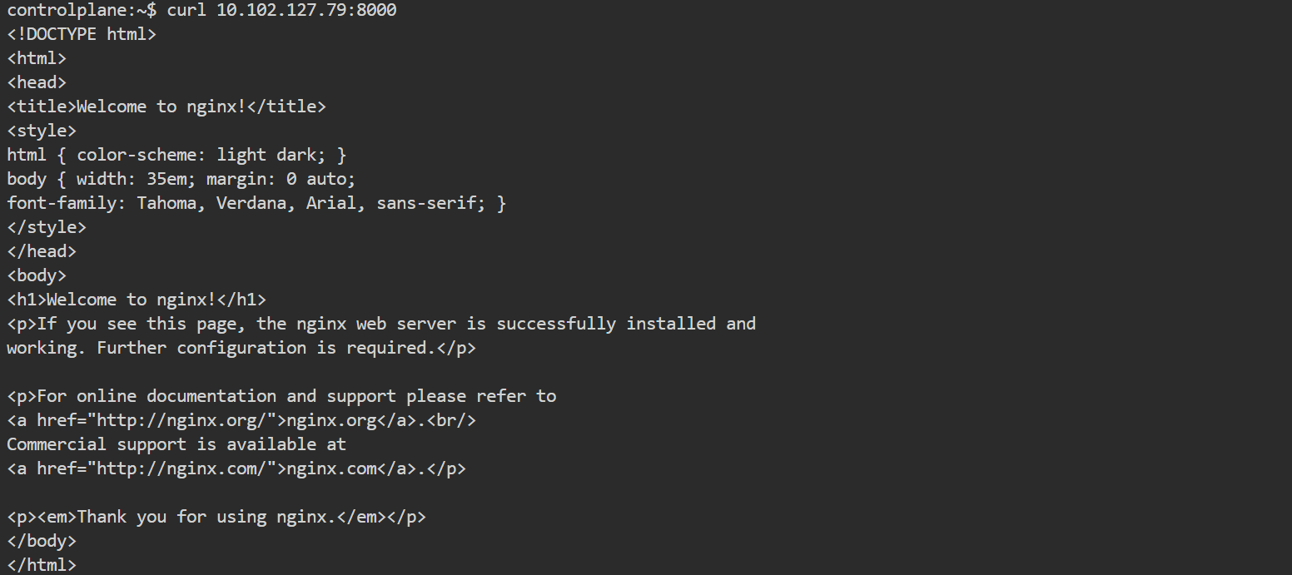

3) Deploy a Replication Controller to maintain 3 replicas of an Nginx pod.

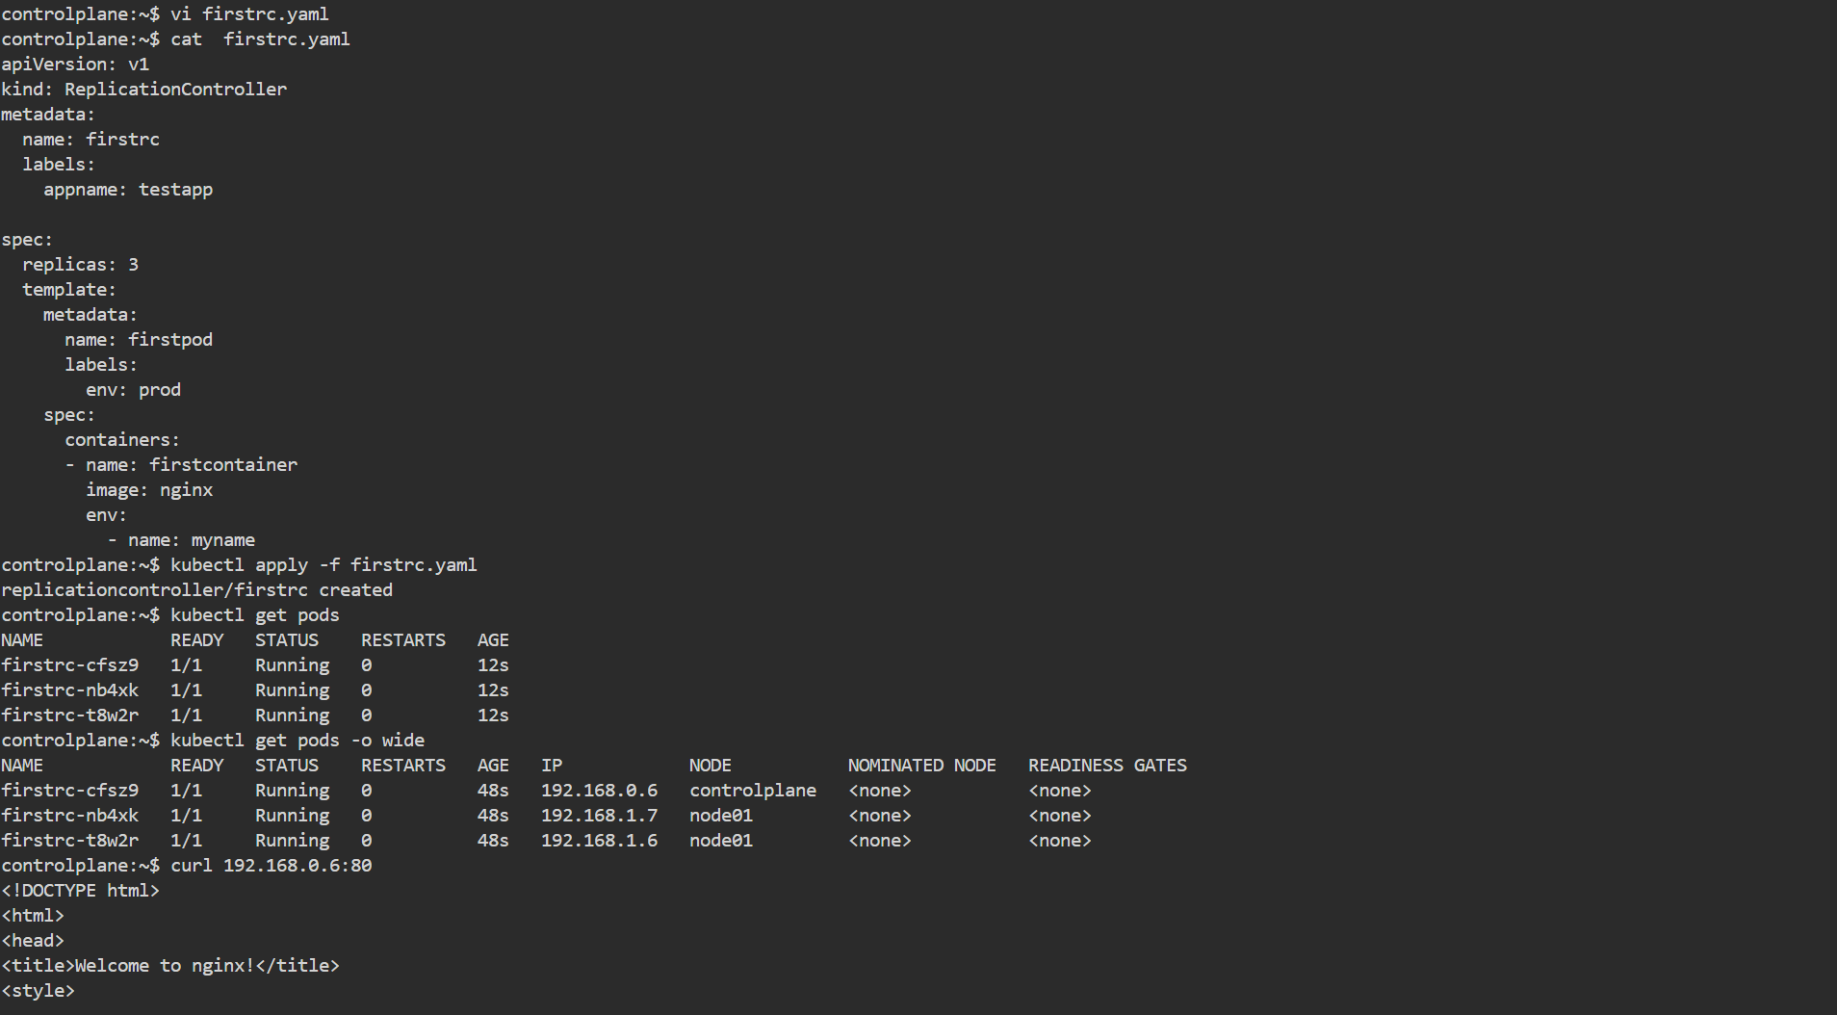  
  
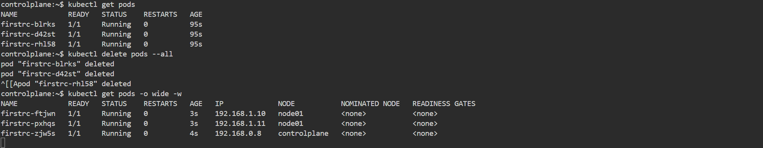  
  
  
  
  
  
  
  
  
  
  
4) Scale the Replication Controller from 3 replicas to 5 replicas.  
  
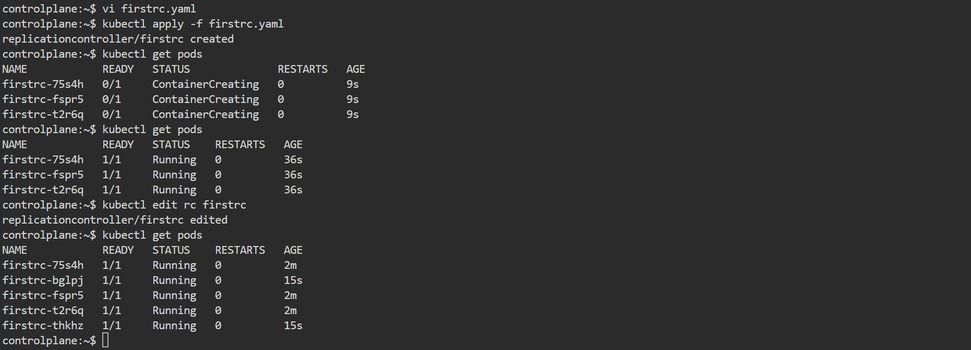  
  
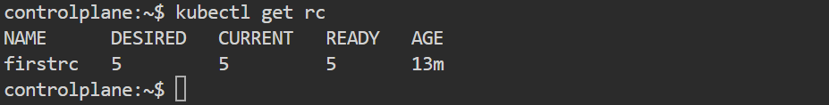  
  
  
  
  
  
  
  
5) Create a Replica Set to manage pods based on multiple labels (prod and test).  
  
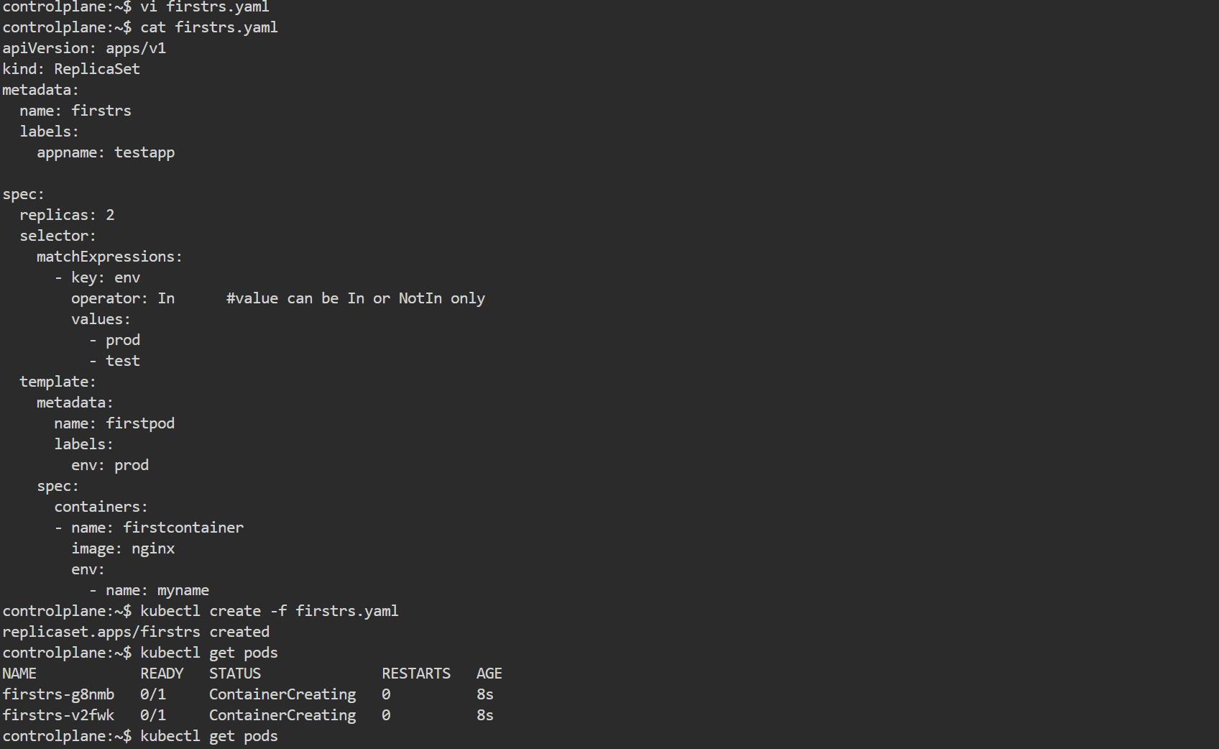

6) Deploy a Replica Set that excludes pods with the label back end.  
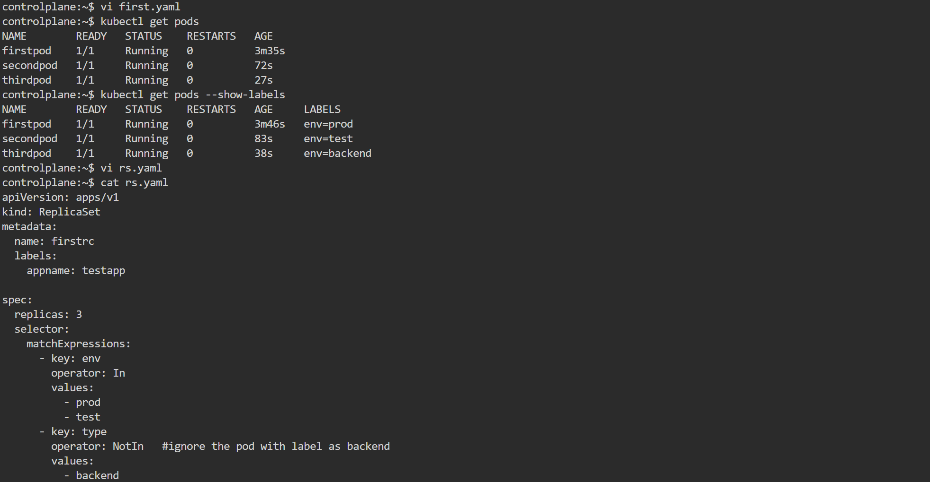  
  
  
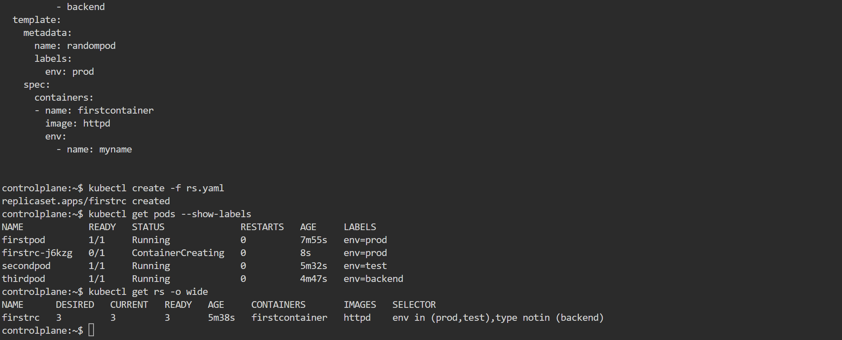

7) Test load balancing across multiple pods using a NodePort service.  
  
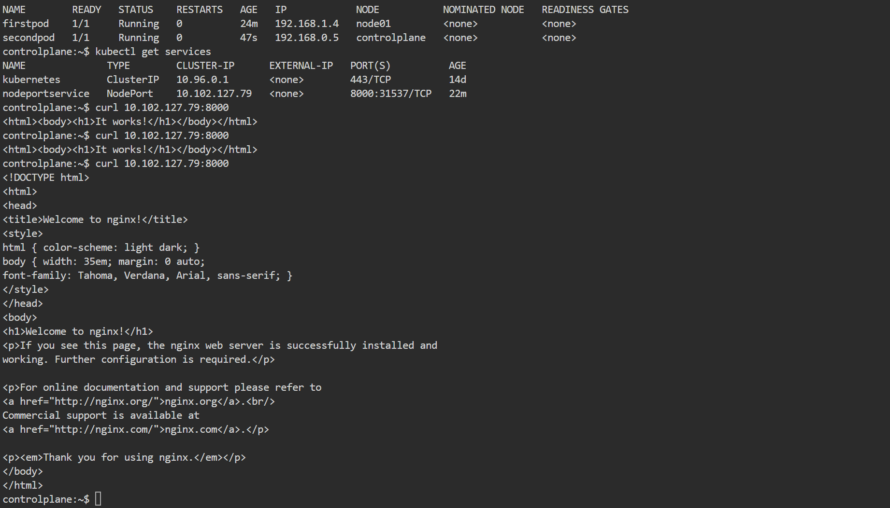

8) Delete a Replication Controller without affecting the running pods.   
  
