**K8’s-05**  
  
1) Create a name space dev-environment and apply a resource-based quota that restricts the number of pods to 3 and services to 2.  
  
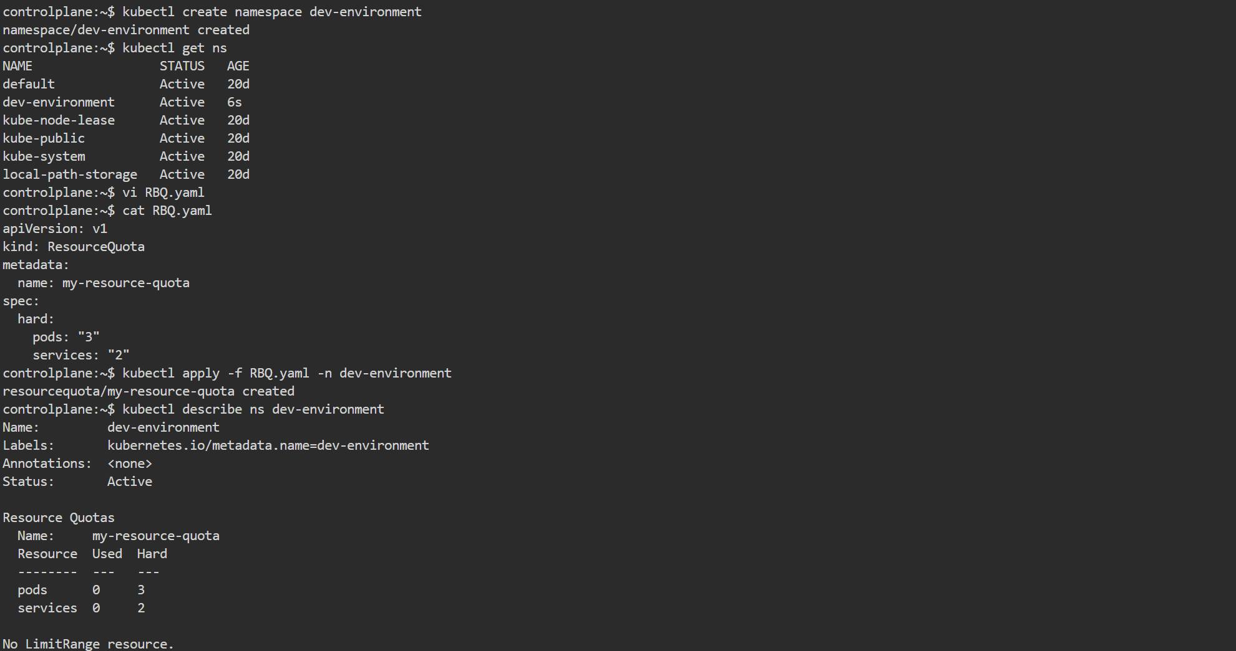

2) Create a pod in the prod-environment name space with 0.2 CPU and 200Mi memory requests, and 0.5 CPU and 500Mi memory limits.

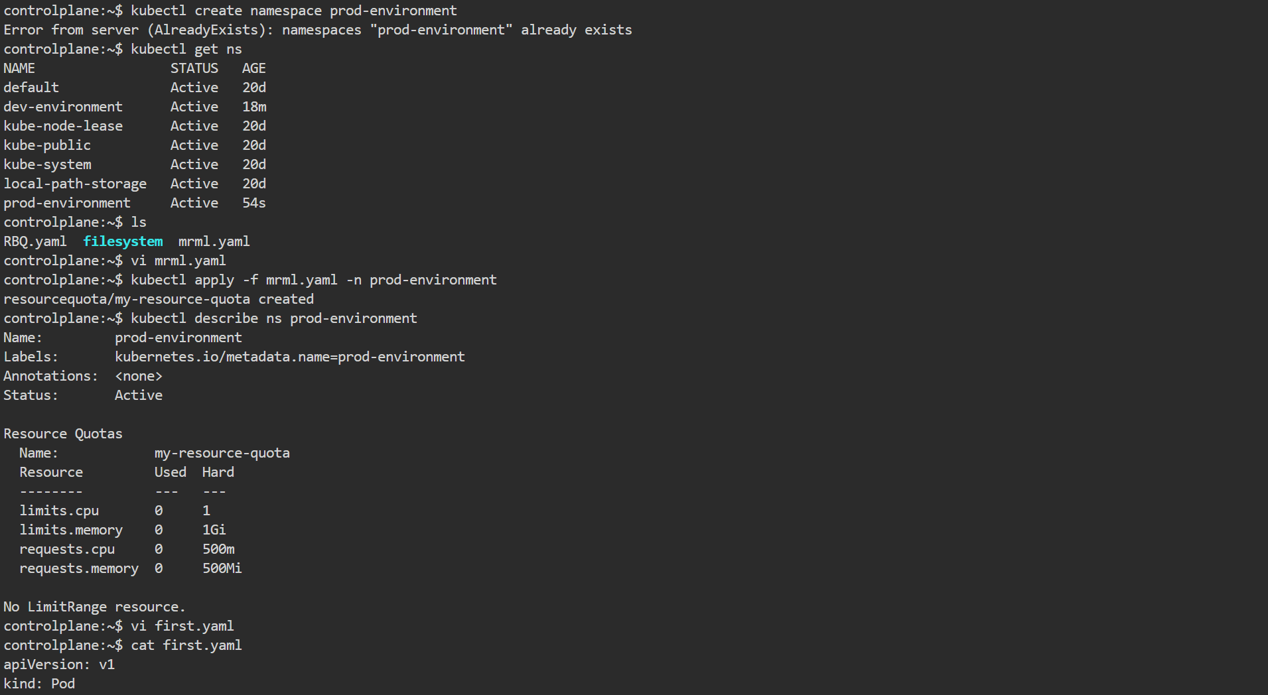

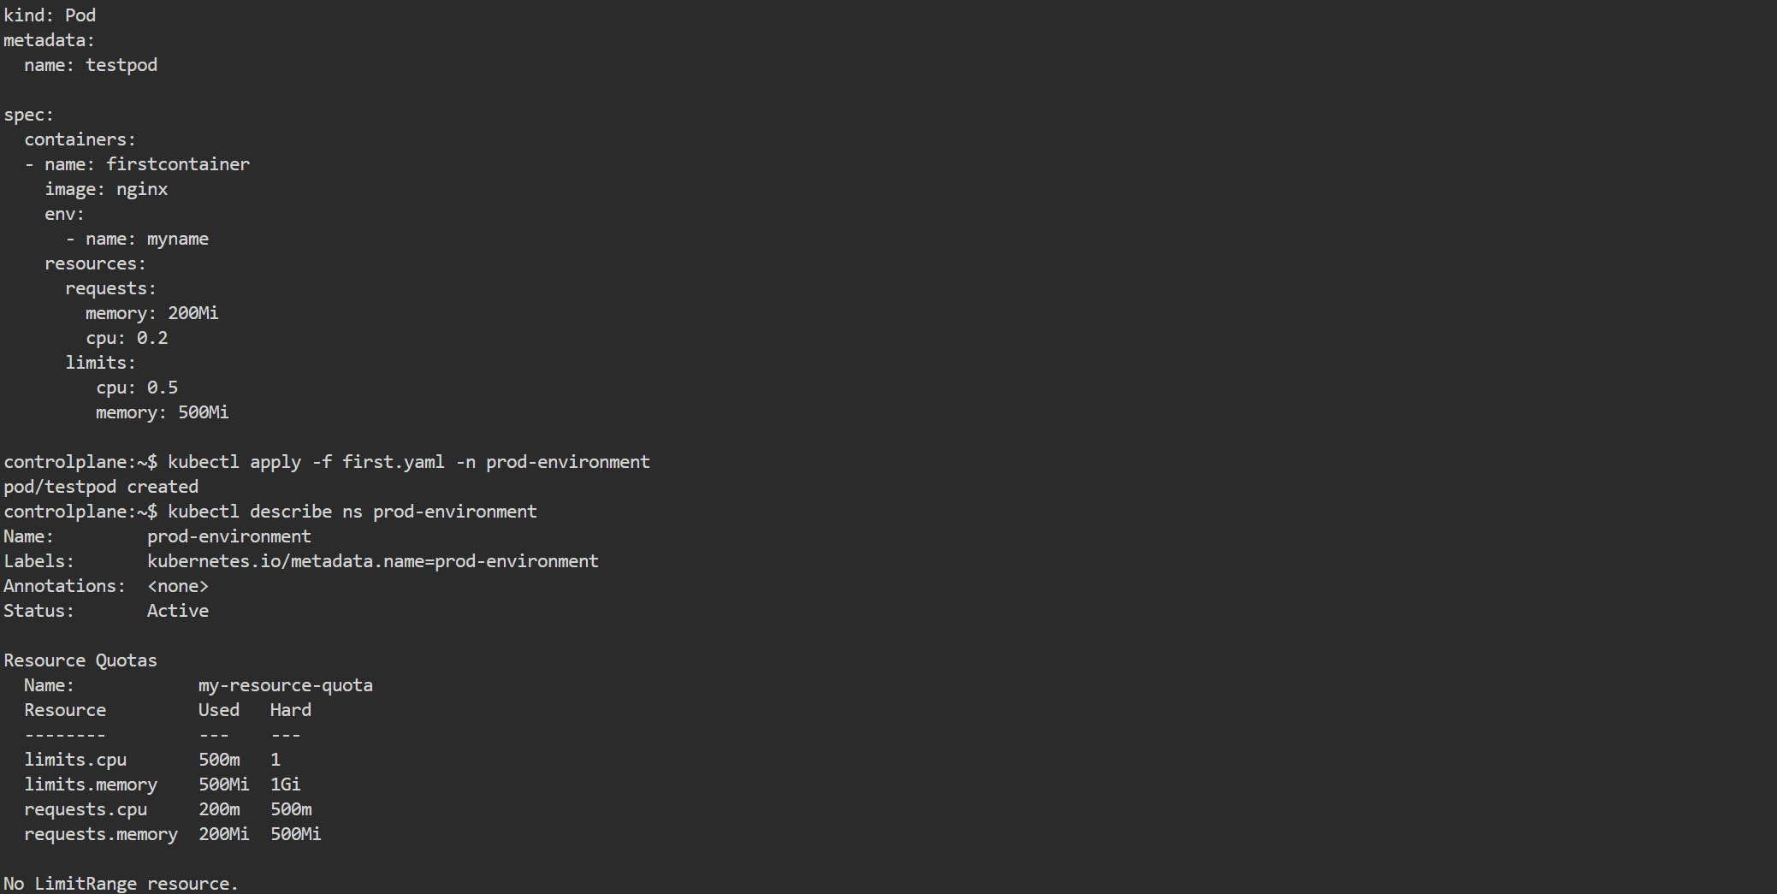  
  
  
3) In the staging-environment name space, set a Limit Range that assigns default CPU and memory limits (300m CPU, 600Mi memory) and applies a minimum and maximum CPU.

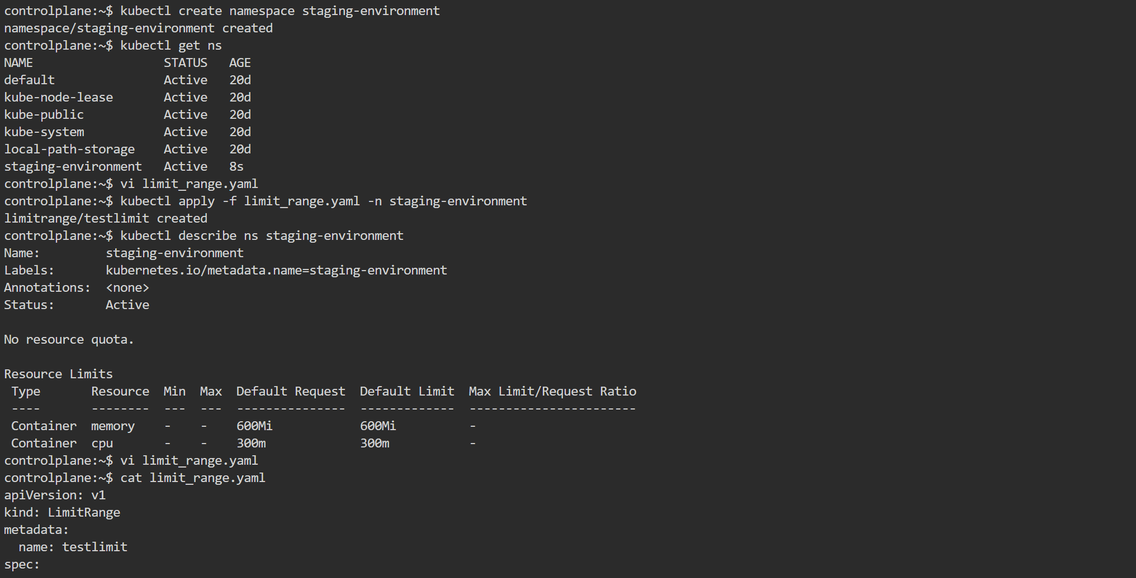  
  
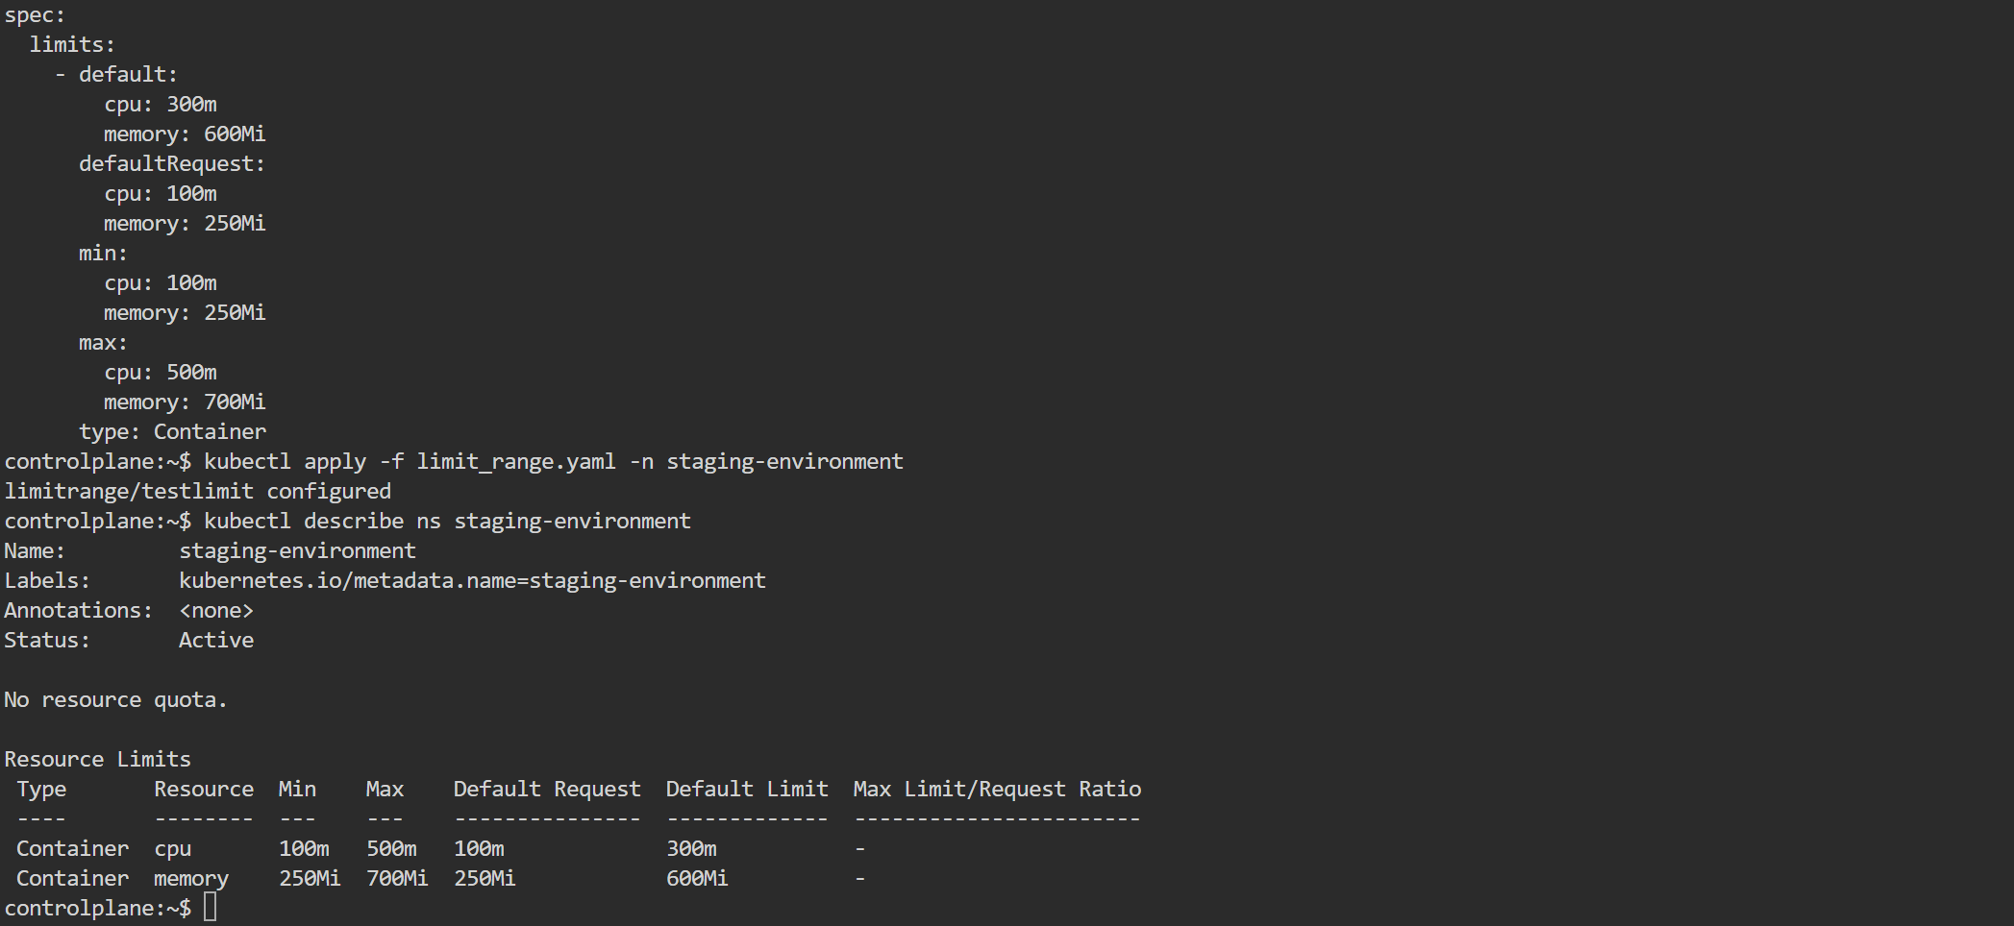  
  
4) Create a pod and a Node Port service in the default name space, then create another pod in the test name space and communicate between them using Service DNS.

5) Apply a Limit Range with a max limit/request ratio of 2 for memory in the performance-environment name space, and test by creating a pod with mismatched resource requests and limits.