**K8’S-06**  
  
1) Create a ConfigMap from a directory containing multiple files and inject the variables into a pod as environment variables.  
  
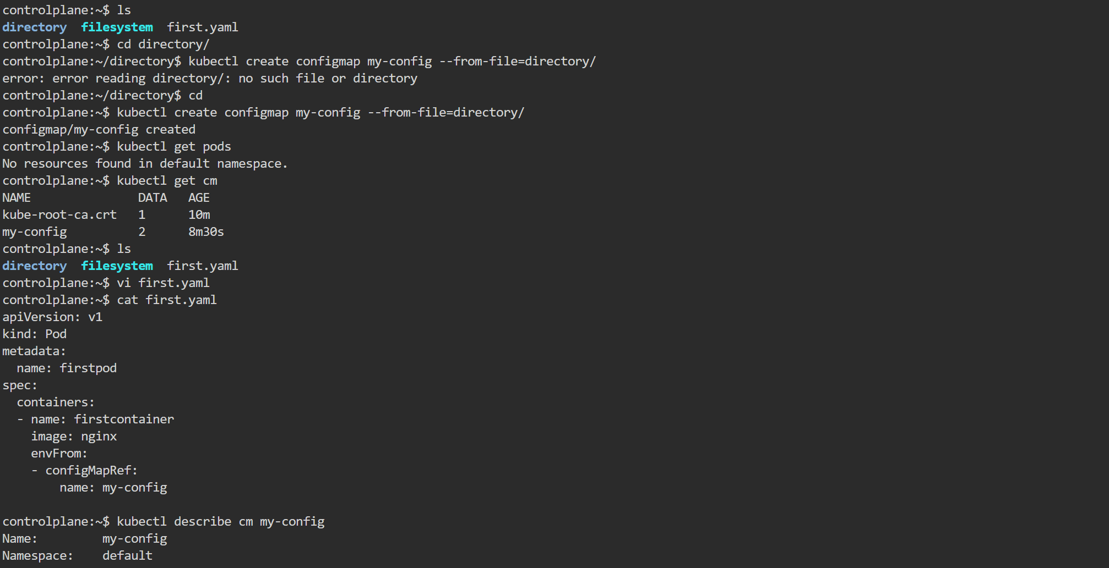  
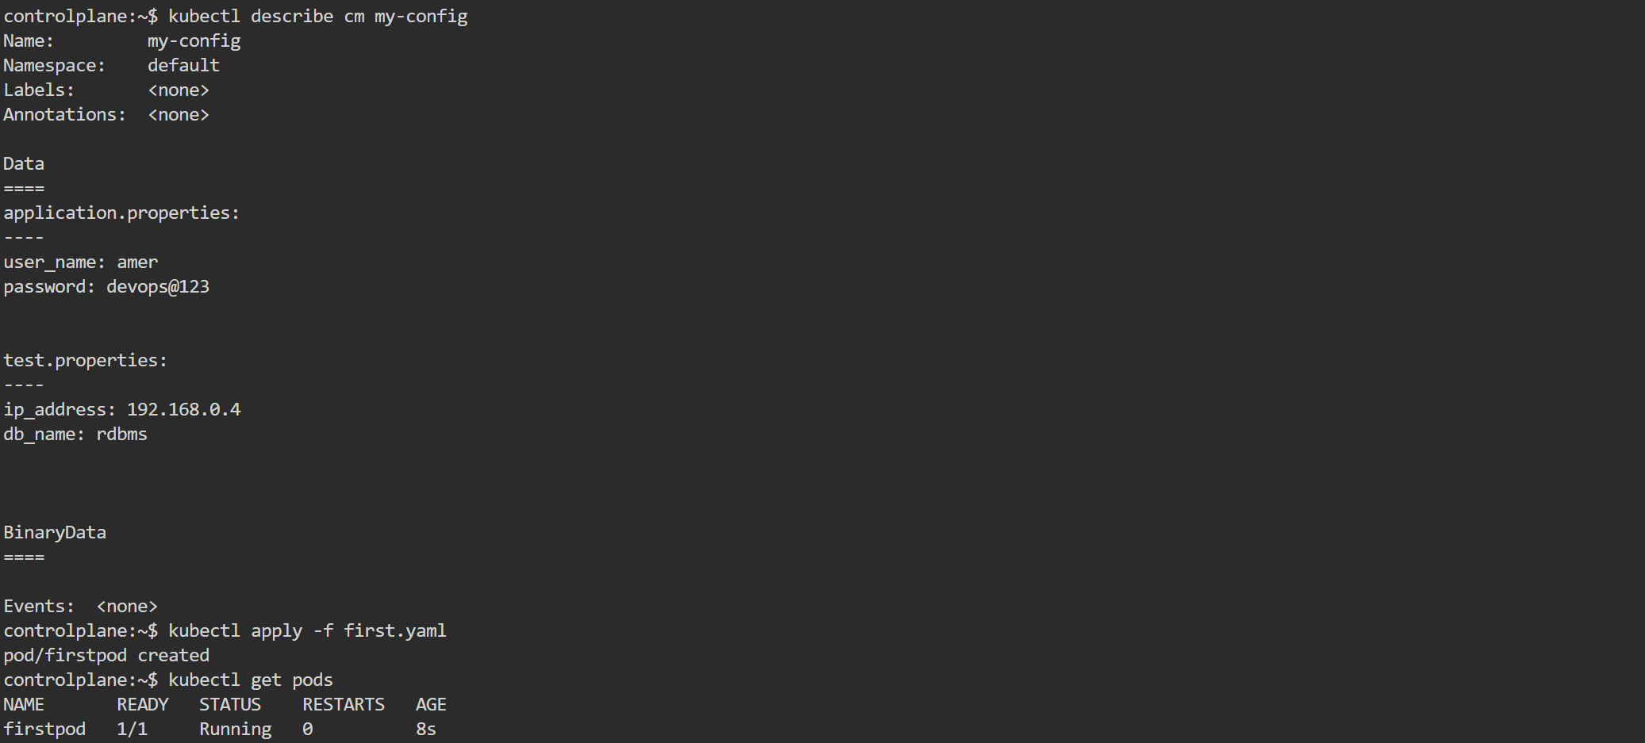  
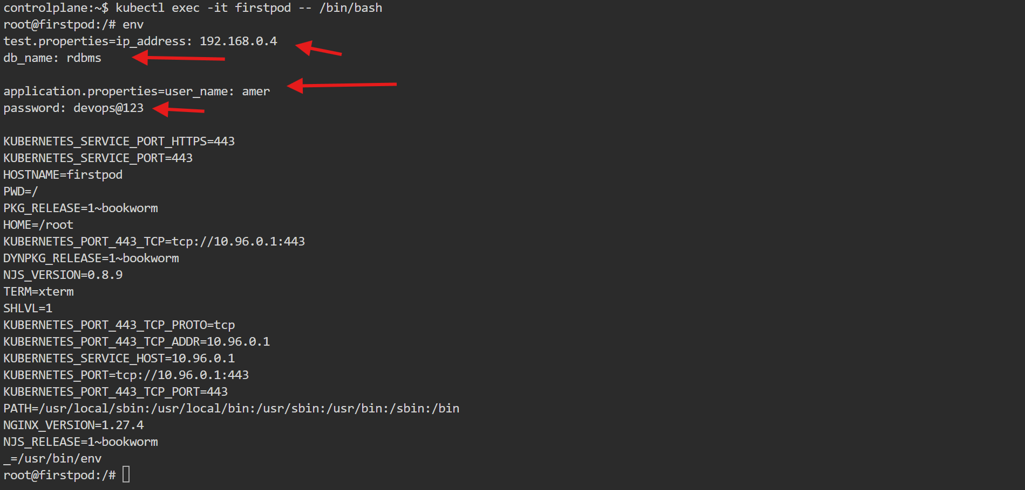  
  
  
2) Create a ConfigMap from a file and mount it as a volume inside a pod, ensuring the configuration data is available as files.  
  
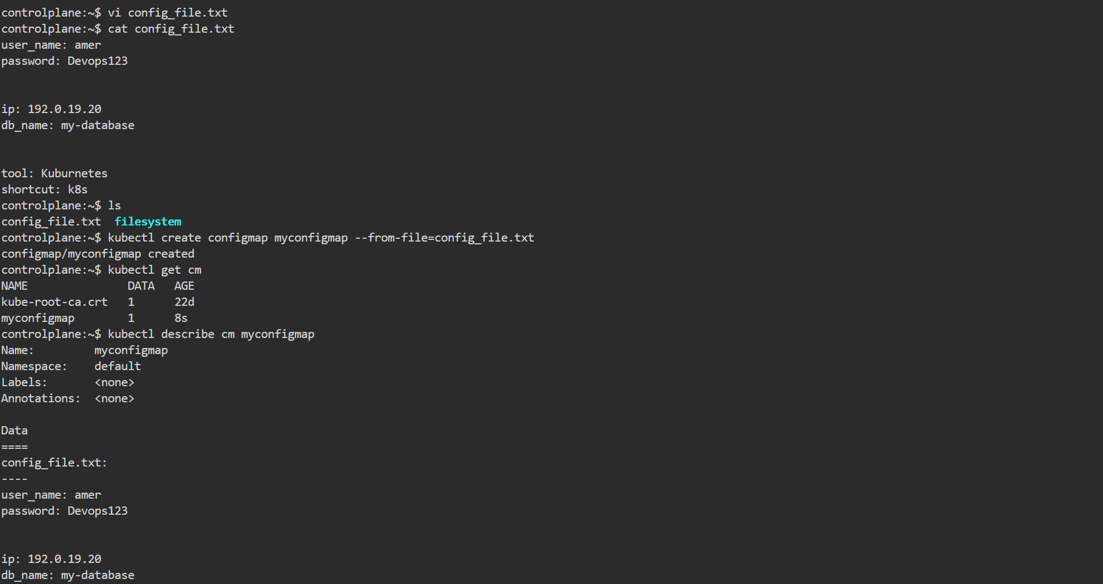  
  
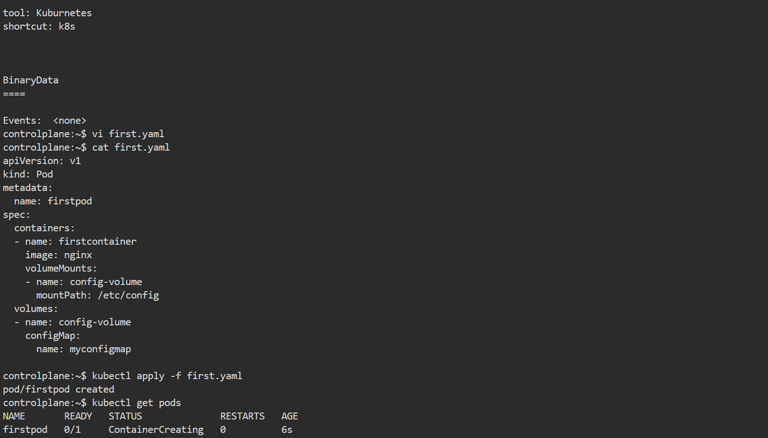  
  
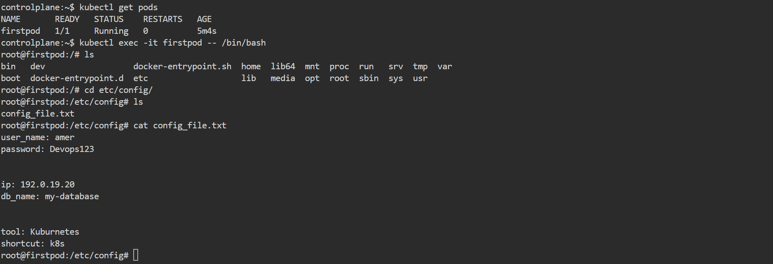

3) Create a Secret with sensitive information (username and password) and inject it into a pod as environment variables.

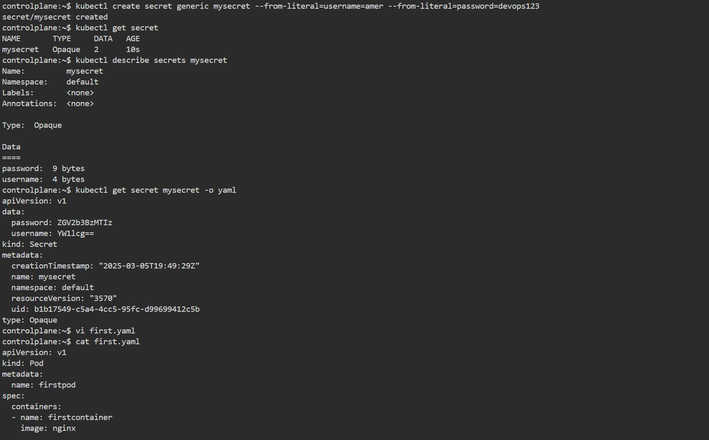  
  
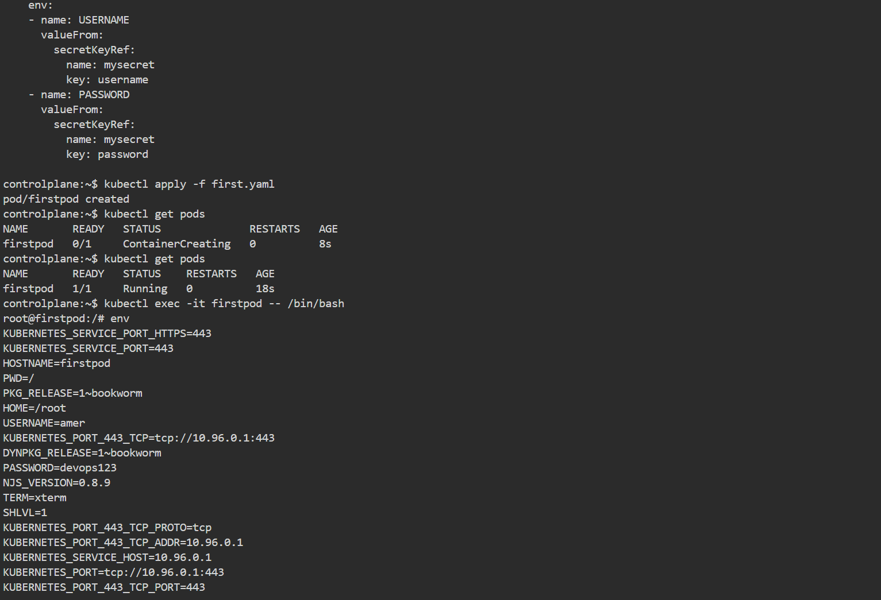

4) Create a Secret using a YAML file, mount it as a volume in a pod, and verify the specific Secret values are available as files.

5) Inject a ConfigMap as environment variables and a Secret as files into the same pod, ensuring both are accessible within the pod.