**K8’s-08**  
  
  
1) Create and Test a Kubernetes Pod with an EmptyDir Volume  
  
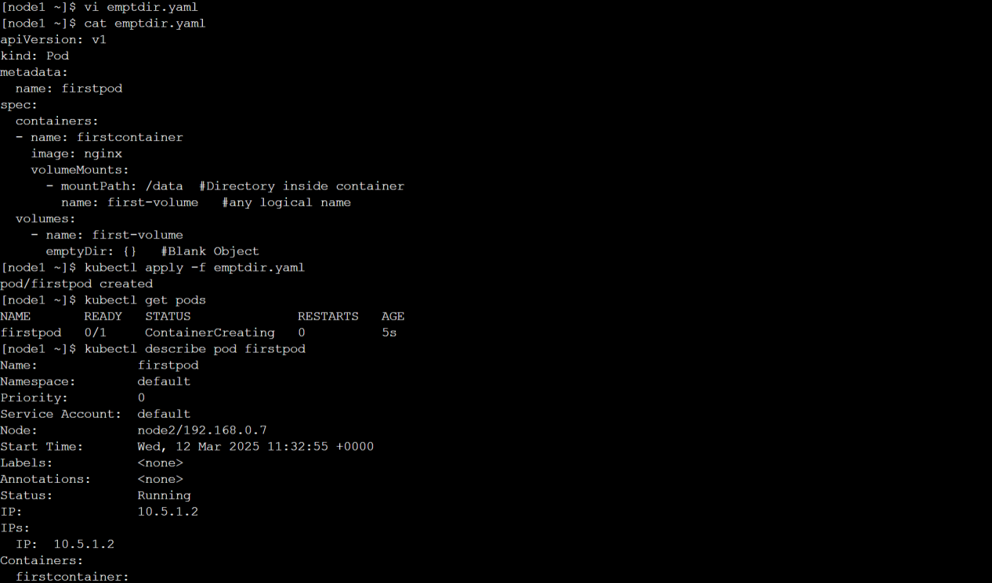  
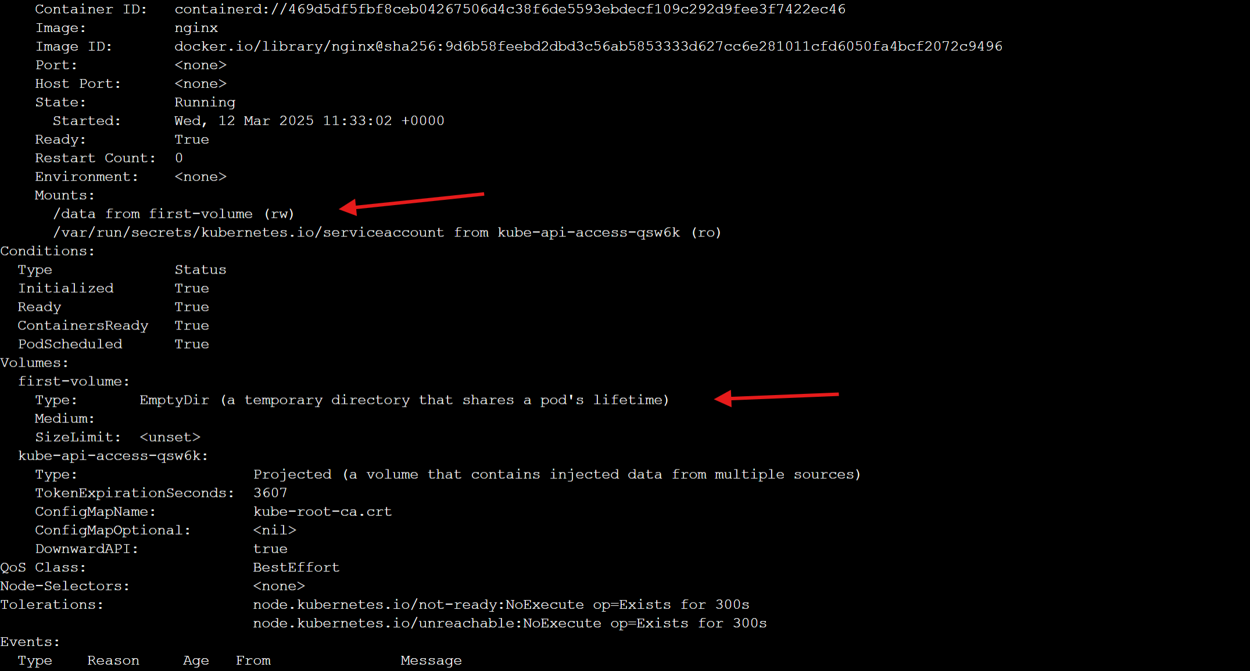  
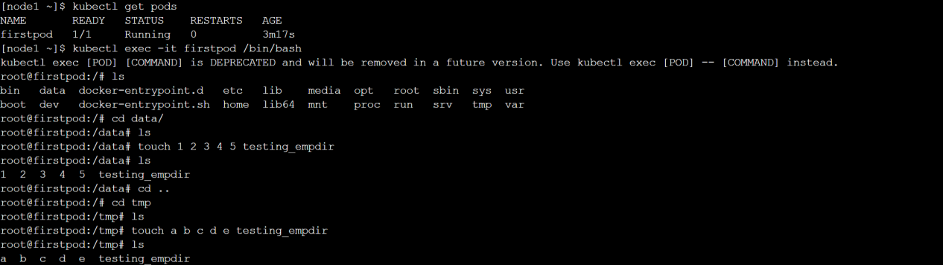  
  
  
  
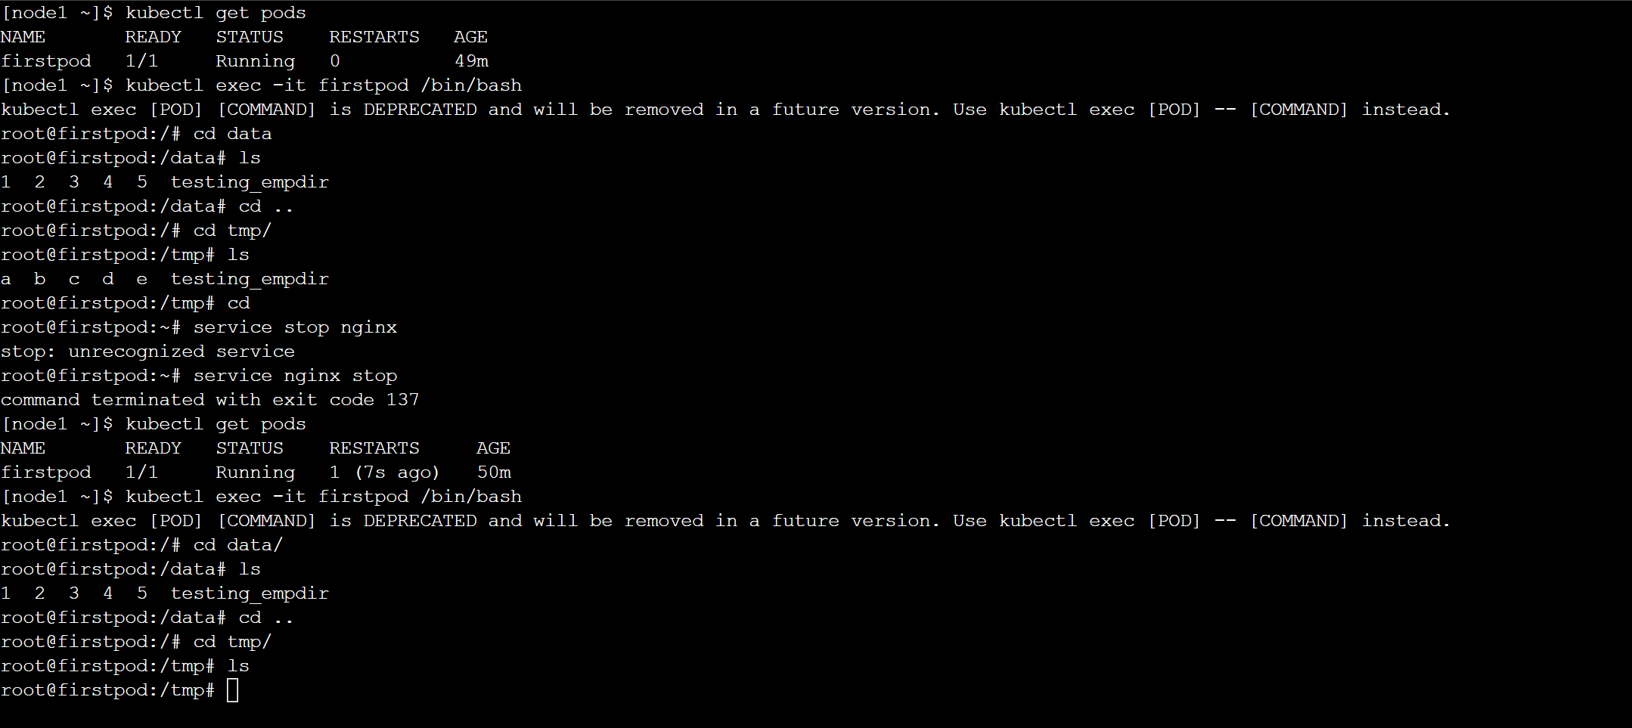  
  
2) Configure a HostPath Volume in Kubernetes and Validate Data Persistence  
  
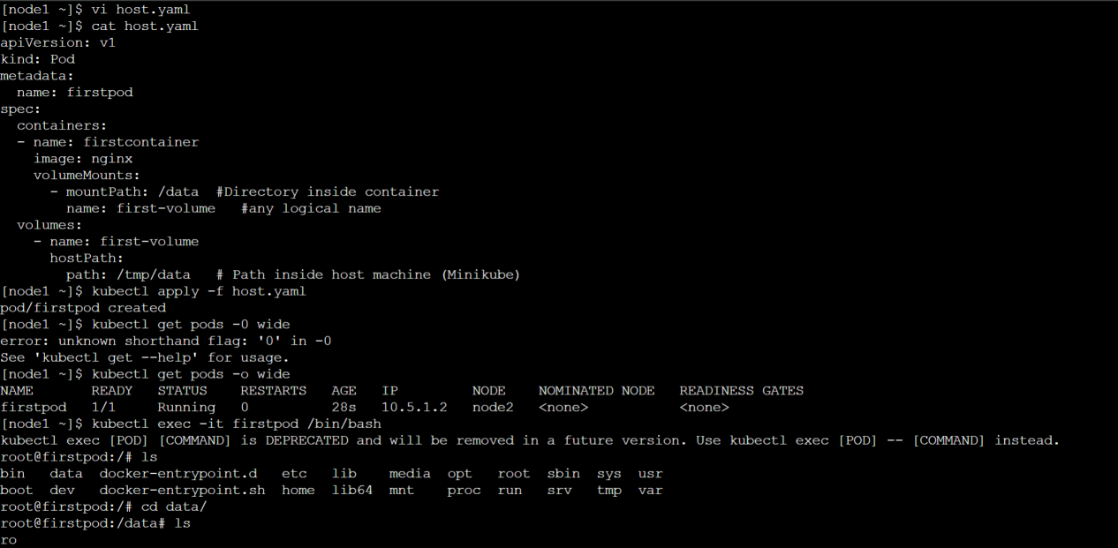  
  
  
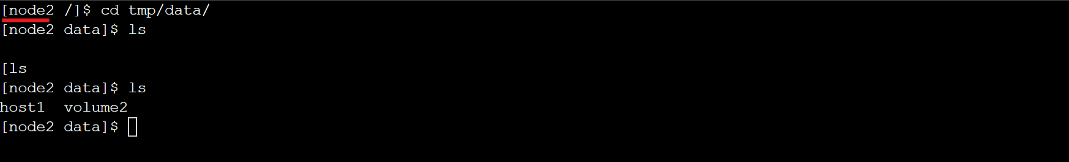

3) Deploy an Amazon EBS Volume Using Persistent Volume and Persistent Volume Claim (PVC)

4) Set Up an Amazon EFS Volume and Attach it to Multiple Pods  
  
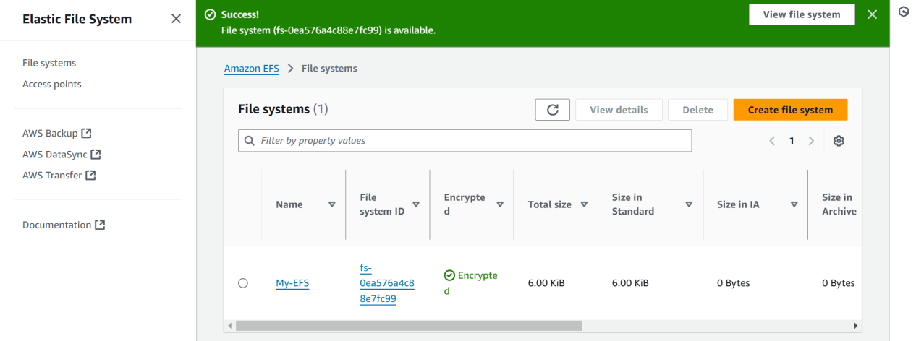  
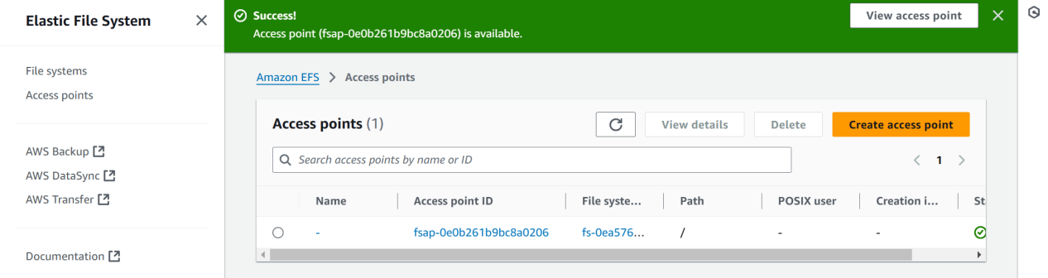  
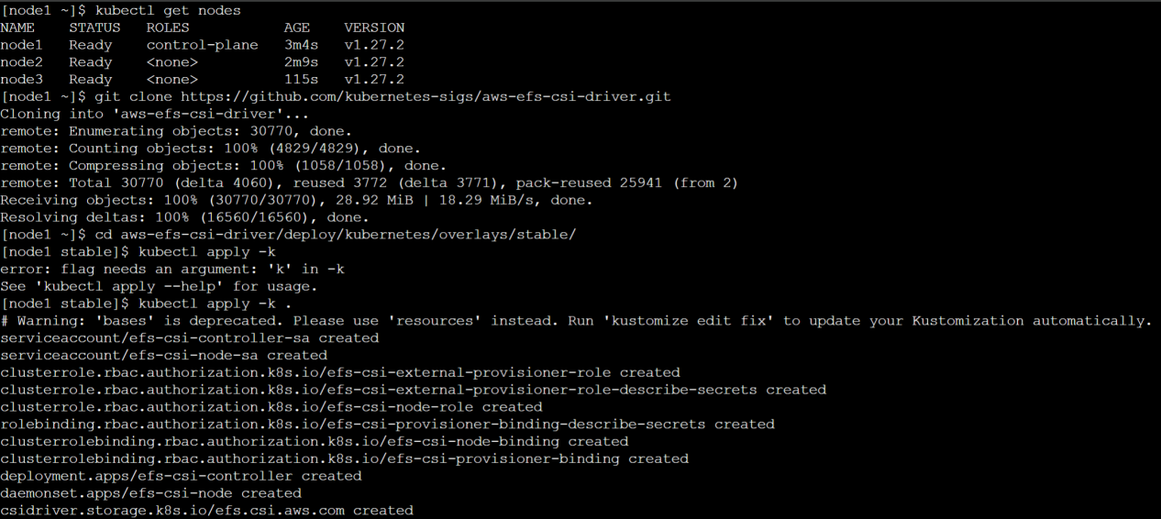  
  
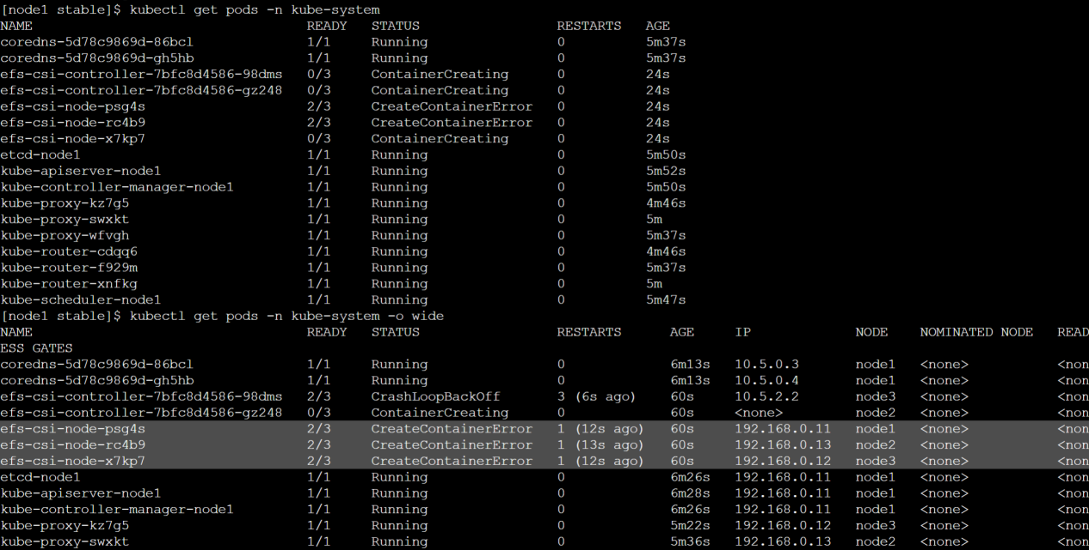  
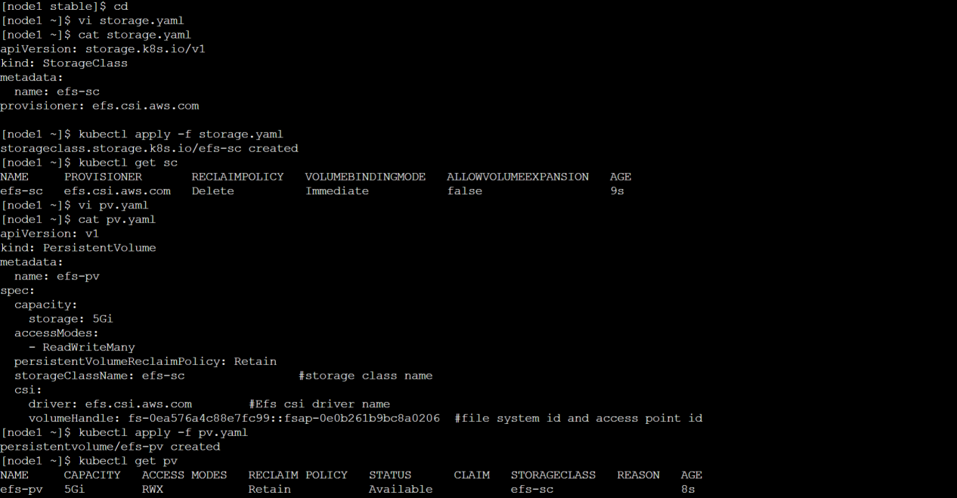  
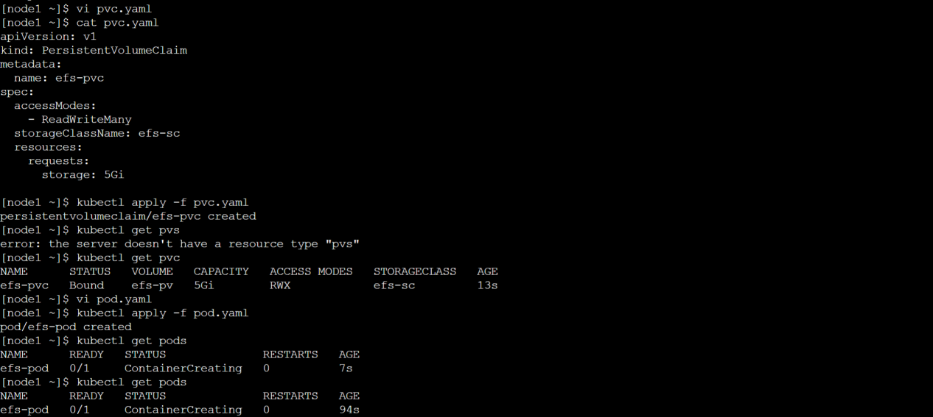  
  
5) Implement and Test Liveness and Readiness Probes in a Kubernetes Pod  
  
**Liveness --**  
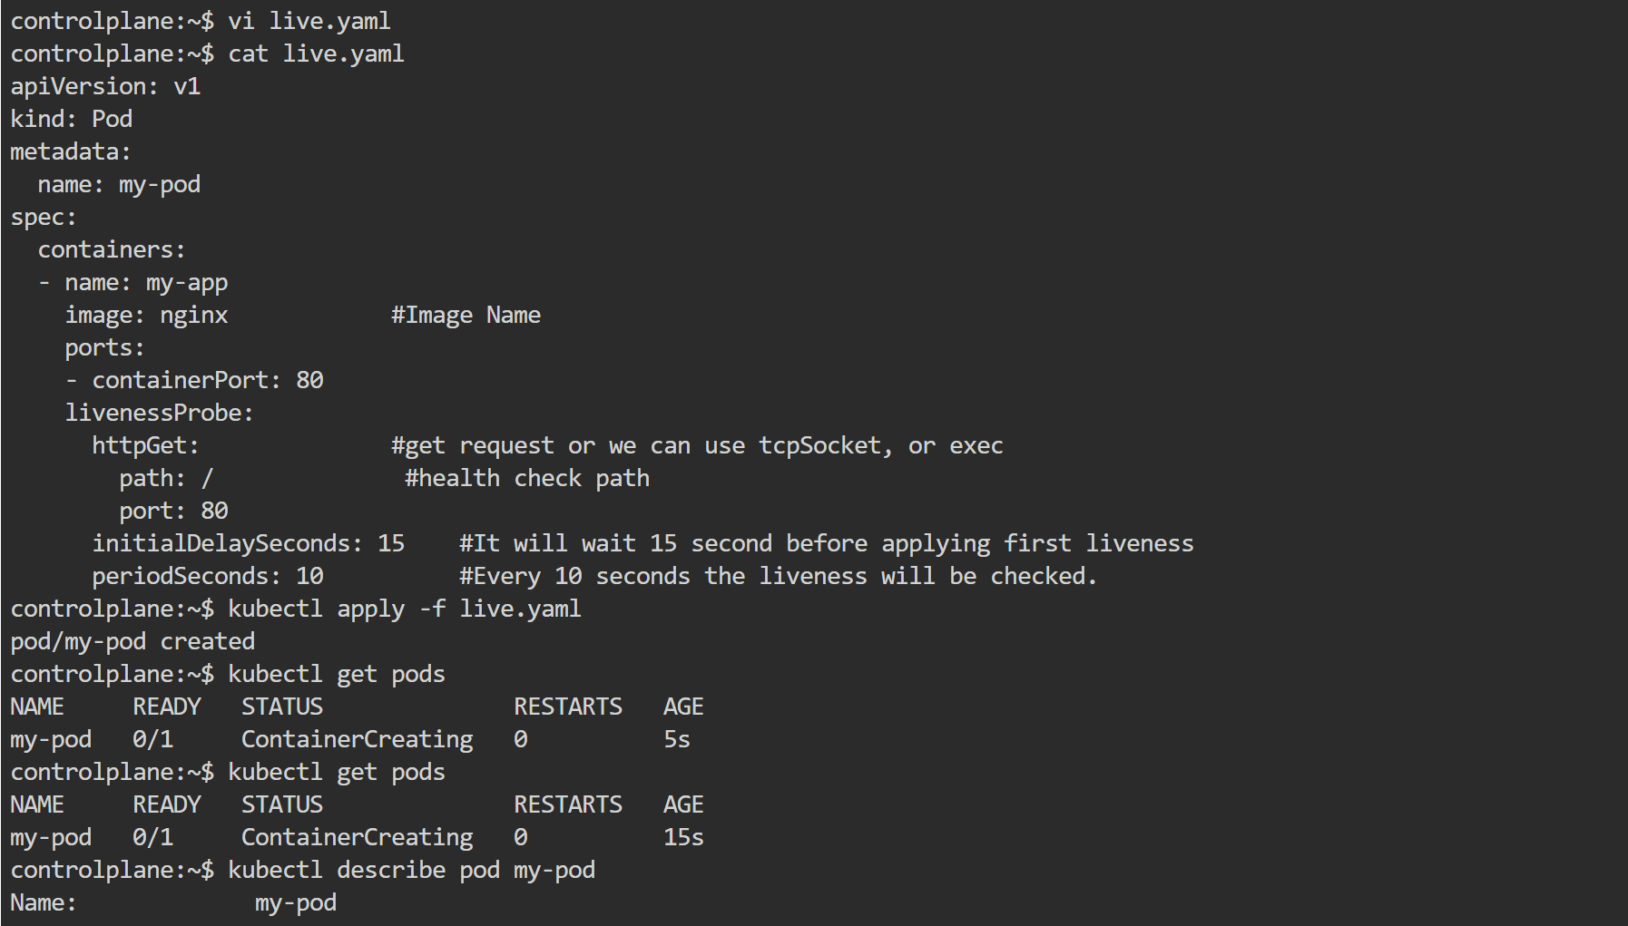  
  
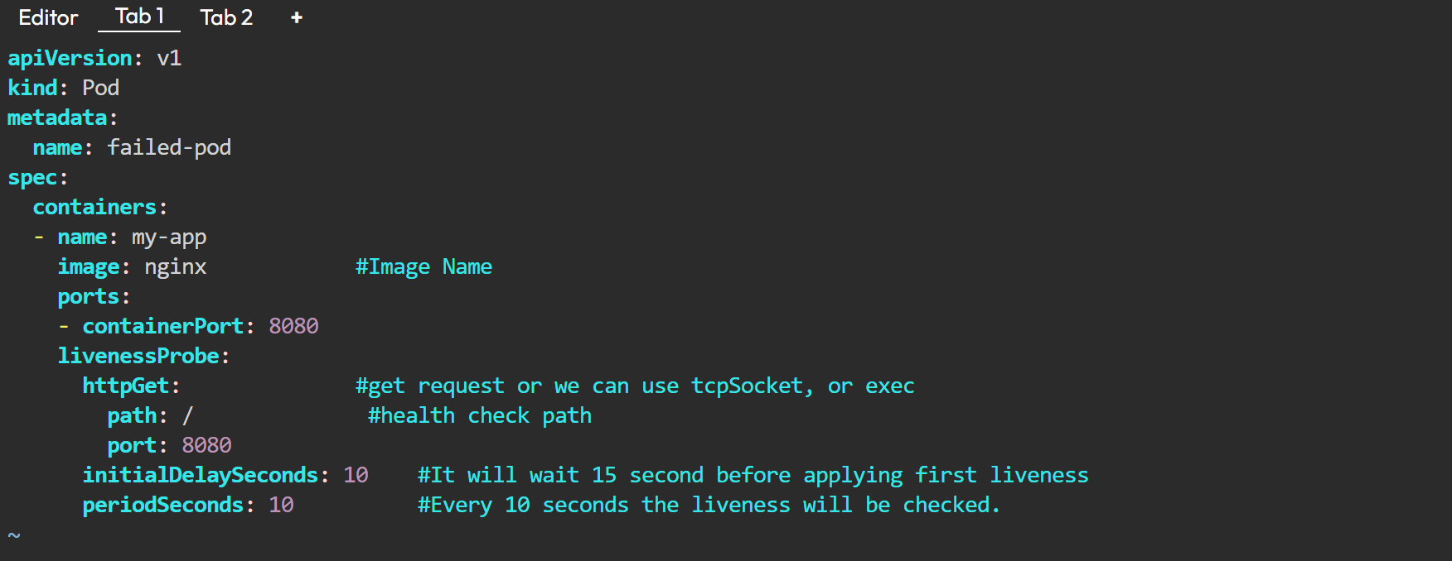  
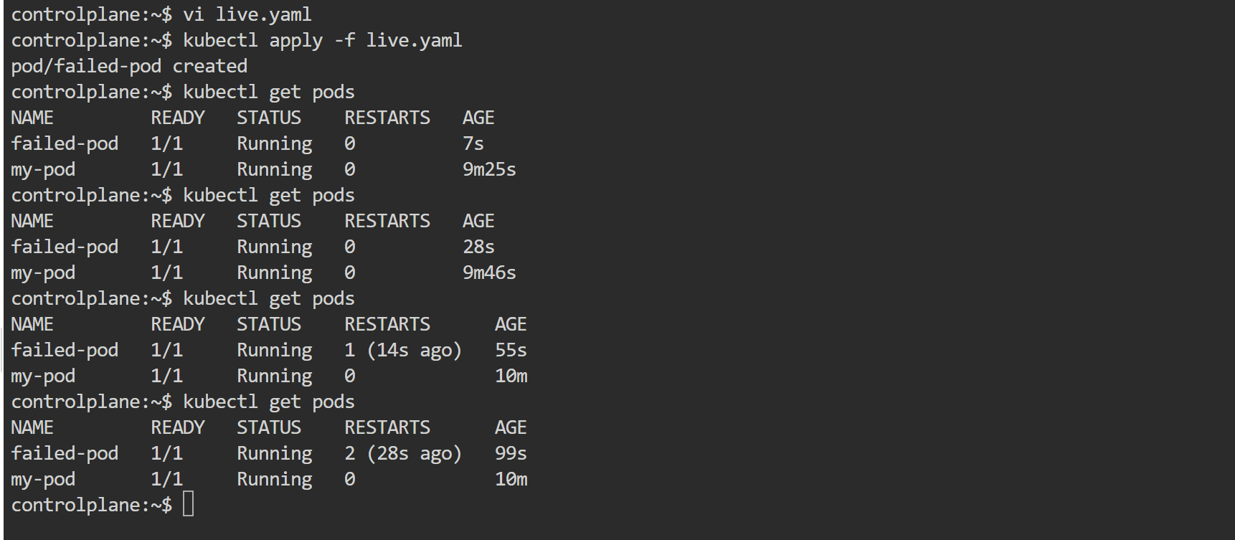  
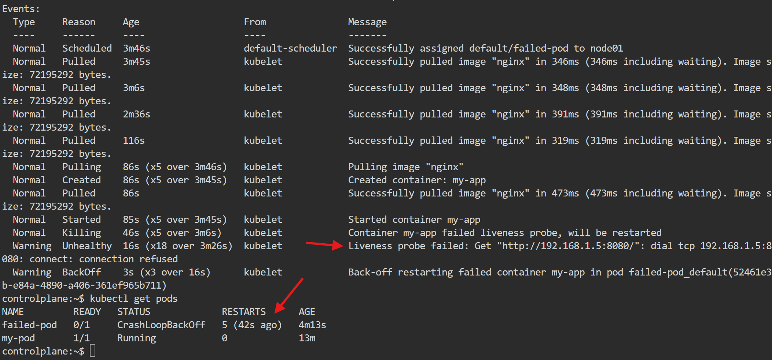  
  
  
  
  
  
  
  
  
  
  
  
  
**Readiness --**