1. Install Terraform on your PC   
     
   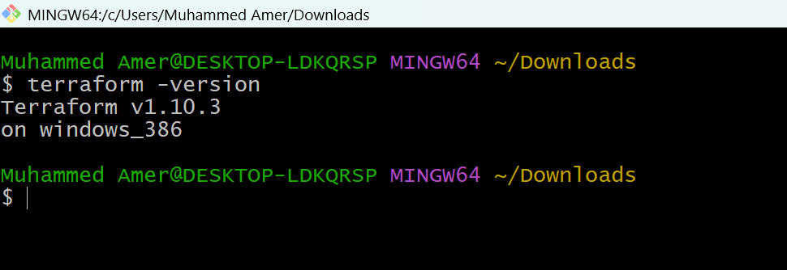  
     
     
     
     
     
     
   2) Execute all the templates shown in video.   
     
   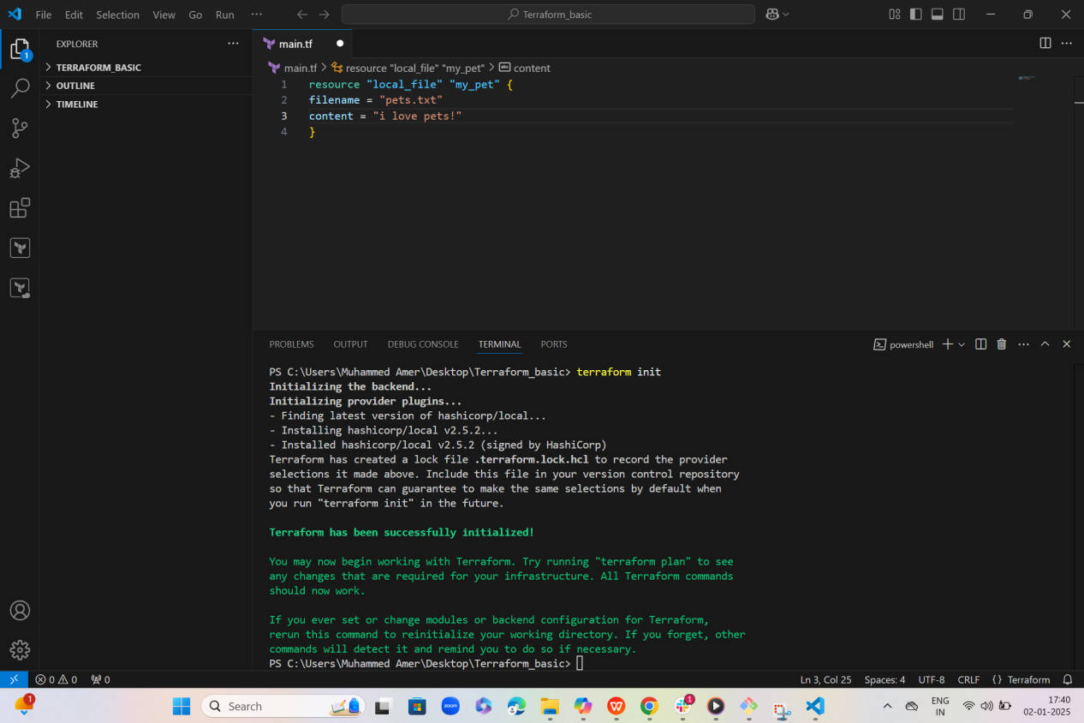  
     
     
     
     
     
     
     
     
     
     
   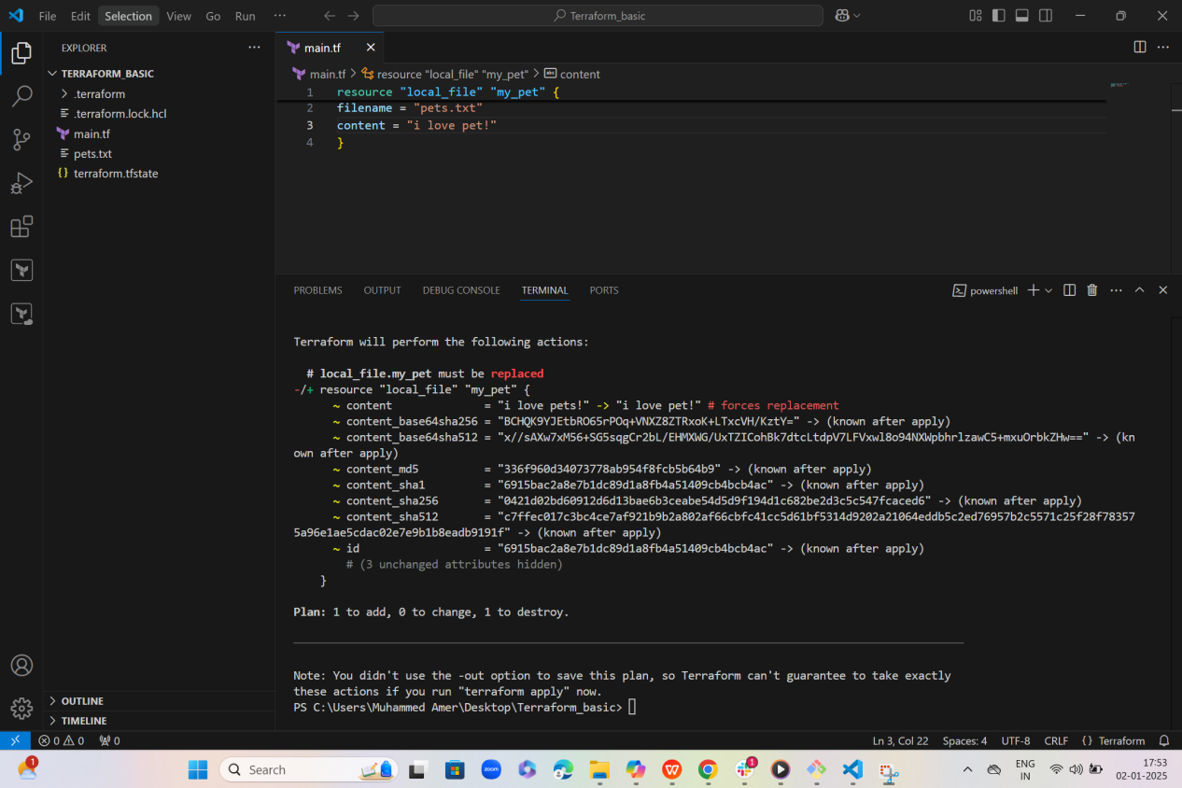  
     
     
     
     
     
   3) Note down below points, Terraform Init Terraform Plan Terraform Apply Terraform Provider.  
     
   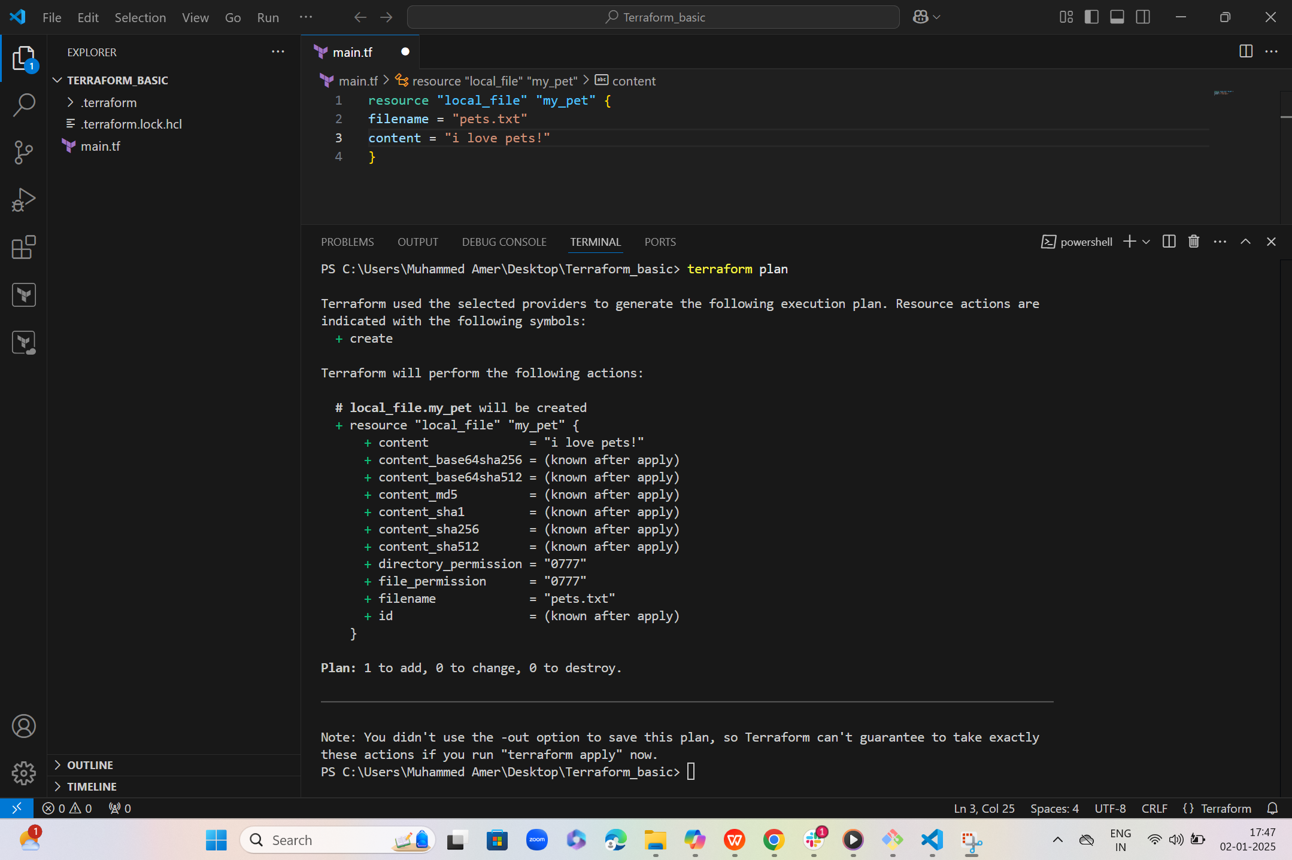   
     
   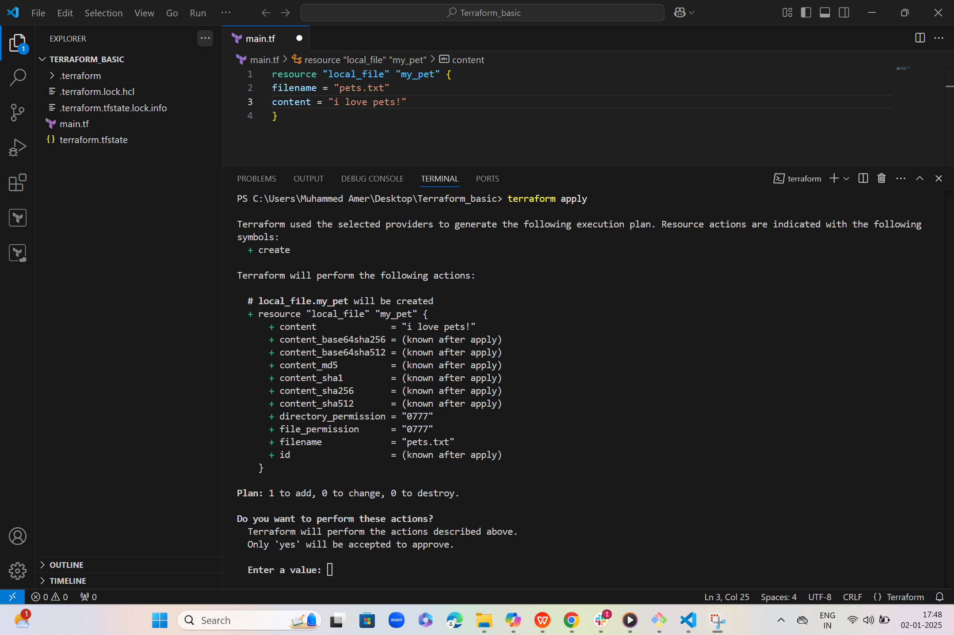  
     
     
   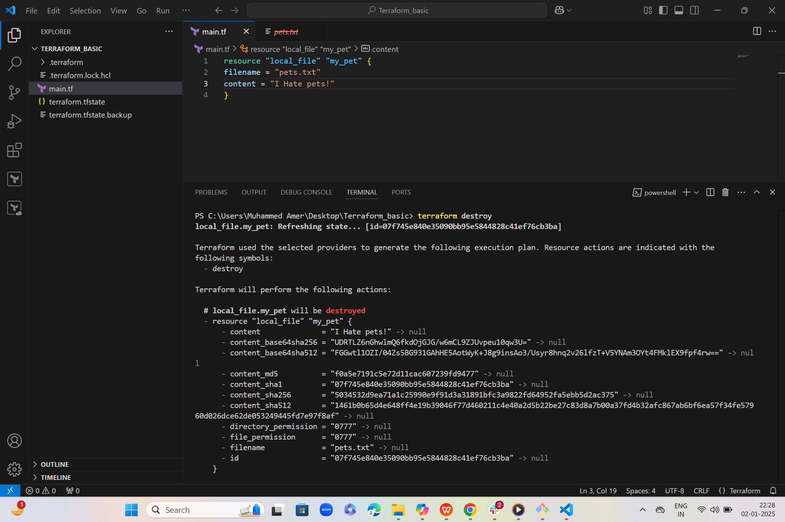  
     
   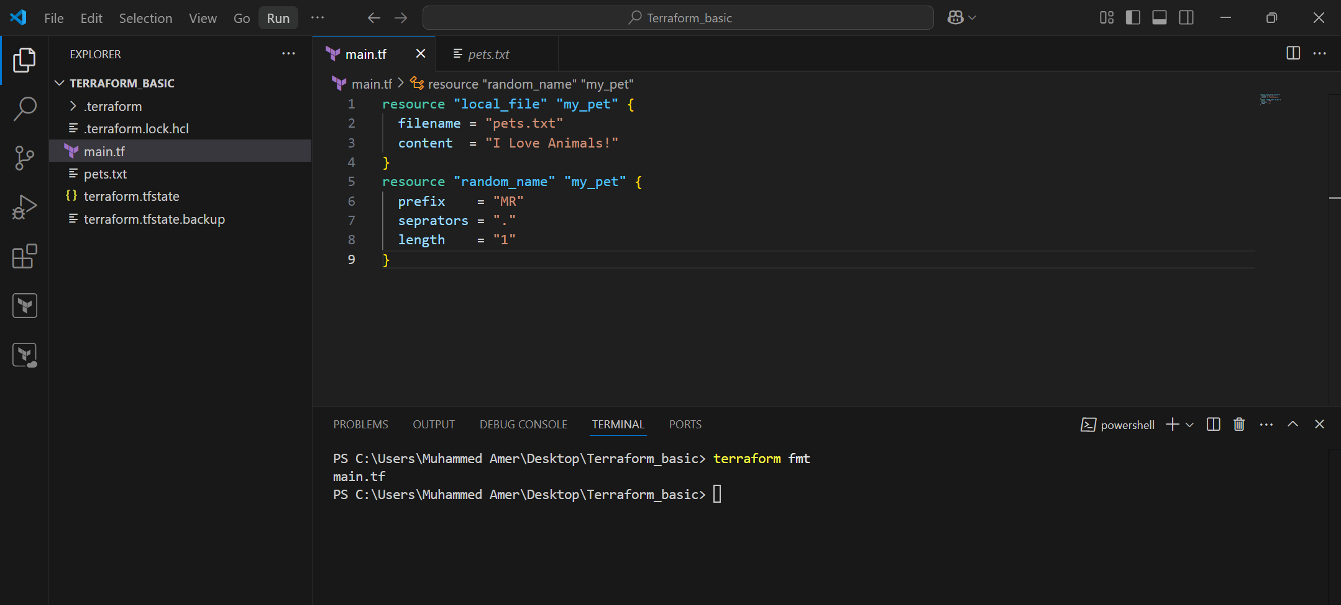  
     
     
   4) Integrate a sample Terraform template in jenkins.   
     
     
     
     
     
     
   5) Watch the terraform-02 video.   
     
   Done ------->>>>  
     
   6) Execute all the templates shown in video.  
   Life-cycles stages

>>>>create_before_destroy  
  
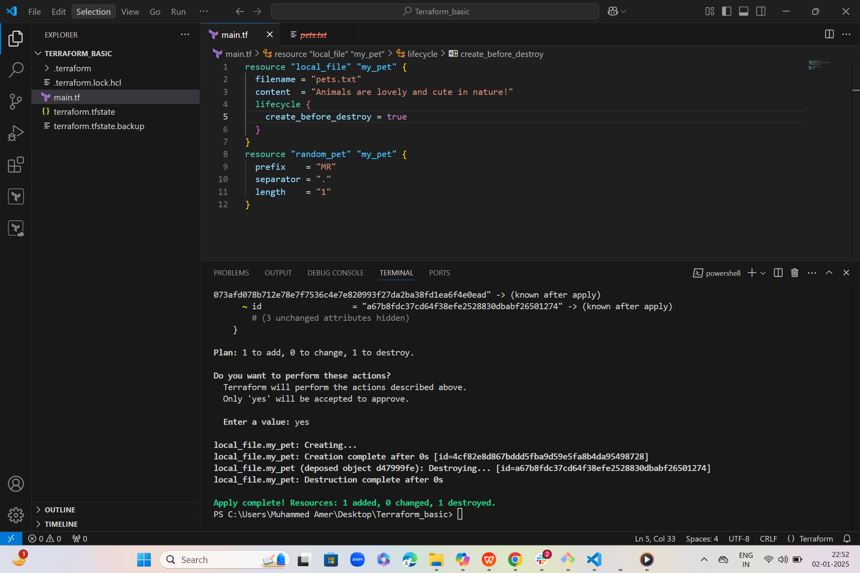  
>>>>Prevent_destroy  
  
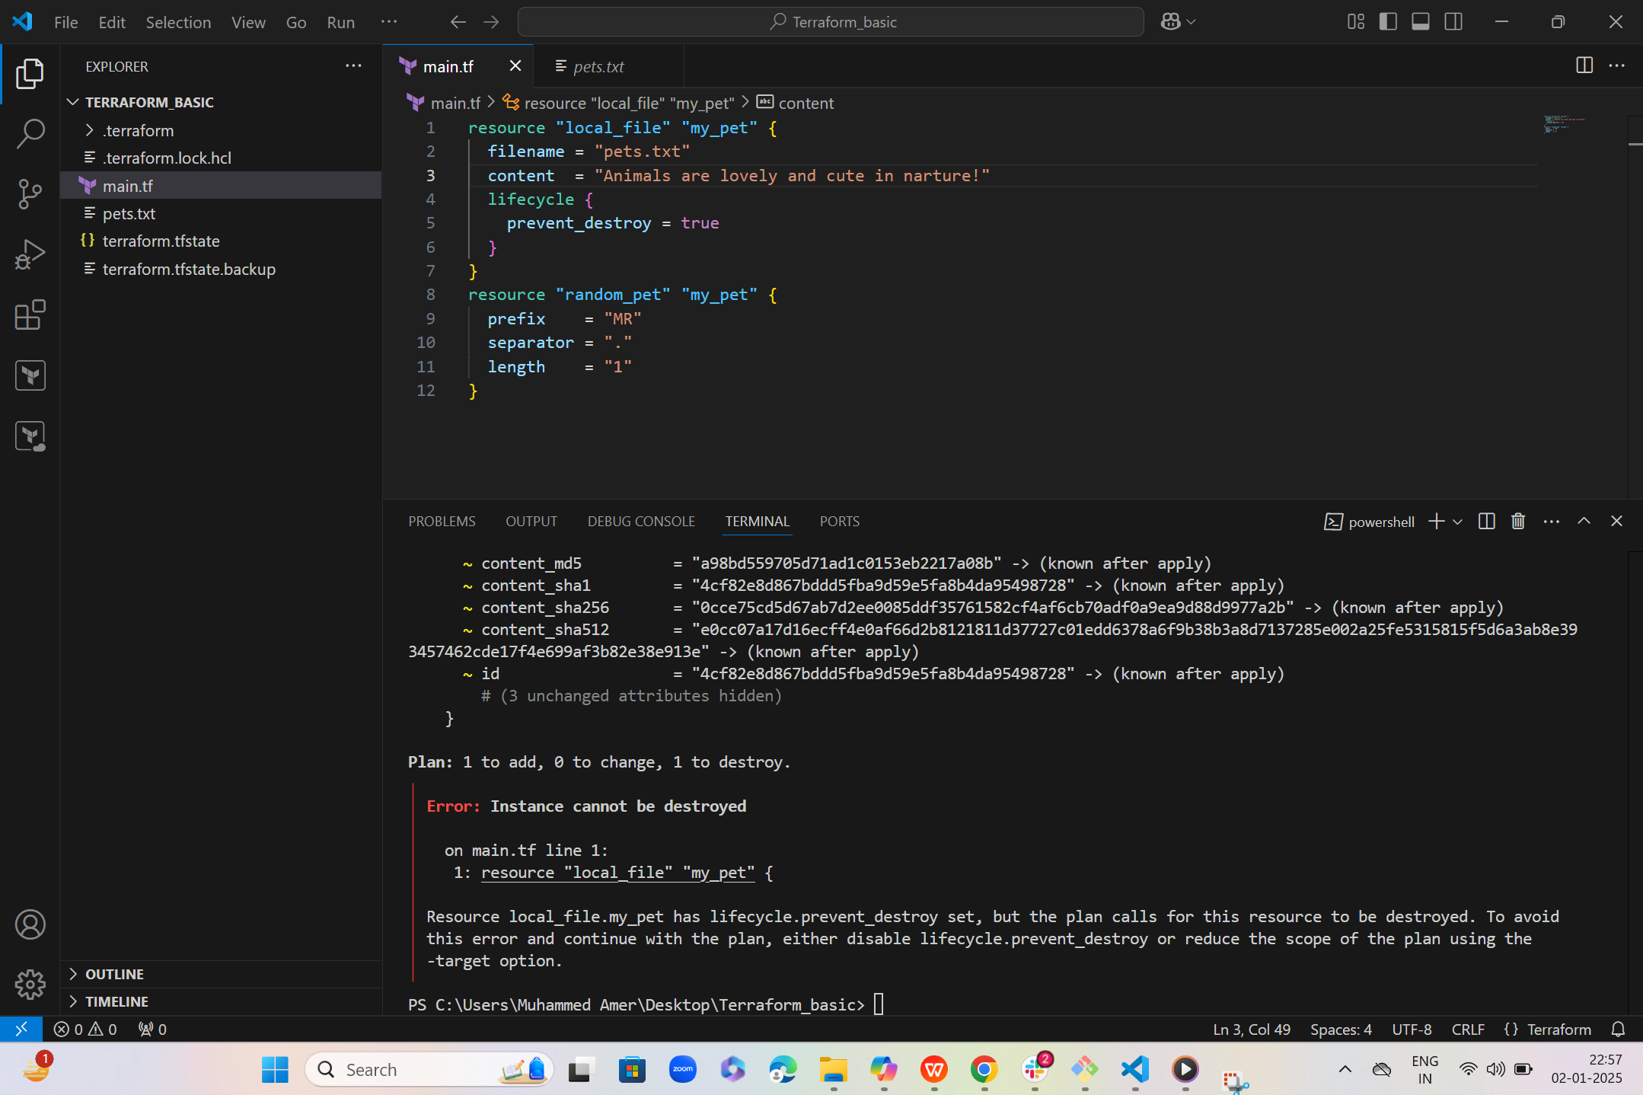   
  
  
>>>>>ignore_changes  
  
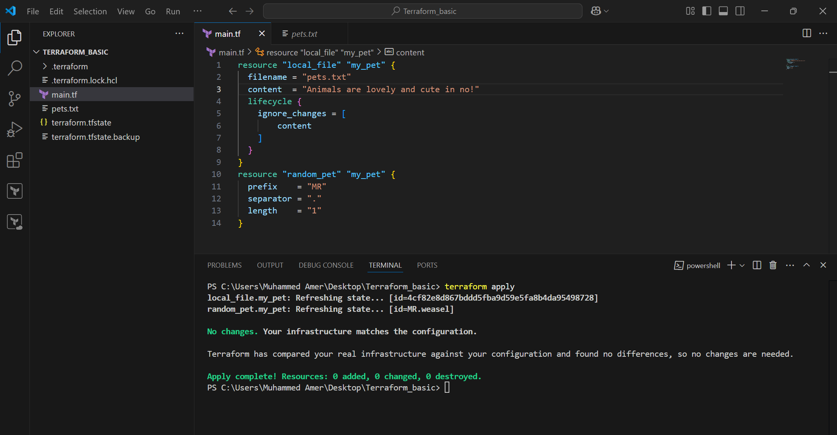  
  
  
  
  
  
  
  
  
  
  
Variables  
  
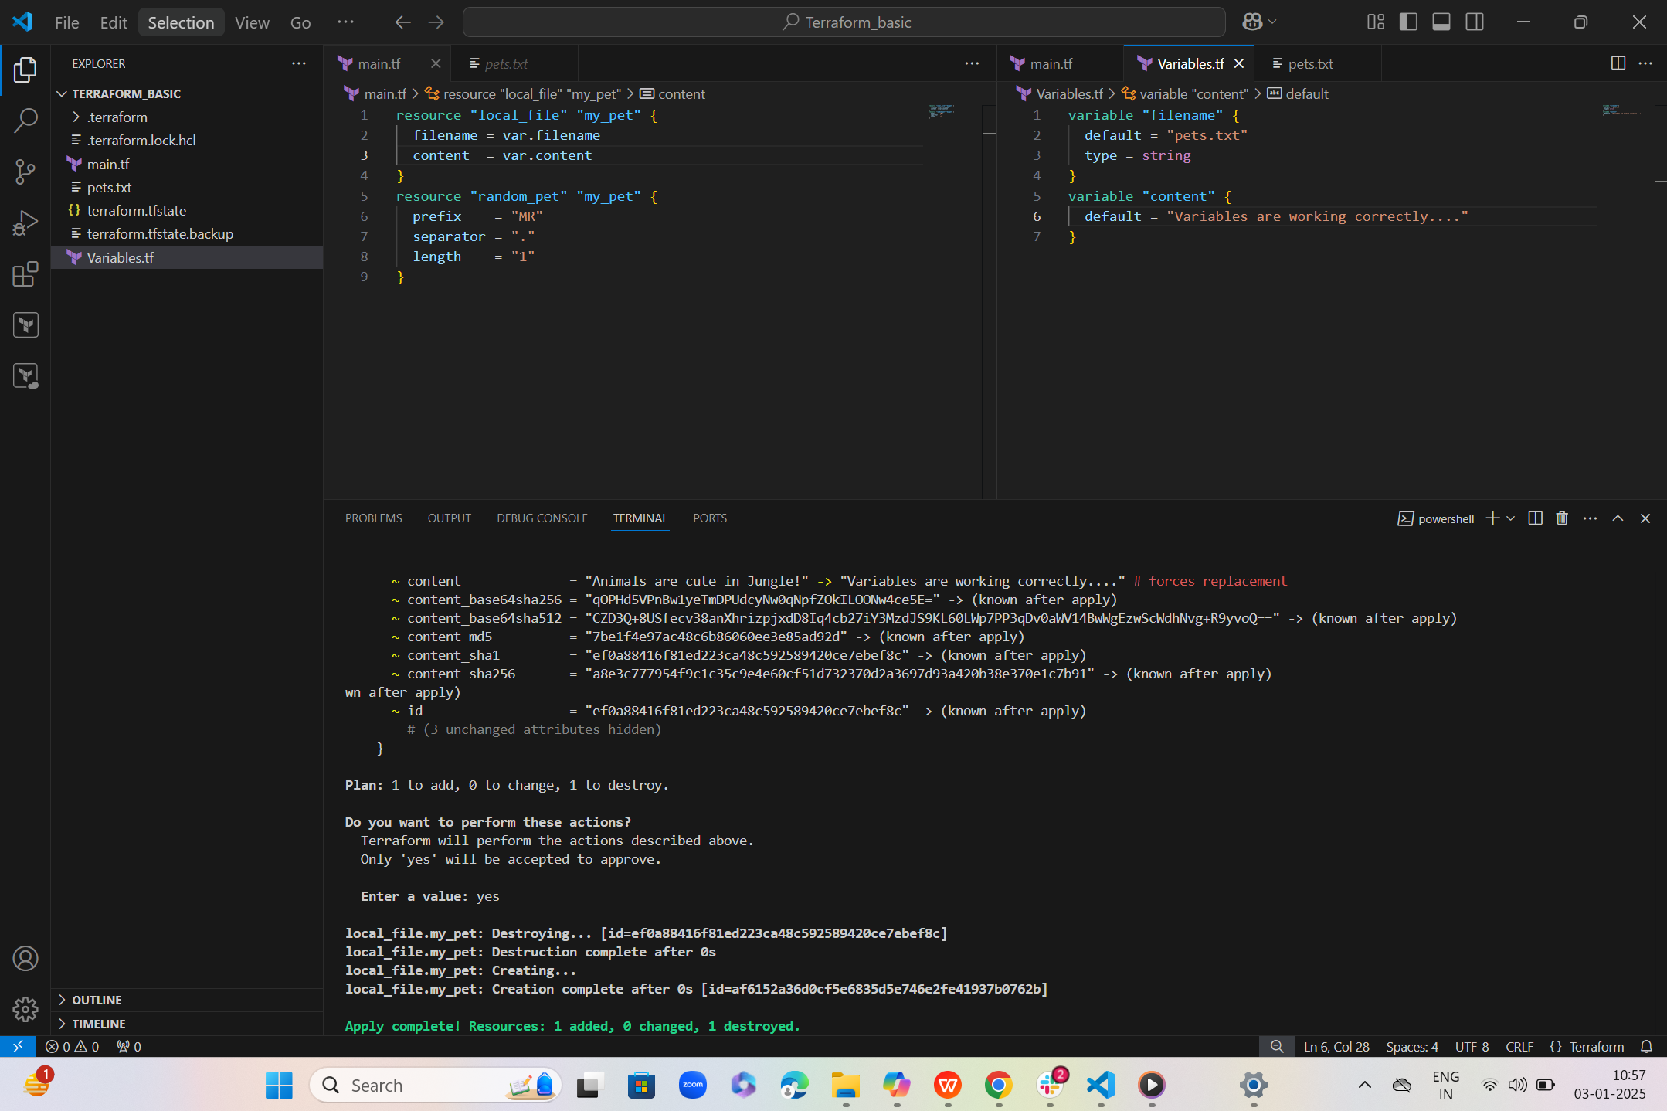  
  
  
Variable -->> 2  
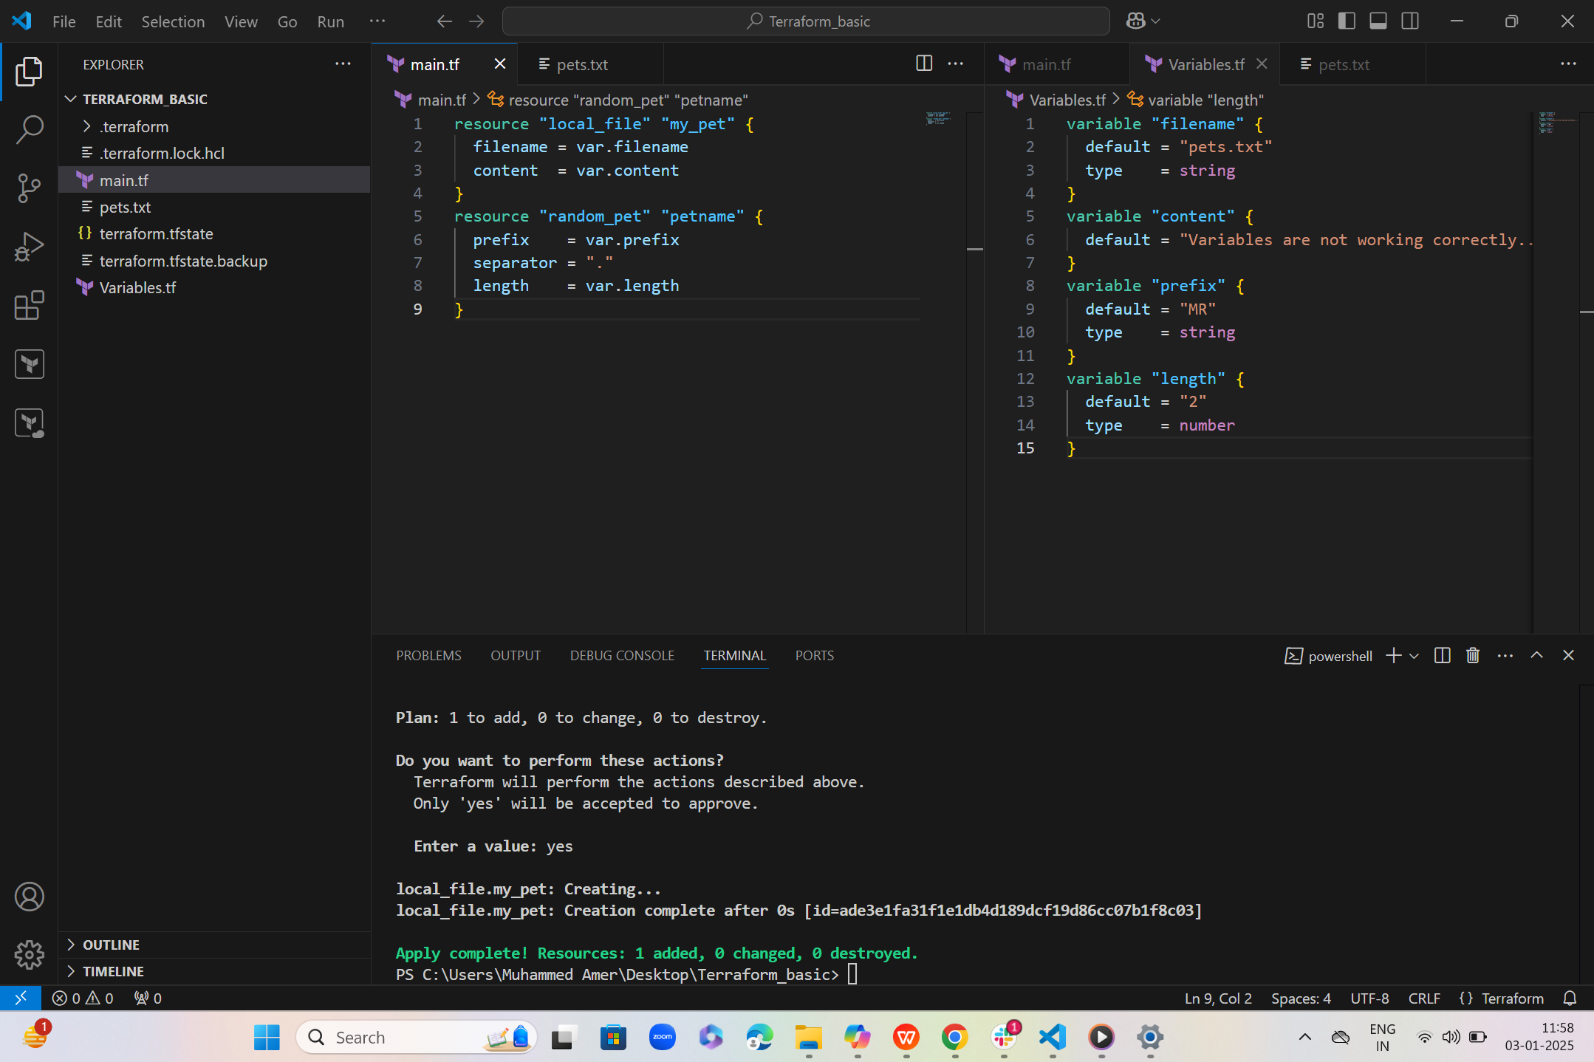  
  
7) Integrate terraform in jenkins using Terraform plugin.