1. Watch terraform-05 video.   
     
   ----DONE  
     
   2) Execute the script shown in video.  
     
   AWS_instance  
   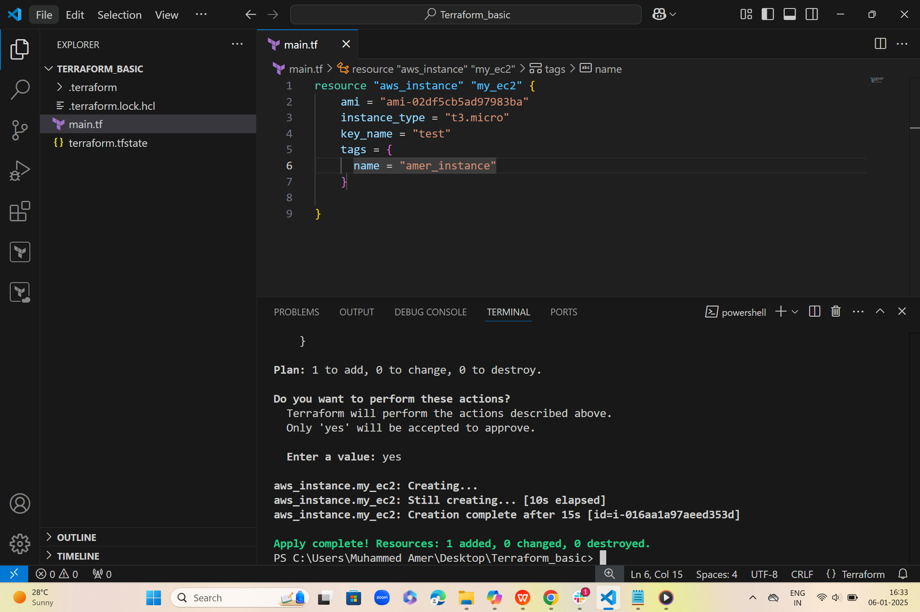  
     
     
   S3-bucket  
   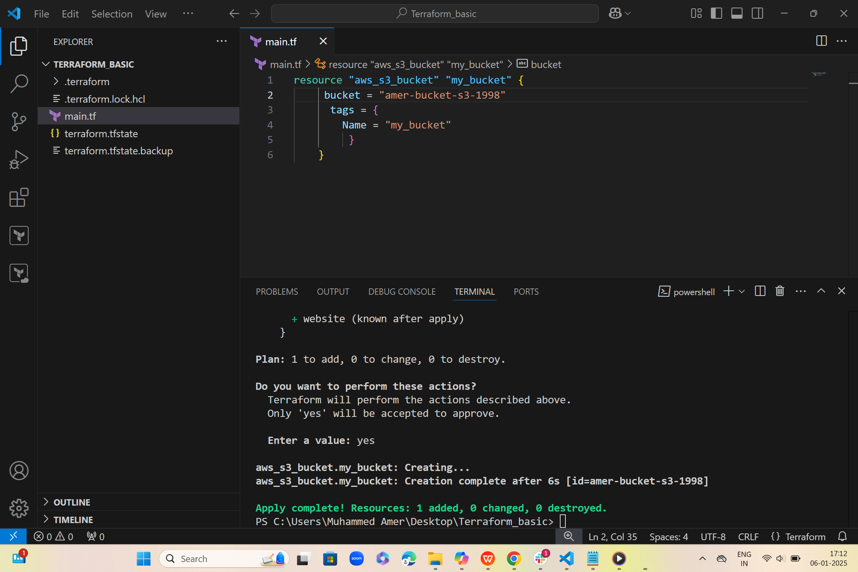

3) Create one ec2 instance with httpd installed using terraform script.   
4) Setup s3 as backend to the task 3.   
5) Setup dynamo db locking for task3.   
6) Watch terraform-06 video.   
7) Execute the script shown in video.   
8) Provision ec2,s3 and vpc using Terraform modules.   
9) Provision ec2 for 3 different environments (Dev, Staging and Prod) using terraform workspaces.  
  
1) Create VPC 2) Create Internet gateway 3) Create Custom Route Table 4) Create Subnet 5) Associate subnet with Route Table 6) Create Security Group to allow port 22.80,443 7) Create a network interface with an ip in the subnet that was created in step 4 8) Assign an elastic IP to the network interface created in step 7 9) Create Ubuntu server and install/enable apache2