Ansar Maqsood

Front End Web Development

Assignment 2

Contents

Introduction 2

Initial Designs 3

Home Page 3

About 4

Travel 4

Final Designs 5

Home Page 5

About 5

Travel 6

Example of Source Code 6

HTML 7

CSS 7

JavaScript 7

User Testing 7

Browser Testing 8

Compatibility Testing 8

Usability Testing 8

Reference 8

Tools Used 9

Frameworks Used 9

# Introduction

The following documentation will give you an insight of the website and as to what the purpose was. It will be covering the initial designs of the website, test strategies and what kind of language was needed to achieve the objective.

The website produced is a portfolio website. My goal was to create a unique presence that would showcase of my personality and display my work in detail. The idea came from looking at inspirations online and how I could showcase myself to the employers and stand out gaining more exposure to the business. Not only that, it allowed me to asses my own skills in a different way. Having all the professional documents and activities gathered in one place, it allowed myself to see what I have accomplished, strengths, weaknesses, and identify what might need improvement.

Designs

The following will give you an insight of my initial designs and the completed version of the website. First I will be showing you my few of my initial designs and then I will show you my completed designs within the website.

# Initial Designs

This section will cover the few initial designs of my website that is developed in the later stages. The idea was to create a SPA (Single Page Application) where it will allow the user to load the content faster and view everything on a single page.

## Home Page

This is the first section of the SPA website. This will showcase myself and a little bit about me to the user. There will be JavaScript used within this section of the SPA and also a logo to make it look professional.

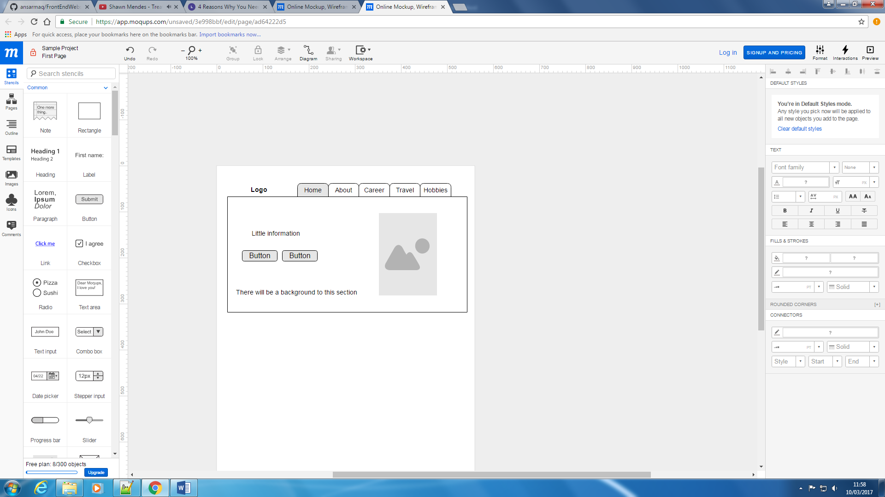

Figure 1. Wireframe design of the proposed Home Page

## About

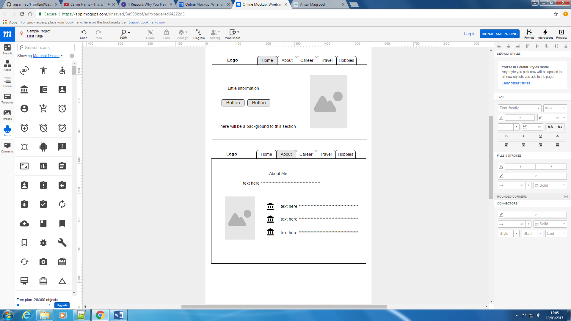

Figure 2. Wireframe design of the proposed About Me page

This is another section of the SPA website. This section will let users get to know more about me and my personality. An image, information of where I am from and JavaScript will be added to this section.

## Travel

In this section, it will show the users the places I have travelled to. It will be a slide show using JS (BXSlider). I will have couple of images and then a counter too to show the number of tourists. This again will be done through JS.

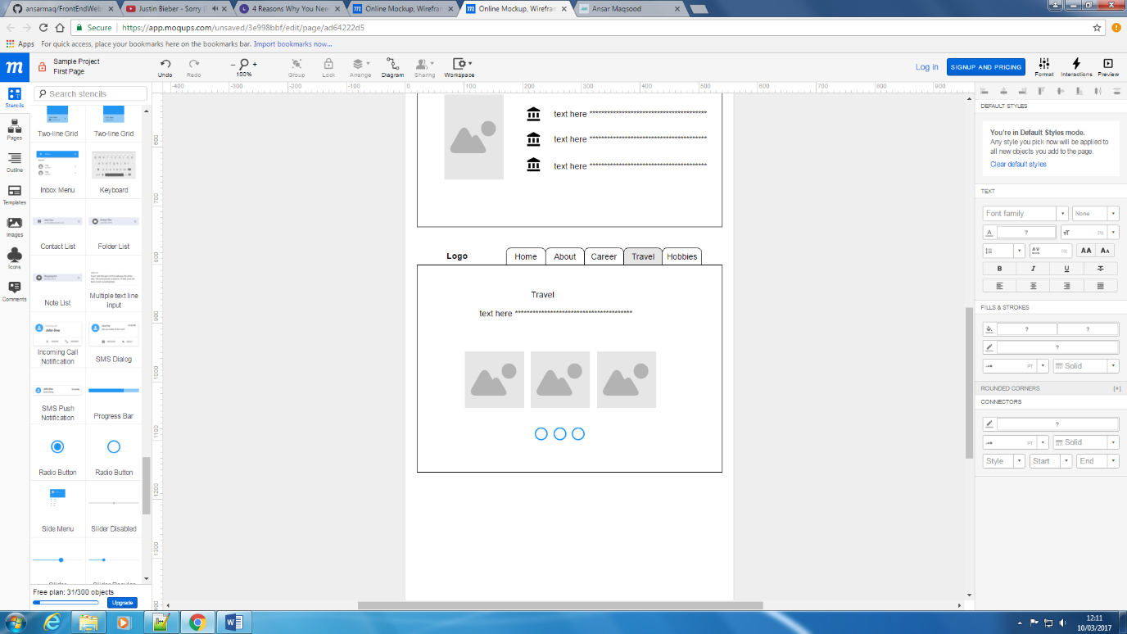

Figure 3. Wireframe design of the proposed Travel page.

# Final Designs

After completing the initial designs, I will now show the completed final designs to the website and how bootstrap to help me aid with the navigation and the sections of the SPA.

## Home Page

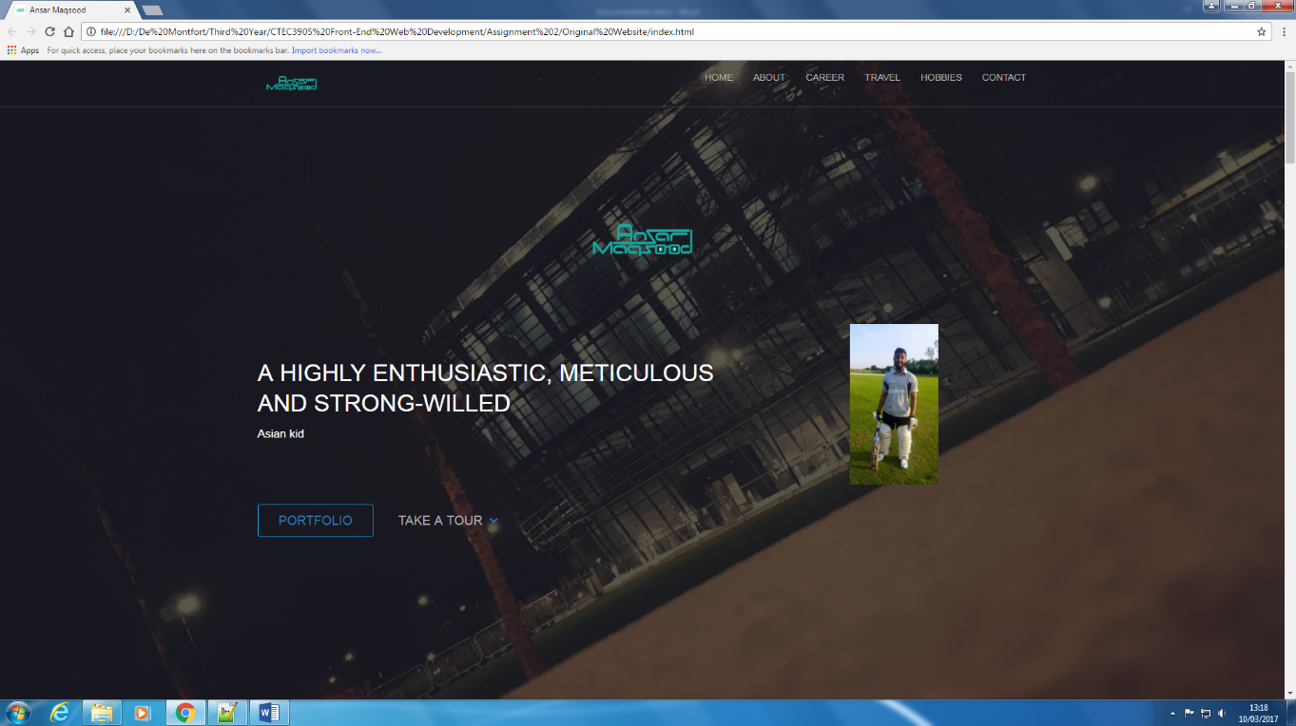This is the home page section of the SPA website that was developed. As you can see form the initial design and the completed design, they both look similar. I used bootstrap for the navigation and JS which helped me with smooth scrolling of the navigation throughout the website.

Figure . Completed home page section of the website.

## About

This is the About section where it showcases more information about me. This has JS where the image and the text slide in from the side. As you can also see, by using JS smooth scrolling of the navigation, it does not disappear.

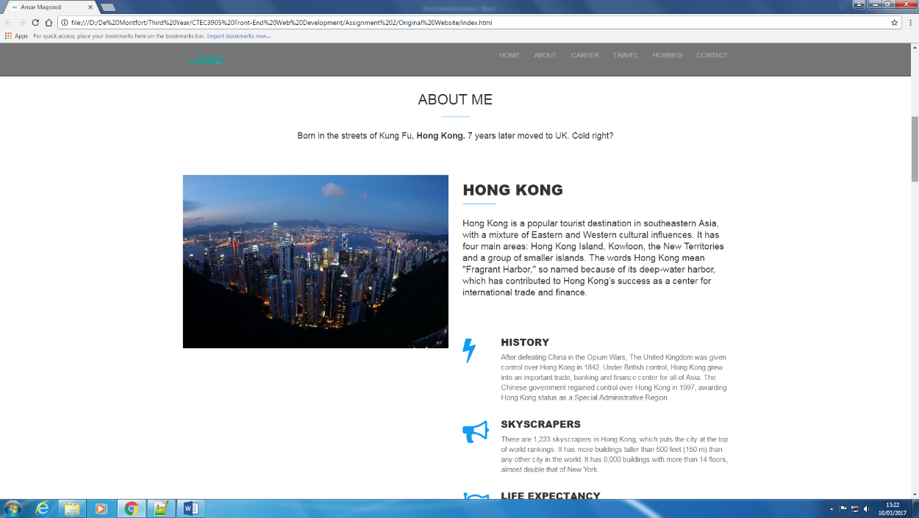

Figure . Completed About section.

## Travel

This is the Travel section where it shows the images of the places I have travelled to. It uses JQuery and BXSlider from online.

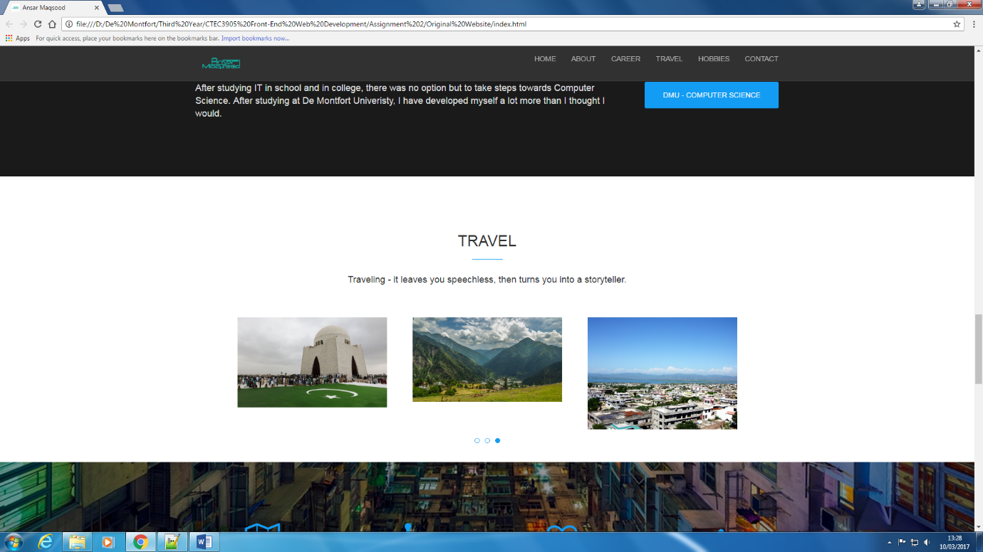

Figure . Completed Travel section.

# Example of Source Code

The following will show an example of each HTML, CSS and JS code.

## HTML

This is the HTML navigation code example that I have used for my website. This allows the user to navigate through the website. I have used Bootstrap to help aid the website.

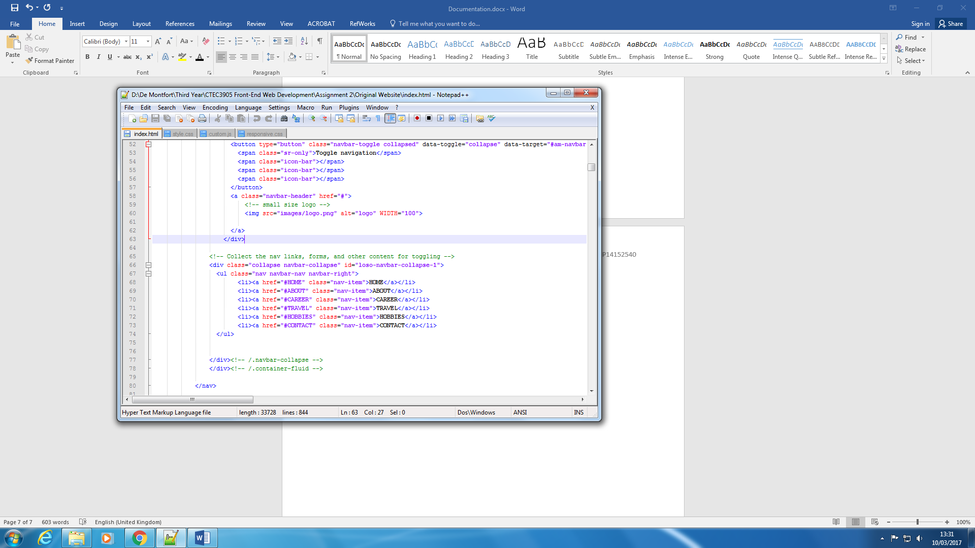

Figure 7. HTML Code

## CSS

This is the CSS that I have used for the navigation. This gives the navigation bar style which enables it to be seen clearly on the site.

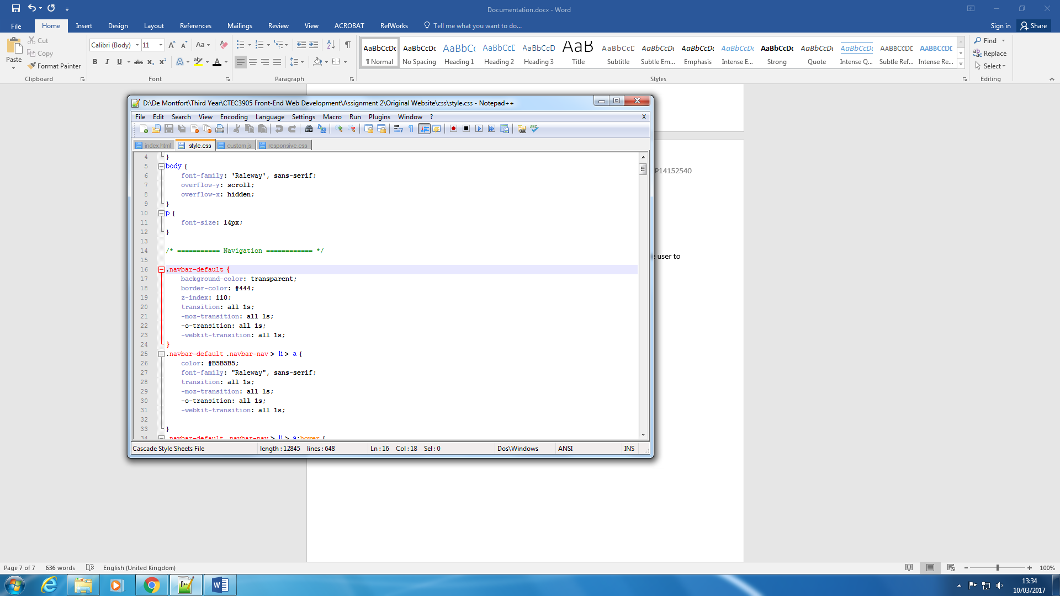

Figure 8. CSS Code

## JavaScript

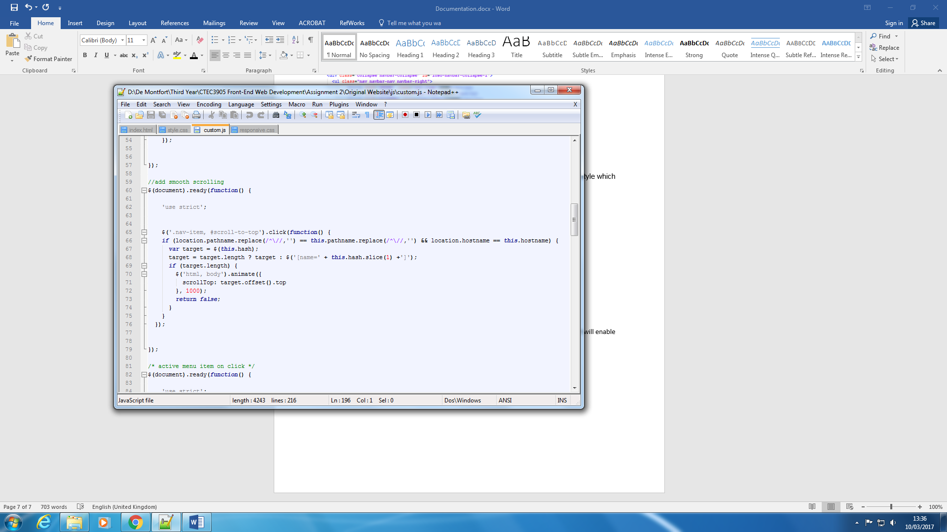This is the JavaScript I have used for the navigation bar. It is for smooth scrolling where it will enable to show on the page when the user is scrolling down.

Figure . JavaScript Code

# User Testing

## Browser Testing

|  |  |
| --- | --- |
| **Browsers** | **Pass or Fail** |
| Google Chrome | Pass |
| Internet Explorer | Pass |
| Firefox | Pass |
| Safari | Pass |
| Opera | Pass |

## Compatibility Testing

|  |  |
| --- | --- |
| **Devices** | **Pass or Fail** |
| Computer | Pass |
| Laptop | Pass |
| Tablet | Pass |
| Phone | Pass |

## Usability Testing

|  |  |
| --- | --- |
| **Features** | **Pass or Fail** |
| Do images load | Pass |
| JavaScript work | Pass |
| Navigation Scrolling | Pass |
|  |  |

# Reference

## Tools Used

Notepad++ - The text editor used to develop my website.

Microsoft Word – I used Word for my initial designs and document my work.

## Frameworks Used

JQuery – I used this framework for my slideshow of the images. It was called BXSlider.

Bootstrap – I used this framework for my navigation bar and through the website to create the columns.