Web Template Cheat Sheet

* Read comments in the code:
  1. You need to have some HTML/CSS and a little JavaScript knowledge to be able to use this template.
  2. Comments are added in the code files to give hints about their functionalities.
* Customize template stylings:
  1. The web page template is using Pure.css v1 for layout. If you want to deeply customize the template layout yourself, it is better to learn about the CSS classes this library uses: <https://purecss.io/>.
  2. Alternatively, you can also just change/add CSS rules in the “/assets/css/style.css” file to modify/override the existing stylings.
* How to add a link to the top navigation: (when clicked, the page can scroll to an element’s position that you’ve specified)
  1. Open the file “/assets/js/scroll.js”.
  2. Around line 100, add a new line for displayed name of the link and unique ID for the element it will scroll to.Text

     Description automatically generatedThe left side is the name that will be displayed in the top navigation (“NEW SECTION NAME”), the right side is the anchor ID given to the element on the web page that the page will scroll to (“UniqueSectionAnchorID”).
  3. Add the anchor ID (“UniqueSectionAnchorID”) to an HTML element on page in “index.html” file:
  4. Then you can click the link in the top nav bar. It will scroll to the element’s position that you’ve specified.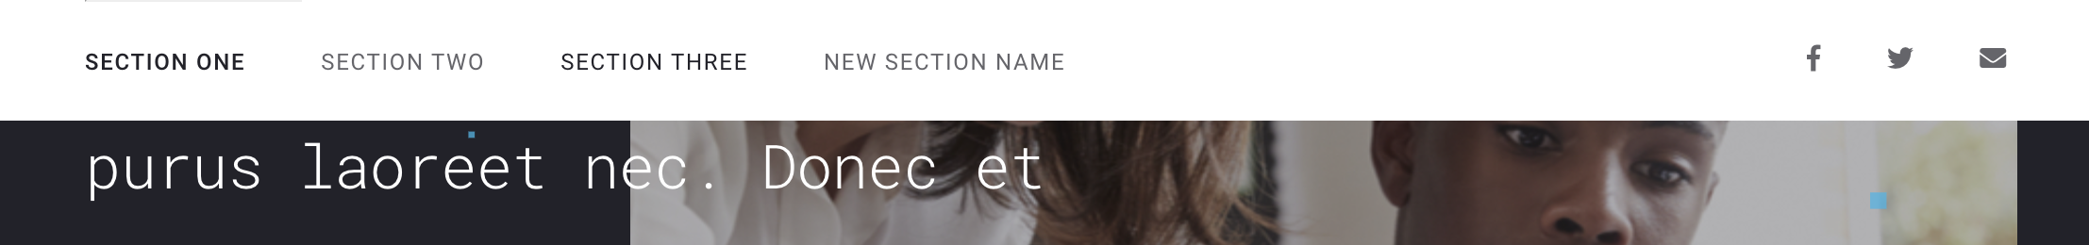
* How to add an image of a chart:
  1. Place the chart image export in the “/charts” folder. It can be PNG, JPEG, or even SVG. The size of the image file should be ideally smaller than 800KB for better performance.
  2. Replace the source path (`src` attribute) to the image in the `img` element of the “chart-image-container” element:Graphical user interface, text, website

     Description automatically generated
  3. For accessibility, add a description in the `alt` attribute for screen reader users.