**Warning (California Proposition 65)**

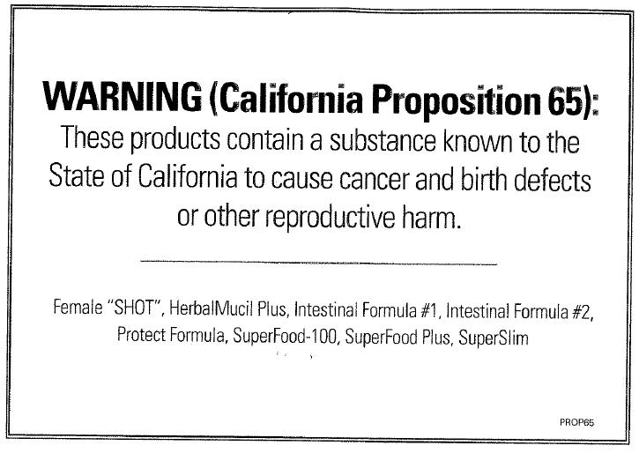

In “**2014**” the laws in the state of “**California**” just got stricter.

According to “**Proposition 65**” ANY company producing “**Supplements**” (which are not considered food by the State of California) is now required by “California Law” to hand out the above warning notice to their customers (e.g., cancer causing substance in products). However, Pharmaceutical Drug companies gets a **FREE PASS** and are not required to hand out this Proposition 65 warning even though the majority of their products have a much HIGHER “Lead” content than Dr. Schulze; plus they even add more medals to their medication).

However, the substance in such products that can cause cancer is:

**A NATURALLY occurring “Lead” from the soil**. This is NOT something Dr. Schulze puts inside his products nor is this “Lead” something Dr. Schulze puts inside his bottled materials. Since it is NATURALLY occurring, this is something that can NOT be filtered out by Dr. Schulze. State legislators have tested ALL of Dr. Schulze’s (and also other companies producing supplements) and found that the “Lead” level (**from the soil**) that the “California’s Meter Gage” shows was a few points higher in some of Dr. Schulze’s specific products (compared to the overall of his other products). This is nothing to be concerned about since the “Lead” level shows very tiny traces and the vitamin benefit outweighs any danger.

However take note:

a) Out of ALL the 50 states, only “**California**” is the only state that has a stricter meter gage requirement. Dr. Schulze (or any other company producing supplements) is not required to put this notice in ANY of his/their other boxes that is mailed to any of the other states.

b) This Naturally occurring “Lead” from the soil is even in the fruits and vegetables at organic stores as “Trader Joes” (notice the same sign when you walk into the main entrance).

c) This same sign (or a similar one) is also hanging above the “Starbuck’s” coffee machine (the coffee beans coming from the soil also has a high “Lead” content according to “**California’s Meter Gage**”).

**We cannot avoid 100% lead-free from the water we drink**

**We cannot avoid 100% lead-free from the soil where we get our food**

**We cannot ever avoid 100% radiation-free from the sun that shines on us**